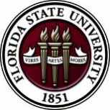
Florida State University
OFFICE OF POSTDOCTORAL AFFAIRS
WEEKLY DIGEST

April 3, 2019

the 6th annual bio/neuroscience oral presentation
The 6th annual Postdoc Oral Presentation/Competition will be held Monday, April 8th, from 10am -3pm in King 2057.
This year, New England Bio labs rep Cassie Black has arranged for sponsorship of the prize with $1000 worth of NEB products to the postdoc with the highest score!!
To sign up for a presentation, just send me an email now with times you are available on April 8 between 10am and 3pm. You can send your title any time between now and Monday, March 11.
The presentations will be 15 minutes each with 3 min. for questions.
This is a great time of year to give a presentation in preparation for summer conferences.
(Lunch will be provided.)
We need at least 7 presentations and can have as many as 10. We are looking for a mix of presentations from all areas of the Bio department and from Neuroscience.
Postdocs in all stages of their projects are encouraged to present. Even if you have been here only a short time, you should still volunteer to give a presentation! Talking about a relatively new project is exciting and early in your postdoc is a great time to get feedback from those outside your group.
Click here to download flyer with agenda.
Spring Semester 3-parts Grants Workshop – PART II
April 26, 2019 12 to 3 pm. Sign up for a time block to have your prepared Specific Aims page critiqued by a panel of experts in your field. This is the heart of every successful grant proposal.
Click here for a helpful document to writing your specific aims
July 26, 2019 12 to 3 pm. Sign up for a time block to have your full grant proposal critiqued by a mock study section of experts in your field. Then take your reviews, modify your full proposal and submit to your targeted agency to receive your intramural award from FSU. You do not have to be awarded your proposed grant to receive the intramural support, but you must complete all three workshop dates and be responsive to the available experts!

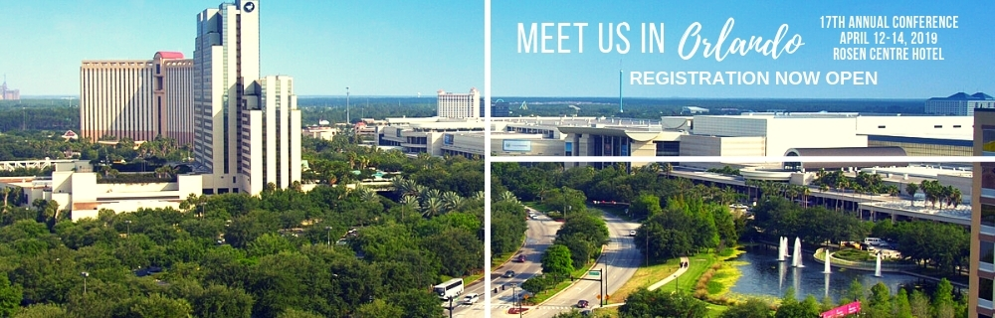
17th Annual Postdoctoral Association Conference

The conference will be held in Orlando, Florida, April 12 – 14, 2019. Because of the close proximity, and the fact that Florida Institutions are coordinating to serve as the host university, we are pleased that several FSU postdoctoral scholars will attend and represent Florida State University. There will be a special career fair on Sunday April 14th with a wide range of employers – the event is free to all NPA members (which you all are with FSU’s institutional membership!). Even if you are not the selected delegate, you are free to attend the career fair at no cost. For more information about the NPA Conference, please click here.

college of medicine – career talk
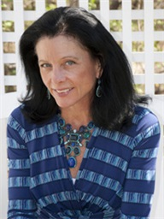
The College of Medicine presents Dr. Nancy Ryan Gray, President and Chie Executive Officer of the Gordon Research Conferences (GRC). Dr. Gray will be visiting FSU to give her famous career talk: "The Keys to Success ... Are Somewhere at the Bottom of My Purse” - Tuesday, April 16th @ 4pm - College of Medicine Room 1306 (Enter COM from the southwest corner of the courtyard. Room 1306 is just inside to the right.)
From Dr. Grey: The title of this presentation should suggest that I am clearly not an expert on the keys to success. Nevertheless, the presentation highlights my circuitous career path, a few of the “lessons” I have learned over the past 30 years, and the “things I know now” but “wish I’d known then.”
To see Dr. gray’s bio, please visit: https://www.grc.org/president-and-ceo/.
For more information on Gordon Research Conferences: https://www.grc.org/about/
Spring 2019 - “welcome” mini-orientation
April 29, 2019, Honors, Scholars & Fellows House, Room 3009, 12 PM
If you are a new postdoctoral scholar to the FSU campus, this “Welcome” is a nice brown bag lunch activity that will fit into your busy schedule. The design will be limited to strictly a 1-hour session, where you will receive the essentials of getting your research started at FSU and have access to Human Resources and Office of Postdoctoral Affairs Staff. At this time, you will also be introduced to the Postdoctoral Association (PDA) – your peer network of postdocs on campus. Attending a ‘welcome’ in your first few months of employment at FSU will serve to fulfill your mandatory orientation. For more information, please contact Debi Fadool at: dfadool@bio.fsu.edu.

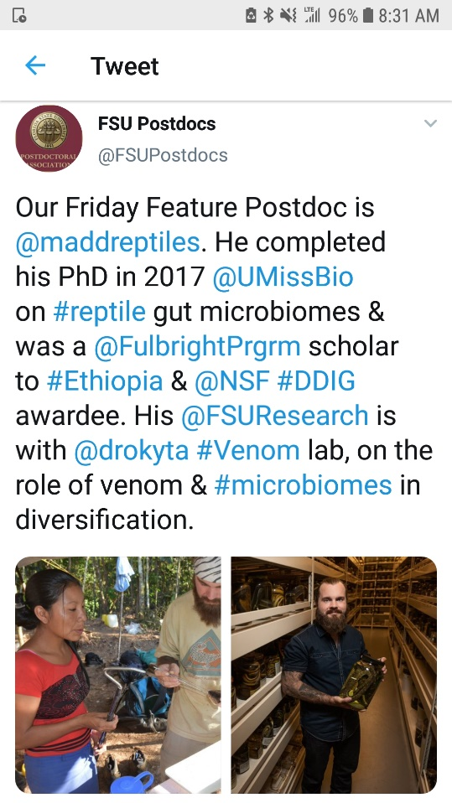
accomplishments – Achievements – research
Postdocs, would you like help to disseminate your research, service, and mentoring achievements to a broader audience via the @FSU Postdocs Twitter account? If you have exciting new findings, just been published, received a grant or award, got hired for a new position, or have other accomplishments you would like to share for yourself or your mentees, please share them with us.
Just send the content to be tweeted to Biological Science postdoc Matt Holding at mlholding@fsu.edu and it will be shared on @FSU Postdocs. Use the following guidelines to prepare your content:
Send links to papers or websites, photos of the activity, or other material that isn’t just text. Tweets get more traction if they contain content other than text alone.
Provide less than 280 characters of text for the tweet describing the activity. Include Twitter handles for your colleagues/collaborators where appropriate, if you know them, and any #hashtags to which the tweet can link. We can also retweet content you put out on our own Twitter account if you drop us a line with your Twitter handle and the specific tweet we should retweet.

coming soon: “postdoc world”
The Graduate School has embarked on an exciting new initiative to develop a brand new interactive video archive for all graduate students, postdocs, faculty and alumni called Grad World FSU. This was an idea inspired by Dr. Harry Kroto, and his GEOSET project at FSU. Our pilot study has concluded and the website is now in the final stages of development. We already have 100 videos on the Grad World FSU site, but what is needed now is postdoc participation to get this initiative off the ground.
A website similar to this one titled Postdoc World is in the works for postdoc scholars. We will let all know when that site is up and running. In the mean-time, we encourage postdocs to go to the Grad World website to create your video.
What is Grad World FSU?
Grad World FSU is a revolutionary website that looks and feels very similar to Google Earth, displaying a variety of personalized videos from graduate students, postdocs, alumni and faculty for the purpose of showcasing their outstanding achievements and contributions to Florida State University. This is an extraordinary opportunity for everyone around the world to see your passion, interests, research goals and learn more about our wonderful university. As you know graduate school, and postdoc opportunities change lives and the world for the better! Once others see you talking with such enthusiasm and excitement about all of the amazing things you are doing, they too will want to join in on the fun and become part of this great scholarly community known as “Family FSU”, or if they are employees, maybe even offer you a job.
How to Contribute?
Interested postdocs can choose to complete one of two video options: Option 1.) a self-filmed Questionnaire Video where you would answer a few questions using a cell phone, digital camera or the Screencast-O-Matic webcam software, or Option 2.) a GEOSET PowerPoint Video in which you would reserve a time to meet with the GEOSET Studio team in the Dirac Library to create a guided video/PowerPoint presentation to present a compelling oration of your research interests, or work at FSU. And remember, if English is not your native language, we encourage you to complete a second video in your native tongue so everyone in the world can enjoy it.
There are helpful tutorials available on how to create your questionnaire video available on this website.
If you are interested in booking your recording session in the GEOSET studio, please click on this link: https://fsu.qualtrics.com/jfe/form/SV_38Kipwda3eQrgxf
asbmb travel awards
ASBMB (American Society for Biochemistry and Molecular Biology) will award over $275,000, through its travel awards program, to assist member, first authors presenting research at the ASBMB annual meeting, April 6-9, 2019, Orlando, Fl. For more information, please click here.
Biological Science/Neuroscience Postdoctoral Mentoring Workshop & Lunch
Kin Life Science Building, room 2057, 12:00 – 1:00 PM
Please mark your calendars for the Fall 2018/Spring 2019 postdoc workshops. This is a special, faculty-led monthly workshop for Postdoctoral Scholars hosted by the Department of Biological Science and the Program in Neuroscience. Although the career focus will be directed to the Life Sciences, all Postdoctoral Scholars and senior Graduate Students are welcome. Sandwiches will be served over the lunch hour during the workshops. Dates, presenters and topics are listed below. For questions, please contact Dr. Kay Jones. No registration required.
Date | Presenter | Title
Mon. Sept. 10 | Dr. Peter Fajer, Cell & Molecular Biology Professor & Director of the Institute of Molecular Biophysics | How to make yourself palatable to academic search committees. A view from the other side of the table.
Mon. Oct. 8 | Dr. Scott Steppan, Professor of Ecology & Evolution in Biological Science | Interviewing for an academic position.
Tues. Nov. 13 | Dr. Qian Yin, Assistant Professor in Cell & Molecular Biology in Biological Science | Plan ahead: from K to interview
Mon. Dec. 10 | Dr. Scott Burgess, Assistant Professor in Ecology & Evolution in Biological Science | Thinking like the job you want
Mon. Jan. 14 | Dr. Yuan Wang, Assistant Professor Biomedical Sciences, College of Medicine & Neuroscience Program | Job search in Neuroscience: where to start and how to decide?
Mon. Feb. 18 | Dr. Crystal L. Young-Erdos, Assistant Prof. of Chemistry at Eckerd College in St.  Petersburg, FL | ‘Multiple perspectives on the academic job search’
Mon. March 11 | Dr. Rob Contreras, Associate Dean, Arts & Sciences | Negotiating Faculty Job Offers
Mon. April 8 |  | Oral Presentation Day

new postdoc science initiative
The Journal of Postdoctoral Research www.postdocjournal.com has been publishing postdoc research for several years now and is currently working on a spin-off journal entitled ‘Postdoc Life Science ‘. This new journal will be focusing only on life sciences research with the goal to be indexed in MEDLINE/PubMed. The launch date is set for 1st April 2019.
Please note of the following rich possibilities and benefits of the new Postdoc Life Science Journal and how it can make a difference in your research career:
1. Call for papers: We are inviting research papers, reviews, methodologies, commentaries, perspectives, progress articles, clinical case summaries and research highlights to be published in the upcoming issues of Postdoc Life Science. Submissions for the inaugural issue may be sent-in by March 1st.
2. We are inviting nominations for our Postdoc of the Month award. Please send-in nominations [self, or PI recommended] to Editor-in-Chief@PostdocJournal.Com. Only Postdocs in life sciences are eligible to apply.
3. Editorial and other activities are available for postdocs, please touch base with us with a brief description on your interests. In addition, we are proposing an associate editor position for a post-doc association (PDA) board member who could bridge between the journal and PDA to update the editorial board on current postdoctoral publications and activities.
This new initiative will showcase and highlight former, current and future postdoc’s contribution to life sciences research, conduct exclusive international conferences, recognize accomplished postdocs with monetary awards and institute postdoctoral research grants, just to name a few.

Cancer control research training program
The University of Rochester Medical Center Cancer Control & Psychoneuroimmunology Laboratory is actively seeking outstanding candidates for their upcoming group of Fellows for 2018. The applicants should be interested in longitudinal studies and clinical trials on translational (e.g. biomarker) symptom science research and/or cancer-related cognitive impairment research to work closely with Dr. Michelle Janelsins (Associate Professor) and her research team. Candidates they are interested in come from a variety of backgrounds including, but not limited to, neuroscience, cognitive science, clinical psychology, epidemiology, clinical trials, applied sciences, and many more.
For more information, and to apply, please click here.
Materials can be sent directly to Dr. Michelle Janelsins or Dr. Gary Morrow (Program Director)
Fellowships
American Diabetes Association – 2019 Core Research Program
Application deadline: July 15, 2019

Postdoc Research Funding Opportunities in Germany
Application deadlines vary
Index of Postdoc Fellowships in the Life Sciences (Broad Institute)
EPA Research Grants

EMBO Life Sciences – Short/Long Term Fellowships

Jobs
Below is a sampling of open positions in the United States –
Postdoctoral Positions Available -
Looking for motivated Postdocs to research mechanisms involved in regulated remodeling of muscle T-tubule membranes in fly models of human myopathy with funding for immediate start date!
For more information, please click here to view flyer. Please contact Dr. Amy Kiger, Section of Cell & Development Biology, University of California, San Diego at: akiger@ucsd.edu.

Postdoctoral and research scientist positions
The Kaczorowski Lab at The Jackson Laboratory is seeking Postdoctoral and Research Scientist Level personnel to investigate mechanisms underlying susceptibility and resilience to normal aging and Alzheimer’s disease (https://www.neuro-central.com/2018/09/19/risk-resilience-understanding-role-genetics-alzheimers-disease/). Dr. Kaczorowski is an Associate Professor and the Evnin Family Endowed Chair in Alzheimer’s Research at the Jackson Laboratory – a research institution specializing in genetics and genomics in order to discover solutions for disease. Projects leverage new translational mouse models, electrophysiology, circuit mapping and genome engineering to decipher how genetic and environmental factors interact to influence learning and memory abilities, cognitive aging, neurodegeneration, and Alzheimer’s. Sources of support include NIH, Bright Focus, The Glenn Foundation for Medical Research, as well as generous philanthropy awards in support of research and innovation in areas of normal aging and Alzheimer’s Disease.
Exceptional candidates will have the opportunity to apply for the prestigious JAX Scholar award, which supports promising early-career postdoctoral associates conducting cutting edge biomedical and basic biological research at JAX. The award includes an independent research and travel budget and a salary above our standard postdoctoral scale https://www.jax.org/education-and-learning/pre-and-postdoctoral-program/jax-scholars.
To apply, please submit (1) a cover letter describing past research accomplishments, research interests, and career goals, (2) a current CV, and (3) the contact information of three references to
catherine.kaczorowski@jax.org

Assistant Professor – Department of Biology (Job number: 10609)
Tenure-Track position in Developmental Molecular Genetics: As part of an expansion in molecular genetics research, West Virginia University invites applications for a tenure-track position at the Assistant Professor level in the Department of Biology (http://biology.wvu.edu) to begin August 2019. We seek an individual who uses molecular and/or functional genomic approaches to explore integrative questions about development in non-mammalian animal model systems. Applicants should have a broad biology background and strong interdisciplinary skills to develop an externally-funded independent research program. Applicants should also have an openness to collaborative research and a desire to contribute to the undergraduate and graduate research and teaching missions of the department. Requirements include a PhD or equivalent degree in biology or a related field, a strong record of scholarly publications, strong post-doctoral experience, excellent written and oral communication skills, and the potential to secure external funding.
WVU, located in Morgantown, is a comprehensive land grant university enrolling about 30,000 students in over 100 degree programs. Our Carnegie Classification is “Doctoral Universities: Highest Research Activity.” The Department of Biology at West Virginia University offers a diverse, highly productive and well-funded research environment that is highly supportive of new junior faculty. Existing departmental strengths include molecular genetics, behavioral neurobiology, and genomics.
To apply, please visit https://careers.wvu.edu, navigate to the position title listed above, and upload a single PDF file including a cover letter, curriculum vitae with a list of publications, a succinct outline of future research plans, and a one page teaching statement. In addition, arrange for 3 letters of reference to be sent electronically to WVUBiology@mail.wvu.edu. Review of completed applications will begin on January 21, 2019 and will continue until the position is filled. For more information about the position contact Kevin C. Daly at kcdaly@mail.wvu.edu. For more information about WVU and the city of Morgantown, WV: https://biology.wvu.edu/about/jobs/about-morgantown.

Florida College System, seeks to fill a position for Executive Director, Florida Student Success Center.
The Florida Student Success Center (FSSC) serves as an intermediary between colleges, and provides greater opportunities for colleges to collaborate and learn from one another. The Executive Director works under the supervision of the Chancellor of the Florida College System.
For more information on the role of the position, qualifications and to apply please click here.

Florida Conservation Corps - Opportunities
FLCC is recruiting for two exciting project areas.
The mission of the Florida Conservation Corps is to develop natural and cultural resource leaders by connecting them to areas of critical need in conservation, preservation, interpretation and resource based recreation. Click here to download flyer. For more information about FLCC, please visit their webpage at: https://www.floridastateparks.org/florida-conservation-corps.
Assistant Professor – Department of Psychology
Jackson State University, Jackson, MS

Staff Scientist – Liver Diseases Branch
National Institutes of Health, Bethesda, MD

Research Assistant Professor – Department of Otolaryngology (Job ID: FAC0002721)
University of North Carolina at Chapel Hill, Chapel Hill, NC

Applied Social Scientist
National Security Agency, Fort Meade, MD

Assistant Professor – Computational Biology (Immunology)
Evergrande Center for Immunologic Diseases at Harvard Medical School, Boston, MA

Research Associate I – Materials Science & Engineering (Job ID: 19000000OJ)
University of Tennessee, Knoxville, TN

Assistant Professor Positions – Exercise Physiology (Job ID: 42380) & Nutrition (Job ID:42371)
FSU College of Human Sciences, Department of Nutrition, Food & Exercise Sciences
Assistant Professor of Research – Center for Craniofacial Molecular Biology
University of Southern California (USC), Biomedical Sciences

Assistant Professor – Clinical Occupational Therapy
University of Southern California, Occupational Therapy
Assistant Professor – Research Emergency Medicine
University of Southern California, Department of Emergency Medicine
Clinical Assistant Professor – Pediatrics
University of Southern California, Department of Pediatrics
Below is a sampling of open positions around the world -
Canada: Assistant Clinical Professor – in Pharmacy & Pharmaceutical Science
University of Alberta, Faculty of Pharmacy & Pharmaceutical Sciences

Tenure Track Assistant Professor – Biomedical or Electrical Engineering
University of Guelph, School of Engineering/Biomedical Engineering
Assistant Professor – REHAB Occupational Therapy
University of Alberta, Department of Occupational Therapy
Assistant Professor – Microbial Science & Micro/Nanomaterials
University of Calgary Canada First Research Excellence Fund
Assistant Professor – Department of Medicine
University of Alberta, Faculty of Medicine & Dentistry
Assistant Professor – Division of Developmental Pediatrics
University of Alberta, Faculty of Medicine & Dentistry

Staff Scientist in Hematology Research
Keenan Research Centre for Biomedical Research of St. Michael’s Hospital
Japan: Assistant Professor in the Graduate School of Biomedical & Health Sciences
Hiroshima University, Graduate School of Biomedical & Health Sciences
Assistant Professor in Medical Education, Pharmacology, Neuroscience
Hiroshima University, Graduate School of Biomedical & Health Sciences
Norway: Head Engineer at Electron Microscopy Core Facility
University of Oslo, Department of Biosciences (IBV)
Singapore: Assistant Professor for Bio-Behaviorist
Duke NUS Medical School, Academic Medicine Research Institute

Assistant Professor – Center for Aging Research & Education
Duke NUS Medical School, Center for Aging Research & Education
South Africa: Associate Researcher in Clinical Micro Infectious Diseases (CMID)
Wits University, School of Pathology, Johannesburg, ZA
Switzerland: PhD in Biomedical Engineering
University of Basel, Adaptable MRI Technology
Click here for featured Biology careers
Subscribe to receive personalized job announcement emails:
Bio Careers
Academic Keys
PhD Jobs
Fierce Biotech Jobs
ASBMB - American Society for Biochemistry and Molecular Biology
http://www.asbmb.org/careers/ (career information)
Career Development Webinars and Blogs
The professor is in: Why You Should Negotiate Every Job Offer
In this article, the author states, whether or not you have the leverage of a second job offer, ask your potential department for what you deserve (within reason).
How mindfulness can help Ph.D. students deal with mental health challenges
Read an article, where the author’s references a meditation study that could possibly help students deal with things like stress and anxiety.

Webinar | Unmasking mental health issues faced by scientists: Addressing the silent pain among us. Tuesday, April 9, 2019, 12 noon Eastern
Webinar | Deciphering CAR T Cells: Exploring functional mechanisms to drive next generation immunotherapy, Thursday, April 11, 2019, 12 noon Eastern
Webinar | Adventures in single-cell RNA transcriptomics
Thursday, April 25, 2019, 12 noon Eastern
How to Be Proactive in Your Mentoring Relationships – National Postdoctoral Association http://www.nationalpostdoc.org/?page=Proactive
ASBMB - Postdoctoral Education & Resources

Versatile PhD
This site helps graduate students and new PhD’s identify, prepare for, and excel in possible non-academic careers.
Click here to learn more. Click here to join
Free NPA Membership
FSU is a sustaining member of the National Postdoctoral Association (NPA). This membership provides free affiliate membership to all FSU postdoctoral scholars. Benefits of joining the NPA include:
    - A subscription to the NPA’s official quarterly newsletter
    - Reduced registration fees to the NPA Annual Meeting
    - Eligibility for the NPA Travel Award Program
    - Professional & Leadership Development
    - Networking opportunities with colleagues nationwide
If you are interested in joining the National Postdoctoral Association, click here.
Please email opda-info@fsu.edu if you encounter any problems.
For previous issues, click here!

