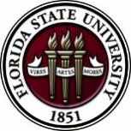
Florida State University
OFFICE OF POSTDOCTORAL AFFAIRS WEEKLY DIGEST

February 13, 2017

Upcoming Events

Biological Science/Neuroscience Postdoctoral Mentoring Workshop and Lunch
Postdoctoral scholars and senior graduate students from all fields are invited to attend. Sandwiches will be served over the lunch hour during the workshops.
For questions, please contact Drs. Erminia Fardone or Kay Jones.

DATE | PRESENTER | TITLE
February 13, 2017 | Drs. Emily Moriarty and Alan Lemmon | Balancing work and family
March 6, 2017 |  | Oral Competition Day

Save the date for the Oral Competition Day. Postdoctoral Scholars orally deliver their research in a 12 minute presentation format to a panel of judges. Great way to receive feedback on your oral communication skills that are essential for interviewing! If you would like to participate in giving an oral presentation of your research, please contact Kay Jones about submission processes.

"Welcome" Mini-Orientation Sessions for New Postdoctoral Scholars on Campus
Honors, Scholars & Fellows House, Room 3009, April 24, 2017 at noon
If you are a new postdoctoral scholar to the FSU campus, this “Welcome” is a nice brown bag lunch activity that will fit into your busy research schedule. The design will be limited to strictly a one hour session, where you will receive the essentials of getting your research started at FSU and have access to Human Resources and Office of Postdoctoral Affairs Staff. At this time, you will also be introduced to the Postdoctoral Association (PDA) - your peer network of postdocs on campus. Attending a “welcome” in your few months of employment at FSU will serve to fulfill your mandatory orientation. For more information, contact Debi Fadool, dfadool@bio.fsu.edu

POSTDOCTORAL SPRING EVENT – Hold the Date – 19 may 2017
We are excited to host Dr. Lori Conlan, Director of Postdoctoral Services at the National Institutes of Health, as our keynote speaker for this event! The theme of the event will be around making yourself marketable and job interviewing. Please hold the date on your calendars. Please see Sumudu Tennakoon or Erminia Fardone if you would like to assist in the organization or planning of the event.
Professional Development Workshops

Interviewing for the Academic Position [PFF/PFP/PIE]

February 17, 2017, 12:30 PM – 2:00 PM
Honors, Scholars & Fellows House, Room 3009

Presenter: Dr. Jonathan Grant, History Department
Do you plan to attend a conference where you may have several interviews? How do you plan for a telephone interview? What should you expect during an interview at a neutral place, such as an airport? How do you prepare for the interview process on a college/university campus?
These and other questions will be answered in this informative workshop led by an experienced faculty member.

To register: https://fsu.qualtrics.com/SE/?SID=SV_cBySO9Whu9wTkNv

Are you prepared for your Social or Behavioral Sciences Conference Presentation?

February 21, 2017, 3:30 PM – 4:30 PM
Honors, Scholars & Fellows House, room 3009

Presenter: Dr. Jennifer Proffitt, Associate Professor, School of Communication

How do you convert a paper into a conference presentation? Will you talk with notes, read your paper, and/or use visuals (e.g., PowerPoint)? How will you ensure that your audience will get your message? Are you prepared for the audience’s questions? Dr. Proffitt will answer these questions and more when she leads you through the process of conference presentation preparation and delivery.

To register: https://fsu.qualtrics.com/SE/?SID=SV_9YO05d0uGSl5Snz

Employer Panel: What we are looking for when we recruit new employees

February 24, 2017, 5:00 PM – 6:30 PM
Honors, Scholars & Fellows House, Room 3009

Presenters: Panel of employers representing a range of fields
Moderator: Amanda Sargent, Assistant Director, FSU Career Center
Our panel will describe what they want to see when they review résumés and CVs. Employers will discuss how students can prepare to join their future profession. Time will also be devoted to preparing for an interview. Attend this workshop with the goal of developing a plan to succeed in a professional work environment.

To register: https://fsu.qualtrics.com/SE/?SID=SV_a4TCF1LeBP7BFzL

PIE Coffee Hour & Teaching Workshop: Go Big or Go Home: Activities for Large Classrooms (PIE/PFF/PFP)

February 27, 2017, 3:30 PM – 5:00 PM
Honors, Scholars & Fellows House, 4th Floor, Great Hall

Presenters: PIE Associates, Mary Marcous, Philosophy, and Ashley Artese, Nutrition, Food & Exercise Sciences
Do you ever wonder how to get those 70 students in your lecture to wake up and participate? Teaching a large number of students can be difficult because of space limits, classroom sizes, or even the layout of the room. This workshop will present a number of strategies and activities to facilitate engagement in classes with a large number of students, regardless of subject area.

Free PIE & Coffee Included!

Click here to register: https://fsu.qualtrics.com/SE/?SID=SV_71G3jIg4IyoGtJX

Funding Announcements

Tufts Training in Education and Critical Research Skills Program (TEACRS)

TEACRS is designed to prepare talented young scientists for the multiple demands of an academic career in biomedical research. Trainees spend on average 75% of their time conducting bench research and 25% of their time in career development activities. Teaching skills are developed through programs involving mentored classroom assignments at minority-serving institutions in the Boston area. The training is supplemented by workshops on teaching methods, career opportunities in academia, and essential skills such as grant writing, mentoring, and scientific presentations. The training components are sequenced to allow trainees to balance the activities and to build on previous experiences. TEACRS fellows receive up to four years of salary support at the NIH postdoctoral stipend levels, and a yearly travel and supply allowance.

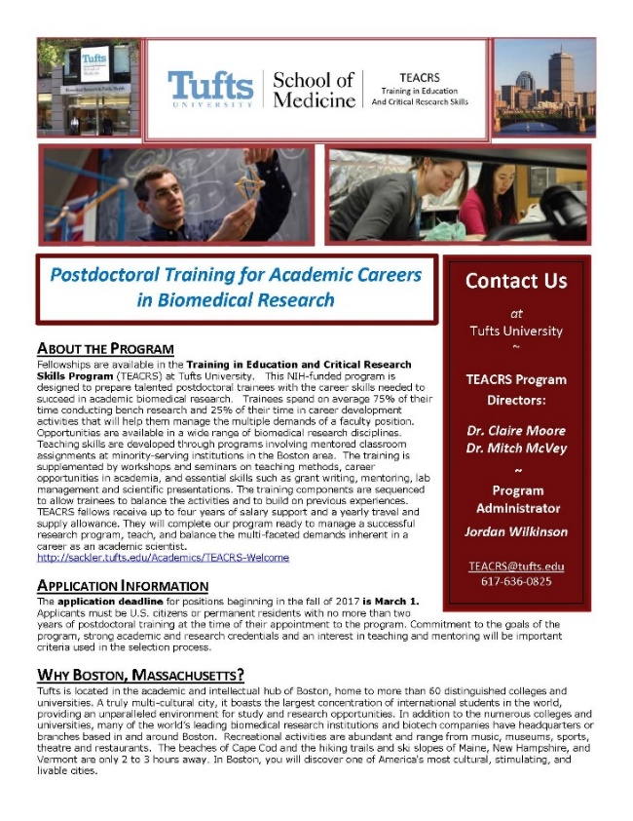
The application deadline for positions beginning in the fall of 2017 is March 1, 2017. Later applications will be considered if positions are available. Applicants must be U.S. citizens or permanent residents with no more than two years of postdoctoral training at the time of their appointment to the program. Commitment to the goals of the program, strong academic and research credentials and a demonstrated interest in teaching and mentoring will be important criteria used in the selection process.

For additional information on the TEACRS program and application procedures, please visit our website, or contact Claire Moore, the Program Director, or Jordan Wilkinson, the Program Administrator with questions. We have also attached a printable flier describing the program.

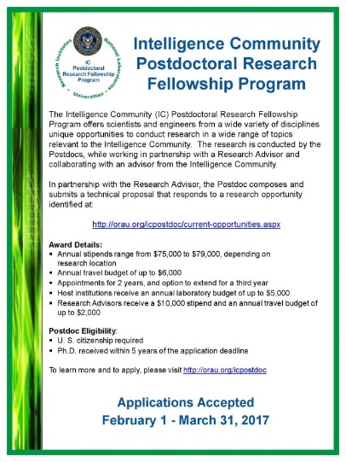
Fellowships

NOAA Sea Grant John A. Knauss Marine Policy Fellowship
http://seagrant.noaa.gov/FundingFellowships/KnaussFellowship/ProspectiveFellows.aspx
Deadline: February 21, 2017

Damon Runyon (Cancer Research) Fellowship Award
https://www.damonrunyon.org/for-scientists/application-guidelines/fellowship/forms
Deadline: March 15, 2017

Summer Scholarships in Epidemiology (Cystic Fibrosis Foundation)
https://www.cff.org/Our-Research/For-Researchers/Training-Awards/Summer-Scholarships-in-Epidemiology/
Deadline: April 1, 2017

Research Training Groups in the Mathematical Sciences (RTG)
https://www.nsf.gov/funding/pgm_summ.jsp?pims_id=5732&org=DMS
Deadline: June 6, 2017

Postdoctoral Program in Environmental Chemistry
http://dreyfus.org/awards/postdoctoral_program.shtml
Deadline: August 1, 2017

Mathematical Sciences Postdoctoral Research Fellowships (MSPRF)
https://www.nsf.gov/funding/pgm_summ.jsp?pims_id=5301&org=NSF&sel_org=NSF&from=fund
Deadline: October 18, 2017

Use the following databases to identify additional opportunities (click on the links) – Pivot, Foundation Center

Jobs
Below is a sampling of open positions around the world.

Assistant Professor – Electrical and Computer Engineering
https://www.pittsource.com/postings/131770
University of Pittsburgh, Pittsburgh, PA

Research Scientist – Research Engineer Scientist
https://honeywell.taleo.net/careersection/9/jobdetail.ftl?lang=en&job=2328668&src=JB-12349
Honeywell, Golden valley, MN

Assistant Professor – College of Medicine
https://jobs.uic.edu/job-board/job-details?jobID=72596&job=assistant-associate-full-professor-department-of-pharmacology
University of Illinois, Chicago, IL

Research Scientist
https://baxter.taleo.net/careersection/2/jobdetail.ftl?job=1600084G
Baxter Healthcare, Round Lake, IL

Assistant Professor – College of Nursing
http://uthsc.edu/hr/employment/job-desc.php?pin=23099
University of Tennessee Health Science Center, Memphis, TN

Research Scientist
http://jobs.leidos.com/ShowJob/Id/1018628/Research-Scientist/
Leidos, Albuquerque, NM

Assistant Professor – Chemical & Biological Engineering
https://www.ubjobs.buffalo.edu/applicants/jsp/shared/position/JobDetails_css.jsp?postingId=220084
University of Buffalo, Buffalo, NY

Subscribe to receive personalized job announcement emails:
http://floridastate.biocareers.com
http://www.academickeys.com/all/subscribe.php
http://jobs.phds.org/alert.new
http://jobs.fiercebiotech.com

Career Development Webinars and Blogs

7 Steps to a Good Interview
https://chroniclevitae.com/news/1680-7-steps-to-a-good-interview
Read advice on how to prepare for an interview.

How to Ace the Screening Interview
https://chroniclevitae.com/news/1694-how-to-ace-the-screening-interview
Read advice on how to get invited back for a second or third interview.

Thriving in a Small Department
https://chroniclevitae.com/news/1697-thriving-in-a-small-department
Learn tips of where you fit into a small department

How to Be Proactive in Your Mentoring Relationships – National Postdoctoral Association http://www.nationalpostdoc.org/?page=Proactive

Versatile PhD
This site helps graduate students and new PhD’s identify, prepare for, and excel in possible non-academic careers.
Click here to learn more. Click here to join
Free NPA Membership
FSU is a sustaining member of the National Postdoctoral Association (NPA). This membership provides free affiliate membership to all FSU postdoctoral scholars. Benefits of joining the NPA include:
    - A subscription to the NPA’s official quarterly newsletter
    - Reduced registration fees to the NPA Annual Meeting
    - Eligibility for the NPA Travel Award Program
    - Professional & Leadership Development
    - Networking opportunities with colleagues nationwide
If you are interested in joining the National Postdoctoral Association, click here.
Please email opda-info@fsu.edu if you encounter any problems.
For previous issues, click here!

