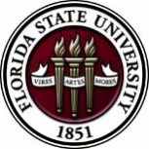
Florida State University
OFFICE OF POSTDOCTORAL AFFAIRS
WEEKLY DIGEST

February 13, 2019

congratulations to the spring 2019 travel award recipients!
Congratulations to our Spring 2019 Travel Award Recipients! The OPDA sponsored the travel of 8 Postdoctoral Scholars across the globe to gain professional development while disseminating their research findings and representing FSU in a variety of fields.
To view all the Spring 2019 Travel Award Winners, please visit: https://opda.fsu.edu/news/news-highlights.

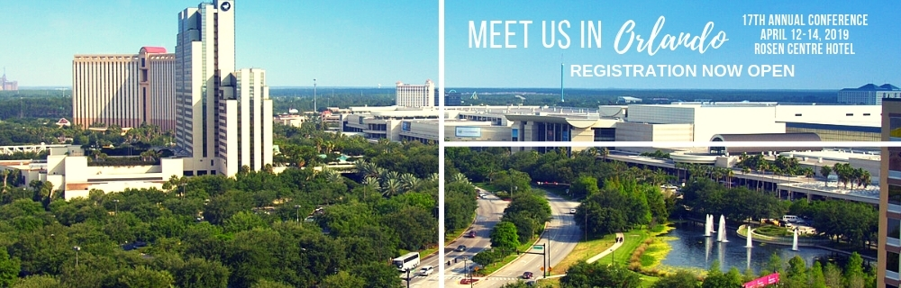
17th Annual Postdoctoral Association Conference
The conference will be held in Orlando, Florida, April 12 – 14, 2019. Because of the close proximity, and the fact that Florida Institutions are coordinating to serve as the host university, we are pleased that several FSU postdoctoral scholars will attend and represent Florida State University. There will be a special career fair on Sunday April 14th with a wide range of employers – the event is free to all NPA members (which you all are with FSU’s institutional membership!). Even if you are not the selected delegate, you are free to attend the career fair at no cost. For more information about the NPA Conference, please click here.

accomplishments – Achievements – research
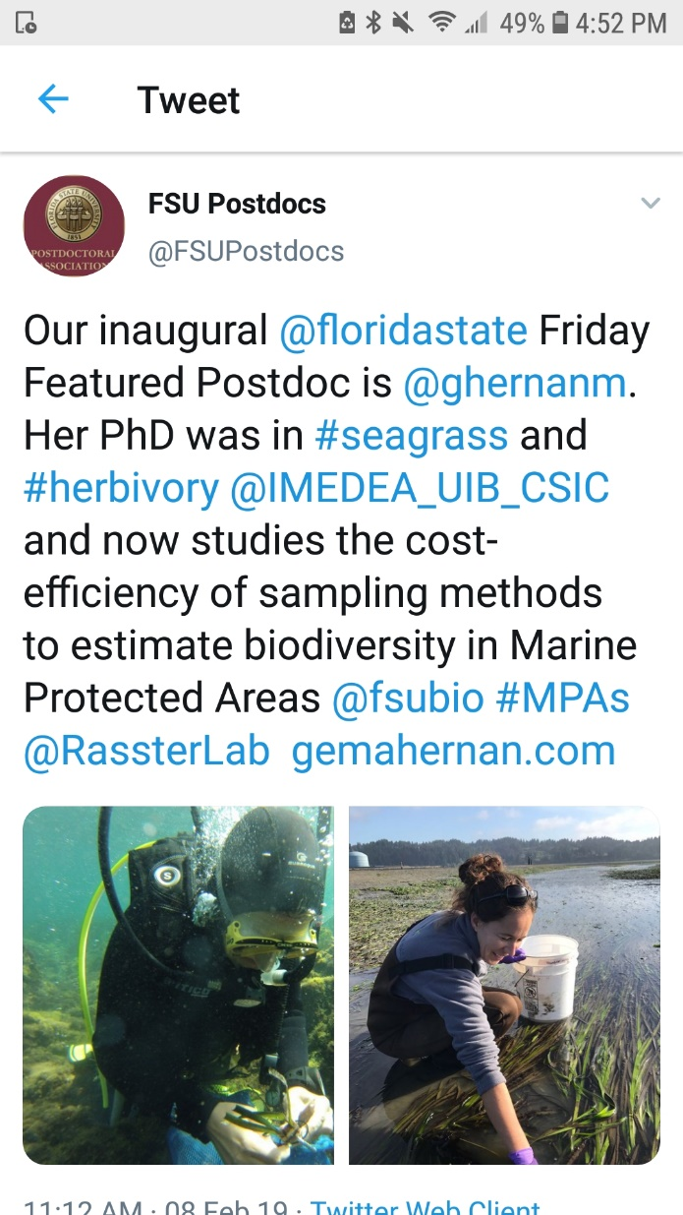
Postdocs, would you like help to disseminate your research, service, and mentoring achievements to a broader audience via the @FSU Postdocs Twitter account? If you have exciting new findings, just been published, received a grant or award, got hired for a new position, or have other accomplishments you would like to share for yourself or your mentees, please share them with us. Just send the content to be tweeted to Biological Science postdoc Matt Holding at mlholding@fsu.edu and it will be shared on @FSU Postdocs. Use the following guidelines to prepare your content:
Send links to papers or websites, photos of the activity, or other material that isn’t just text. Tweets get more traction if they contain content other than text alone.
Provide less than 280 characters of text for the tweet describing the activity. Include Twitter handles for your colleagues/collaborators where appropriate, if you know them, and any #hashtags to which the tweet can link. We can also retweet content you put out on our own Twitter account if you drop us a line with your Twitter handle and the specific tweet we should retweet.

coming soon: “postdoc world”
The Graduate School has embarked on an exciting new initiative to develop a brand new interactive video archive for all graduate students, postdocs, faculty and alumni called Grad World FSU. This was an idea inspired by Dr. Harry Kroto, and his GEOSET project at FSU. Our pilot study has concluded and the website is now in the final stages of development. We already have 100 videos on the Grad World FSU site, but what is needed now is postdoc participation to get this initiative off the ground.
A website similar to this one titled Postdoc World is in the works for postdoc scholars. We will let all know when that site is up and running. In the mean-time, we encourage postdocs to go to the Grad World website to create your video.
What is Grad World FSU?
Grad World FSU is a revolutionary website that looks and feels very similar to Google Earth, displaying a variety of personalized videos from graduate students, postdocs, alumni and faculty for the purpose of showcasing their outstanding achievements and contributions to Florida State University. This is an extraordinary opportunity for everyone around the world to see your passion, interests, research goals and learn more about our wonderful university. As you know graduate school, and postdoc opportunities change lives and the world for the better! Once others see you talking with such enthusiasm and excitement about all of the amazing things you are doing, they too will want to join in on the fun and become part of this great scholarly community known as “Family FSU”, or if they are employees, maybe even offer you a job.
How to Contribute?
Interested postdocs can choose to complete one of two video options: Option 1.) a self-filmed Questionnaire Video where you would answer a few questions using a cell phone, digital camera or the Screencast-O-Matic webcam software, or Option 2.) a GEOSET PowerPoint Video in which you would reserve a time to meet with the GEOSET Studio team in the Dirac Library to create a guided video/PowerPoint presentation to present a compelling oration of your research interests, or work at FSU. And remember, if English is not your native language, we encourage you to complete a second video in your native tongue so everyone in the world can enjoy it.
There are helpful tutorials available on how to create your questionnaire video available on this website.
If you are interested in booking your recording session in the GEOSET studio, please click on this link: https://fsu.qualtrics.com/jfe/form/SV_38Kipwda3eQrgxf
Spring Semester 3-parts Grants Workshop
Save the date for the upcoming 3-parts grant workshop! The OPDA and FSU faculty will be hosting a grant workshop specifically for postdoctoral scholars – if you participate in all three parts and then submit an extramural application to a major federal or private foundation, then you can be eligible to receive a $1,000 intramural grant from the OPDA for research related expenses.
March 1, 2019 1 -3 pm. Experienced faculty that have served on grant review panels will present the latest criteria and strategies for a number of different agencies in a variety of fields and disciplines. (Please see below for Agenda for the day)
April 26, 2019 12 to 3 pm. Sign up for a time block to have your prepared Specific Aims page critiqued by a panel of experts in your field. This is the heart of every successful grant proposal.
June 28, 2019 12 to 3 pm. Sign up for a time block to have your full grant proposal critiqued by a mock study section of experts in your field. Then take your reviews, modify your full proposal and submit to your targeted agency to receive your intramural award from FSU. You do not have to be awarded your proposed grant to receive the intramural support, but you must complete all three workshop dates and be responsive to the available experts!
Friday March 1, workshop will be in G0040 of the William Johnson Building
Tentative Agenda and time frame:
1:00 - 1:25 pm – Welcome and Overview of Successful Grant Planning and Submission – Debra Ann Fadool
1:25 – 1:40 pm – National Institutes of Health F31 & F32 – Rick Hyson
1:40 – 2:00 pm – National Institutes of Health R03/R21, K99-R00 – Alan Spector
2:00 - 2:20 pm – National Institutes of Health DSpan, Minority Supplements, HHMI minority program, and Women in Science L’Oréal – James Fadool
2:20 – 2:30 pm – USDA – Kay Jones
2:30 – 2:45 pm – National Science Foundation GFRP – Emily Moriarty- Lemmon
2:45 – 3:00 pm – American Heart Association AHA – Jose Pinto
3:00 pm – Meet & Greet with the Peer Mentors
Registration is Now Open for 3 parts Grants Workshop.
For questions, please contact D. Fadool, dfadool@bio.fsu.edu or Mr. David Martin at OPDA-Info@fsu.edu
fsu libraries events
FSU Libraries is hosting a variety of events, please visit: https://www.lib.fsu.edu/workshops/all-workshops for dates, times & location. They have initiated a new program called “STEM every day data” and are providing training sessions in Python, Matlab, Linux, R Programming, and QGIS throughout the spring semester. Come and learn! Advance registration is required.
spring event
Planning for the Spring Event in May 2019 is underway by the PDA and OPDA. If you would like to specify your preference for the choice of theme, please follow this 2-minute survey to make your selection on the topic. The PDA will then have your input for selecting guest speakers accordingly. If you are interested in helping with the planning, please see Dr. Katy Sparrow at katysparrow@gmail.com
Survey to select topic = https://fsu.qualtrics.com/jfe/form/SV_81inxOgoXUxtS8l

FSU benefits & perks for postdocs
- Postdoc Meal Plan – FSU provides two meal plans for purchase. For more information, please visit: https://seminoledining.sodexomyway.com/meal-plans.

- FSU Childcare: https://childcare.fsu.edu/
- Seminole Savings – Employee Discount Program designed exclusively for faculty and staff. For more information, please visit: https://hr.fsu.edu/?page=benefits/benefits_perks/benefits_perks_seminole_savings

- Florida Prepaid College Savings Plan – to celebrate their 30th anniversary, they are waiving the $50 enrollment fee starting February 1 through March 2. A prepaid plan allows families to lock in future college costs at today’s prices so you save money. A 4-year University plan could be as low as $187 a month, and a 2-year College plan could be as low as $55 a month for a newborn.
There is an online calculating tool that allows you to calculate your cost based on child’s age. The plan is designed for Florida schools; however, they can be used at most schools nationwide. If you move out-of-state, and your child decides to attend a Florida school, the plan qualifies them for in-state tuition. And if your child decides not to attend college, the money can be transferred to another family member. For more information, or to enroll, please visit: https://www.myfloridaprepaid.com/prepaid-plans/

ever wonder where your training at FSU will lead you?
The results of 2017 and 2018 job placement for FSU Postdoctoral Scholars are out! If you are a postdoctoral scholar, you can look forward to joining this group of alumni in upcoming years! If you are seeking a postdoctoral scholar as a mentor, please share these placement results with prospective postdoctoral trainees. Twenty-five to 33 percent of our postdoctoral scholar are obtaining tenure-track positions in academia, 21-22% are obtaining permanent employment in industry, and 10-15% of our scholars are joining the ranks of research faculty.
See Details here = https://opda.fsu.edu/about-us/postdoctoral-success-rate

become a neuroscience scholar
The Neuroscience Scholars Program (NSP) is a two-year online training program open to underrepresented neuroscience graduate students and postdoctoral fellows. Eighteen candidates will be selected as NSP Fellows, who will also have access to a mentor, complimentary registration and travel to Neuroscience 2019 and 2020, and support for additional professional development activities.
To view a checklist of items needed to get started, please click here.
For more information about the program, please click here.
Application window closes: February 21, 2019

asbmb travel awards
ASBMB (American Society for Biochemistry and Molecular Biology) will award over $275,000, through its travel awards program, to assist member, first authors presenting research at the ASBMB annual meeting, April 6-9, 2019, Orlando, Fl.
For more information, please click here.

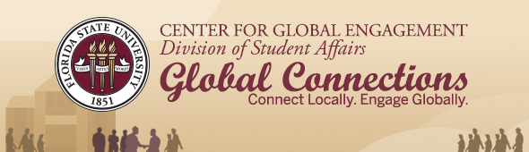
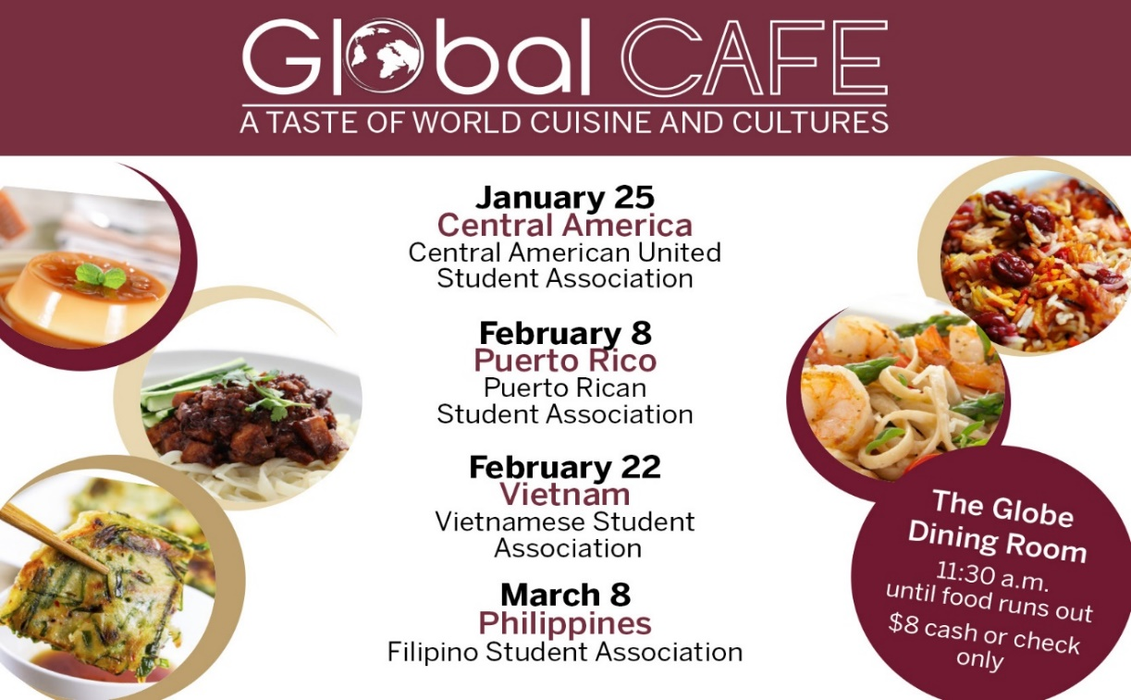

CGE Announces Spring 2019 Global Café Dates
FSU’s Center for Global Engagement will co-host four Global Cafés in spring on select Fridays from 11:30 a.m. until food runs out in The Globe Dining Room.
Students, faculty, staff, and members of the Tallahassee community enjoy authentic international cuisine and music at this student-led fundraiser for just $8 per plate (cash or check only).
Spring semester Global Café dates and co-hosts include the following.
- February 22: Vietnam, Vietnamese Student Association
- March 8: Philippines, Filipino Student Association
Read More

Biological Science/Neuroscience Postdoctoral Mentoring Workshop & Lunch
Kin Life Science Building, room 2057, 12:00 – 1:00 PM
Please mark your calendars for the Fall 2018/Spring 2019 postdoc workshops. This is a special, faculty-led monthly workshop for Postdoctoral Scholars hosted by the Department of Biological Science and the Program in Neuroscience. Although the career focus will be directed to the Life Sciences, all Postdoctoral Scholars and senior Graduate Students are welcome. Sandwiches will be served over the lunch hour during the workshops. Dates, presenters and topics are listed below. For questions, please contact Dr. Kay Jones. No registration required.
Date | Presenter | Title
Mon. Sept. 10 | Dr. Peter Fajer, Cell & Molecular Biology Professor & Director of the Institute of Molecular Biophysics | How to make yourself palatable to academic search committees. A view from the other side of the table.
Mon. Oct. 8 | Dr. Scott Steppan, Professor of Ecology & Evolution in Biological Science | Interviewing for an academic position.
Tues. Nov. 13 | Dr. Qian Yin, Assistant Professor in Cell & Molecular Biology in Biological Science | Plan ahead: from K to interview
Mon. Dec. 10 | Dr. Scott Burgess, Assistant Professor in Ecology & Evolution in Biological Science | Thinking like the job you want
Mon. Jan. 14 | Dr. Yuan Wang, Assistant Professor Biomedical Sciences, College of Medicine & Neuroscience Program | Job search in Neuroscience: where to start and how to decide?
Mon. Feb. 18 | Dr. Crystal L. Young-Erdos, Assistant Prof. of Chemistry at Eckerd College in St.  Petersburg, FL | ‘Multiple perspectives on the academic job search’
Mon. March 11 |  | Oral Presentation Day
Mon. April 8 | TBA

postdoctoral fellow position – tizzano lab
Dr. Marco Tizzano’s laboratory at the Monell Chemical Senses Center is now accepting applications for a Postdoctoral Fellowship position beginning in January 2019. The Monell Chemical Senses Center in Philadelphia is a world-renowned institute focusing on taste and smell research. It is closely associated with the University of Pennsylvania and provides a highly vibrant, collegial and intellectually stimulating environment.
Harmful compounds and xenobiotics carried in inhaled air or ingested food continually assault the nasal and oral cavities and can cause severe inflammatory conditions. Chemosensitivity of the respiratory and oral mucosae plays an important role in airway inflammation and oral health disorders. Solitary chemosensory cells (SCCs), specialized chemosensitive sentinel cells of the epithelial mucosa, respond to bitter-like chemicals and bacterial metabolites by triggering inflammatory and behavioral protective mechanisms. As such, fundamental questions arise as to how animals sense dangerous compounds and bacterial infection and how the mucosal immune system interact with epithelial cells to control pathogens. Using multiple approaches ranging from genetics to molecular biology, imaging, physiology, electro-physiology and behavior, the Tizzano’s lab aims to address the molecular and cellular mechanisms of SCC function as a mucosal protective element and its interaction with the immune system to promote elimination of the pathogen.
To view qualifications, or to apply, please click here
oak ridge institute opportunities fellowship program
The Intelligence Community (IC) Postdoctoral Research Fellowship Program offers scientists and engineers from a wide variety of disciplines unique opportunities to conduct research in a wide range of topics relevant to the Intelligence Community. The research is conducted by the Postdocs, while working in partnership with a Research Advisor and collaborating with an advisor from the Intelligence Community.
In partnership with the Research Advisor, the Postdoc composes and submits a technical proposal that responds to a current research opportunity.

Application deadline: March 1, 2019, 6 PM EST. For more information, please click here
new postdoc science initiative
The Journal of Postdoctoral Research www.postdocjournal.com has been publishing postdoc research for several years now and is currently working on a spin-off journal entitled ‘Postdoc Life Science ‘. This new journal will be focusing only on life sciences research with the goal to be indexed in MEDLINE/PubMed. The launch date is set for 1st April 2019.
Please note of the following rich possibilities and benefits of the new Postdoc Life Science Journal and how it can make a difference in your research career:
1. Call for papers: We are inviting research papers, reviews, methodologies, commentaries, perspectives, progress articles, clinical case summaries and research highlights to be published in the upcoming issues of Postdoc Life Science. Submissions for the inaugural issue may be sent-in by March 1st.
2. We are inviting nominations for our Postdoc of the Month award. Please send-in nominations [self, or PI recommended] to Editor-in-Chief@PostdocJournal.Com. Only Postdocs in life sciences are eligible to apply.
3. Editorial and other activities are available for postdocs, please touch base with us with a brief description on your interests. In addition, we are proposing an associate editor position for a post-doc association (PDA) board member who could bridge between the journal and PDA to update the editorial board on current postdoctoral publications and activities.
This new initiative will showcase and highlight former, current and future postdoc’s contribution to life sciences research, conduct exclusive international conferences, recognize accomplished postdocs with monetary awards and institute postdoctoral research grants, just to name a few.

Cancer control research training program
The University of Rochester Medical Center Cancer Control & Psychoneuroimmunology Laboratory is actively seeking outstanding candidates for their upcoming group of Fellows for 2018. The applicants should be interested in longitudinal studies and clinical trials on translational (e.g. biomarker) symptom science research and/or cancer-related cognitive impairment research to work closely with Dr. Michelle Janelsins (Associate Professor) and her research team. Candidates they are interested in come from a variety of backgrounds including, but not limited to, neuroscience, cognitive science, clinical psychology, epidemiology, clinical trials, applied sciences, and many more.
For more information, and to apply, please click here.
Materials can be sent directly to Dr. Michelle Janelsins or Dr. Gary Morrow (Program Director)
Fellowships
Charles A. King Trust Postdoctoral Research Fellowship Program-Basic Science
Application deadline: March 1, 2019, 3:00 PM ET

AACR-Neuroendocrine Tumor Research Foundation-AACR Grant
Application deadline: March 19, 2019, 1:00 PM
American Diabetes Association – 2019 Core Research Program
Application deadline: July 15, 2019

Postdoc Research Funding Opportunities in Germany
Application deadlines vary
Index of Postdoc Fellowships in the Life Sciences (Broad Institute)
EPA Research Grants

Jobs
Below is a sampling of open positions in the United States –
Postdoctoral Positions Available -
Looking for motivated Postdocs to research mechanisms involved in regulated remodeling of muscle T-tubule membranes in fly models of human myopathy with funding for immediate start date!
For more information, please click here to view flyer. Please contact Dr. Amy Kiger, Section of Cell & Development Biology, University of California, San Diego at: akiger@ucsd.edu.

Postdoctoral and research scientist positions
The Kaczorowski Lab at The Jackson Laboratory is seeking Postdoctoral and Research Scientist Level personnel to investigate mechanisms underlying susceptibility and resilience to normal aging and Alzheimer’s disease (https://www.neuro-central.com/2018/09/19/risk-resilience-understanding-role-genetics-alzheimers-disease/). Dr. Kaczorowski is an Associate Professor and the Evnin Family Endowed Chair in Alzheimer’s Research at the Jackson Laboratory – a research institution specializing in genetics and genomics in order to discover solutions for disease. Projects leverage new translational mouse models, electrophysiology, circuit mapping and genome engineering to decipher how genetic and environmental factors interact to influence learning and memory abilities, cognitive aging, neurodegeneration, and Alzheimer’s. Sources of support include NIH, Bright Focus, The Glenn Foundation for Medical Research, as well as generous philanthropy awards in support of research and innovation in areas of normal aging and Alzheimer’s Disease.
Exceptional candidates will have the opportunity to apply for the prestigious JAX Scholar award, which supports promising early-career postdoctoral associates conducting cutting edge biomedical and basic biological research at JAX. The award includes an independent research and travel budget and a salary above our standard postdoctoral scale https://www.jax.org/education-and-learning/pre-and-postdoctoral-program/jax-scholars.
To apply, please submit (1) a cover letter describing past research accomplishments, research interests, and career goals, (2) a current CV, and (3) the contact information of three references to
catherine.kaczorowski@jax.org

Assistant Professor – Department of Biology (Job number: 10609)
Tenure-Track position in Developmental Molecular Genetics: As part of an expansion in molecular genetics research, West Virginia University invites applications for a tenure-track position at the Assistant Professor level in the Department of Biology
(http://biology.wvu.edu) to begin August 2019. We seek an individual who uses molecular and/or functional genomic approaches to explore integrative questions about development in non-mammalian animal model systems. Applicants should have a broad biology background and strong interdisciplinary skills to develop an externally-funded independent research program. Applicants should also have an openness to collaborative research and a desire to contribute to the undergraduate and graduate research and teaching missions of the department. Requirements include a PhD or equivalent degree in biology or a related field, a strong record of scholarly publications, strong post-doctoral experience, excellent written and oral communication skills, and the potential to secure external funding.
WVU, located in Morgantown, is a comprehensive land grant university enrolling about 30,000 students in over 100 degree programs. Our Carnegie Classification is “Doctoral Universities: Highest Research Activity.” The Department of Biology at West Virginia University offers a diverse, highly productive and well-funded research environment that is highly supportive of new junior faculty. Existing departmental strengths include molecular genetics, behavioral neurobiology, and genomics.
To apply, please visit https://careers.wvu.edu, navigate to the position title listed above, and upload a single PDF file including a cover letter, curriculum vitae with a list of publications, a succinct outline of future research plans, and a one page teaching statement. In addition, arrange for 3 letters of reference to be sent electronically to WVUBiology@mail.wvu.edu. Review of completed applications will begin on January 21, 2019 and will continue until the position is filled. For more information about the position contact Kevin C. Daly at kcdaly@mail.wvu.edu. For more information about WVU and the city of Morgantown, WV: https://biology.wvu.edu/about/jobs/about-morgantown.

Florida College System, seeks to fill a position for Executive Director, Florida Student Success Center.
The Florida Student Success Center (FSSC) serves as an intermediary between colleges, and provides greater opportunities for colleges to collaborate and learn from one another. The Executive Director works under the supervision of the Chancellor of the Florida College System.
For more information on the role of the position, qualifications and to apply please click here.

Florida Conservation Corps - Opportunities
FLCC is recruiting for two exciting project areas.
The mission of the Florida Conservation Corps is to develop natural and cultural resource leaders by connecting them to areas of critical need in conservation, preservation, interpretation and resource based recreation. Click here to download flyer. For more information about FLCC, please visit their webpage at: https://www.floridastateparks.org/florida-conservation-corps.
Instructional Assistant Professor – Department of Physics and Astronomy
The University of Mississippi, University, MS

Development Engineering Rotation Associate
First Solar, Perrysburg, OH
Assistant Professor – Department of Biomedical Engineering
North Carolina State University, Raleigh, NC

Geomechanical Engineer
The University of Texas at Austin, Austin, TX
Tenure-Track Assistant Professor – Environmental Social Science
George Mason University, Fairfax, VA

Production Engineer
W.R. Grace & Co., Chicago, IL
Assistant Professor Positions – Exercise Physiology (Job ID: 42380) & Nutrition (Job ID:42371)
FSU College of Human Sciences, Department of Nutrition, Food & Exercise Sciences
Assistant Professor of Research – Center for Craniofacial Molecular Biology
University of Southern California (USC), Biomedical Sciences

Assistant Professor – Clinical Occupational Therapy
University of Southern California, Occupational Therapy
Assistant Professor – Research Emergency Medicine
University of Southern California, Department of Emergency Medicine
Clinical Assistant Professor – Pediatrics
University of Southern California, Department of Pediatrics
Below is a sampling of open positions around the world -
Canada: Assistant Clinical Professor – in Pharmacy & Pharmaceutical Science
University of Alberta, Faculty of Pharmacy & Pharmaceutical Sciences

Tenure Track Assistant Professor – Biomedical or Electrical Engineering
University of Guelph, School of Engineering/Biomedical Engineering
Assistant Professor – REHAB Occupational Therapy
University of Alberta, Department of Occupational Therapy
Assistant Professor – Microbial Science & Micro/Nanomaterials
University of Calgary Canada First Research Excellence Fund
Assistant Professor – Department of Medicine
University of Alberta, Faculty of Medicine & Dentistry
Assistant Professor – Division of Developmental Pediatrics
University of Alberta, Faculty of Medicine & Dentistry

Staff Scientist in Hematology Research
Keenan Research Centre for Biomedical Research of St. Michael’s Hospital
Japan: Assistant Professor in the Graduate School of Biomedical & Health Sciences
Hiroshima University, Graduate School of Biomedical & Health Sciences
Assistant Professor in Medical Education, Pharmacology, Neuroscience
Hiroshima University, Graduate School of Biomedical & Health Sciences
Norway: Head Engineer at Electron Microscopy Core Facility
University of Oslo, Department of Biosciences (IBV)
Singapore: Assistant Professor for Bio-Behaviorist
Duke NUS Medical School, Academic Medicine Research Institute

Assistant Professor – Center for Aging Research & Education
Duke NUS Medical School, Center for Aging Research & Education
South Africa: Associate Researcher in Clinical Micro Infectious Diseases (CMID)
Wits University, School of Pathology, Johannesburg, ZA
Switzerland: PhD in Biomedical Engineering
University of Basel, Adaptable MRI Technology
Click here for featured Biology careers
Subscribe to receive personalized job announcement emails:
Bio Careers
Academic Keys
PhD Jobs
Fierce Biotech Jobs
ASBMB - American Society for Biochemistry and Molecular Biology
http://www.asbmb.org/careers/ (career information)
Career Development Webinars and Blogs
Ready for Your Close-Up?
In this article where the author points out, just because academics have grown up with video doesn’t mean they are masters of self-presentation on camera. Here is a primer.
UC staff researchers opt to form a union, joining postdocs
Several staff members at the University of California sought to unionize for better benefits
Webinar | Deciphering fibrosis: Exploring the biological drivers of fibrotic disease in the liver and heart Wednesday, February 20, 2019, 12 noon ET

Webinar | Fighting fake science: Barriers and solutions
Tuesday, February 26, 2019, 12 noon ET
How to Be Proactive in Your Mentoring Relationships – National Postdoctoral Association http://www.nationalpostdoc.org/?page=Proactive
ASBMB - Postdoctoral Education & Resources

Versatile PhD
This site helps graduate students and new PhD’s identify, prepare for, and excel in possible non-academic careers.
Click here to learn more. Click here to join
Free NPA Membership
FSU is a sustaining member of the National Postdoctoral Association (NPA). This membership provides free affiliate membership to all FSU postdoctoral scholars. Benefits of joining the NPA include:
    - A subscription to the NPA’s official quarterly newsletter
    - Reduced registration fees to the NPA Annual Meeting
    - Eligibility for the NPA Travel Award Program
    - Professional & Leadership Development
    - Networking opportunities with colleagues nationwide
If you are interested in joining the National Postdoctoral Association, click here.
Please email opda-info@fsu.edu if you encounter any problems.
For previous issues, click here!

