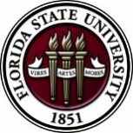
Florida State University
OFFICE OF POSTDOCTORAL AFFAIRS WEEKLY DIGEST

February 20, 2017

Upcoming Events
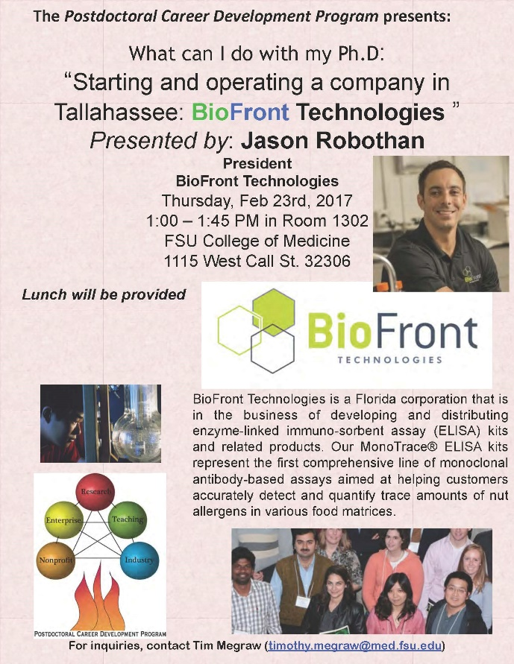

Biological Science/Neuroscience Postdoctoral Mentoring Workshop and Lunch
Postdoctoral scholars and senior graduate students from all fields are invited to attend. Sandwiches will be served over the lunch hour during the workshops.
For questions, please contact Drs. Erminia Fardone or Kay Jones.

DATE | PRESENTER | TITLE
March 6, 2017 |  | Oral Competition Day

Save the date for the Oral Competition Day. Postdoctoral Scholars orally deliver their research in a 12-minute presentation format to a panel of judges. Great way to receive feedback on your oral communication skills that are essential for interviewing! If you would like to participate in giving an oral presentation of your research, please contact Kay Jones about submission processes.

"Welcome" Mini-Orientation Sessions for New Postdoctoral Scholars on Campus
Honors, Scholars & Fellows House, Room 3009, April 24, 2017 at noon
If you are a new postdoctoral scholar to the FSU campus, this “Welcome” is a nice brown bag lunch activity that will fit into your busy research schedule. The design will be limited to strictly a one hour session, where you will receive the essentials of getting your research started at FSU and have access to Human Resources and Office of Postdoctoral Affairs Staff. At this time, you will also be introduced to the Postdoctoral Association (PDA) - your peer network of postdocs on campus. Attending a “welcome” in your few months of employment at FSU will serve to fulfill your mandatory orientation. Registration for April will open late March; continue to check website http://opda.fsu.edu/upcoming-events-workshops/upcoming-events for link.

POSTDOCTORAL SPRING EVENT – Hold the Date – 19 may 2017
Matriculating to your Career after your Postdoctoral Training
Please save the date for this special afternoon workshop for postdoctoral scholars, senior graduate students, and mentors. Our keynote address will be given by Dr. Lori Conlan, Director of Postdoctoral Affairs at the National Institutes of Health (NIH). Dr. Conlan will help map the course to different pathways to be pursued in academia, industry, and federal government and the transferable skills that have been built during your postdoctoral training to transition you to these career tracks. She will present strategies for the application packet, interviewing, and securing the best position for your ambitions. We are thrilled she will share her experiences from her insight working with the NIH and her knowledge of postdoctoral hiring trends across the country. A potluck dinner for scholars, their lab mates, mentors, and family members will follow the afternoon event, so we hope you will come out to network and engage with the FSU postdoctoral community. Postdoctoral scholars interested in helping to organize this event please contact PDA President, Nikhil Gupta or Vice-president, Erminia Fardone.
Professional Development Workshops
Are you prepared for your Social or Behavioral Sciences Conference Presentation?

February 21, 2017, 3:30 PM – 4:30 PM
Honors, Scholars & Fellows House, room 3009

Presenter: Dr. Jennifer Proffitt, Associate Professor, School of Communication

How do you convert a paper into a conference presentation? Will you talk with notes, read your paper, and/or use visuals (e.g., PowerPoint)? How will you ensure that your audience will get your message? Are you prepared for the audience’s questions? Dr. Proffitt will answer these questions and more when she leads you through the process of conference presentation preparation and delivery.

To register: https://fsu.qualtrics.com/SE/?SID=SV_9YO05d0uGSl5Snz

Employer Panel: What we are looking for when we recruit new employees

February 24, 2017, 5:00 PM – 6:30 PM
Honors, Scholars & Fellows House, Room 3009

Presenters: Panel of employers representing a range of fields
Moderator: Amanda Sargent, Assistant Director, FSU Career Center
Our panel will describe what they want to see when they review résumés and CVs. Employers will discuss how students can prepare to join their future profession. Time will also be devoted to preparing for an interview. Attend this workshop with the goal of developing a plan to succeed in a professional work environment.

To register: https://fsu.qualtrics.com/SE/?SID=SV_a4TCF1LeBP7BFzL

PIE Coffee Hour & Teaching Workshop: Go Big or Go Home: Activities for Large Classrooms (PIE/PFF/PFP)

February 27, 2017, 3:30 PM – 5:00 PM
Honors, Scholars & Fellows House, 4th Floor, Great Hall

Presenters: PIE Associates, Mary Marcous, Philosophy, and Ashley Artese, Nutrition, Food & Exercise Sciences
Do you ever wonder how to get those 70 students in your lecture to wake up and participate? Teaching a large number of students can be difficult because of space limits, classroom sizes, or even the layout of the room. This workshop will present a number of strategies and activities to facilitate engagement in classes with a large number of students, regardless of subject area.

Free PIE & Coffee Included!

Click here to register: https://fsu.qualtrics.com/SE/?SID=SV_71G3jIg4IyoGtJX

Funding Announcements

Tufts Training in Education and Critical Research Skills Program (TEACRS)

TEACRS is designed to prepare talented young scientists for the multiple demands of an academic career in biomedical research. Trainees spend on average 75% of their time conducting bench research and 25% of their time in career development activities. Teaching skills are developed through programs involving mentored classroom assignments at minority-serving institutions in the Boston area. The training is supplemented by workshops on teaching methods, career opportunities in academia, and essential skills such as grant writing, mentoring, and scientific presentations. The training components are sequenced to allow trainees to balance the activities and to build on previous experiences. TEACRS fellows receive up to four years of salary support at the NIH postdoctoral stipend levels, and a yearly travel and supply allowance.

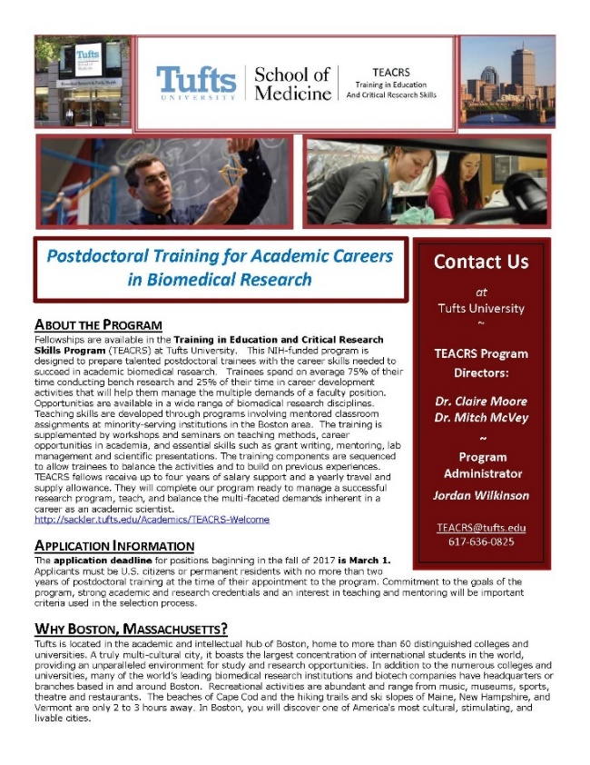
The application deadline for positions beginning in the fall of 2017 is March 1, 2017. Later applications will be considered if positions are available. Applicants must be U.S. citizens or permanent residents with no more than two years of postdoctoral training at the time of their appointment to the program. Commitment to the goals of the program, strong academic and research credentials and a demonstrated interest in teaching and mentoring will be important criteria used in the selection process.

For additional information on the TEACRS program and application procedures, please visit our website, or contact Claire Moore, the Program Director, or Jordan Wilkinson, the Program Administrator with questions. We have also attached a printable flier describing the program.

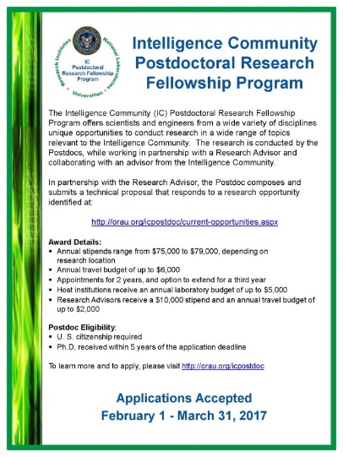
Fellowships

NOAA Sea Grant John A. Knauss Marine Policy Fellowship
http://seagrant.noaa.gov/FundingFellowships/KnaussFellowship/ProspectiveFellows.aspx
Deadline: February 21, 2017

Damon Runyon (Cancer Research) Fellowship Award
https://www.damonrunyon.org/for-scientists/application-guidelines/fellowship/forms
Deadline: March 15, 2017

Summer Scholarships in Epidemiology (Cystic Fibrosis Foundation)
https://www.cff.org/Our-Research/For-Researchers/Training-Awards/Summer-Scholarships-in-Epidemiology/
Deadline: April 1, 2017

Research Training Groups in the Mathematical Sciences (RTG)
https://www.nsf.gov/funding/pgm_summ.jsp?pims_id=5732&org=DMS
Deadline: June 6, 2017

Postdoctoral Program in Environmental Chemistry
http://dreyfus.org/awards/postdoctoral_program.shtml
Deadline: August 1, 2017

Mathematical Sciences Postdoctoral Research Fellowships (MSPRF)
https://www.nsf.gov/funding/pgm_summ.jsp?pims_id=5301&org=NSF&sel_org=NSF&from=fund
Deadline: October 18, 2017

Use the following databases to identify additional opportunities (click on the links) – Pivot, Foundation Center

Jobs
Below is a sampling of open positions around the world.

Assistant Professor – College of Human Medicine
https://jobs.msu.edu/applicants/jsp/shared/frameset/Frameset.jsp?time=1487358802574
Michigan State University, East Lansing, MI

Scientist – Molecular Biology
https://biorad-openhire.silkroad.com/epostings/index.cfm?fuseaction=app.dspjob&jobid=9873&company_id=16446&version=1&jobBoardId=1112
Pleasanton, CA

Assistant Professor – Biostatistics
http://www.pers.hawaii.edu/wuh/Jobs/NAdvert/24504
University of Hawaii, Honolulu, Hi

Research Scientist
https://cna.hua.hrsmart.com/hrsmart/ats/Posting/view/990
CNA Corp., Arlington, VA

Assistant Professor – Department of Pharmacy & Therapeutics
https://www.pittsource.com/postings/132507
University of Pittsburgh, Pittsburgh, PA

Scientist – Functional Genomics
https://globaljobs.pfizer.com/pages/job-details.aspx
Pfizer, Inc., Pearl River, NY

Assistant Professor – Computational Biology
https://ais.ohsu.edu/OA_HTML/OA.jsp?page=/oracle/apps/irc/candidateSelfService/webui/VisVacDispPG&OAHP=IRC_EXT_SITE_VISITOR_APPL&OASF=IRC_VIS_VAC_DISPLAY&akRegionApplicationId=821&transactionid=2079084136&retainAM=N&addBreadCrumb=RP&p_svid=56922&p_spid=81213
Oregon Health & Science University, Portland, OR

Subscribe to receive personalized job announcement emails:
http://floridastate.biocareers.com
http://www.academickeys.com/all/subscribe.php
http://jobs.phds.org/alert.new
http://jobs.fiercebiotech.com

Career Development Webinars and Blogs

Same Lesson, Different Semester
https://chroniclevitae.com/news/1705-same-lesson-different-semester
Read how to keep the course materials fresh when you’ve taught them over and over.

Scientists are pro-testing
http://www.sciencemag.org/careers/2017/02/scientists-are-pro-testing
Read how some scientists are protesting because their work is not taken seriously.

The Diversity Question and the Administrative-Job Interview
https://chroniclevitae.com/news/1706-the-diversity-question-and-the-administrative-job-interview
Learn how to ask or answer this question honestly during the interview process.

How to Be Proactive in Your Mentoring Relationships – National Postdoctoral Association http://www.nationalpostdoc.org/?page=Proactive

Versatile PhD
This site helps graduate students and new PhD’s identify, prepare for, and excel in possible non-academic careers.
Click here to learn more. Click here to join
Free NPA Membership
FSU is a sustaining member of the National Postdoctoral Association (NPA). This membership provides free affiliate membership to all FSU postdoctoral scholars. Benefits of joining the NPA include:
    - A subscription to the NPA’s official quarterly newsletter
    - Reduced registration fees to the NPA Annual Meeting
    - Eligibility for the NPA Travel Award Program
    - Professional & Leadership Development
    - Networking opportunities with colleagues nationwide
If you are interested in joining the National Postdoctoral Association, click here.
Please email opda-info@fsu.edu if you encounter any problems.
For previous issues, click here!

