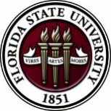
Florida State University
OFFICE OF POSTDOCTORAL AFFAIRS WEEKLY DIGEST

February 6, 2017

Upcoming Events

"Welcome" Mini-Orientation Sessions for New Postdoctoral Scholars on Campus
Honors, Scholars & Fellows House, Room 3009, April 24, 2017 at noon
If you are a new postdoctoral scholar to the FSU campus, this “Welcome” is a nice brown bag lunch activity that will fit into your busy research schedule. The design will be limited to strictly a one hour session, where you will receive the essentials of getting your research started at FSU and have access to Human Resources and Office of Postdoctoral Affairs Staff. At this time, you will also be introduced to the Postdoctoral Association (PDA) - your peer network of postdocs on campus. Attending a “welcome” in your few months of employment at FSU will serve to fulfill your mandatory orientation.
Please check back for event registration.

POSTDOCTORAL SPRING EVENT – Hold the Date – 12 may 2017
We are excited to host Dr. Lori Conlan, Director of Postdoctoral Services at the National Institutes of Health, as our keynote speaker for this event! Please hold the date on your calendars. We would like to get your input on programming for the Spring Event!!
Please take this 2 minute survey so we know what programming to generate for the event!
Thank you so much – your PDA
https://fsu.qualtrics.com/SE/?SID=SV_aWxzIFu8M0QqtzD

Postdoctoral scholars and senior graduate students from all fields are invited to attend. Sandwiches will be served over the lunch hour during the workshops.
For questions, please contact Drs. Erminia Fardone or Kay Jones.

Biological Science/Neuroscience Postdoctoral Mentoring Workshop and Lunch

DATE | PRESENTER | TITLE
February 13, 2017 | Drs. Emily Moriarty and Alan Lemmon | Balancing work and family
March 6, 2017 |  | Oral Competition Day

Save the date for the Oral Competition Day. Postdoctoral Scholars orally deliver their research in a 12 minute presentation format to a panel of judges. Great way to receive feedback on your oral communication skills that are essential for interviewing!

Professional Development Workshops

PIE Coffee Hour & Teaching Workshop: How to Create a Teaching Portfolio (PIE/PFF/PFP)

February 9, 2017, 1:30 PM – 3:00 PM (Session 1) 3:30 – 5:00 PM (Session 2)
Honors, Scholars & Fellows House, 4th Floor, Great Hall

Presenters: PIE Associate and 2016 OTAA Recipient, Lacey Ritter, Sociology, and Dr. Lisa Liseno, Assistant Dean of The Graduate School & Director of the Program for Instructional Excellence and Fellows Society

Creating a teaching portfolio is an important way to illustrate the strategies and techniques you use to help support and encourage student learning. It also gives you the opportunity to reflect on your teaching and ways to improve for the future. Not only is this a helpful exercise, but may be a requirement when applying for future employment. This workshop will show you how to assemble an electronic teaching portfolio. Requirements for the submission of teaching portfolios from nominees of FSU’s Outstanding Teaching Assistant Award (OTAA) will also be addressed.

Free PIE & Coffee Included!
Click here to register for Session 1 (1:30-3pm): https://fsu.qualtrics.com/SE/?SID=SV_8jZDy4UKogZqrFH

Click here to register for Session 2 (3:30-5pm):
https://fsu.qualtrics.com/SE/?SID=SV_9siK3GlZj7p9DCd

Connecting Skills with Options: Putting your degree to Work

February 10, 2017, 3:30 PM – 5:00 PM
Honors, Scholars & Fellows House, Room 3009

Presenter: Amanda Sargent, Assistant Director, FSU Career Center
You know that your education has given you important and valuable skills, but how does this translate into the world of work? In this presentation, learn how to acquire quality occupational information, identify transferable skills, and articulate your value to future employers.

To register: https://fsu.qualtrics.com/SE/?SID=SV_0dFAFL1pdS3Yb41
Interviewing for the Academic Position [PFF/PFP/PIE]

February 17, 2017, 12:30 PM – 2:00 PM
Honors, Scholars & Fellows House, Room 3009

Presenter: Dr. Jonathan Grant, History Department
Do you plan to attend a conference where you may have several interviews? How do you plan for a telephone interview? What should you expect during an interview at a neutral place, such as an airport? How do you prepare for the interview process on a college/university campus?
These and other questions will be answered in this informative workshop led by an experienced faculty member.

To register: https://fsu.qualtrics.com/SE/?SID=SV_cBySO9Whu9wTkNv

Employer Panel: What we are looking for when we recruit new employees

February 24, 2017, 5:00 PM – 6:30 PM
Honors, Scholars & Fellows House, Room 3009

Presenters: Panel of employers representing a range of fields
Moderator: Amanda Sargent, Assistant Director, FSU Career Center
Our panel will describe what they want to see when they review résumés and CVs. Employers will discuss how students can prepare to join their future profession. Time will also be devoted to preparing for an interview. Attend this workshop with the goal of developing a plan to succeed in a professional work environment.

To register: https://fsu.qualtrics.com/SE/?SID=SV_a4TCF1LeBP7BFzL

Funding Announcements

Tufts Training in Education and Critical Research Skills Program (TEACRS)

TEACRS is designed to prepare talented young scientists for the multiple demands of an academic career in biomedical research. Trainees spend on average 75% of their time conducting bench research and 25% of their time in career development activities. Teaching skills are developed through programs involving mentored classroom assignments at minority-serving institutions in the Boston area. The training is supplemented by workshops on teaching methods, career opportunities in academia, and essential skills such as grant writing, mentoring, and scientific presentations.

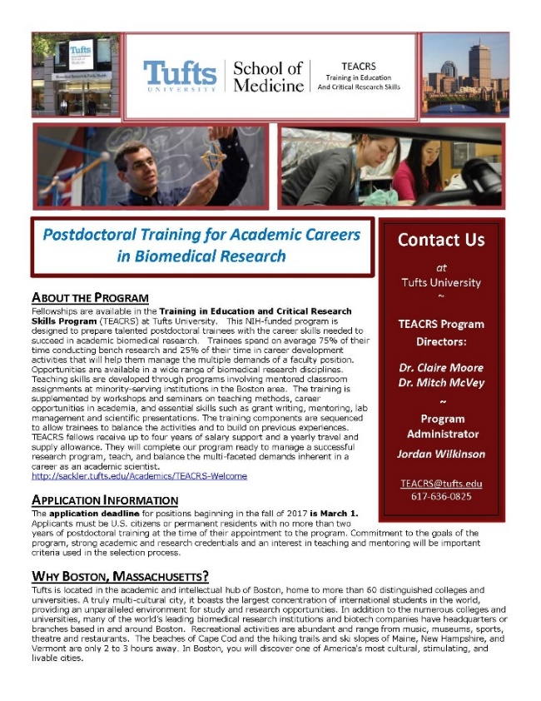
The training components are sequenced to allow trainees to balance the activities and to build on previous experiences. TEACRS fellows receive up to four years of salary support at the NIH postdoctoral stipend levels, and a yearly travel and supply allowance.

The application deadline for positions beginning in the fall of 2017 is March 1, 2017. Later applications will be considered if positions are available. Applicants must be U.S. citizens or permanent residents with no more than two years of postdoctoral training at the time of their appointment to the program. Commitment to the goals of the program, strong academic and research credentials and a demonstrated interest in teaching and mentoring will be important criteria used in the selection process.

For additional information on the TEACRS program and application procedures, please visit our website, or contact Claire Moore, the Program Director, or Jordan Wilkinson, the Program Administrator with questions. We have also attached a printable flier describing the program.

Fellowships
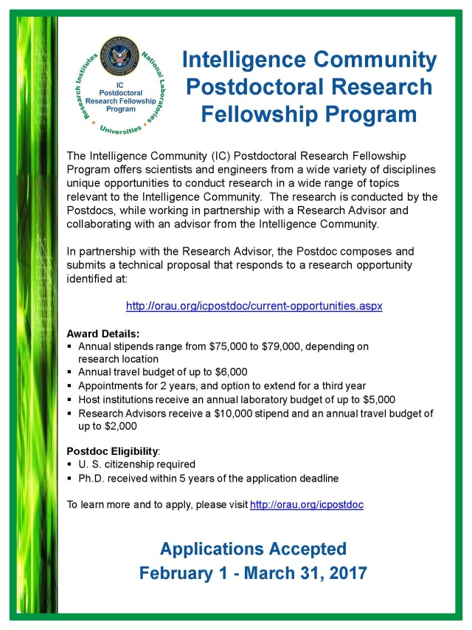
American Heart Association Postdoctoral Fellowship
http://professional.heart.org/professional/ResearchPrograms/ApplicationInformation/UCM_443314_Postdoctoral-Fellowship.jsp
Deadline: February 10, 2017

NOAA Sea Grant John A. Knauss Marine Policy Fellowship
http://seagrant.noaa.gov/FundingFellowships/KnaussFellowship/ProspectiveFellows.aspx
Deadline: February 21, 2017

Damon Runyon (Cancer Research) Fellowship Award
https://www.damonrunyon.org/for-scientists/application-guidelines/fellowship/forms
Deadline: March 15, 2017

Summer Scholarships in Epidemiology (Cystic Fibrosis Foundation)
https://www.cff.org/Our-Research/For-Researchers/Training-Awards/Summer-Scholarships-in-Epidemiology/
Deadline: April 1, 2017

Research Training Groups in the Mathematical Sciences (RTG)
https://www.nsf.gov/funding/pgm_summ.jsp?pims_id=5732&org=DMS
Deadline: June 6, 2017

Postdoctoral Program in Environmental Chemistry
http://dreyfus.org/awards/postdoctoral_program.shtml
Deadline: August 1, 2017

Use the following databases to identify additional opportunities (click on the links) – Pivot, Foundation Center

Jobs
Below is a sampling of open positions around the world.

Assistant Professor – Surgery-Vascular
http://explore.jobs.ufl.edu/cw/en-us/job/493485/assistantassociatefull-professor
University of Florida, Gainesville, FL

Robotics Research Scientist
https://www.mathworks.com/company/jobs/opportunities/15218-robotics-research-scientist?source=10193
The Math Works, Natick, MA

Assistant Professor – Electrical Engineering
http://www.pers.hawaii.edu/wuh/Jobs/NAdvert/24440
University of Hawaii, Honolulu, HI

Scientist/Engineer – Plasma Research
https://jobs.riversideresearch.org/CyberWeb/Careers.aspx?adata=EI8zS7qyuob6k9OMEWZioQbnnEdpHp%2f0QDeR%2bu%2bvpMxbh4by6l9JAi%2bllrdo2VJlDwj%2fP3ZCd5MK8mhgf6Z2KvwexJS03qmyly3gMoiMHAKgxvNhVNm0YgZX36Khn1OWogYUFMN0Ic%2fjkAuunBfxfNtsdeAvl0Eha5KMYKzEI%2fgsuUAQ79CKdQ5b90XXj9e6BLBacfTVtTH6gwya6bn8Clk%3d
University of Massachusetts Amherst, Amherst, MA

Assistant Professor – Biostatistics
https://umass.interviewexchange.com/jobofferdetails.jsp;jsessionid=F8E99CD44118DEC61B011ACA868AF558?JOBID=77049&CNTRNO=118&TSTMP=0
University of North Carolina,

Scientist – Research & Development
https://sjobs.brassring.com/TGWEbHost/jobdetails.aspx?jobId=2748795&PartnerId=25666&SiteId=5503&codes=INDD
Illumina, Inc. San Diego, CA

Assistant Professor – Electrical & Computer Engineering
https://utah.peopleadmin.com/postings/57491
University of Utah, Salt Lake City, UT

Subscribe to receive personalized job announcement emails:
http://floridastate.biocareers.com
http://www.academickeys.com/all/subscribe.php
http://jobs.phds.org/alert.new
http://jobs.fiercebiotech.com

Career Development Webinars and Blogs

Speaking as an Academic
https://chroniclevitae.com/news/1678-speaking-as-an-academic
Read advice if you are invited to speak, or are in charge of inviting a speaker to your campus.

Relearning how to write
http://www.sciencemag.org/careers/2017/01/relearning-how-write
Read advice on writing articles for your audience.

From Bench Science to …?
https://chroniclevitae.com/news/1679-from-bench-science-to
Read how one author discussed job market challenges in the sciences and shared her research.

How to Be Proactive in Your Mentoring Relationships – National Postdoctoral Association http://www.nationalpostdoc.org/?page=Proactive

Versatile PhD
This site helps graduate students and new PhD’s identify, prepare for, and excel in possible non-academic careers.
Click here to learn more. Click here to join
Free NPA Membership
FSU is a sustaining member of the National Postdoctoral Association (NPA). This membership provides free affiliate membership to all FSU postdoctoral scholars. Benefits of joining the NPA include:
    - A subscription to the NPA’s official quarterly newsletter
    - Reduced registration fees to the NPA Annual Meeting
    - Eligibility for the NPA Travel Award Program
    - Professional & Leadership Development
    - Networking opportunities with colleagues nationwide
If you are interested in joining the National Postdoctoral Association, click here.
Please email opda-info@fsu.edu if you encounter any problems.
For previous issues, click here!

