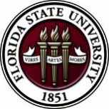
Florida State University
OFFICE OF POSTDOCTORAL AFFAIRS WEEKLY DIGEST

January 22, 2018

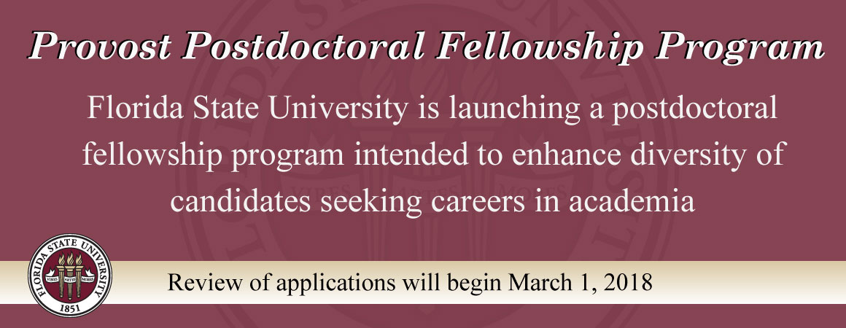
Upcoming Events
Faculty Mentors for PPFP Program being sought
We are currently seeking experienced faculty that would like to serve as an advisor for a postdoctoral scholar in our new PPFP program. 10 PPFP fellows will be supported for two years through generous funding from the Provost/VP Faculty Development. To find out more about this program and complete the survey to become a faculty mentor – please see details at the Office of Postdoctoral Affairs Website. http://opda.fsu.edu/fellowships-and-awards/postdoctoral-fellowships-and-stipend-support/provost-postdoctoral-fellowship
Faculty profiles will be accepted through February 1, 2018.
Postdoctoral scholars can start pairing with faculty mentors to submit their application starting March 1, 2018.
“Welcome” mini-orientation sessions for new postdoctoral scholars on campus
Honors, Scholars & Fellows House, Room 3009, January 29, 2018, 12PM
Registration is now OPEN
If you are a new postdoctoral scholar to the FSU campus, this “Welcome” is a nice brown bag lunch activity that will fit into your busy research schedule. The design will be limited to strictly a 1-hour session, where you will receive the essentials of getting your research started at FSU and have access to Human Resources and Office of Postdoctoral Affairs Staff. At this time, you will also be introduced to the Postdoctoral Association (PDA) – your peer network of postdocs on campus. Attending a “welcome” in your first few months of employment at FSU will serve to fulfill your mandatory orientation. For more information, please contact Debi Fadool.
Special Joint postdoc & graduate student workshop & lunch
Thurs. Feb 1, 2018 at 12:15 pm in King 2057. Dr Allen Eaves, founder and CEO of StemCell Tech has accepted an invitation to speak to Postdocs & Graduate Students about ‘Starting a Biotech: Going over to the Dark Side or Seeing the Light’
Dr. Allen Eaves is the Chairman, President, and CEO of STEMCELL Technologies, an international biotechnology company that develops specialty cell culture media, cell separation products and ancillary reagents for life science research. Dr. Eaves was an academic leader in leukemia and stem cell research during his time as founder and director of the Terry Fox Laboratory of the British Columbia Cancer Agency and as Head of Hematology at the University of British Columbia. Dr. Eaves was recently named EY Entrepreneur of the Year TM Pacific 2016 for his work at STEMCELL Technologies, which is currently one of the largest biotechnology companies in Canada with over 800 employees worldwide.

United Nations International Day of Women and Girls
Women faculty members and postdoctoral scholars are invited to participate in the
2018 United Nations International Day of Women and Girls in Science on February 11. Since the actual day is on a Sunday, events will be held before that week. There will be a Mentor Networking Event on Thursday, February 8 – details below. If you would like to participate in this 2 hour panel activity, please contact Roxanne Hughes, Diversity Chair, National High Magnetic Field Laboratory, hughes@magnet.fsu.edu or 850 645-8179 by January 22, 2018.

Location: Tallahassee Community College, 444 Appleyard Drive,
Tallahassee, FL 32304
Time: 3:00pm-5:00pm
Lead: Mabry Gaboardi, PhD, TCC

The event will begin with a 30 min panel discussion from 10 women in science (mentors). Each of these women will briefly describe what they do and what they needed to do to get in their fields. Then each of those women will go to a round table for 15 minute discussions with a
group of students. Students will get to choose which tables they want to go to and they will get to ask questions of the scientist at the table. They will rotate every 15 minutes.

This mentoring session will be an opportunity for young women – middle, high school, and early college - considering science careers to directly interact with women who are already successful scientists. The focus will be on career awareness and contact building. Students will learn more about what careers are available, career pathways, obstacles women face, and how these individual women overcame obstacles to become successful scientists. They will also make
contacts with women who can serve as advocates and facilitators for them as they move into college, university, and early career.

Biological Science/Neuroscience Postdoctoral Mentoring Workshop & Lunch
KIN Life Science Building, Room 2057, 12:00 – 1:00 PM

Please mark your calendar for the spring 2018 postdoc workshops. This is a special, faculty-led monthly workshop for Postdoctoral Scholars hosted by the Department of Biological Science and the Program in Neuroscience. Although the career focus will be directed to the Life Sciences, all Postdoctoral Scholars and senior Graduate Students are welcome. Sandwiches will be served over the lunch hour during the workshops. Dates and topics are listed below. For questions, please contact Dr. Kay Jones. No registration required.

Date | Presenter | Title
Monday Feb. 12, 2018 | Dr. Meghan Talkington, Senior Science Writer, Broad Institute, Cambridge MA. | Science Communication for Everyone
Monday Mar. 5, 2018 |  | Postdoc Oral Competition – 9 AM – 3 PM
Monday April 9, 2018 | Dr. Joe Travis | Understanding the Structure of a Typical (US) University
TBA | Dr. Anita Nag, Furman University | FSU Postdocs Made Good
4th Annual Art in stem exhibition
Graduate Women in Science is holding its 4th Annual Art in STEM Exhibition in March 2018. Submissions are currently being accepted until January 31, 2018. Please submit your photo/picture via this submission link for a chance to win $25. Click here for more information.

Interdisciplinary training in Computational neuroscience
This two-week Summer Course starts June 4, 2018 at 9am and ends at noon on June 15, 2018. The course is limited to 24 participants. The deadline to register: February 1, 2018.
Eligibility is for pre- and postdocs from a variety of STEM fields. National Institutes of Health (NIH) is covering all expenses including travel, lodging and meals at residence halls.
For more information, and to apply, please click here.
Funding Announcements
L’Oréal-UNESCO for Women in Science Program:
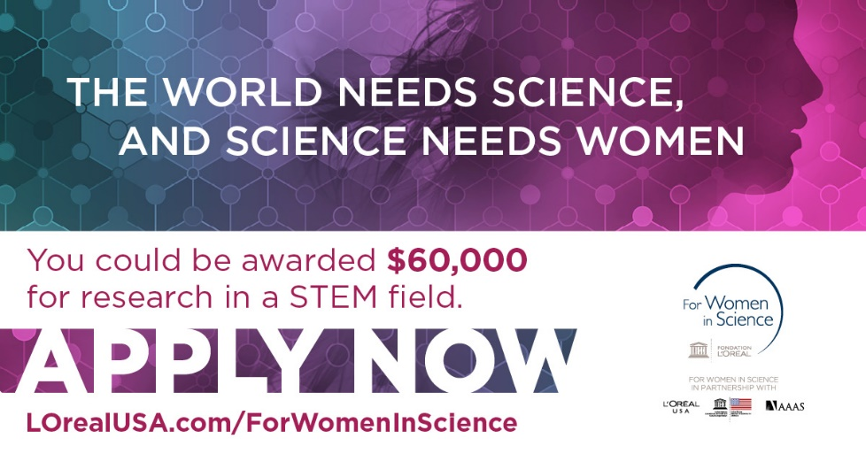
Fellowship program honors female scientists at a critical stage in their careers. Since 2003, they have awarded 70 postdoctoral women scientists over $3.5 million in grants. In 2018, they are seeking five exceptional female scientists looking to advance their research and serve as role models for the next generation of females in STEM.
The 2018 L'Oréal USA for Women in Science application period is now open, and applications are due by February 2, 2018.
For more information and to apply, please click here.
Tufts university school of medicine presents teacrs
Fellowships are available in the Training in Education and Critical Research Skills Program (TEACRS) at Tufts University. This NIH-funded program is designed to prepare talented postdoctoral trainees with the career skills needed to succeed in academic biomedical research.
For more information, and to apply click here. Download the flyer here.
Applicants must be U.S. citizens or permanent residents with no more than two years of postdoctoral training at the time of their appointment to the program.
The application deadline for positions beginning in the fall of 2018 is March 1, 2018.
New National Database for Postdoctoral funding
A new postdoctoral-centered, searchable database of 275 funding opportunities for postdoctoral scholars has been released by John Hopkins University. Please check it out for good ideas for your next extramural grant/award application! Remember that if you submit an extramural application to a federally supported or major other mechanism, then you are eligible to receive a $1,000 intramural award from the OPDA to use for your general research-related expenses at FSU.
John Hopkins University Funding Resources

Cancer control research training program
The University of Rochester Medical Center Cancer Control & Psychoneuroimmunology Laboratory is actively seeking outstanding candidates for their upcoming group of Fellows for 2018. The applicants should be interested in longitudinal studies and clinical trials on translational (e.g. biomarker) symptom science research and/or cancer-related cognitive impairment research to work closely with Dr. Michelle Janelsins (Associate Professor) and her research team. Candidates they are interested in come from a variety of backgrounds including, but not limited to, neuroscience, cognitive science, clinical psychology, epidemiology, clinical trials, applied sciences, and many more.
They will begin interviewing candidates in January 2018. For more information, and to apply, please click here.

Materials can be sent directly to Dr. Michelle Janelsins and Dr. Gary Morrow (Program Director)
fens – ibro forum of neuroscience
FENS, the European voice for Neuroscience is hosting a forum of Neuroscience July 7-11, 2018 in Berlin, Germany. FENS is also providing travel grants to young investigators to attend the forum. For more information about the forum, click here.
Young investigators in Neuroscience may also apply for a training program where German Neuroscience PI’s allow young investigators to spend 2-3 weeks in German lab. For more information on the training program, click here. The deadline to apply is February 13, 2018.
Fellowships
AACR Gastric Cancer Research Fellowships
Application deadline: January 25, 2018 1:00 PM

American Epilepsy Society Postdoctoral Research Fellowship
Full proposals due: Jan. 31, 2018

Charles A. King Trust Postdoctoral Research Fellowship Program
Application deadline: February 9, 2018, 3:00 PM, EST
AACR-Kure it Research Grant for Immunotherapy in Kidney Cancer
Application deadline: February 15, 2018
Helen Hay Whitney Fellowship for Biomedical Research
Application deadline: No later than 5pm EST, July 2, 2018
Index of Postdoc Fellowships in the Life Sciences (Broad Institute)

EPA Research Grants

Use the following databases to identify additional opportunities (click on the links) – Pivot, Foundation Center
Jobs
Below is a sampling of open positions in the United States -
Assistant Professing in Nursing – Department of Health Sciences
Colorado Mesa University, Grand Junction, CO

Research Scientist – Smart Sensor Arrays
UES, Dayton, OH

Assistant Professor – Biomedical Engineering
University of Hawaii Manoa, Honolulu, HI

Research Scientist – Electrical Engineering
Facebook, Redmond, WA

Research Assistant Professor – Department of Neuroscience (Job ID: 206103)
University of Rochester, Rochester, NY

Scientist – Discovery Biology (Job ID: 38638)
Eli Lilly, Greenfield, IN

Assistant Professor Positions – Exercise Physiology (Job ID: 42380) & Nutrition (Job ID:42371)
FSU College of Human Sciences, Department of Nutrition, Food & Exercise Sciences
Assistant Professor of Research – Center for Craniofacial Molecular Biology
University of Southern California (USC), Biomedical Sciences

Assistant Professor – Clinical Occupational Therapy
University of Southern California, Occupational Therapy

Assistant Professor – Research Emergency Medicine
University of Southern California, Department of Emergency Medicine
Clinical Assistant Professor – Pediatrics
University of Southern California, Department of Pediatrics
University of Washington Faculty Positions
The College of Engineering & School of Medicine is accepting applications for tenure-track Assistant Professor position in the Department of Bioengineering. Download flyer for more information. To apply, click here.

Postdoctoral Position in Public Participation in Digitization of Biodiversity Collections
A postdoctoral position is available with iDigBio in the research group of Prof. Austin Mast (Department of Biological Science, Florida State University; http://www.bio.fsu.edu/faculty-mast.php) to study engagement of the public in the digitization of biodiversity research
collections, especially as it relates to the community’s Worldwide Engagement for Digitizing Bio collections (WeDigBio) Event. iDigBio (www.idigbio.org) is the US NSF's National Resource for Advancing Digitization of Biodiversity Collections, and it is located at the University of Florida and Florida State University. The WeDigBio Event (www.wedigbio.org) is an annual, 4-day event that mixes onsite engagement at museums, universities, etc. with engagement of distributed participants to produce an exciting, educational global data campaign for science. New developments that could be a part of this postdoc’s activities include the build-out of the nascent WeDigBio virtual science festival, creation of virtual reality bio collections tours, and completion of a strategic plan for the WeDigBio Event. The WeDigBio Event has a history of innovation, including in the area of augmented reality.

To apply, send a cover letter and CV with contact information for three references in a single pdf file to Austin Mast (amast@bio.fsu.edu). In the cover letter, please cite past activities that demonstrate each of (1) through (4) above as well as provide the
date on which you could start the position and a paragraph or two on your long-term career goals and how you see this position fitting into them. Applications will be considered beginning on Nov 15, 2017 until the position is filled.
Below is a sampling of open positions around the world -

Canada: Assistant Clinical Professor – in Pharmacy & Pharm Science
University of Alberta, Faculty of Pharmacy & Pharmaceutical Sciences

Tenure Track Assistant Professor – Biomedical or Electrical Engineering
University of Guelph, School of Engineering/Biomedical Engineering
Assistant Professor – REHAB Occupational Therapy
University of Alberta, Department of Occupational Therapy

Assistant Professor – Microbial Science & Micro/Nanomaterials
University of Calgary Canada First Research Excellence Fund
Assistant Professor – Department of Medicine
University of Alberta, Faculty of Medicine & Dentistry

Assistant Professor – Division of Developmental Pediatrics
University of Alberta, Faculty of Medicine & Dentistry

Staff Scientist in Hematology Research
Keenan Research Centre for Biomedical Research of St. Michael’s Hospital
Japan: Assistant Professor in the Graduate School of Biomedical & Health Sciences
Hiroshima University, Graduate School of Biomedical & Health Sciences

Assistant Professor in Medical Education, Pharmacology, Neuroscience
Hiroshima University, Graduate School of Biomedical & Health Sciences

Norway: Head Engineer at Electron Microscopy Core Facility
University of Oslo, Department of Biosciences (IBV)
Singapore: Assistant Professor for Bio-Behaviorist
Duke NUS Medical School, Academic Medicine Research Institute

Assistant Professor – Center for Aging Research & Education
Duke NUS Medical School, Center for Aging Research & Education
South Africa: Associate Researcher in Clinical Micro Infectious Diseases (CMID)
Wits University, School of Pathology, Johannesburg, ZA

Switzerland: PhD in Biomedical Engineering
University of Basel, Adaptable MRI Technology

Click here for featured Biology careers

Subscribe to receive personalized job announcement emails:
Bio Careers
Academic Keys
PhD Jobs
Fierce Biotech Jobs

ASBMB - American Society for Biochemistry and Molecular Biology
http://www.asbmb.org/careers/ (career information)
Career Development Webinars and Blogs
10 Common Grant-Writing Mistakes
In this article, the author points out, it might not be the science that brought you a rejection but the nonscientific gaffes in your proposal.
Learn the rules of the road to land that industry job
In this article, the author hones in on three types of rules you should familiarize yourself with, whether you want to land a job in academic or an industry job.

Best Practices in transfection: Impacts on gene editing, virus production, and more
January 25, 2018 12:00pm ET
Deciphering neurodegeneration: Inflammation, immune response, and Alzheimer’s
February 7, 2018 12:00pm ET
How to Be Proactive in Your Mentoring Relationships – National Postdoctoral Association http://www.nationalpostdoc.org/?page=Proactive

Versatile PhD
This site helps graduate students and new PhD’s identify, prepare for, and excel in possible non-academic careers.
Click here to learn more. Click here to join
Free NPA Membership
FSU is a sustaining member of the National Postdoctoral Association (NPA). This membership provides free affiliate membership to all FSU postdoctoral scholars. Benefits of joining the NPA include:
    - A subscription to the NPA’s official quarterly newsletter
    - Reduced registration fees to the NPA Annual Meeting
    - Eligibility for the NPA Travel Award Program
    - Professional & Leadership Development
    - Networking opportunities with colleagues nationwide
If you are interested in joining the National Postdoctoral Association, click here.
Please email opda-info@fsu.edu if you encounter any problems.

For previous issues, click here!

