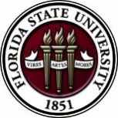
Florida State University
OFFICE OF POSTDOCTORAL AFFAIRS WEEKLY DIGEST

January 8, 2018

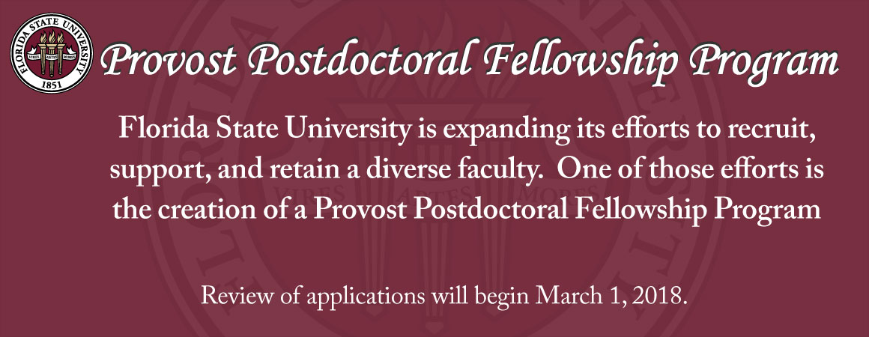
Upcoming Events

sponsorship to the national postdoctoral association!
Deadline to apply = January 15, 2018
We are seeking a member of the FSU postdoctoral community to attend the National Postdoctoral Association Conference that will be held in Cleveland, OH on April 6-8, 2018. If you are interested in representing FSU, please see Debra Ann Fadool concerning how to apply. One member of our postdoc community will be sponsored by the OPDA to attend the conference. Preference will be given to postdocs that are involved in organizing events on campus or have contributed to the PDA, and those that have not ever had the opportunity to attend previously.
More about the conference can be found here –
http://www.nationalpostdoc.org/general/custom.asp?page=2018AnnualConference
Spring 2018 PIE Teaching/training workshop/ta orientation
This abridged Spring TA training workshop is primarily offered to meet the needs of graduate students and postdocs who will be newly serving as a TA or instructor in the Spring or Summer of 2018, and others who were unable to attend the annual Fall PIE conference because of extenuating circumstances that have been documented by the graduate student’s academic department.
This TA training is delivered partly face-to-face and partly online via Blackboard. The face-to- face portion will be held Friday, January 12, 2018, 1:00pm – 4:30pm, in the Great Hall of the
Honors, Scholars & Fellows House.
For more information and to register for face-to-face training, click here. To be enrolled in the online training, please send an email to: pie-info@fsu.edu.

Biological Science/Neuroscience Postdoctoral Mentoring Workshop & Lunch
KIN Life Science Building, Room 2057, 12:00 – 1:00 PM

Please mark your calendar for the fall 2017 through spring 2018 workshops. This is a special, faculty-led monthly workshop for Postdoctoral Scholars hosted by the Department of Biological Science and the Program in Neuroscience. Although the career focus will be directed to the Life Sciences, all Postdoctoral Scholars and senior Graduate Students are welcome. Sandwiches will be served over the lunch hour during the workshops. Dates and topics are listed below. For questions, please contact Dr. Kay Jones. No registration required.

Date | Presenter | Title
Tuesday Jan. 16, 2018 | Dr. Hank Bass | The Academic Career Trajectory
Monday Feb. 12, 2018 | Dr. Meghan Talkington, Senior Science Writer, Broad Institute, Cambridge MA. | Science Communication for Everyone
Monday Mar. 5, 2018 |  | Postdoc Oral Competition – 9 AM – 3 PM
Monday April 9, 2018 | Dr. Joe Travis | Understanding the Structure of a Typical (US) University
TBA | Dr. Anita Nag, Furman University | FSU Postdocs Made Good

Interdisciplinary training in Computational neuroscience
This two-week Summer Course starts June 4, 2018 at 9am and ends at noon on June 15, 2018. The course is limited to 24 participants. The deadline to register: February 1, 2018.
Eligibility is for pre- and postdocs from a variety of STEM fields. National Institutes of Health (NIH) is covering all expenses including travel, lodging and meals at residence halls.
For more information, and to apply, please click here.
Funding Announcements
L’Oréal-UNESCO for Women in Science Program:
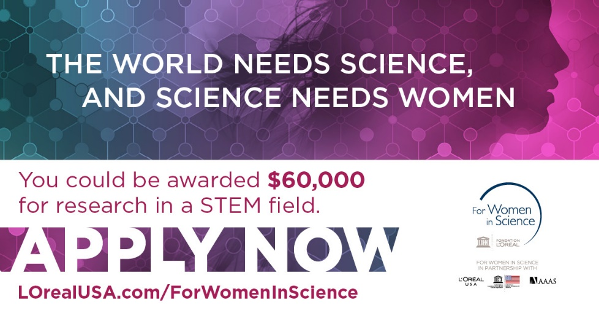
Fellowship program honors female scientists at a critical stage in their careers. Since 2003, they have awarded 70 postdoctoral women scientists over $3.5 million in grants. In 2018, they are seeking five exceptional female scientists looking to advance their research and serve as role models for the next generation of females in STEM.
The 2018 L'Oréal USA for Women in Science application period is now open, and applications are due by February 2, 2018.
For more information and to apply, please click here.
Tufts university school of medicine presents teacrs
Fellowships are available in the Training in Education and Critical Research Skills Program (TEACRS) at Tufts University. This NIH-funded program is designed to prepare talented postdoctoral trainees with the career skills needed to succeed in academic biomedical research.
For more information, and to apply click here. Download the flyer here.
Applicants must be U.S. citizens or permanent residents with no more than two years of postdoctoral training at the time of their appointment to the program.
The application deadline for positions beginning in the fall of 2018 is March 1, 2018.

New National Database for Postdoctoral funding
A new postdoctoral-centered, searchable database of 275 funding opportunities for postdoctoral scholars has been released by John Hopkins University. Please check it out for good ideas for your next extramural grant/award application! Remember that if you submit an extramural application to a federally supported or major other mechanism, then you are eligible to receive a $1,000 intramural award from the OPDA to use for your general research-related expenses at FSU.
John Hopkins University Funding Resources

Cancer control research training program
The University of Rochester Medical Center Cancer Control & Psychoneuroimmunology Laboratory is actively seeking outstanding candidates for their upcoming group of Fellows for 2018. The applicants should be interested in longitudinal studies and clinical trials on translational (e.g. biomarker) symptom science research and/or cancer-related cognitive impairment research to work closely with Dr. Michelle Janelsins (Associate Professor) and her research team. Candidates they are interested in come from a variety of backgrounds including, but not limited to, neuroscience, cognitive science, clinical psychology, epidemiology, clinical trials, applied sciences, and many more.
They will begin interviewing candidates in January 2018. For more information, and to apply, please click here.

Materials can be sent directly to Dr. Michelle Janelsins and Dr. Gary Morrow (Program Director)

Fellowships
Postdoctoral Enrichment Program Grant
Application Deadline: January 16, 2018 4:00 pm EST

Burroughs Wellcome Fund Postdoctoral Enrichment Program
Deadline: January 16, 2018

AACR Gastric Cancer Research Fellowships
Application deadline: 1/25/2018 1:00 PM

American Epilepsy Society Postdoctoral Research Fellowship
Full proposals due: Jan. 31, 2018

Charles A. King Trust Postdoctoral Research Fellowship Program
Application deadline: February 9, 2018, 3:00 PM, EST
Index of Postdoc Fellowships in the Life Sciences (Broad Institute)

EPA Research Grants

Use the following databases to identify additional opportunities (click on the links) – Pivot, Foundation Center
Jobs
Below is a sampling of open positions in the United States -
Research Assistant Professor – Department of Anatomy & Physiology
Kansas State University, Manhattan, KS

Assistant Research Scientist – College of Optical Sciences
University of Arizona, Tucson, AZ

Tenure Track Assistant Professor – College of Engineering, Technical & Management
Oregon Tech, Wilsonville, OR

Staff Scientist Research & Development – Job ID: 59769BR
Thermo Fisher Scientific, Austin, TX

Tenure Track Assistant Professor – Department of Cell Biology & Anatomy
University of South Carolina School of Medicine
Contact: Dr. Wayne Carver (Chair) to apply (803) 216-3803

Research Scientist – Department of Experimental & Applied Mechanics
University of Dayton, Dayton, OH

Assistant Professor Positions – Exercise Physiology (Job ID: 42380) & Nutrition (Job ID:42371)
FSU College of Human Sciences, Department of Nutrition, Food & Exercise Sciences
Assistant Professor of Research – Center for Craniofacial Molecular Biology
University of Southern California (USC), Biomedical Sciences

Assistant Professor – Clinical Occupational Therapy
University of Southern California, Occupational Therapy

Assistant Professor – Research Emergency Medicine
University of Southern California, Department of Emergency Medicine
Clinical Assistant Professor – Pediatrics
University of Southern California, Department of Pediatrics
University of Washington Faculty Positions
The College of Engineering & School of Medicine is accepting applications for tenure-track Assistant Professor position in the Department of Bioengineering. Download flyer for more information. To apply, click here.

Postdoctoral Position in Public Participation in Digitization of Biodiversity Collections
A postdoctoral position is available with iDigBio in the research group of Prof. Austin Mast (Department of Biological Science, Florida State University; http://www.bio.fsu.edu/faculty-mast.php) to study engagement of the public in the digitization of biodiversity research
collections, especially as it relates to the community’s Worldwide Engagement for Digitizing Bio collections (WeDigBio) Event. iDigBio (www.idigbio.org) is the US NSF's National Resource for Advancing Digitization of Biodiversity Collections, and it is located at the University of Florida and Florida State University. The WeDigBio Event (www.wedigbio.org) is an annual, 4-day event that mixes onsite engagement at museums, universities, etc. with engagement of distributed participants to produce an exciting, educational global data campaign for science. New developments that could be a part of this postdoc’s activities include the build-out of the nascent WeDigBio virtual science festival, creation of virtual reality bio collections tours, and completion of a strategic plan for the WeDigBio Event. The WeDigBio Event has a history of innovation, including in the area of augmented reality.

To apply, send a cover letter and CV with contact information for three references in a single pdf file to Austin Mast (amast@bio.fsu.edu). In the cover letter, please cite past activities that demonstrate each of (1) through (4) above as well as provide the
date on which you could start the position and a paragraph or two on your long-term career goals and how you see this position fitting into them. Applications will be considered beginning on Nov 15, 2017 until the position is filled.
Below is a sampling of open positions around the world -

Canada: Assistant Clinical Professor – in Pharmacy & Pharm Science
University of Alberta, Faculty of Pharmacy & Pharmaceutical Sciences

Tenure Track Assistant Professor – Biomedical or Electrical Engineering
University of Guelph, School of Engineering/Biomedical Engineering
Assistant Professor – REHAB Occupational Therapy
University of Alberta, Department of Occupational Therapy

Assistant Professor – Microbial Science & Micro/Nanomaterials
University of Calgary Canada First Research Excellence Fund
Assistant Professor – Department of Medicine
University of Alberta, Faculty of Medicine & Dentistry

Assistant Professor – Division of Developmental Pediatrics
University of Alberta, Faculty of Medicine & Dentistry

Staff Scientist in Hematology Research
Keenan Research Centre for Biomedical Research of St. Michael’s Hospital
Japan: Assistant Professor in the Graduate School of Biomedical & Health Sciences
Hiroshima University, Graduate School of Biomedical & Health Sciences

Assistant Professor in Medical Education, Pharmacology, Neuroscience
Hiroshima University, Graduate School of Biomedical & Health Sciences

Norway: Head Engineer at Electron Microscopy Core Facility
University of Oslo, Department of Biosciences (IBV)
Singapore: Assistant Professor for Bio-Behaviorist
Duke NUS Medical School, Academic Medicine Research Institute
Assistant Professor – Center for Aging Research & Education
Duke NUS Medical School, Center for Aging Research & Education
South Africa: Associate Researcher in Clinical Micro Infectious Diseases (CMID)
Wits University, School of Pathology, Johannesburg, ZA

Switzerland: PhD in Biomedical Engineering
University of Basel, Adaptable MRI Technology

Click here for featured Biology careers

Subscribe to receive personalized job announcement emails:
Florida State University Bio Careers
Academic Keys
PhD Jobs
Fierce Biotech Jobs

ASBMB - American Society for Biochemistry and Molecular Biology
http://www.asbmb.org/careers/ (career information)
Career Development Webinars and Blogs
What Are You Working on Today?
In this article, the author points out, how you can turn your grad-school, or postdoc friendship into a model of “remote co-working.”

The keys to a powerful LinkedIn profile
Read an article on how to make your LinkedIn profile powerful and make it stand out.

How to Be Proactive in Your Mentoring Relationships – National Postdoctoral Association http://www.nationalpostdoc.org/?page=Proactive

Monitoring immune responses in cancer therapies: Avoiding the cytokine storm and other negative outcomes (Webinar)
January 16, 2018 – 12:00 pm ET. Click here to register.

Versatile PhD
This site helps graduate students and new PhD’s identify, prepare for, and excel in possible non-academic careers.
Click here to learn more. Click here to join
Free NPA Membership
FSU is a sustaining member of the National Postdoctoral Association (NPA). This membership provides free affiliate membership to all FSU postdoctoral scholars. Benefits of joining the NPA include:
    - A subscription to the NPA’s official quarterly newsletter
    - Reduced registration fees to the NPA Annual Meeting
    - Eligibility for the NPA Travel Award Program
    - Professional & Leadership Development
    - Networking opportunities with colleagues nationwide
If you are interested in joining the National Postdoctoral Association, click here.
Please email opda-info@fsu.edu if you encounter any problems.

For previous issues, click here!

