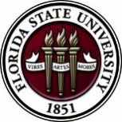
Florida State University
OFFICE OF POSTDOCTORAL AFFAIRS WEEKLY DIGEST

July 3, 2018

Upcoming Events
Postdoctoral travel awards
Travel Award Registration for July – December 2018 is NOW Open! To read about what the Travel Awards cover including costs, eligibility, and application procedures, please visit: https://opda.fsu.edu/awards-and-fellowships/travel-awards. Travel award applications are due on July 1 by midnight for travel occurring through December 31st, 2018.
nominate your postdoc mentor

Nominate your Postdoc mentor for the chance to win $1,000 for your lab. Many of the critical mentors in science go unheralded. This award recognizes senior postdoctoral fellows who help mentor and support the development of fellow researchers. Prointech is offering a $1000 award and a mentor care package ($100 Visa gift card, notebook, pen, and commemorative mug).

Nominees must be based in a research laboratory in a university or research institution.

For more information, and to nominate your postdoc advisor. Nominate now

Deadline for all nominations: July 11, 2018
postdoc & senior graduate “summer two-part workshop”
Friday, July 13, 12 pm in KIN 2057, King Life Sciences Building, Biological Science
Dr. Tracy Costello, FSU Alumna, and Director, Postdoctoral Affairs, Moffitt Cancer Center
For rising senior graduate scholars in the STEM disciplines desiring to arrange a postdoctoral training period.
Part 1 Workshop = “Is the Postdoctoral Training Period Right for you?”
Part 2 Recruitment Program = “Postdoctoral Opportunities at Moffitt Cancer Center”
Part 1 Workshop = “Is the Postdoctoral Period Right for You”?
Description: You’ve trained for a few years and are nearly done! How do you decide what your next career step should be? Is a postdoctoral position right for you? How do you pick an institution or find a great mentor? This workshop will help you navigate these questions and begin career exploration.
Some learning objectives: Participants should be able to:
- Identify resources to help decide their next career step
- Determine if a postdoc is required or recommended
- Compare and contrast different postdoc opportunities
- Prepare application materials
- Prepare for interviews and job talks
Factors include: research group’s history, institutional culture, funding/salary/benefits, research structure expectations, work-life balance, international considerations, and career/professional development.
Part 2 Recruitment Program = “Postdoctoral Opportunities at Moffitt Cancer Center “
Moffitt Cancer Center’s goal is to nurture the next generation of cancer researchers. Our postdoctoral fellows have access to modern research facilities in nine departments within the divisions of: Basic Science, Population Science, Clinical Science, and Quantitative Science. Come discuss postdoctoral fellow opportunities and learn more about our benefits and policies on July 13.

(Only 20 stipend positions are available)
Lunch will be provided; no registration is required!

Postdoc Made Good Special Mentoring Workshop and Lunch
KIN Life Science Building, Room 2057, 12:00 – 1:00 PM, Friday July 23

Please welcome Dr. Anita Nag who will be this year’s ‘Postdocs Made Good’ invited guest from Furman University. Every wonder what it would be like to take on a one-year temporary position in academia? Come on out to ask her about transitioning as an FSU Postdoctoral Scholar to a university position as a Visiting Assistant Professor in Chemistry. Lunch will be provided. Senior graduate scholars and postdoctoral scholars are welcome! For questions, please contact Dr. Kay Jones. No registration required.

L’Oreal-Unesco for Women in Science
International Awards 2019 Edition

For the first time, the 2019 Awards will designate five outstanding researchers in the Physical Sciences, Mathematics and Computer Science, each working in one of the following regions: Africa and the Arab States, Asia-Pacific, Europe, Latin America & North America.
The Awards will be presented in March 2019 in Paris to the five women selected by an international jury for their outstanding contribution to scientific advancement. Each of the Award Laureates will receive €100,000.
To nominate a candidate, please visit: https://www.forwomeninscience.com/en/awards.
Please note that nomination files must be submitted by midnight on July 13th 2018 (France GMT/UTC + 2h)

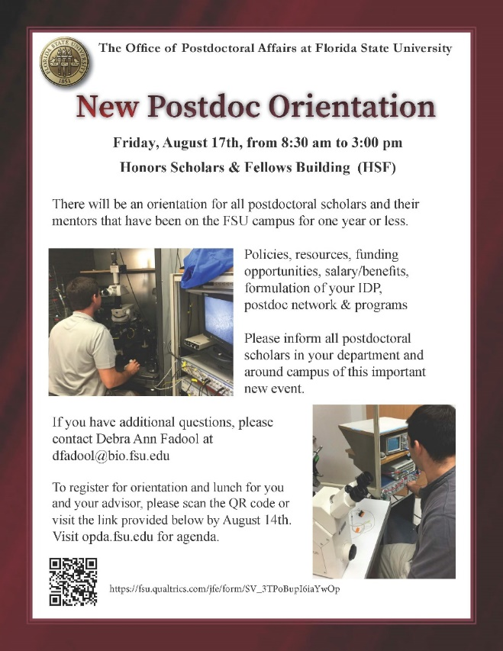
New Postdoctoral Orientation
New Postdoctoral Orientation will be held on August 17, 2018 in the Nancy Marcus Great Hall of the Honors Scholar and Fellows Building (HSF), from 8:30 am to 3 pm. All new postdoctoral scholars on campus less than 6 months are required to attend.
Postdoctoral advisors/mentors are highly encouraged to accompany your postdoctoral scholar to assist in the development of the Individual Development Plan (IDP) that is required for individual investigator NIH research performance progress reports (RPPR).
Registration link is NOW open “Click Here”
For more information about the orientation, please see our archive and New Postdoctoral Orientation division of the website. Download Orientation flyer here.

Undergraduate Research Opportunity Program (UROP)
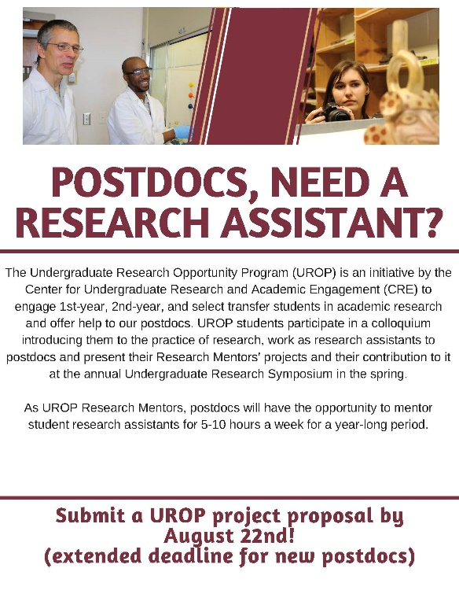

Could you use a research assistant for the 2018-2019 academic year (at no cost to you and up to $250 to help cover the cost of research materials)?
Why not consider becoming a UROP Mentor? Come learn about the Undergraduate Research Opportunity Program (UROP) at one of the info sessions listed on the flyer.

UROP helps FSU first & second year, and transfer students in all majors, get started in research.

If you are interested in this exciting opportunity, you can find more information by visiting: https://fla.st/2rwKjGh.

New National Database for Postdoctoral funding
A new postdoctoral-centered, searchable database of 275 funding opportunities for postdoctoral scholars has been released by John Hopkins University. Please check it out for good ideas for your next extramural grant/award application! Remember that if you submit an extramural application to a federally supported or major other mechanism, then you are eligible to receive a $1,000 intramural award from the OPDA to use for your general research-related expenses at FSU.
John Hopkins University Funding Resources
Cancer control research training program
The University of Rochester Medical Center Cancer Control & Psychoneuroimmunology Laboratory is actively seeking outstanding candidates for their upcoming group of Fellows for 2018. The applicants should be interested in longitudinal studies and clinical trials on translational (e.g. biomarker) symptom science research and/or cancer-related cognitive impairment research to work closely with Dr. Michelle Janelsins (Associate Professor) and her research team. Candidates they are interested in come from a variety of backgrounds including, but not limited to, neuroscience, cognitive science, clinical psychology, epidemiology, clinical trials, applied sciences, and many more.
For more information, and to apply, please click here.
Materials can be sent directly to Dr. Michelle Janelsins or Dr. Gary Morrow (Program Director)
Fellowships
The Company of Biologists – Traveling Fellowships
Next deadline: August 31, 2018
Postdoc Research Funding Opportunities in Germany
Application deadlines vary
Index of Postdoc Fellowships in the Life Sciences (Broad Institute)
EPA Research Grants

Use the following databases to identify additional opportunities (click on the links) – Pivot, Foundation Center
Jobs
Below is a sampling of open positions in the United States –

Florida College System, seeks to fill a position for Executive Director, Florida Student Success Center.

The Florida Student Success Center (FSSC) serves as an intermediary between colleges, and provides greater opportunities for colleges to collaborate and learn from one another. The Executive Director works under the supervision of the Chancellor of the Florida College System.
For more information on the role of the position, qualifications and to apply please click here.
Assistant Professor – Engineering (Job ID: 9219407)
Jefferson, East Falls, PA
Licensed Clinical Psychologist
Medstar Medical Group, Washington, DC

Assistant Professor – School of Engineering
Virginia Commonwealth University, Richmond, VA

Scientist – Cell Biology, Molecular Biology
Apex Life Sciences, San Diego, CA

Assistant Professor – Engineering/Computer Science
University of Florida, Gainesville, FL

Research Scientist – MoL002132
Danaher, San Jose, CA

Project Manager, Student Communities/Learning and Career Development
American Chemical Society, Washington, DC

Science Editor for Educational Media – Tracking Code: 774-908
Howard Hughes Medical Institute, Chevy Chase, MD
Postdoctoral Fellowship in Cognitive Aging
School of Psychology, Georgia Institute of Technology, Atlanta, GA

Assistant Professor Positions – Exercise Physiology (Job ID: 42380) & Nutrition (Job ID:42371)
FSU College of Human Sciences, Department of Nutrition, Food & Exercise Sciences
Assistant Professor of Research – Center for Craniofacial Molecular Biology
University of Southern California (USC), Biomedical Sciences

Assistant Professor – Clinical Occupational Therapy
University of Southern California, Occupational Therapy
Assistant Professor – Research Emergency Medicine
University of Southern California, Department of Emergency Medicine
Clinical Assistant Professor – Pediatrics
University of Southern California, Department of Pediatrics
Below is a sampling of open positions around the world -
Canada: Assistant Clinical Professor – in Pharmacy & Pharmaceutical Science
University of Alberta, Faculty of Pharmacy & Pharmaceutical Sciences

Tenure Track Assistant Professor – Biomedical or Electrical Engineering
University of Guelph, School of Engineering/Biomedical Engineering
Assistant Professor – REHAB Occupational Therapy
University of Alberta, Department of Occupational Therapy
Assistant Professor – Microbial Science & Micro/Nanomaterials
University of Calgary Canada First Research Excellence Fund
Assistant Professor – Department of Medicine
University of Alberta, Faculty of Medicine & Dentistry
Assistant Professor – Division of Developmental Pediatrics
University of Alberta, Faculty of Medicine & Dentistry

Staff Scientist in Hematology Research
Keenan Research Centre for Biomedical Research of St. Michael’s Hospital
Japan: Assistant Professor in the Graduate School of Biomedical & Health Sciences
Hiroshima University, Graduate School of Biomedical & Health Sciences

Assistant Professor in Medical Education, Pharmacology, Neuroscience
Hiroshima University, Graduate School of Biomedical & Health Sciences

Norway: Head Engineer at Electron Microscopy Core Facility
University of Oslo, Department of Biosciences (IBV)
Singapore: Assistant Professor for Bio-Behaviorist
Duke NUS Medical School, Academic Medicine Research Institute

Assistant Professor – Center for Aging Research & Education
Duke NUS Medical School, Center for Aging Research & Education
South Africa: Associate Researcher in Clinical Micro Infectious Diseases (CMID)
Wits University, School of Pathology, Johannesburg, ZA
Switzerland: PhD in Biomedical Engineering
University of Basel, Adaptable MRI Technology
Click here for featured Biology careers
Subscribe to receive personalized job announcement emails:
Bio Careers
Academic Keys
PhD Jobs
Fierce Biotech Jobs
ASBMB - American Society for Biochemistry and Molecular Biology
http://www.asbmb.org/careers/ (career information)
Career Development Webinars and Blogs
How to Advocate for Yourself as an Early-Career Scholar
In this article, the author points out that many academics spend 60 percent of their time on tasks that go unrecognized. Don’t let it happen to you.

Until academic careers do us part
In this article that addresses dual career couples.

Career Path: “Leveraging Your PhD for Career Success” – Bio Careers Webinar
Wednesday, July 18, 2018 1:00 pm – 2:00 pm EDT

Career Path: “What industry can offer: Tips for putting your foot inside the door” – Webinar
Wednesday, August 29, 2018 1:00 pm – 2:00 pm EDT Bio Careers

How to Be Proactive in Your Mentoring Relationships – National Postdoctoral Association http://www.nationalpostdoc.org/?page=Proactive
ASBMB - Postdoctoral Education & Resources

Versatile PhD
This site helps graduate students and new PhD’s identify, prepare for, and excel in possible non-academic careers.
Click here to learn more. Click here to join
Free NPA Membership
FSU is a sustaining member of the National Postdoctoral Association (NPA). This membership provides free affiliate membership to all FSU postdoctoral scholars. Benefits of joining the NPA include:
    - A subscription to the NPA’s official quarterly newsletter
    - Reduced registration fees to the NPA Annual Meeting
    - Eligibility for the NPA Travel Award Program
    - Professional & Leadership Development
    - Networking opportunities with colleagues nationwide
If you are interested in joining the National Postdoctoral Association, click here.
Please email opda-info@fsu.edu if you encounter any problems.
For previous issues, click here!

