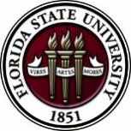
Florida State University
OFFICE OF POSTDOCTORAL AFFAIRS WEEKLY DIGEST

March 20, 2017

Upcoming Events

Biological Science/Neuroscience Postdoctoral Oral Competition day

The Biological Science/Neuroscience Postdoctoral Oral Competition Day held on Monday March 6, 2017 in the King Life Science Building was a huge success! Congratulations to Dale Bosco who was the winner of the $500 shopping spree sponsored by VWR lab supply. Click Here for a copy of the flyer and all the presentations and participants.

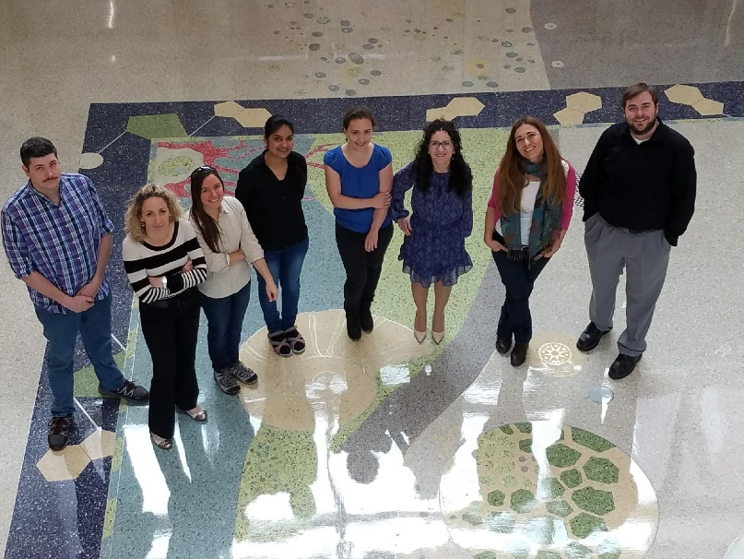
Postdoctoral Oral Competition Participants

"Welcome" Mini-Orientation Sessions for New Postdoctoral Scholars on Campus
Honors, Scholars & Fellows House, Room 3009, April 24, 2017 12:00 PM
If you are a new postdoctoral scholar to the FSU campus, this “Welcome” is a nice brown bag lunch activity that will fit into your busy research schedule. The design will be limited to strictly a one-hour session, where you will receive the essentials of getting your research started at FSU and have access to Human Resources and Office of Postdoctoral Affairs Staff. At this time, you will also be introduced to the Postdoctoral Association (PDA) - your peer network of postdocs on campus. Attending a “welcome” in your few months of employment at FSU will serve to fulfill your mandatory orientation. Registration for April will open in late March; continue to check website http://opda.fsu.edu/upcoming-events-workshops/upcoming-events for link.

POSTDOCTORAL SPRING EVENT – Hold the Date – 19 may 2017

Breaking Out of Your Postdoc
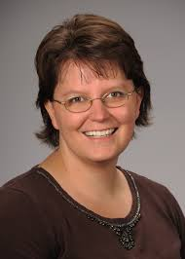
Please save the date for this special afternoon workshop for postdoctoral scholars, senior graduate students, and mentors. Our keynote address will be given by Dr. Lori Conlan, Director of Postdoctoral Affairs at the National Institutes of Health (NIH). Dr. Conlan will help map the course to different pathways to be pursued in academia, industry, and federal government and the transferable skills that have been built during your postdoctoral training to transition you to these career tracks. She will present strategies for the application packet, interviewing, and securing the best position for your ambitions. We are thrilled she will share her experiences from her insight working with the NIH and her knowledge of postdoctoral hiring trends across the country. A potluck dinner for scholars, their lab mates, mentors, and family members will follow the afternoon event, so we hope you will come out to network and engage with the FSU postdoctoral community. Postdoctoral scholars interested in helping to organize this event please contact PDA President, Nikhil Gupta or Vice-president, Erminia Fardone.
Tentative Schedule – Thursday May 18th Time: TBA
Social get together at Aloft Hotel, sponsored by VWR – all PDA members welcome to host Dr. Conlan!
Tentative Schedule – Friday May 19th
1:00 – 1:10 PM | Welcoming Remarks | Dr. Janet Kistner | VP Faculty Development
1:10 – 2:10 PM | Keynote Address & Question Exchange | Dr. Lori Conlan | NIH Director of Postdoctoral Affairs
2:10 – 2:50 PM | Workshop – Building your Interview Opportunities | Dr. Lori Conlan
2:50 – 3:10 PM | Coffee Break & Group Photograph | Mr. Charles Badland, MFA | FSU Graphic Artist
3:10 – 3:25 PM | Introductions of Panel Speakers –  Don Compton (Florida Reading Institute), Kenneth Hanson (FSU Chemistry), Christine Beekman (FSU Physics/NHFML),  Matthew Curan (Food Safety at Florida DACS), Fadi Adleek (Florida DACS & Adjunct TCC), Brian Washburn (FSU Research Specialist) | Moderator: Dr. Sudumu Tennakoon | Postdoctoral Scholar, Earth, Atmospheric Ocean Sciences
3:25 – 4:30 PM | Audience Open Mike & Live Stream
4:30 – 4:45 PM | Industrial Presentation Summary | TBA
4:45 – 5:00 PM | Academic Presentation Summary | TBA
5:30 PM | Potluck Dinner – Families (both biological & collaborative are welcome)

Professional Development Workshops

Formative Assessment and Review Strategies (PIE/PFF/PFP)

March 23, 2017, 3:30 PM – 5:00 PM
Honors, Scholars & Fellows House, 4th Floor, Great Hall

Presenters: PIE Associates, Kate Hill, Biology, and Ana Ndumu, Information Science

Formative assessment strategies are effective ways of gauging ongoing student learning to provide feedback for both the student and teacher. In this session, participants will discover ways of monitoring student learning and improving content mastery through timely feedback and purposeful review activities. The presenters will provide tips for large and small classes in a variety of content areas.

Free PIE & Coffee Included!

To register: https://fsu.qualtrics.com/SE/?SID=SV_5tAXhpTLeE6QZZb

Negotiating Job Offers

March 24, 2017, 3:30 PM – 5:00 PM
Honors, Scholars & Fellows House, Room 3009

Presenter: Ms. Amanda Sargent, Assistant Director, FSU Career Center

Did you know that you can prepare to negotiate job offers? This workshop will include discussion of the uniqueness of each negotiation, factors that may be negotiated, what is involved in making the best decision, how to negotiate from a point of power, and the final steps.

To register: https://fsu.qualtrics.com/SE/?SID=SV_d6lw0AnGAjcwQpT
Faculty in a Research Institution: Expectations, Opportunities & Challenges

March 28, 2017, 8:30 AM – 12:00 PM
Honors, Scholars & Fellows House, 4th Floor, Great Hall

Presenters: FSU administrators and faculty

This workshop will help graduate students and postdoctoral scholars prepare for faculty responsibilities in a research work environment. Senior administrators will provide their perspectives on faculty life and/or current responsibilities at FSU. This workshop can be used for the “Career Development” requirement for the Preparing Future Faculty (PFF). Refreshments will be provided by the Congress of Graduate Students.

To register: https://fsu.qualtrics.com/SE/?SID=SV_6lOZ1IxTwzvQpHT

Engaging Students with Social Media, Apps & More! (PIE/PFF/PFP)

April 3, 2017, 3:30 PM – 5:00 PM
Honors, Scholars & Fellows House, 4th Floor, Great Hall

Presenter: Kendra Scholz, School of Communication

Learn about and practice using social media, apps, and more to help you engage your students both in and out of the classroom. You need not be a tech expert – all levels of experience are welcome! Come join us, and bring your laptop if you can (we will have some laptops available for you to use)!

Free PIE & Coffee Included!

To register: https://fsu.qualtrics.com/SE/?SID=SV_6rqRsKdNQSP7AGh

PIE Coffee Hour & Teaching Workshop: Creating Student-Centered Learning Environments (PIE/PFF/PFP)

April 19, 2017, 3:30 PM – 5:00 PM
Honors, Scholars & Fellows House, 4th Floor, Great Hall

Presenters: PIE Associates, Vincent Lakey, Physics, and David Jeffcoat, Chemistry
Student-centered learning environments shift the focus of classroom activity from teacher to students. Instead of treating students as passive receptacles, this workshop will teach you how to stimulate, engage and help them become active participants in their own education.

Free PIE & Coffee Included!
To register: https://fsu.qualtrics.com/SE/?SID=SV_9HwmiDnCned4izj

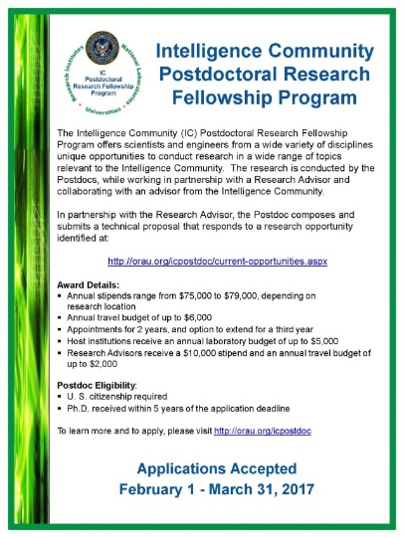
Fellowships

Summer Scholarships in Epidemiology (Cystic Fibrosis Foundation)
https://www.cff.org/Our-Research/For-Researchers/Training-Awards/Summer-Scholarships-in-Epidemiology/
Deadline: April 1, 2017 by 5PM

Research Training Groups in the Mathematical Sciences (RTG)
https://www.nsf.gov/funding/pgm_summ.jsp?pims_id=5732&org=DMS
Deadline: June 6, 2017 by 5 PM

Postdoctoral Program in Environmental Chemistry
http://dreyfus.org/awards/postdoctoral_program.shtml
Deadline: August 1, 2017

Fulbright Postdoctoral Scholar Awards
http://www.cies.org/program/postdoc
Deadline: August 1, 2017

Life Sciences Research Foundation
http://www.lsrf.org/apply
Applications open: Wed. September 6, 2017. Deadline: October 1, 2017 8 PM EST

Mathematical Sciences Postdoctoral Research Fellowships (MSPRF)
https://www.nsf.gov/funding/pgm_summ.jsp?pims_id=5301&org=NSF&sel_org=NSF&from=fund
Deadline: October 18, 2017 by 5 PM

NHC Fellowships
http://nationalhumanitiescenter.org/become-a-fellow/
Deadline: By midnight EDT, October 18, 2017

Mathematical Sciences Research Institute Fellowship (MSRI)
https://www.msri.org/web/msri/scientific/member-application/postdoctoral-fellow
Deadline: December 1, 2017

Use the following databases to identify additional opportunities (click on the links) – Pivot, Foundation Center

Jobs
Below is a sampling of open positions around the world.

Assistant/Associate Professor, Tenure Track – School of Nursing Engineering
http://utmb.jobs/galveston-tx/assistantassociate-professor-school-of-nursing/E03FE7D2A4604C01A17E2717FAFC43AC/job/?utm_source=Indeed&utm_medium=organic&utm_campaign=Indeed
The University of Texas Medical Branch, Galveston, TX

Associate or Full Researcher – Oceans & Atmosphere Section
https://apol-recruit.ucsd.edu/apply/JPF01349?emid=3640
UC San Diego, San Diego, CA

Assistant Professor – Civil & Environmental Engineering
https://www.pittsource.com/postings/133581
The University of Pittsburgh, Pittsburgh, PA

Scientist – Molecular Biology
http://atreca.hrmdirect.com/employment/job-opening.php?req=520039&&&nohd#job
Atreca, Redwood City, CA

Assistant Professor – College of Humanities & Sciences, Department of Biology
https://www.vcujobs.com/postings/60934
Virginia Commonwealth University, Richmond, VA

Materials Scientist – Materials Science, Chemical Engineering
https://rew11.ultipro.com/EIN1000/JobBoard/JobDetails.aspx?__ID=*0A1299A47D381906
E Ink Corporation, Billerica, MA

Postdoc Associate – Engineering/Computer Science, Research
http://explore.jobs.ufl.edu/cw/en-us/job/501644/post-doc-associate?utm_source=Indeed&utm_medium=organic&utm_campaign=Indeed
University of Florida, Gainesville, FL

Subscribe to receive personalized job announcement emails:
http://floridastate.biocareers.com
http://www.academickeys.com/all/subscribe.php
http://jobs.phds.org/alert.new
http://jobs.fiercebiotech.com

ASBMB - American Society for Biochemistry and Molecular Biology
http://www.asbmb.org/careers/

Career Development Webinars and Blogs

Can a Failing Grade Motivate a Student?
https://chroniclevitae.com/news/1734-can-a-failing-grade-motivate-a-student
Read how the grade you give, and the feedback you give can motivate a student to do better.

Navigating technology transfer issues
http://www.sciencemag.org/careers/features/2017/03/navigating-technology-transfer-issues
Read advice on how to patent your idea, or discovery.

10 Real World Skills Scientists Bring to the Workplace.
http://www.asbmb.org/Careers/Blog/
Read how your learned skills are not limited to the lab.

How to Be Proactive in Your Mentoring Relationships – National Postdoctoral Association http://www.nationalpostdoc.org/?page=Proactive

Cover Your Alt-Ac Cover Letter Bases – (webinar)

Wednesday March 22, 2017, 3:00 PM – 4:00 PM (EST)
Presenter: Dr. Melissa Dalgleish

To register: https://goto.webcasts.com/starthere.jsp?ei=1138489

Negotiating Your Way to a Job in Academia (webinar)

Wed. April 5, 2017, 1:00 PM – 2:00 PM (EST)
Presenter: James Gould

To register: https://attendee.gotowebinar.com/register/478591404121468418

Versatile PhD
This site helps graduate students and new PhD’s identify, prepare for, and excel in possible non-academic careers.
Click here to learn more. Click here to join
Free NPA Membership
FSU is a sustaining member of the National Postdoctoral Association (NPA). This membership provides free affiliate membership to all FSU postdoctoral scholars. Benefits of joining the NPA include:
    - A subscription to the NPA’s official quarterly newsletter
    - Reduced registration fees to the NPA Annual Meeting
    - Eligibility for the NPA Travel Award Program
    - Professional & Leadership Development
    - Networking opportunities with colleagues nationwide
If you are interested in joining the National Postdoctoral Association, click here.
Please email opda-info@fsu.edu if you encounter any problems.
For previous issues, click here!

