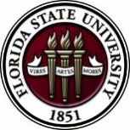
Florida State University
OFFICE OF POSTDOCTORAL AFFAIRS WEEKLY DIGEST

March 27, 2017

Travel Advisory

Effective immediately! Please click here to read about the latest travel advisory implemented by the U.S. Department of Homeland Security regarding travel from 10 last point departure airports traveling to the United States.

Upcoming Events

“Welcome" Mini-Orientation Sessions for New Postdoctoral Scholars on Campus
Honors, Scholars & Fellows House, Room 3009, April 24, 2017 12:00 PM
If you are a new postdoctoral scholar to the FSU campus, this “Welcome” is a nice brown bag lunch activity that will fit into your busy research schedule. The design will be limited to strictly a one-hour session, where you will receive the essentials of getting your research started at FSU and have access to Human Resources and Office of Postdoctoral Affairs Staff. At this time, you will also be introduced to the Postdoctoral Association (PDA) - your peer network of postdocs on campus. Attending a “welcome” in your few months of employment at FSU will serve to fulfill your mandatory orientation. Visuals from the January Welcome can be found in the presentation archive section of the OPDA website. For more information, contact Debi Fadool, dfadool@bio.fsu.edu. Registration for April 24th is Now Open – please click here.

POSTDOCTORAL SPRING EVENT – Hold the Date – 19 may 2017

Breaking Out of Your Postdoc
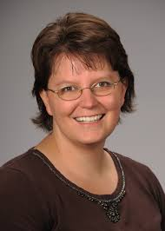
Please save the date for this special afternoon workshop for postdoctoral scholars, senior graduate students, and mentors. Our keynote address will be given by Dr. Lori Conlan, Director of Postdoctoral Affairs at the National Institutes of Health (NIH). Dr. Conlan will help map the course to different pathways to be pursued in academia, industry, and federal government and the transferable skills that have been built during your postdoctoral training to transition you to these career tracks. She will present strategies for the application packet, interviewing, and securing the best position for your ambitions. We are thrilled she will share her experiences from her insight working with the NIH and her knowledge of postdoctoral hiring trends across the country. A potluck dinner for scholars, their lab mates, mentors, and family members will follow the afternoon event, so we hope you will come out to network and engage with the FSU postdoctoral community. Postdoctoral scholars interested in helping to organize this event please contact PDA President, Nikhil Gupta or Vice-president, Erminia Fardone.
Tentative Schedule – Thursday May 18th Time: TBA
Social get together at Aloft Hotel, sponsored by VWR – all PDA members welcome to host Dr. Conlan!
Tentative Schedule – Friday May 19th
1:00 – 1:10 PM | Welcoming Remarks | Dr. Janet Kistner | VP Faculty Development
1:10 – 2:10 PM | Keynote Address & Question Exchange | Dr. Lori Conlan | NIH Director of Postdoctoral Affairs
2:10 – 2:50 PM | Workshop – Building your Interview Opportunities | Dr. Lori Conlan
2:50 – 3:10 PM | Coffee Break & Group Photograph | Mr. Charles Badland, MFA | FSU Graphic Artist
3:10 – 3:25 PM | Introductions of Panel Speakers –  Don Compton (Florida Reading Institute), Kenneth Hanson (FSU Chemistry), Christine Beekman (FSU Physics/NHFML),  Matthew Curan (Food Safety at Florida DACS), Fadi Adleek (Florida DACS & Adjunct TCC), Brian Washburn (FSU Research Specialist) | Moderator: Dr. Sudumu Tennakoon | Postdoctoral Scholar, Earth, Atmospheric Ocean Sciences
3:25 – 4:30 PM | Audience Open Mike & Live Stream
4:30 – 4:45 PM | Industrial Presentation Summary | TBA
4:45 – 5:00 PM | Academic Presentation Summary | TBA
5:30 PM | Potluck Dinner – Families (both biological & collaborative are welcome)

Future of Bioscience postdoctoral training Conference

Implementation – What to Change and How to Change it?
University of Colorado Anschutz Medical Center, Denver, CO, June 8-10, 2017
More information, travel form and to register visit: https://gs.ucdenver.edu/fobgapt2/main.php
Travel award applications due April 1, 2017
Registration Deadline: April 15, 2017

2017 Postdoctoral preparation institute: career Transitions

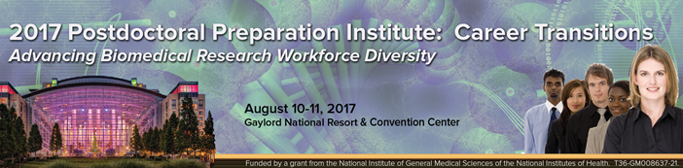

Advancing Biomedical Research Workforce Diversity

On August 10-11, 2017 the FASEB (Federation of American Societies for Experimental Biology) MARC Program will be hosting a Postdoctoral Preparation Institute seminar (PPI) at the Gaylord National Resort & Convention Center in Maryland.

Who should attend: This meeting is primarily for postdoctoral fellows, new assistant professors, and advanced PhD students (near conferral of PhD degree)

Seminar dates: August 10-11, 2017
Location: Gaylord National Resort & Convention Center, 201 Waterfront Street, National Harbor, MD 20745

* Travel Awards are available. Registration/Travel Award Application receipt deadline: Sunday, July 9, 2017. For more information & to register visit: http://twdprograms.org/2017PPI/About.aspx.

Professional Development Workshops

Faculty in a Research Institution: Expectations, Opportunities & Challenges

March 28, 2017, 8:30 AM – 12:00 PM
Honors, Scholars & Fellows House, 4th Floor, Great Hall

Presenters: FSU administrators and faculty

This workshop will help graduate students and postdoctoral scholars prepare for faculty responsibilities in a research work environment. Senior administrators will provide their perspectives on faculty life and/or current responsibilities at FSU. This workshop can be used for the “Career Development” requirement for the Preparing Future Faculty (PFF). Refreshments will be provided by the Congress of Graduate Students.

To register: https://fsu.qualtrics.com/SE/?SID=SV_6lOZ1IxTwzvQpHT

Engaging Students with Social Media, Apps & More! (PIE/PFF/PFP)

April 3, 2017, 3:30 PM – 5:00 PM
Honors, Scholars & Fellows House, 4th Floor, Great Hall

Presenter: Kendra Scholz, School of Communication

Learn about and practice using social media, apps, and more to help you engage your students both in and out of the classroom. You need not be a tech expert – all levels of experience are welcome! Come join us, and bring your laptop if you can (we will have some laptops available for you to use)!

Free PIE & Coffee Included!

To register: https://fsu.qualtrics.com/SE/?SID=SV_6rqRsKdNQSP7AGh

PIE Coffee Hour & Teaching Workshop: Creating Student-Centered Learning Environments (PIE/PFF/PFP)

April 19, 2017, 3:30 PM – 5:00 PM
Honors, Scholars & Fellows House, 4th Floor, Great Hall

Presenters: PIE Associates, Vincent Lakey, Physics, and David Jeffcoat, Chemistry
Student-centered learning environments shift the focus of classroom activity from teacher to students. Instead of treating students as passive receptacles, this workshop will teach you how to stimulate, engage and help them become active participants in their own education.
Free PIE & Coffee Included!

To register: https://fsu.qualtrics.com/SE/?SID=SV_9HwmiDnCned4izj

Fellowships
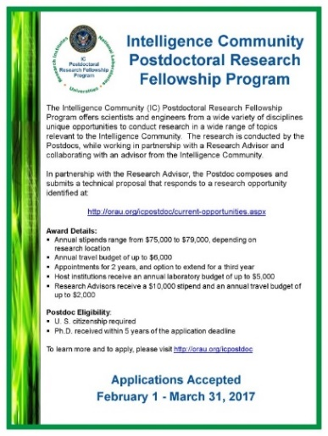

Summer Scholarships in Epidemiology (Cystic Fibrosis Foundation)
https://www.cff.org/Our-Research/For-Researchers/Training-Awards/Summer-Scholarships-in-Epidemiology/
Deadline: April 1, 2017 by 5PM

Postdoctoral Fellowship – Florida Institute for Child Welfare
For more information, Click Here! For a copy of the PDF, Click Here!
Deadline: April 21, 2017

Research Training Groups in the Mathematical Sciences (RTG)
https://www.nsf.gov/funding/pgm_summ.jsp?pims_id=5732&org=DMS
Deadline: June 6, 2017 by 5 PM

Postdoctoral Program in Environmental Chemistry
http://dreyfus.org/awards/postdoctoral_program.shtml
Deadline: August 1, 2017

Fulbright Postdoctoral Scholar Awards
http://www.cies.org/program/postdoc
Deadline: August 1, 2017

Life Sciences Research Foundation
http://www.lsrf.org/apply
Applications open: Wed. September 6, 2017. Deadline: October 1, 2017 8 PM EST

Mathematical Sciences Postdoctoral Research Fellowships (MSPRF)
https://www.nsf.gov/funding/pgm_summ.jsp?pims_id=5301&org=NSF&sel_org=NSF&from=fund
Deadline: October 18, 2017 by 5 PM

NHC Fellowships
http://nationalhumanitiescenter.org/become-a-fellow/
Deadline: By midnight EDT, October 18, 2017

Mathematical Sciences Research Institute Fellowship (MSRI)
https://www.msri.org/web/msri/scientific/member-application/postdoctoral-fellow
Deadline: December 1, 2017

Use the following databases to identify additional opportunities (click on the links) – Pivot, Foundation Center

Jobs
Below is a sampling of open positions around the world.

Assistant Teaching Professor, Tenure Track – Industrial Engineering
https://neu.peopleadmin.com/postings/47210
Northeastern University, Boston, MA

Scientist – Assay Development
https://jobs.lever.co/ginkgobioworks/24f8e749-861d-423f-ac5e-a87c4e5dc113
Ginkgo Bio works, Boston, MA

Assistant Professor – Biology
https://jobs.liu.edu/#/job_details/247
Long Island University, Brookville, NY

Scientist – Research & Development
https://careers-foundationmedicine.icims.com/jobs/1703/scientist/job
Foundation Medicine, Inc., Cambridge, MA

Assistant or Associate Professor – Civil & Environmental Engineering
http://usu.hiretouch.com/job-details?jobID=1939&job=assistant-or-associate-professor
Utah State University, Logan UT

Optical Research Scientist – Research & Development
https://www.edmundoptics.com/company/careers/optical-research-scientist/
Edmund Optics, Barrington, NJ

Subscribe to receive personalized job announcement emails:
http://floridastate.biocareers.com
http://www.academickeys.com/all/subscribe.php
http://jobs.phds.org/alert.new
http://jobs.fiercebiotech.com

ASBMB - American Society for Biochemistry and Molecular Biology
http://www.asbmb.org/careers/

Career Development Webinars and Blogs

Can I Negotiate?
https://chroniclevitae.com/news/1741-the-professor-is-in-can-i-negotiate
Read about how to negotiate a job offer.

The keys to career control
http://www.sciencemag.org/careers/2017/03/keys-career-control
Read advice on who, and how to control your job search.

How to Be Proactive in Your Mentoring Relationships – National Postdoctoral Association http://www.nationalpostdoc.org/?page=Proactive

Negotiating Your Way to a Job in Academia (webinar)

Wed. April 5, 2017, 1:00 PM – 2:00 PM (EST)
Presenter: James Gould
To register: https://attendee.gotowebinar.com/register/478591404121468418

Versatile PhD
This site helps graduate students and new PhD’s identify, prepare for, and excel in possible non-academic careers.
Click here to learn more. Click here to join
Free NPA Membership
FSU is a sustaining member of the National Postdoctoral Association (NPA). This membership provides free affiliate membership to all FSU postdoctoral scholars. Benefits of joining the NPA include:
    - A subscription to the NPA’s official quarterly newsletter
    - Reduced registration fees to the NPA Annual Meeting
    - Eligibility for the NPA Travel Award Program
    - Professional & Leadership Development
    - Networking opportunities with colleagues nationwide
If you are interested in joining the National Postdoctoral Association, click here.
Please email opda-info@fsu.edu if you encounter any problems.
For previous issues, click here!

