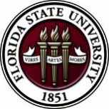
Florida State University
OFFICE OF POSTDOCTORAL AFFAIRS WEEKLY DIGEST

May 15, 2017

Upcoming Events

POSTDOCTORAL SPRING EVENT – 19 may 2017

Download Flyer & Event Agenda Here
Click Here to register for the event
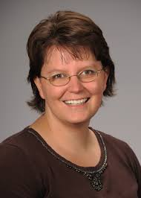
Registration deadline May 17th. Hope you can come this week to this special afternoon workshop for postdoctoral scholars, senior graduate students, and mentors. Our keynote address will be given by Dr. Lori Conlan, Director of Postdoctoral Affairs at the National Institutes of Health (NIH). Dr. Conlan will help map the course to different pathways to be pursued in academia, industry, and federal government and the transferable skills that have been built during your postdoctoral training to transition you to these career tracks.
She will present strategies for the application packet, interviewing, and securing the best position for your ambitions. We are thrilled she will share her experiences from her insight working with the NIH and her knowledge of postdoctoral hiring trends across the country. Additionally, we will have a panel discussion provided by 3 industrial scientists/research specialists and 3 assistant professors with insight into the academic route.
There will be an open mike time for you to interchange with these experts to gain their experiences in breaking out of the postdoc! A potluck dinner for scholars, their lab mates, mentors, and family members will follow the afternoon event, so we hope you will come out to network and engage with the FSU postdoctoral community.
Questions? Please contact, President, Erminia Fardone.

Schedule for Thursday May 18th
Social Get Together 6:30 PM at Edison Restaurant (470 Suwannee Street, Tallahassee); – All PDA members are welcome to host Dr. Conlan!
Schedule for Main Events Friday May 19th
Download Flyer & Event Agenda Here
Biological science/neuroscience postdoctoral mentoring workshop & lunch

Kin Life Science Building, Room 2057

This is a special, faculty-led monthly workshop for Postdoctoral Scholars hosted by the Department of Biological Sciences and the Program in Neuroscience. We have now completed our spring series. The lineup of lectures for summer & fall 2017 season will be posted soon. In the summer months we have traditionally had a “Postdoc Made Good” lecture by inviting back a successful alumnus to speak with our group. If you have suggestions for a “Postdoc Made Good” for this summer, please contact Drs. Erminia Fardone or Kay Jones. No registration is required. Please check the OPDA website for date of next workshop.

“Welcome" Mini-Orientation Sessions for New Postdoctoral Scholars on Campus

Honors, Scholars & Fellows House, Room 3009, October 30, 2017
(Full Orientation set for August 17, 2017)

If you are a new postdoctoral scholar to the FSU campus, this “Welcome” is a nice brown bag lunch activity that will fit into your busy research schedule. The design will be limited to strictly a one-hour session, where you will receive the essentials of getting your research started at FSU and have access to Human Resources and Office of Postdoctoral Affairs Staff. At this time, you will also be introduced to the Postdoctoral Association (PDA) - your peer network of postdocs on campus. Attending a “welcome” in your few months of employment at FSU will serve to fulfill your mandatory orientation. Visuals from the January Welcome can be found in the presentation archive section of the OPDA website. Please continue to check weekly digest for registration link to August 17 orientation. For more information, contact Debi Fadool, at dfadool@bio.fsu.edu.

Faseb Science Research Conferences
Please click here to view and register for Science Research Conferences hosted by FASEB.

Registration deadlines vary based on conference date.

To find out about available Travel Awards Click Here.

2017 Postdoctoral preparation institute: career Transitions

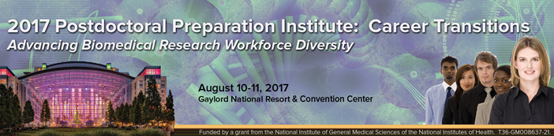

Advancing Biomedical Research Workforce Diversity

On August 10-11, 2017, the FASEB (Federation of American Societies for Experimental Biology) MARC Program will be hosting a Postdoctoral Preparation Institute (PPI) seminar at the Gaylord National Resort & Convention Center in Maryland.

Who should attend: This meeting is primarily for postdoctoral fellows, new assistant professors, and advanced PhD students (near conferral of PhD degree)

Seminar dates: August 10-11, 2017
Location: Gaylord National Resort & Convention Center, 201 Waterfront Street, National Harbor, MD 20745

Registration/Travel Award Application deadline: Sunday, July 9, 2017.
For travel award applications & to register please visit: http://twdprograms.org/2017PPI/About.aspx.

The National diversity in stem conference

SACNAS – Society for Advancement of Chicanos/Hispanics & Native Americans in Science
The conference motivates, inspires and engages participants to achieve their highest goals in pursuing education and careers in STEM fields. Conference programming is specifically tailored to support undergraduate and graduate students, postdoctoral researchers, and career professionals at each transition stage of their career as they move towards positions of science leadership.
The 2017 SACNAS Conference will be held October 19-21, 2017 at the Salt Lake Palace Convention Center in Salt Lake City, Utah. Registration is now open
For more information and to register for the conference, please click here. Registration Deadline: Thursday, October 5, 2017.
Fellowships
Research Training Groups in the Mathematical Sciences (RTG)
https://www.nsf.gov/funding/pgm_summ.jsp?pims_id=5732&org=DMS
Deadline: June 6, 2017 by 5 PM

Postdoctoral Program in Environmental Chemistry
http://dreyfus.org/awards/postdoctoral_program.shtml
Deadline: August 1, 2017

Fulbright Postdoctoral Scholar Awards
http://www.cies.org/program/postdoc
Deadline: August 1, 2017

Life Sciences Research Foundation
http://www.lsrf.org/apply
Applications open: Wed. September 6, 2017. Deadline: October 1, 2017 8 PM (EST)

Mathematical Sciences Postdoctoral Research Fellowships (MSPRF)
https://www.nsf.gov/funding/pgm_summ.jsp?pims_id=5301&org=NSF&sel_org=NSF&from=fund
Deadline: October 18, 2017 by 5 PM

NHC Fellowships
http://nationalhumanitiescenter.org/become-a-fellow/
Deadline: By midnight EDT, October 18, 2017

Mathematical Sciences Research Institute Fellowship (MSRI)
https://www.msri.org/web/msri/scientific/member-application/postdoctoral-fellow
Deadline: December 1, 2017

Use the following databases to identify additional opportunities (click on the links) – Pivot, Foundation Center

Jobs
Below is a sampling of open positions around the world.

Assistant Professor – Family Nurse Practitioner Program
https://jobs.walsh.edu/postings/693
Walsh University, (Byers School of Nursing), North Canton, OH

Research Scientist I – Kidney Disease Initiative
https://recruiting.adp.com/srccar/public/RTI.home?c=1131007&d=External&rb=INDEED&r=5000213732906
Broad Institute, Boston, MA
Assistant/Associate Professor – Department of Pediatrics
https://www.ubjobs.buffalo.edu/postings/9354
University at Buffalo, Buffalo, NY

Institute Research Scientist – Program Biology
https://careers.mdanderson.org/jobs/institute-research-scientist-program-biology-6332?src=JB-10140
MD Anderson Cancer Center, Houston, TX

Assistant Professor – School of Medicine
https://cu.taleo.net/careersection/2/jobdetail.ftl?job=92327&src=JB-10100
University of Colorado, Aurora, CO

Research Scientist – Center for Healthcare Delivery Science
http://careers.nemours.org/jobs/Research_Scientist/Center_for_Healthcare_Delivery_Science/Jacksonville_Florida/104/130538/
Nemours Children’s Health System, Jacksonville, FL

Regular, Limited-Term Assistant Professor – Department of Biology
Georgia Southern University, Statesboro, GA

The Department of Biology at Georgia Southern University expects to have an opening for a regular, limited-term assistant professor in the academic year 2017-18. This is a 9-month, non-tenure track appointment with benefits beginning August 2017. Preferred qualifications are a PhD in the biological sciences and some teaching experience. This position involves teaching 15 contact hours per semester, typically some combination of the following courses: General Biology or Environmental Biology lectures for non-majors, Biology 1 or 2 lectures or laboratories for majors, or Microbiology depending on the individual’s area of expertise. There are occasionally opportunities to participate in upper-level courses for majors. Summer teaching assignments (paid on a per course basis) are typically available if desired. Apply or direct questions to Dr. Risa Cohen, Associate Chair (rcohen@georgiasouthern.edu). Applicants should send a letter of interest describing their teaching experience, a CV, and the names and contact information for three references.
For featured Biology careers please visit: http://jobs.sciencecareers.org/jobs/biology/?utm_source=house-list&utm_medium=email&utm_content=Jobs_Biology&utm_campaign=JF_BiologyApr17-12098&et_rid=17165890&et_cid=1248318

Subscribe to receive personalized job announcement emails:
http://floridastate.biocareers.com
http://www.academickeys.com/all/subscribe.php
http://phds.org/jobs
http://jobs.fiercebiotech.com

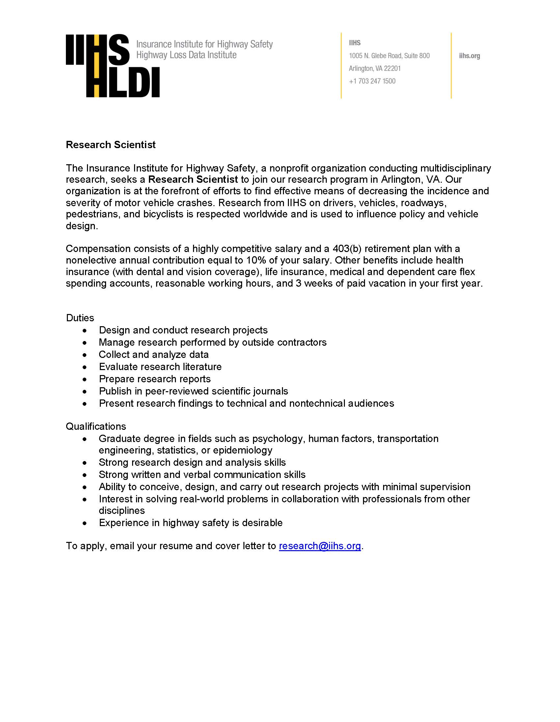
ASBMB - American Society for Biochemistry and Molecular Biology
http://www.asbmb.org/careers/ (career information)

Career Development Webinars and Blogs

Bio Careers Webinar
Topic: Job search: “It’s not who’s hiring, it’s who can hire me, and why would they want to?”
Wednesday June 14, 2017, 7-8 PM EST, Presenter: Coach Tom Chuna
To register visit: http://floridastate.biocareers.com/events

From Bench Science to Academic Administration
https://chroniclevitae.com/news/1794-from-bench-science-to-academic-administration
Read how one research scientist found a rewarding career outside research.

How to get the most out of attending conferences
http://www.sciencemag.org/careers/2017/05/how-get-most-out-attending-conferences
Read tips from other scientists on how they get the most out of conferences.

How to Be Proactive in Your Mentoring Relationships – National Postdoctoral Association http://www.nationalpostdoc.org/?page=Proactive

Versatile PhD
This site helps graduate students and new PhD’s identify, prepare for, and excel in possible non-academic careers.
Click here to learn more. Click here to join
Free NPA Membership
FSU is a sustaining member of the National Postdoctoral Association (NPA). This membership provides free affiliate membership to all FSU postdoctoral scholars. Benefits of joining the NPA include:
    - A subscription to the NPA’s official quarterly newsletter
    - Reduced registration fees to the NPA Annual Meeting
    - Eligibility for the NPA Travel Award Program
    - Professional & Leadership Development
    - Networking opportunities with colleagues nationwide
If you are interested in joining the National Postdoctoral Association, click here.
Please email opda-info@fsu.edu if you encounter any problems.

For previous issues, click here!

