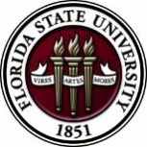
Florida State University
OFFICE OF POSTDOCTORAL AFFAIRS WEEKLY DIGEST

September 5, 2018

Fall Symposium and 5 Minute research competition! – September 21, 2018
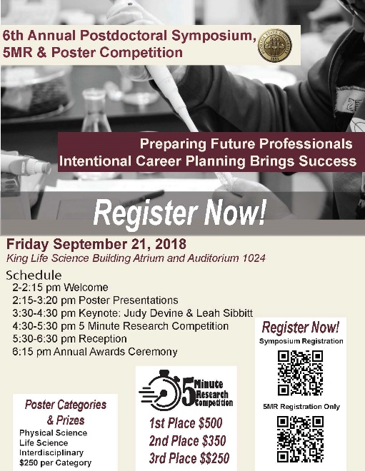
Registration for Fall Symposium (by Sept 18^{TH,} Abstract Submission by the 12th)
To register for Fall Symposium click here
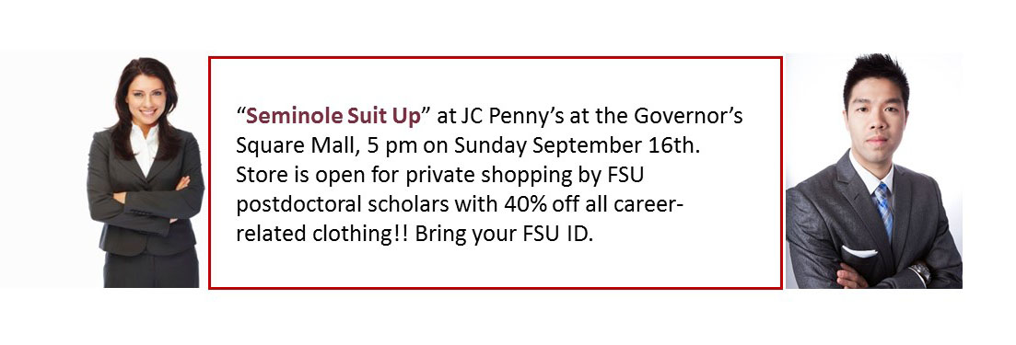
This year’s Fall Symposium will highlight a dual keynote address by our own Judy Devine and Leah Sibbitt. Dr. Devine will roll out the new Preparing Future Professional Program (PFP) along with the accompanying Preparing Future Faculty (PFP) that was launched last Spring as a program to guide Postdoctoral Scholars during their job search preparations. Ms. Leah Sibbitt, Director of the Career Center, will provide helpful tips in the job search process to include resources available to postdoctoral scholars and their spouses during the process of the job hunt. Postdoctoral Scholars can take advantage of the “Seminole Suit UP!” at JC Penney’s at 5 pm on September 16th, where they will have open shopping for FSU scholars only with 40% off all career-related clothing! In addition, Postdoctoral Scholars can now take advantage of the FSU Professional Clothes Closet here on campus – for details – see here - https://www.career.fsu.edu/ClothingCloset.
5 Minute Research Competition
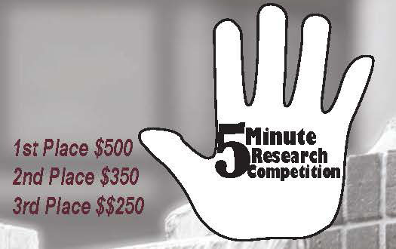
In celebration of the National Postdoctoral Awareness Week that is held in the third week of September, the Florida State University Office of Postdoctoral Affairs (OPDA) and Postdoctoral Association (PDA) are jointly hosting the sixth annual Fall Postdoctoral Poster Competition and Symposium. Poster awards will be $250 for first place in three divisions – Life Sciences, Physical Sciences, and Interdisciplinary/Humanities. New this year is a 5 Minute Research Competition – Hands Down the Best Event!!! The only two regulations are that you (1) have to explain the impact of your research in 5 minutes and (2) have to do so alone (no teams). You are allowed to use ANY medium you want (slides, video, sing, dance, recite literature, props – anything) but must appeal to an Educated Lay Audience, Reach Across your Discipline, and Challenge your Audience to Want to Know More! A practice for all 5 MR competitors will be held Sept 4th, 7th, and 10th in front of a small panel of judges. Feedback will be provided over the subsequent 2 weeks so you are ready to shine on September 21st. Prizes will be awarded, 1st - $500, 2nd - $350, and 3rd - $250 and you must agree to be filmed. Registration is NOW OPEN, please see Debi Fadool for questions, dfadool@bio.fsu.edu
Biological Science/Neuroscience Postdoctoral Mentoring Workshop & Lunch
Kin Life Science Building, room 2057, 12:00 – 1:00 PM
Please mark your calendars for the Fall 2018/Spring 2019 postdoc workshops. This is a special, faculty-led monthly workshop for Postdoctoral Scholars hosted by the Department of Biological Science and the Program in Neuroscience. Although the career focus will be directed to the Life Sciences, all Postdoctoral Scholars and senior Graduate Students are welcome. Sandwiches will be served over the lunch hour during the workshops. Dates, presenters and topics are listed below. For questions, please contact Dr. Kay Jones. No registration required.
Date | Presenter | Title
Mon. Sept. 10 | Dr. Peter Fajer, Cell & Molecular Biology Professor & Director of the Institute of Molecular Biophysics | How to make yourself palatable to academic search committees. A view from the other side of the table.
Mon. Oct. 8 | Dr. Scott Steppan, Professor of Ecology & Evolution in Biological Science | Interviewing for an academic position.
Tues. Nov. 13 | Dr. Qian Yin, Assistant Professor in Cell & Molecular Biology in Biological Science | TBA
Mon. Dec. 10 | Dr. Scott Burgess, Assistant Professor in Ecology & Evolution in Biological Science | Thinking like the job you want
Mon. Jan. 14 | Dr. Yuan Wang, Assistant Professor Biomedical Sciences, College of Medicine & Neuroscience Program | TBA
Mon. Feb. 11 | TBA | TBA
Mon. March 11 |  | Oral Presentation Day
Mon. April 8 | TBA

Cancer control research training program
The University of Rochester Medical Center Cancer Control & Psychoneuroimmunology Laboratory is actively seeking outstanding candidates for their upcoming group of Fellows for 2018. The applicants should be interested in longitudinal studies and clinical trials on translational (e.g. biomarker) symptom science research and/or cancer-related cognitive impairment research to work closely with Dr. Michelle Janelsins (Associate Professor) and her research team. Candidates they are interested in come from a variety of backgrounds including, but not limited to, neuroscience, cognitive science, clinical psychology, epidemiology, clinical trials, applied sciences, and many more.
For more information, and to apply, please click here.
Materials can be sent directly to Dr. Michelle Janelsins or Dr. Gary Morrow (Program Director)
Fellowships
The Company of Biologists – Traveling Fellowships
Next deadline: November 30, 2018
Postdoc Research Funding Opportunities in Germany
Application deadlines vary
Index of Postdoc Fellowships in the Life Sciences (Broad Institute)
EPA Research Grants

Jobs
Below is a sampling of open positions in the United States –

Postdoctoral Positions Available -
Looking for motivated Postdocs to research mechanisms involved in regulated remodeling of muscle T-tubule membranes in fly models of human myopathy with funding for immediate start date!
For more information, please click here to view flyer. Please contact Dr. Amy Kiger, Section of Cell & Development Biology, University of California, San Diego at: akiger@ucsd.edu.

Florida College System, seeks to fill a position for Executive Director, Florida Student Success Center.
The Florida Student Success Center (FSSC) serves as an intermediary between colleges, and provides greater opportunities for colleges to collaborate and learn from one another. The Executive Director works under the supervision of the Chancellor of the Florida College System.
For more information on the role of the position, qualifications and to apply please click here.
Assistant Professor – Physics
University of Illinois at Chicago, Chicago, IL

Engineering Development Program – Simulation Engineer (Job number: 1800096G)
Caterpillar, Mossville, IL

Assistant Professor – Chemical Engineering
University of Nevada, Reno, Reno NV

R&D Chemist/Chemical Engineer with ERC, at the AFRL Rocket Lab – (1012)
ERC, Inc., Edwards AFB, CA

Assistant Professor – Bioengineering
Rice University, Houston, TX

Systems Engineering – Entry Level, Full Time
Cummins Inc., Columbus, IN

Postdoctoral Fellowship in Cognitive Aging
School of Psychology, Georgia Institute of Technology, Atlanta, GA
Assistant Professor Positions – Exercise Physiology (Job ID: 42380) & Nutrition (Job ID:42371)
FSU College of Human Sciences, Department of Nutrition, Food & Exercise Sciences
Assistant Professor of Research – Center for Craniofacial Molecular Biology
University of Southern California (USC), Biomedical Sciences

Assistant Professor – Clinical Occupational Therapy
University of Southern California, Occupational Therapy
Assistant Professor – Research Emergency Medicine
University of Southern California, Department of Emergency Medicine
Clinical Assistant Professor – Pediatrics
University of Southern California, Department of Pediatrics
Below is a sampling of open positions around the world -
Canada: Assistant Clinical Professor – in Pharmacy & Pharmaceutical Science
University of Alberta, Faculty of Pharmacy & Pharmaceutical Sciences

Tenure Track Assistant Professor – Biomedical or Electrical Engineering
University of Guelph, School of Engineering/Biomedical Engineering
Assistant Professor – REHAB Occupational Therapy
University of Alberta, Department of Occupational Therapy
Assistant Professor – Microbial Science & Micro/Nanomaterials
University of Calgary Canada First Research Excellence Fund
Assistant Professor – Department of Medicine
University of Alberta, Faculty of Medicine & Dentistry
Assistant Professor – Division of Developmental Pediatrics
University of Alberta, Faculty of Medicine & Dentistry

Staff Scientist in Hematology Research
Keenan Research Centre for Biomedical Research of St. Michael’s Hospital
Japan: Assistant Professor in the Graduate School of Biomedical & Health Sciences
Hiroshima University, Graduate School of Biomedical & Health Sciences

Assistant Professor in Medical Education, Pharmacology, Neuroscience
Hiroshima University, Graduate School of Biomedical & Health Sciences

Norway: Head Engineer at Electron Microscopy Core Facility
University of Oslo, Department of Biosciences (IBV)
Singapore: Assistant Professor for Bio-Behaviorist
Duke NUS Medical School, Academic Medicine Research Institute

Assistant Professor – Center for Aging Research & Education
Duke NUS Medical School, Center for Aging Research & Education
South Africa: Associate Researcher in Clinical Micro Infectious Diseases (CMID)
Wits University, School of Pathology, Johannesburg, ZA
Switzerland: PhD in Biomedical Engineering
University of Basel, Adaptable MRI Technology
Click here for featured Biology careers
Subscribe to receive personalized job announcement emails:
Bio Careers
Academic Keys
PhD Jobs
Fierce Biotech Jobs
ASBMB - American Society for Biochemistry and Molecular Biology
http://www.asbmb.org/careers/ (career information)
Career Development Webinars and Blogs
Can You Train Your Ph.D.’s for Diverse careers When You Don’t have One?
In this article, the author makes mention of a new seminar at Michigan that helps doctoral students explore non-faculty job, and helped a professor learn how to teach about them..
A unique calling: careers in career development for STEM doctorates
Read an article about a handful of PhD’s who found satisfying careers helping other PhD’s with their career choices.

Career Path: “What industry can offer: Tips for putting your foot inside the door” – Webinar
Wednesday, September 5, 2018 1:00 pm – 2:00 pm EDT Bio Careers

Getting it right: The importance of rigorous validation for high-sensitivity immunoassays – Webinar, September 12, 2018, 12:00 pm ET

Deciphering aging: Linking senescence with DNA damage and the cell cycle – Webinar
September 19, 2018, 12:00 pm ET

How to Be Proactive in Your Mentoring Relationships – National Postdoctoral Association http://www.nationalpostdoc.org/?page=Proactive
ASBMB - Postdoctoral Education & Resources
Versatile PhD
This site helps graduate students and new PhD’s identify, prepare for, and excel in possible non-academic careers.
Click here to learn more. Click here to join
Free NPA Membership
FSU is a sustaining member of the National Postdoctoral Association (NPA). This membership provides free affiliate membership to all FSU postdoctoral scholars. Benefits of joining the NPA include:
    - A subscription to the NPA’s official quarterly newsletter
    - Reduced registration fees to the NPA Annual Meeting
    - Eligibility for the NPA Travel Award Program
    - Professional & Leadership Development
    - Networking opportunities with colleagues nationwide
If you are interested in joining the National Postdoctoral Association, click here.
Please email opda-info@fsu.edu if you encounter any problems.
For previous issues, click here!

