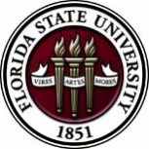

**Florida State University**

**OFFICE** **OF** **POSTDOCTORAL** **AFFAIRS** **WEEKLY** **DIGEST**

**April 17, 2017**

**Travel Advisory**

Effective immediately! Please [click here](http://opda.fsu.edu/resources/travel-advisory) to read about the latest travel advisory implemented by the U.S. Department of Homeland Security regarding travel from 10 last point departure airports traveling to the United States.

**Upcoming Events**

**“Welcome" Mini-Orientation Sessions for New Postdoctoral Scholars on Campus**

**Honors, Scholars & Fellows House, Room 3009, April 24, 2017 12:00 PM**

If you are a new postdoctoral scholar to the FSU campus, this “Welcome” is a nice brown bag lunch activity that will fit into your busy research schedule. The design will be limited to strictly a one-hour session, where you will receive the essentials of getting your research started at FSU and have access to Human Resources and Office of Postdoctoral Affairs Staff. At this time, you will also be introduced to the Postdoctoral Association (PDA) - your peer network of postdocs on campus.  Attending a “welcome” in your few months of employment at FSU will serve to fulfill your mandatory orientation. Visuals from the January Welcome can be found in the [presentation archive section](http://opda.fsu.edu/upcoming-events-workshops/workshop-slides-and-video-archive) of the OPDA website. For more information, contact Debi Fadool, at [dfadool@bio.fsu.edu](mailto:dfadool@bio.fsu.edu). Registration for April 24th is Now Open – [please click here](https://fsu.qualtrics.com/jfe/form/SV_eXowQWqaDSi2InP).

**Biological science/neuroscience postdoctoral mentoring workshop & lunch**

**Kin Life Science Building, Room 2057**

This is a special, faculty-led monthly workshop for Postdoctoral Scholars hosted by the Department of Biological Sciences and the Program in Neuroscience. We have now completed our spring series. The lineup of lectures for summer & fall 2017 season will be posted soon. In the summer months we have traditionally had a “Postdoc Made Good” lecture by inviting back a successful alumnus to speak with our group. If you have suggestions for a “Postdoc Made Good” for this summer, please contact Drs. [Erminia Fardone](mailto:efardone@bio.fsu.edu) or [Kay Jones](mailto:kmjones@bio.fsu.edu). No registration is required. Please check the OPDA website for date of next workshop.

**Tallahassee March for Science**

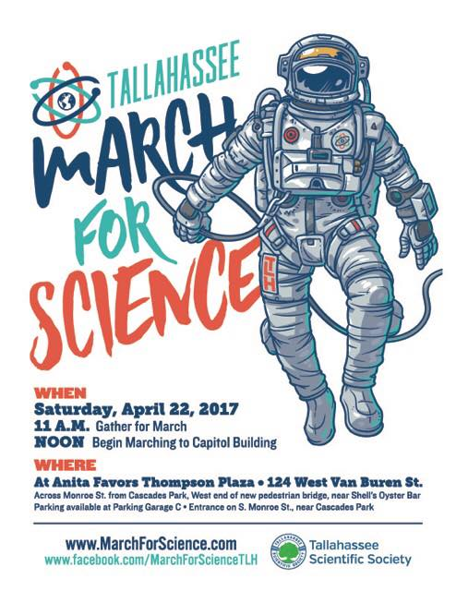

To find out more information, please visit: [March for Science](https://www.facebook.com/MarchForScienceTLH) on Facebook!

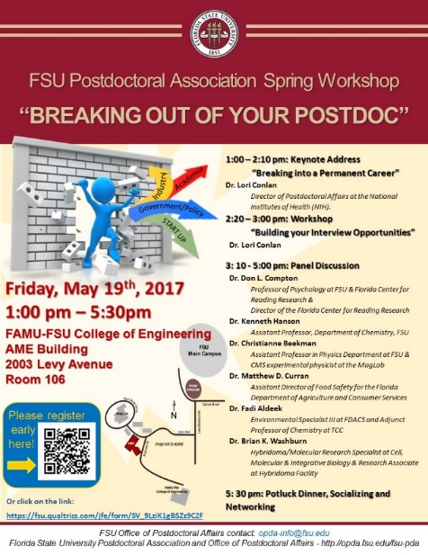

**POSTDOCTORAL SPRING EVENT – Hold the Date – 19 may 2017**

Please save the date for this special afternoon workshop for postdoctoral scholars, senior graduate students, and mentors. Our keynote address will be given by Dr. Lori Conlan, Director of 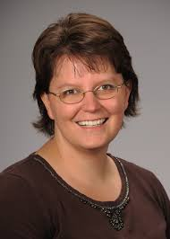Postdoctoral Affairs at the National Institutes of Health (NIH). Dr. Conlan will help map the course to different pathways to be pursued in academia, industry, and federal government and the transferable skills that have been built during your postdoctoral training to transition you to these career tracks.

She will present strategies for the application packet, interviewing, and securing the best position for your ambitions. We are thrilled she will share her experiences from her insight working with the NIH and her knowledge of postdoctoral hiring trends across the country. Additionally, we will have a panel discussion provided by 3 industrial scientists/research specialists and 3 assistant professors with insight into the academic route.

There will be an open mike time for you to interchange with these experts to gain their experiences in breaking out of the postdoc! A potluck dinner for scholars, their lab mates, mentors, and family members will follow the afternoon event, so we hope you will come out to network and engage with the FSU postdoctoral community.

Postdoctoral scholars interested in helping to organize this event please contact PDA President, [Nikhil Gupta](mailto:ng10@fsu.edu) or Vice-president, [Erminia Fardone](mailto:efardone@neuro.fsu.edu).

**Tentative Schedule – Thursday May 18th Time: TBA**

Social Get Together at Aloft Hotel (200 N. Monroe St. Tallahassee); Sponsored by VWR – all PDA members welcome to host Dr. Conlan!

**Schedule for Main Events – Friday May 19th**

Download Flyer & Event Agenda Here

[Click Here](https://fsu.qualtrics.com/jfe/form/SV_9LziK1gBSZz9C2F) to register for the event

**NIH Regional Seminars on program funding & grants administration**

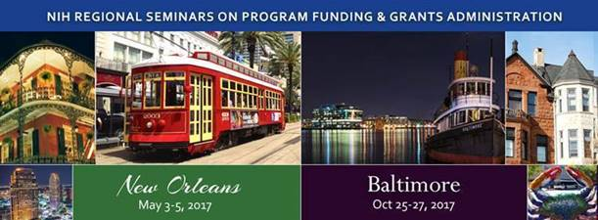

Two seminar dates available where you can meet face-to-face with experts from NIH & HHS in 2017.

“*The NIH Regional Seminar on Program Funding & Grants Administration provides an unparalleled opportunity for you to gain a better perspective of NIH policies & programs, network with peers, gather helpful NIH contacts, and return to your office or lab with useful information, resources, and tools to assist in obtaining and managing NIH awards.”*

Registration is now open for the following 2017 NIH Regional Seminar locations:

* May 3-5: [New Orleans, LA](https://regionalseminars.od.nih.gov/neworleans2017/). Workshop is filling up fast, so don’t delay in registering if this is the seminar for you.
* October 25-27: [Baltimore, MD](https://regionalseminars.od.nih.gov/baltimore2017/) (Just opened – be one of the first to register)

Who should/is attending? The seminar and optional workshops are appropriate for those who are new to working with the NIH grants process. Administrators, new & early stage investigators, researchers, grant writers, graduate students. There will be a questions & discussion session with others who have a similar role as yours. [Click Here](https://regionalseminars.od.nih.gov/baltimore2017/welcome/) for more information!

**Faseb Science Research Conferences**

Please click on the link below to view and register for Science Research Conferences hosted by FASEB. To find out about available Travel Awards [Click Here](http://www.faseb.org/Science-Research-Conferences/Attendee-Information/Awards-and-Travel-Grants.aspx).

<http://www.faseb.org/Science-Research-Conferences/Attendee-Information/Register-Today.aspx>.

**ASbmb Grant writing workshop**

[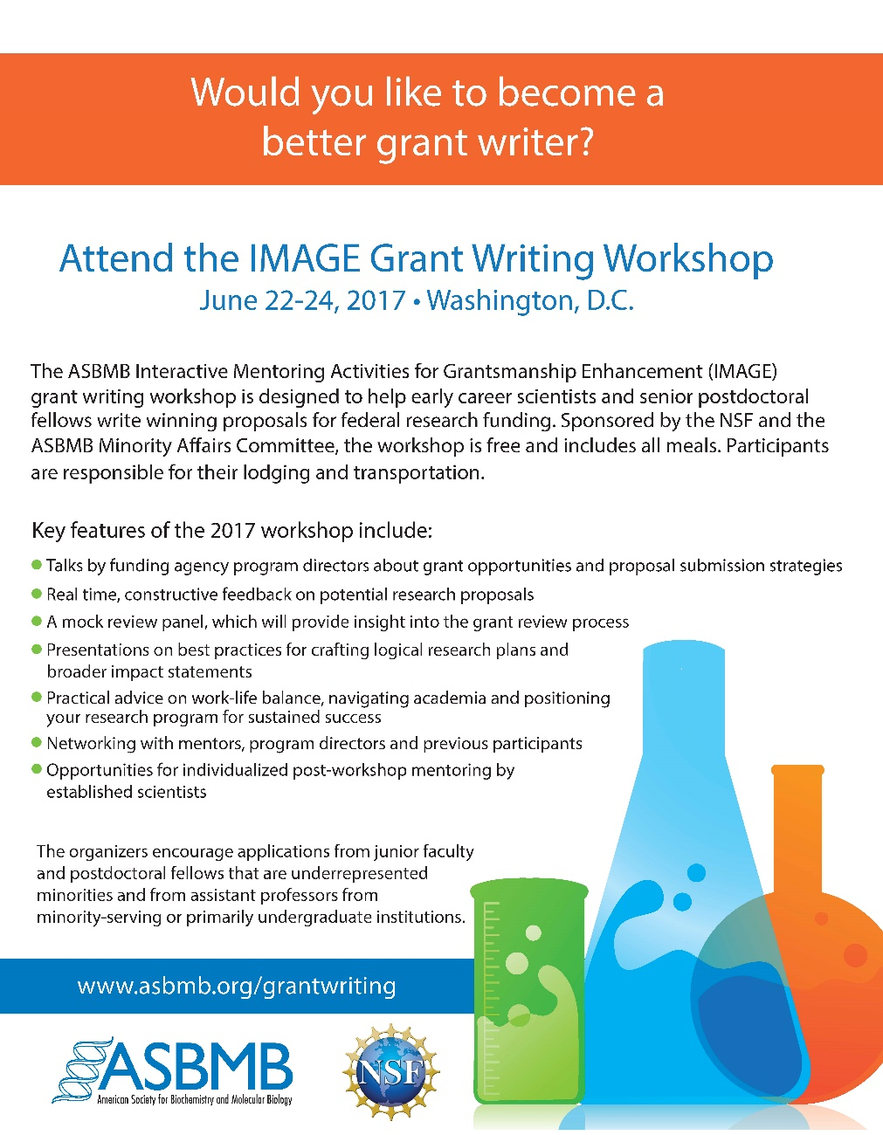](http://www.asbmb.org/grantwriting/)

Nomination Deadline: Friday May 5, 2017 at 5 PM (EDT)

For more information and application instructions, please visit: <http://www.asbmb.org/grantwriting/>

**2017 Postdoctoral preparation institute: career Transitions**

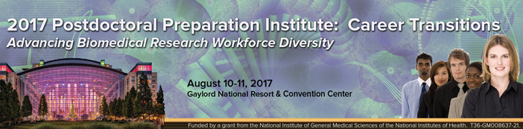

***Advancing Biomedical Research Workforce Diversity***

On August 10-11, 2017 the FASEB (Federation of American Societies for Experimental Biology) MARC Program will be hosting a Postdoctoral Preparation Institute (PPI) seminar at the Gaylord National Resort & Convention Center in Maryland.

**Who should attend**: This meeting is primarily for postdoctoral fellows, new assistant professors, and advanced PhD students (near conferral of PhD degree)

**Seminar dates:** August 10-11, 2017

**Location:** Gaylord National Resort & Convention Center, 201 Waterfront Street, National Harbor, MD 20745

* Travel Awards are available. Registration/Travel Award Application deadline:

Sunday, July 9, 2017. For more information & to register please visit: <http://twdprograms.org/2017PPI/About.aspx>.

**The National diversity in stem conference**

SACNAS – Society for Advancement of Chicanos/Hispanics & Native Americans in Science

The conference motivates, inspires and engages participants to achieve their highest goals in pursuing education and careers in STEM fields. Conference programming is specifically tailored to support undergraduate and graduate students, postdoctoral researchers, and career professionals at each transition stage of their career as they move towards positions of science leadership.

The 2017 SACNAS Conference will be held October 19-21, 2017 at the Salt Lake Palace Convention Center in Salt Lake City, Utah.

For more information and to register for the conference, please visit: <http://www.2017sacnas.org/events/2017-sacnas-the-national-diversity-in-stem-conference/event-summary-344a437cdada442d9179834c162b0a21.aspx>.

**Professional Development Workshops**

**PIE Coffee Hour & Teaching Workshop: Creating Student-Centered Learning Environments (PIE/PFF/PFP)**

**April 19, 2017, 3:30 PM – 5:00 PM**

**Honors, Scholars & Fellows House, 4th Floor, Great Hall**

**Presenters: PIE Associates, Vincent Lakey, Physics, and David Jeffcoat, Chemistry**

Student-centered learning environments shift the focus of classroom activity from teacher to students. Instead of treating students as passive receptacles, this workshop will teach you how to stimulate, engage and help them become active participants in their own education.

Free PIE & Coffee Included!

To register:  <https://fsu.qualtrics.com/SE/?SID=SV_9HwmiDnCned4izj>

**Fellowships**

**Postdoctoral Fellowship – Florida Institute for Child Welfare**

For more information, [Click Here](http://opda.fsu.edu/awards-and-fellowships/nih-fsu-postdoctoral-fellowships/individual-investigator-postdoctoral)! For a copy of the PDF, Click Here!

Application Due Date: April 21, 2017

**Research Training Groups in the Mathematical Sciences (RTG)**

<https://www.nsf.gov/funding/pgm_summ.jsp?pims_id=5732&org=DMS>

Deadline: June 6, 2017 by 5 PM

**Postdoctoral Program in Environmental Chemistry**

<http://dreyfus.org/awards/postdoctoral_program.shtml>

Deadline: August 1, 2017

**Fulbright Postdoctoral Scholar Awards**

<http://www.cies.org/program/postdoc>

Deadline: August 1, 2017

**Life Sciences Research Foundation**

<http://www.lsrf.org/apply>

Applications open: Wed. September 6, 2017. Deadline: October 1, 2017 8 PM (EST)

**Mathematical Sciences Postdoctoral Research Fellowships (MSPRF)**

<https://www.nsf.gov/funding/pgm_summ.jsp?pims_id=5301&org=NSF&sel_org=NSF&from=fund>

Deadline: October 18, 2017 by 5 PM

**NHC Fellowships**

<http://nationalhumanitiescenter.org/become-a-fellow/>

Deadline: By midnight EDT, October 18, 2017

**Mathematical Sciences Research Institute Fellowship (MSRI)**

<https://www.msri.org/web/msri/scientific/member-application/postdoctoral-fellow>

Deadline: December 1, 2017

Use the following databases to identify additional opportunities (click on the links) – [Pivot](http://pivot.cos.com/), [Foundation Center](https://fconline.foundationcenter.org/?li_message=)

**Jobs**

*Below is a sampling of open positions around the world.*

**Assistant Professor – College of Medicine**

<https://psu.jobs/job/70564>

Penn State university, Hershey, PA

**Research Scientist & Engineer – Research Development Group**

<https://jobs.lever.co/duolingo/77929180-0420-426b-97e1-8a4a46d48fc8>

DuoLingo, Pittsburgh, PA

**Assistant Professor – Infectious Diseases**

<http://jobs.cincinnatichildrens.org/us/en-us/Job-Details/Assistant-Professor-%E2%80%93-Infectious-Diseases-Job/Burnet-Building-Location-S/XjdP-jf871-ct104645-jid72649482>

Cincinnati Children’s Hospital, Cincinnati, OH

**Manufacturing Sciences Engineer – Commercial Operations & Manufacturing**

<https://www.coherus.com/join-our-team/openings/?gh_jid=663121&gh_src=intxh11>

Coherus Bio Sciences, Boulder, CO

**Assistant Research Professor – Department of Population Sciences**

<https://chm.tbe.taleo.net/chm04/ats/careers/requisition.jsp?org=CITYOFHOPE&cws=1&rid=9575>

City of Hope, Duarte, CA

**Research Scientist**

<https://jobs.lever.co/tri/2700ed5a-e8e7-4a02-9e25-944bc422769a>

Toyota Research Institute, Ann Arbor, MI

For featured Biology careers please visit: <http://jobs.sciencecareers.org/jobs/biology/?utm_source=house-list&utm_medium=email&utm_content=Jobs_Biology&utm_campaign=JF_BiologyApr17-12098&et_rid=17165890&et_cid=1248318>

**Subscribe to receive personalized job announcement emails:**<http://floridastate.biocareers.com>

<http://www.academickeys.com/all/subscribe.php>

<http://jobs.phds.org/alert.new>

<http://jobs.fiercebiotech.com>

**ASBMB** - American Society for Biochemistry and Molecular Biology

<http://www.asbmb.org/careers/>

**Career Development Webinars and Blogs**

**The Art of ‘No’**

<https://chroniclevitae.com/news/1757-the-art-of-no>

Read how to say no to some requests, so you can say yes to others.

**Talk yourself right into a job**

<http://www.sciencemag.org/careers/2017/04/talk-yourself-right-job>

Read how to separate yourself from being an applicant to being a candidate.

**How to Be Proactive in Your Mentoring Relationships – National Postdoctoral Association** <http://www.nationalpostdoc.org/?page=Proactive>

**Versatile PhD**  
This site helps graduate students and new PhD’s identify, prepare for, and excel in possible non-academic careers.  
[Click here](http://gradschool.fsu.edu/professional-development/versatile-phd) to learn more. [Click here](https://campus.fsu.edu/webapps/login/bb_bb60/logincas.jsp?service=https://netprod.oti.fsu.edu/VersatilePhD/Default.aspx) to join

**Free NPA Membership**  
FSU is a sustaining member of the National Postdoctoral Association (NPA). This membership provides free affiliate membership to all FSU postdoctoral scholars. Benefits of joining the NPA include:

* + - A subscription to the NPA’s official quarterly newsletter
    - Reduced registration fees to the NPA Annual Meeting
    - Eligibility for the NPA Travel Award Program
    - Professional & Leadership Development
    - Networking opportunities with colleagues nationwide

If you are interested in joining the National Postdoctoral Association, [click here](http://www.nationalpostdoc.org/).

Please email [opda-info@fsu.edu](mailto:opda-info@fsu.edu) if you encounter any problems.

For previous issues, [click here](http://opda.fsu.edu/weekly-digest-archive)!

[](https://www.linkedin.com/start/join?trk=login_reg_redirect&session_redirect=https://www.linkedin.com/groups/4860161)[](https://twitter.com/FSUPostdocs)

[](https://www.facebook.com/FSUPostdocs)