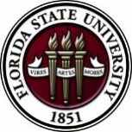
Florida State University
OFFICE OF POSTDOCTORAL AFFAIRS
WEEKLY DIGEST

April 24, 2019

Spring Semester 3-parts Grants Workshop – PART II
April 26, 2019 12 to 3 pm. Sign up for a time block to have your prepared Specific Aims page critiqued by a panel of experts in your field. This is the heart of every successful grant proposal.
Click here for a helpful document to writing your specific aims
July 26, 2019 12 to 3 pm. Sign up for a time block to have your full grant proposal critiqued by a mock study section of experts in your field. Then take your reviews, modify your full proposal and submit to your targeted agency to receive your intramural award from FSU. You do not have to be awarded your proposed grant to receive the intramural support, but you must complete all three workshop dates and be responsive to the available experts!
Spring 2019 - “welcome” mini-orientation
April 29, 2019, Honors, Scholars & Fellows House, Room 3009, 12 PM
If you are a new postdoctoral scholar to the FSU campus, this “Welcome” is a nice brown bag lunch activity that will fit into your busy schedule. The design will be limited to strictly a 1-hour session, where you will receive the essentials of getting your research started at FSU and have access to Human Resources and Office of Postdoctoral Affairs Staff. At this time, you will also be introduced to the Postdoctoral Association (PDA) – your peer network of postdocs on campus. Attending a ‘welcome’ in your first few months of employment at FSU will serve to fulfill your mandatory orientation. For more information, please contact Debi Fadool at dfadool@bio.fsu.edu.
Here is the agenda for the April Welcome:
12:00 pm: Welcome: Debra Ann Fadool, Director of the Office of Postdoctoral Affairs (OPDA)
12:05 – 12:15 pm: Luciana Hornung, Assistant Director for the Center for Global Engagement (VISA, International Scholars)
12:15 – 12:25 pm: Lisa Liseno, Assistant Dean, Director of Instructional Excellence (Teaching Postdoctoral Scholars)
12:25 -12:40 pm: Debra Fadool, Opportunities, Resources, Annual Events, and Policies
12:40 – 12:50 pm: Kathy Worthman, Human Resources (health Insurance, OPS and Campus Benefits)
12:50 – 1:00 pm: Tim Colston, Vice-President of the Postdoctoral Association (PDA Activities)
Click this link to register for the welcome

postdoctoral association spring 2019 event
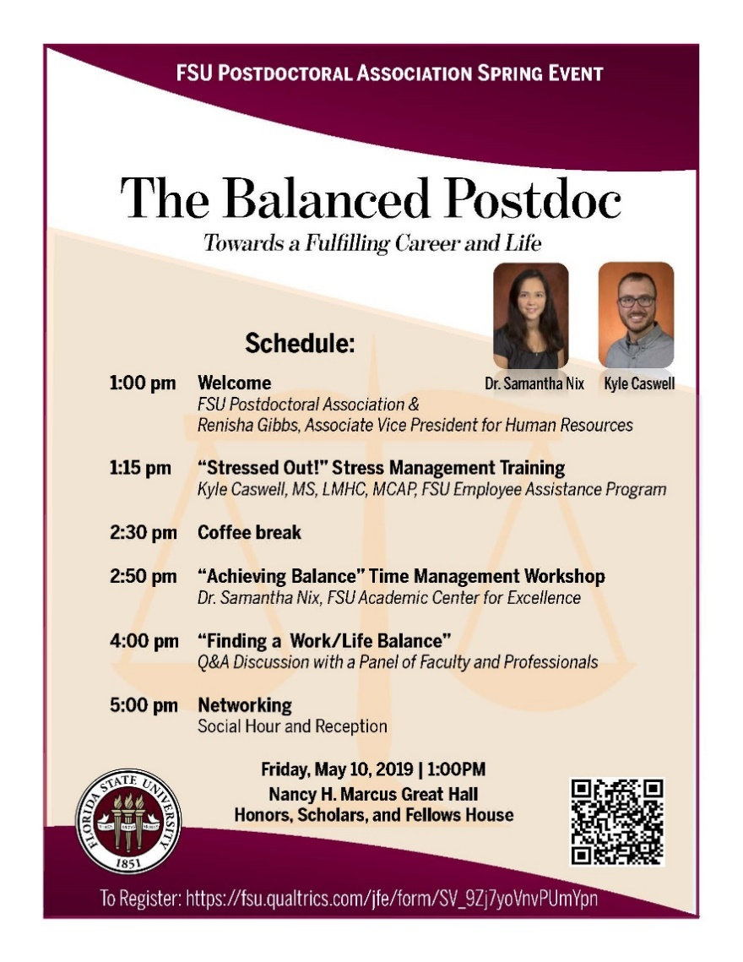
On Friday, May 10, 2019, the FSU Postdoctoral Association will host their annual spring event, beginning at 1:00 pm in the Nancy H. Marcus Great Hall, in the Honors, Scholars, and Fellows House.
The title of this year’s event is “The Balanced Postdoc” Towards a Fulfilling Career and Life.
Click on the image to view and print out flyer.
To register please scan QR code.

accomplishments – Achievements – research
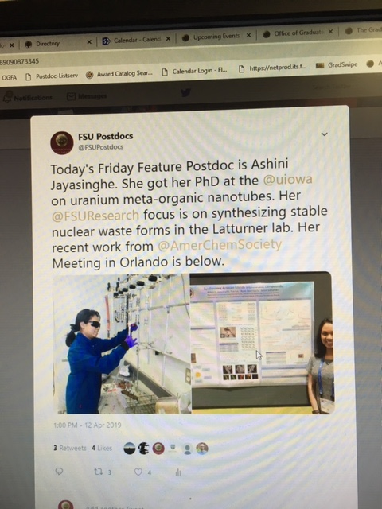
Postdocs, would you like help to disseminate your research, service, and mentoring achievements to a broader audience via the @FSU Postdocs Twitter account? If you have exciting new findings, just been published, received a grant or award, got hired for a new position, or have other accomplishments you would like to share for yourself or your mentees, please share them with us.
Just send the content to be tweeted to Biological Science postdoc Matt Holding at mlholding@fsu.edu and it will be shared on @FSU Postdocs. Use the following guidelines to prepare your content:
Send links to papers or websites, photos of the activity, or other material that isn’t just text. Tweets get more traction if they contain content other than text alone.
Provide less than 280 characters of text for the tweet describing the activity. Include Twitter handles for your colleagues/collaborators where appropriate, if you know them, and any #hashtags to which the tweet can link. We can also retweet content you put out on our own Twitter account if you drop us a line with your Twitter handle and the specific tweet we should retweet.
coming soon: “postdoc world”
The Graduate School has embarked on an exciting new initiative to develop a brand new interactive video archive for all graduate students, postdocs, faculty and alumni called Grad World FSU. This was an idea inspired by Dr. Harry Kroto, and his GEOSET project at FSU. Our pilot study has concluded and the website is now in the final stages of development. We already have 100 videos on the Grad World FSU site, but what is needed now is postdoc participation to get this initiative off the ground.
A website similar to this one titled Postdoc World is in the works for postdoc scholars. We will let all know when that site is up and running. In the meantime, we encourage postdocs to go to the Grad World website to create your video.
What is Grad World FSU?
Grad World FSU is a revolutionary website that looks and feels very similar to Google Earth, displaying a variety of personalized videos from graduate students, postdocs, alumni and faculty for the purpose of showcasing their outstanding achievements and contributions to Florida State University. This is an extraordinary opportunity for everyone around the world to see your passion, interests, and research goals and learn more about our wonderful university. As you know graduate school, and postdoc opportunities change lives and the world for the better! Once others see you talking with such enthusiasm and excitement about all of the amazing things you are doing, they too will want to join in on the fun and become part of this great scholarly community known as “Family FSU”, or if they are employees, maybe even offer you a job.
How to Contribute?
Interested postdocs can choose to complete one of two video options: Option 1.) a self-filmed Questionnaire Video where you would answer a few questions using a cell phone, digital camera or the Screencast-O-Matic webcam software, or Option 2.) a GEOSET PowerPoint Video in which you would reserve a time to meet with the GEOSET Studio team in the Dirac Library to create a guided video/PowerPoint presentation to present a compelling oration of your research interests, or work at FSU. And remember, if English is not your native language, we encourage you to complete a second video in your native tongue so everyone in the world can enjoy it.
There are helpful tutorials available on how to create your questionnaire video available on this website.
If you are interested in booking your recording session in the GEOSET studio, please click on this link: https://fsu.qualtrics.com/jfe/form/SV_38Kipwda3eQrgxf
new postdoc science initiative
The Journal of Postdoctoral Research www.postdocjournal.com has been publishing postdoc research for several years now and is currently working on a spin-off journal entitled ‘Postdoc Life Science’. This new journal will be focusing only on life sciences research with the goal to be indexed in MEDLINE/PubMed.
Please note of the following rich possibilities and benefits of the new Postdoc Life Science Journal and how it can make a difference in your research career:
1. Call for papers: We are inviting research papers, reviews, methodologies, commentaries, perspectives, progress articles, clinical case summaries and research highlights to be published in the upcoming issues of Postdoc Life Science.
2. We are inviting nominations for our Postdoc of the Month award. Please send-in nominations [self, or PI recommended] to Editor-in-Chief@PostdocJournal.Com. Only Postdocs in life sciences are eligible to apply.
3. Editorial and other activities are available for postdocs; please touch base with us with a brief description on your interests. In addition, we are proposing an associate editor position for a post-doc association (PDA) board member who could bridge between the journal and PDA to update the editorial board on current postdoctoral publications and activities.
This new initiative will showcase and highlight former, current and future postdoc’s contribution to life sciences research, conduct exclusive international conferences, recognize accomplished postdocs with monetary awards and institute postdoctoral research grants, just to name a few.
Cancer control research training program
The University of Rochester Medical Center Cancer Control & Psychoneuroimmunology Laboratory is actively seeking outstanding candidates for their upcoming group of Fellows for 2018. The applicants should be interested in longitudinal studies and clinical trials on translational (e.g. biomarker) symptom science research and/or cancer-related cognitive impairment research to work closely with Dr. Michelle Janelsins (Associate Professor) and her research team. Candidates they are interested in come from a variety of backgrounds including, but not limited to, neuroscience, cognitive science, clinical psychology, epidemiology, clinical trials, applied sciences, and many more.
For more information, and to apply, please click here.
Materials can be sent directly to Dr. Michelle Janelsins or Dr. Gary Morrow (Program Director)
Fellowships
American Diabetes Association – 2019 Core Research Program
Application deadline: July 15, 2019

Agriculture & Food Research Initiative – Education & Workforce Development
Application Deadline: Thursday, August 22, 2019 (Clink link above for application)

2019-2020 Banting Postdoctoral Fellowships
Application Deadline: September 18, 2019
Postdoc Research Funding Opportunities in Germany
Application deadlines vary
Index of Postdoc Fellowships in the Life Sciences (Broad Institute)
EPA Research Grants
EMBO Life Sciences – Short/Long Term Fellowships

Jobs
Below is a sampling of open positions in the United States –
Postdoctoral Positions Available -
Looking for motivated Postdocs to research mechanisms involved in regulated remodeling of muscle T-tubule membranes in fly models of human myopathy with funding for immediate start date!
For more information, please click here to view flyer. Please contact Dr. Amy Kiger, Section of Cell & Development Biology, University of California, San Diego at akiger@ucsd.edu.

Postdoctoral and research scientist positions
The Kaczorowski Lab at The Jackson Laboratory is seeking Postdoctoral and Research Scientist Level personnel to investigate mechanisms underlying susceptibility and resilience to normal aging and Alzheimer’s disease (https://www.neuro-central.com/2018/09/19/risk-resilience-understanding-role-genetics-alzheimers-disease/). Dr. Kaczorowski is an Associate Professor and the Evnin Family Endowed Chair in Alzheimer’s Research at the Jackson Laboratory – a research institution specializing in genetics and genomics in order to discover solutions for disease. Projects leverage new translational mouse models, electrophysiology, circuit mapping and genome engineering to decipher how genetic and environmental factors interact to influence learning and memory abilities, cognitive aging, neurodegeneration, and Alzheimer’s. Sources of support include NIH, Bright Focus, and The Glenn Foundation for Medical Research, as well as generous philanthropy awards in support of research and innovation in areas of normal aging and Alzheimer’s disease.
Exceptional candidates will have the opportunity to apply for the prestigious JAX Scholar award, which supports promising early-career postdoctoral associates conducting cutting edge biomedical and basic biological research at JAX. The award includes an independent research and travel budget and a salary above our standard postdoctoral scale https://www.jax.org/education-and-learning/pre-and-postdoctoral-program/jax-scholars.
To apply, please submit (1) a cover letter describing past research accomplishments, research interests, and career goals, (2) a current CV, and (3) the contact information of three references to
catherine.kaczorowski@jax.org

Assistant Professor – Department of Biology (Job number: 10609)
Tenure-Track position in Developmental Molecular Genetics: As part of an expansion in molecular genetics research, West Virginia University invites applications for a tenure-track position at the Assistant Professor level in the Department of Biology (http://biology.wvu.edu) to begin August 2019. We seek an individual who uses molecular and/or functional genomic approaches to explore integrative questions about development in non-mammalian animal model systems. Applicants should have a broad biology background and strong interdisciplinary skills to develop an externally funded independent research program. Applicants should also have an openness to collaborative research and a desire to contribute to the undergraduate and graduate research and teaching missions of the department. Requirements include a PhD or equivalent degree in biology or a related field, a strong record of scholarly publications, strong post-doctoral experience, excellent written and oral communication skills, and the potential to secure external funding.
WVU, located in Morgantown, is a comprehensive land grant university enrolling about 30,000 students in over 100 degree programs. Our Carnegie Classification is “Doctoral Universities: Highest Research Activity.” The Department of Biology at West Virginia University offers a diverse, highly productive and well-funded research environment that is highly supportive of new junior faculty. Existing departmental strengths include molecular genetics, behavioral neurobiology, and genomics.
To apply, please visit https://careers.wvu.edu, navigate to the position title listed above, and upload a single PDF file including a cover letter, curriculum vitae with a list of publications, a succinct outline of future research plans, and a one page teaching statement. In addition, arrange for three letters of reference to be sent electronically to WVUBiology@mail.wvu.edu. Review of completed applications will begin on January 21, 2019 and will continue until the position is filled. For more information about the position, contact Kevin C. Daly at kcdaly@mail.wvu.edu. For more information about WVU and the city of Morgantown, WV: https://biology.wvu.edu/about/jobs/about-morgantown.

Florida College System seeks to fill a position for Executive Director, Florida Student Success Center.
The Florida Student Success Center (FSSC) serves as an intermediary between colleges, and provides greater opportunities for colleges to collaborate and learn from one another. The Executive Director works under the supervision of the Chancellor of the Florida College System.
For more information on the role of the position, qualifications and to apply please, click here.
Florida Conservation Corps - Opportunities
FLCC is recruiting for two exciting project areas.
The mission of the Florida Conservation Corps is to develop natural and cultural resource leaders by connecting them to areas of critical need in conservation, preservation, interpretation and resource based recreation. Click here to download flyer. For more information about FLCC, please visit their webpage at https://www.floridastateparks.org/florida-conservation-corps.
Oak Ridge National Laboratory Opportunities

Faculty Opportunities – Summer Research, Sabbatical Research Experiences
https://orise.orau.gov/ornl/faculty/default.html
Postdoctoral Opportunities - https://jobs.ornl.gov/
Clinical Assistant Professor – Biological Sciences & Psychology (Job ID: 113741)
University of Illinois at Chicago, Chicago, IL
Assistant Professor - Biology
Barry University, Miami Shores, FL

Aero – Thermal Engineer (Requisition ID: 17391BR)
Danfoss, Tallahassee, FL

Visiting Assistant Professor – Department of Sociology
The George Washington University, Washington, DC

R&D Engineer
Formlabs, Raleigh-Durham, North Carolina

Assistant Professor – Forest Engineering/Resources
Oregon State University, Corvallis, OR

Imaging Algorithm Engineer
Lenovo, Chicago, IL

Assistant Professor Positions – Exercise Physiology (Job ID: 42380) & Nutrition (Job ID: 42371)
FSU College of Human Sciences, Department of Nutrition, Food & Exercise Sciences
Assistant Professor of Research – Center for Craniofacial Molecular Biology
University of Southern California (USC), Biomedical Sciences

Assistant Professor – Clinical Occupational Therapy
University of Southern California, Occupational Therapy
Assistant Professor – Research Emergency Medicine
University of Southern California, Department of Emergency Medicine
Clinical Assistant Professor – Pediatrics
University of Southern California, Department of Pediatrics
Below is a sampling of open positions around the world -
Canada: Assistant Clinical Professor – in Pharmacy & Pharmaceutical Science
University of Alberta, Faculty of Pharmacy & Pharmaceutical Sciences

Tenure Track Assistant Professor – Biomedical or Electrical Engineering
University of Guelph, School of Engineering/Biomedical Engineering
Assistant Professor – REHAB Occupational Therapy
University of Alberta, Department of Occupational Therapy
Assistant Professor – Microbial Science & Micro/Nanomaterials
University of Calgary Canada First Research Excellence Fund
Assistant Professor – Department of Medicine
University of Alberta, Faculty of Medicine & Dentistry
Assistant Professor – Division of Developmental Pediatrics
University of Alberta, Faculty of Medicine & Dentistry

Staff Scientist in Hematology Research
Keenan Research Centre for Biomedical Research of St. Michael’s Hospital
Japan: Assistant Professor in the Graduate School of Biomedical & Health Sciences
Hiroshima University, Graduate School of Biomedical & Health Sciences
Assistant Professor in Medical Education, Pharmacology, Neuroscience
Hiroshima University, Graduate School of Biomedical & Health Sciences
Norway: Head Engineer at Electron Microscopy Core Facility
University of Oslo, Department of Biosciences (IBV)
Singapore: Assistant Professor for Bio-Behaviorist
Duke NUS Medical School, Academic Medicine Research Institute

Assistant Professor – Center for Aging Research & Education
Duke NUS Medical School, Center for Aging Research & Education
South Africa: Associate Researcher in Clinical Micro Infectious Diseases (CMID)
Wits University, School of Pathology, Johannesburg, ZA
Switzerland: PhD in Biomedical Engineering
University of Basel, Adaptable MRI Technology
Click here for featured Biology careers
Subscribe to receive personalized job announcement emails:
Bio Careers
Academic Keys
PhD Jobs
Fierce Biotech Jobs
ASBMB - American Society for Biochemistry and Molecular Biology
http://www.asbmb.org/careers/ (career information)
Career Development Webinars and Blogs
How to Become a Better Listener
Even though this article was written from the standpoint of an administrator, to administration leadership, there are tips that most anyone in academia can benefit from.
Think you can’t negotiate your job offer or postdoc position? Think again
In this article, the author interviews a negotiation expert. The expert states that job negation is nothing more than problem solving on both sides.

Webinar | Adventures in single-cell RNA transcriptomics
Thursday, April 25, 2019, 12 noon Eastern
Webinar | The changing landscape of diagnostic biomarkers: Exploring the one-biomarker-per-drug paradigm in oncology, Wednesday, May 1, 2019, 12 noon Eastern
How to Be Proactive in Your Mentoring Relationships – National Postdoctoral Association http://www.nationalpostdoc.org/?page=Proactive
ASBMB - Postdoctoral Education & Resources

Versatile PhD
This site helps graduate students and new PhD’s identify, prepare for, and excel in possible non-academic careers.
Click here to learn more. Click here to join
Free NPA Membership
FSU is a sustaining member of the National Postdoctoral Association (NPA). This membership provides free affiliate membership to all FSU postdoctoral scholars. Benefits of joining the NPA include:
    - A subscription to the NPA’s official quarterly newsletter
    - Reduced registration fees to the NPA Annual Meeting
    - Eligibility for the NPA Travel Award Program
    - Professional & Leadership Development
    - Networking opportunities with colleagues nationwide
If you are interested in joining the National Postdoctoral Association, click here.
Please email opda-info@fsu.edu if you encounter any problems.
For previous issues, click here!

