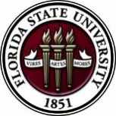
Florida State University
OFFICE OF POSTDOCTORAL AFFAIRS WEEKLY DIGEST

August 14, 2017

Upcoming Events

New Postdoctoral Scholar Orientation

Honors, Scholars & Fellows House, Room 4003, Great Hall
Date: August 16, 2017, 8:30 AM – 3:00 PM
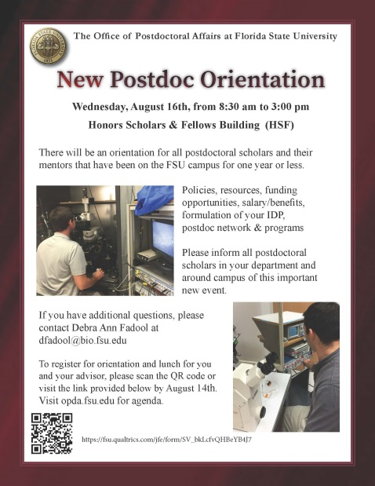
Click here to Register until August 13th

All postdocs that have been on campus for one year or less are required to attend a new postdoctoral orientation. Older postdocs are welcome to attend but it is not mandatory. During orientation you will have the ability to meet fellow postdoctoral scholars on campus as part of the postdoctoral association (PDA), interface with human resources (HR) staff to ask questions about benefits, meet the director of the office of postdoctoral affairs to hear about travel scholarships and other opportunities supported by the university’s main office for postdocs, and develop your independent development plan (IDP) with your advisor. You will also be provided several text book sources on career development and navigating your postdoctoral training, and advisors will be provided a mentoring workbook.

Download Postdoc Orientation Agenda here.

Fall 2017 PIE Teaching Conference/TA Orientation

Registration is now open for the annual fall Program for Instructional Excellence (PIE) TA Orientation/Teaching Conference. This event is held Wednesday & Thursday the week prior to the first week of classes each fall. This conference includes sessions that provide graduate students & postdoctoral scholars with teaching policy training requirements as stated in the University-wide TA Standards along with best practices in grading, communicating with students, encouraging critical thinking in the classroom, and Blackboard and technology usage.

Note: Teaching Postdoctoral Scholars, if you have not attended a PIE TA Orientation before, you are required to attend the full two days of the conference/orientation!

Where: New Classroom Building, HCB 101

When: Wednesday, August 23, 2017, 9:00 AM – 4:00 PM
Thursday, August 24, 2017, 9:00 AM – 3:00 PM

To register to attend the fall 2017 PIE Teaching Conference/TA Orientation, click here: https://fsu.qualtrics.com/jfe/form/SV_3m8pmfGZUHL2klL

Postdoctoral Fall Symposium, Poster Competition, and Awards Ceremony
FSU College of Medicine Atrium & COM 1306, September 22, 2017, 12:00 PM to 6:00 PM

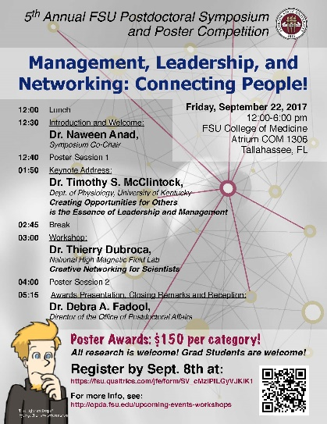
The 5th Annual Postdoctoral Symposium and Poster Competition will start at the FSU College of Medicine Atrium. This event is in celebration of the National Postdoctoral Awareness Week and is a wonderful opportunity for you to meet your fellow postdoctoral colleagues!

Please join us for a wonderful afternoon of research interactions, a keynote address by Dr. Timothy McClintock of the University of Kentucky (“Creating Opportunities for Others is the Essence of Leadership and Management”), and an interactive LinkedIn workshop by our own Thierry Dubroca on the theme “Management, Leadership, and Networking – Connecting People!”. There will be faculty judges for postdoctoral submitted poster presentations in 4 different divisions ($150 award checks to the top presenters) including a People’s Choice Award.

Postdoctoral scholars, senior graduate students, advisors, and laboratory colleagues are all invited to participate! Lunch will be served prior to the first poster session and there will be a reception/bar starting at 4 pm during the second poster session. Annual awards and poster competition awards will be presented at approximately 5:30 pm. Professional Development Travel Award Grantees over the 2016-2017 selections will receive recognition at this ceremony. All categories of attendees (presenters, non-presenters, judges, and speakers) should register to help us prepare food quantities.

Click here to Register for the Event by September 8th, 2017

Click here for How to Write a Strong Scientific Abstract (Submission instructions within the registration survey)

Flyer and Agenda for the Event

Having Trouble or Have Questions about Filling out Your Postdoctoral Annual Evaluation?

KIN Life Science Building, Room 2057, 12:00 – 1:00 PM, August, 14th, 2017

Postdoctoral annual reviews across the university are due on September 1st. If you have not completed a review before, this is a nice noon workshop (lunch provided!) where Dr. Kay Jones will discuss the following (all disciplines are welcome!):
- Tips for self-assessment of strengths and areas for improvement.
- Integration of project-based goals with your long-term career development goals.
- Asking questions about your evaluation to get the most specific feedback from your advisor.
- Implementing the feedback with specific action items.
- Managing upward. Are there a few specific changes you and your advisor can make that will help you implement the feedback and attain your goals?

Alumni Made Good: A Scientific Editor’s Tips for Getting Your Paper Published and Finding a Job in Publishing

KIN Life Science Building, Room 2057, 12:00 – 1:00 PM, September 1st

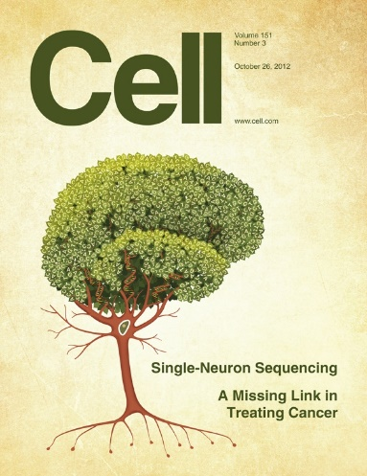
Presenter: FSU Alumna Shawnna Buttery, PhD (Scientific Editor, Cell Reports)

Ever wonder what it would be like to be an editor at a scientific journal or publisher? Please join the Department of Biological Sciences over lunch as they welcome back FSU Alumna, Dr. Shawnna Buttery for an ‘Alumni Made Good’ talk on Friday September 1, 2017 from 12:00 – 1:00 PM at the King Life Sciences Building, Room 2057. Dr. Shawnna Buttery, is the Scientific Editor at Cell Reports. Although the talk will be directed toward the Life Sciences, all Postdoctoral Scholars and senior Graduate Students are welcome.

Dr. Shawnna Buttery (@yeastgrrl) joined the Cell Reports team as a Scientific Editor in August 2016. She previously worked for Elsevier’s BBA journals. Her training in the laboratory was in cell biology, studying the cytoskeleton in worm sperm as a grad student at FSU and in budding yeast as a postdoc at Dana Farbor Cancer Institute.

Biological Science/Neuroscience Postdoctoral Mentoring Workshop & Lunch

KIN Life Science Building, Room 2057, 12:00 – 1:00 PM

Please mark your calendar for the fall 2017 through spring 2018 workshops. This is a special, faculty-led monthly workshop for Postdoctoral Scholars hosted by the Department of Biological Science and the Program in Neuroscience. Although the career focus will be directed to the Life Sciences, all Postdoctoral Scholars and senior Graduate Students are welcome. Sandwiches will be served over the lunch hour during the workshops. Dates are listed below. Please continue to check website for presenters and their topics as workshops are formulated. For questions, please contact Drs. Erminia Fardone or Kay Jones. No registration required.

Date | Presenter | Title
Monday Aug. 14, 2017 | Dr. Kay Jones | Getting the most out of your annual evaluation.
Friday Sept. 1, 2017 | Dr. Shawnna Buttery | A scientific editor’s tips for getting your paper published and finding a job in publishing.
Monday Oct. 9, 2017 | TBA
Monday Nov. 13, 2017 | TBA
Monday Dec. 11, 2017 | TBA
Tuesday Jan. 16, 2018 | TBA
Monday Feb. 12, 2018 | TBA
Monday Mar. 5, 2018 | TBA | Oral Competition – 10 AM
Monday April 9, 2018 | TBA

Special travel opportunities

Faseb Science Research Conferences
Please click here to view and register for Science Research Conferences hosted by FASEB.
Registration deadlines vary based on conference date. Only a few dates left.

18th International conference on alzheimer’s drug discovery
September 11-12, 2017, Jersey City, NJ (across from NYC on the Hudson)
The purpose for this annual Alzheimer’s Drug Discovery Foundation (ADDF) conference is to accelerate the development of innovative treatments for Alzheimer’s disease, related dementias and cognitive aging.
The two-day meeting is organized around four sub-topics: Neuroinflammation; Neuroprotection and Neutral Regeneration; Epigenetics and Cognitive Enhancing; and Misfolded Proteins and Proteostasis.
For more information, please visit: http://www.worldeventsforum.com/addf/addrugdiscovery/.
Click Here to register for conference. Download flyer here.
The National diversity in stem conference

SACNAS – Society for Advancement of Chicanos/Hispanics & Native Americans in Science
The conference motivates, inspires and engages participants to achieve their highest goals in pursuing education and careers in STEM fields. Conference programming is specifically tailored to support undergraduate and graduate students, postdoctoral researchers, and career professionals at each transition stage of their career as they move towards positions of science leadership.
The 2017 SACNAS Conference will be held October 19-21, 2017 at the Salt Lake Palace Convention Center in Salt Lake City, Utah. Registration is now open
For more information and to register for the conference, please click here. Pre-registration Deadline: Thursday, October 5, 2017.

Center for Molecular Medicine Symposium
The University of Georgia is announcing the opening and dedication of its new facility, the Center for Molecular Medicine (CMM) and is hosting a two-day Symposium on October 10-11, 2017. The Symposium will feature world leaders in the field of ‘molecular medicine’. Topics will include stem cells and regenerative medicine, disease modeling and target identification, drug discovery and immunity.
To read about the program agenda, click here. Early Bird Registration cost (for postdocs & students) is $30, deadline is Friday September 15,2017. For hotel accommodations & travel please click here.
Scientific Writing Retreat

Organized by Cold Spring Harbor Laboratory (CSHL) November 15 – 19, 2017
Are you currently working on a scientific writing project such as a manuscript, grant proposal, job application, or research/teaching statement? Do you find that it is difficult to carve out dedicated writing time, or do you often feel as if you need to “get away” to make significant progress? Are you interested in learning how to improve the clarity and effectiveness of your professional writing? If so, consider applying to the CSHL Scientific Writing Retreat!
The goal of this retreat is to have participants progress significantly on writing projects while improving their professional communication skills.
The CSHL Scientific Writing Retreat is designed for postdoctoral fellows and junior faculty in all areas of biology who are actively working on professional pieces of writing such as manuscripts, grant proposals, job applications, or research/teaching/personal statements.
For more information about the retreat, and to apply, please click here.
Fellowships
Postdoctoral Program in Environmental Chemistry
Deadline: August 29, 2017

Life Sciences Research Foundation
Applications open: Wed. September 6, 2017. Deadline: October 1, 2017 8 PM (EST)

Marie Currie Individual Fellowship
This Fellowship would lead to a 2-year post doctorate contract to perform cutting-edge research in a young innovative French company in Paris while being trained in business & entrepreneurship.
Application submission deadline: September 14, 2017, 11:00 AM EDT

Mathematical Sciences Postdoctoral Research Fellowships (MSPRF)
Deadline: October 18, 2017 by 5 PM

NHC Fellowships
Deadline: By midnight EDT, October 18, 2017

Mathematical Sciences Research Institute Fellowship (MSRI)
Deadline: December 1, 2017

Index of Postdoc Fellowships in the Life Sciences (Broad Institute)

Use the following databases to identify additional opportunities (click on the links) – Pivot, Foundation Center

Jobs
Below is a sampling of open positions in the United States -
Assistant Professor, Tenure Track – Electrical & Computer Engineering
New Mexico State University, Las Cruces, NM

Research & Development Engineer (Mechanical Engineer)
Penn State University, University Park, PA

Open Rank Assistant Professor – Department of Biomedical Engineering
Tulane University, New Orleans, LA

Research Scientist – SSIE
Research Foundation of SUNY at (Binghamton University), Vestal, NY

Assistant Professor – College of Medicine
Ohio State University Medical Center, Columbus, OH

Research Scientist – Engineering Support
Intel, Hillsboro, OR

Below is a sampling of open positions around the world –
Australia: EMBL Australian Partner Laboratory Group Leader Bioinformatics
Australian National University, Department of Genome Sciences

Canada: Assistant Professor in Clinical Pharmacology
University of Montreal
Assistant Clinical Professor – in Pharmacy & Pharm Science
University of Alberta, Faculty of Pharmacy & Pharmaceutical Sciences

Tenure Track Assistant Professor – Human Motor Control & Learning
University of Waterloo, Department of Kinesiology, Applied Health Sciences Faculty

Assistant Professor – REHAB Occupational Therapy
University of Alberta, Department of Occupational Therapy

Tenure Track Assistant Professor – Cardiovascular Physiology
University of Waterloo, Department of Kinesiology, Applied Health Sciences Faculty

Assistant Professor – Department of Medicine
University of Alberta, Faculty of Medicine & Dentistry

Assistant Professor – Division of Developmental Pediatrics
University of Alberta, Faculty of Medicine & Dentistry

China: Academic Track Assistant Professor – Biomedical Sciences
Zhejiang University, Haining China

Hong Kong: Tenure-Track Non-Clinical Assistant Professor – School of Biomedical Sciences
Hong Kong University, School of Biomedical Sciences

Japan: Assistant Professor in the Graduate School of Biomedical & Health Sciences
Hiroshima University, Graduate School of Biomedical & Health Sciences

Assistant Professor in Medical Education, Pharmacology, Neuroscience
Hiroshima University, Graduate School of Biomedical & Health Sciences

Norway: Head Engineer at Electron Microscopy Core Facility
University of Oslo, Department of Biosciences (IBV)

Singapore: Assistant Professor for Bio-Behaviorist
Duke NUS Medical School, Academic Medicine Research Institute

Assistant Professor – Center for Aging Research & Education
Duke NUS Medical School, Center for Aging Research & Education

South Africa: Associate Researcher in Clinical Micro Infectious Diseases (CMID)
Wits University, School of Pathology, Johannesburg, ZA

Switzerland: PhD in Biomedical Engineering
University of Basel, Adaptable MRI Technology

Faculty Position – Gene Therapy of the Nervous System
Swiss federal Institute of Technology Lausanne, Life Sciences

United States: Assistant Professor of Research – Center for Craniofacial Molecular Biology
University of Southern California (USC), Biomedical Sciences

Assistant Professor – Clinical Occupational Therapy
University of Southern California

Assistant Professor – Research Emergency Medicine
University of Southern California, Department of Emergency Medicine

Clinical Assistant Professor – Pediatrics
University of Southern California, Department of Pediatrics

Click here for featured Biology careers

Subscribe to receive personalized job announcement emails:
Florida State University Bio Careers
Academic Keys
PhD Jobs
Fierce Biotech Jobs

ASBMB - American Society for Biochemistry and Molecular Biology
http://www.asbmb.org/careers/ (career information)

Career Development Webinars and Blogs

How to Create and Keep a Useful Network
Read an article where the author explains how fall is a good time to maintain, and prune, your professional contacts.

The toll of short-term contracts
Read an article that a new French report highlights, that early-career researchers face significant challenges landing permanent academic positions-but there may also be some rays of hope.

Job hunting: Compensation negotiation ASBMB (webinar)
September 12, 2017, 1 PM ET
Presenter: Bill Lindstaedt, Ph.D. Asst. Vice Chancellor, UCSF
Click link above to register for webinar

How to Be Proactive in Your Mentoring Relationships – National Postdoctoral Association http://www.nationalpostdoc.org/?page=Proactive

Versatile PhD
This site helps graduate students and new PhD’s identify, prepare for, and excel in possible non-academic careers.
Click here to learn more. Click here to join
Free NPA Membership
FSU is a sustaining member of the National Postdoctoral Association (NPA). This membership provides free affiliate membership to all FSU postdoctoral scholars. Benefits of joining the NPA include:
    - A subscription to the NPA’s official quarterly newsletter
    - Reduced registration fees to the NPA Annual Meeting
    - Eligibility for the NPA Travel Award Program
    - Professional & Leadership Development
    - Networking opportunities with colleagues nationwide
If you are interested in joining the National Postdoctoral Association, click here.
Please email opda-info@fsu.edu if you encounter any problems.

For previous issues, click here!

