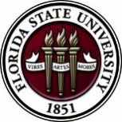
Florida State University
OFFICE OF POSTDOCTORAL AFFAIRS WEEKLY DIGEST

August 22, 2018

Program for instructional excellence ta orientation/conference – August 22 & 23, 2018
Registration is now open for the Fall Program for Instructional Excellence (PIE) TA Orientation/Teaching Conference! This is a mandatory training for all postdocs who will be teaching a class!

This event is held Wednesday & Thursday the week prior to the first week of classes each fall, and this year will be held 8/22 – 8/23/18. This conference includes sessions that provide graduate students & postdocs with teaching policy training requirements as stated in the current University-wide TA Standards along with best practices in grading, communicating with students, appreciating student diversity in the classroom, and technology usage. By the end of this training, participants will be able to explain and have procedures in place to address University policy issues related to the Academic Honor Policy, the Family Educational Rights and Privacy Act (FERPA), the Americans with Disabilities Act (ADA), and Discrimination-Sexual Harassment-Retaliation. Participants will also be equipped with strategies to help navigate use of Canvas features essential to their role as a TA, communicate effectively with students, and provide productive student feedback.

Who should attend?
- New graduate student & Postdocs – a graduate student & postdocs CANNOT hold a TA or IOR UNLESS he or she satisfies the University-wide TA Standards, so be sure to review these standards carefully!
- New graduate students who do not yet hold a TA assignment, but will likely do so in the future
- Returning graduate students who have never attended a PIE or department equivalent, but who may teach in the future are also encouraged to attend
- Faculty and staff are also welcome

Please note: our priority is to meet the needs of those who will teaching in the coming semester/year, but if there is room in HCB 101, and the overflow HCB 102, we should be able to accommodate graduate students and postdocs who do not yet have a TA assignment but want to become certified and develop their credentials for teaching in the future.

Where: New Classroom Building (HCB 101)
When: Wednesday & Thursday, August 22-23, 2018 (sessions on each day are distinct, i.e., Thursday is not a repeat of Wednesday) You must attend both days to get certified!

Wednesday 8/22/18, 8 AM – 3:30 PM
Thursday 8/23/18, 8 AM – 12:20 PM
Please click here to register to attend!
More information is also posted on the PIE website!

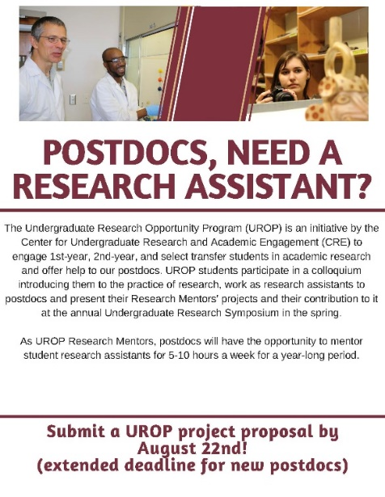
Undergraduate Research Opportunity Program (UROP) – August 23, 2018

Could you use a research assistant for the 2018-2019 academic year (at no cost to you and up to $250 to help cover the cost of research materials)?
Why not consider becoming a UROP Mentor? Come learn about the Undergraduate Research Opportunity Program (UROP) at one of the info sessions listed on the flyer.

UROP helps FSU first & second year, and transfer students in all majors, get started in research.

If you are interested in this exciting opportunity, you can find more information by visiting: https://fla.st/2rwKjGh.

Fall Symposium and 5 Minute research competition! – September 21, 2018
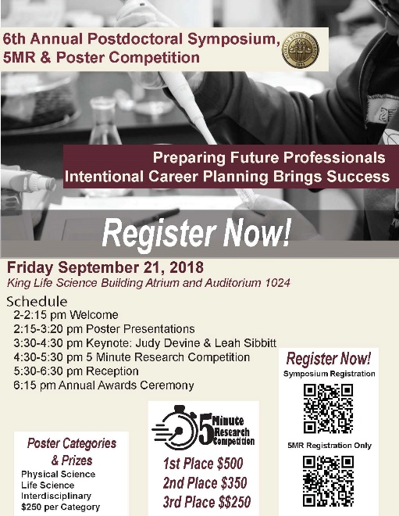
Registration for Fall Symposium (by Sept 18th)
To register for Fall Symposium click here
To register for 5MR competition, please click here
This year’s Fall Symposium will highlight a dual keynote address by our own Judy Devine and Leah Sibbitt. Dr. Devine will role out the new Preparing Future Professional Program (PFP) along with the accompanying Preparing Future Faculty (PFP) that was launched last Spring as a program to guide Postdoctoral Scholars during their job search preparations. Ms. Leah Sibbitt, Director of the Career Center, will provide helpful tips in the job search process to include resources available to postdoctoral scholars and their spouses during the process of the job hunt. Postdoctoral Scholars can take advantage of the “Seminole Suit UP!” at JC Penney’s at 5 pm on September 16th, where they will have open shopping for FSU scholars only with 40% off all career-related clothing!

Registration for 5 Minute Research Competition (by August 24^{TH)}
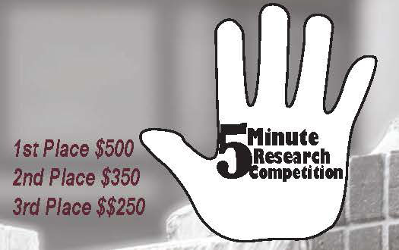
In celebration of the National Postdoctoral Awareness Week that is held in the third week of September, the Florida State University Office of Postdoctoral Affairs (OPDA) and Postdoctoral Association (PDA) are jointly hosting the sixth annual Fall Postdoctoral Poster Competition and Symposium. Poster awards will be $250 for first place in three divisions – Life Sciences, Physical Sciences, and Interdisciplinary/Humanities. New this year is a 5 Minute Research Competition – Hands Down the Best Event!!! The only two regulations are that you (1) have to explain the impact of your research in 5 minutes and (2) have to do so alone (no teams). You are allowed to use ANY medium you want (slides, video, sing, dance, recite literature, props – anything) but must appeal to an Educated Lay Audience, Reach Across your Discipline, and Challenge your Audience to Want to Know More! A practice for all 5 MR competitors will be held August 30-31st in front of a small panel of judges. Feedback will be provided over the subsequent 2 weeks so you are ready to shine on September 21st. Prizes will be awarded, 1st - $500, 2nd - $350, and 3rd - $250 and you must agree to be filmed. Registration is NOW OPEN, please see Debi Fadool for questions, dfadool@bio.fsu.edu
Meeting with the AAAS - Big Data – September 5th
The American Association Advancement of Science (AAAS) is visiting FSU in early September and would like to meet with our postdocs doing “Big Data” type of analyses. If this is you, please contact Associate Dean Jeffery Joyce if you are available for a lunch on September 5th. Jeffrey.Joyce@med.fsu.edu
Cancer control research training program
The University of Rochester Medical Center Cancer Control & Psychoneuroimmunology Laboratory is actively seeking outstanding candidates for their upcoming group of Fellows for 2018. The applicants should be interested in longitudinal studies and clinical trials on translational (e.g. biomarker) symptom science research and/or cancer-related cognitive impairment research to work closely with Dr. Michelle Janelsins (Associate Professor) and her research team. Candidates they are interested in come from a variety of backgrounds including, but not limited to, neuroscience, cognitive science, clinical psychology, epidemiology, clinical trials, applied sciences, and many more.
For more information, and to apply, please click here.
Materials can be sent directly to Dr. Michelle Janelsins or Dr. Gary Morrow (Program Director)
Fellowships
The Company of Biologists – Traveling Fellowships
Next deadline: August 31, 2018
Postdoc Research Funding Opportunities in Germany
Application deadlines vary
Index of Postdoc Fellowships in the Life Sciences (Broad Institute)
EPA Research Grants

Jobs
Below is a sampling of open positions in the United States –

Postdoctoral Positions Available -
Looking for motivated Postdocs to research mechanisms involved in regulated remodeling of muscle T-tubule membranes in fly models of human myopathy with funding for immediate start date!
For more information, please click here to view flyer. Please contact Dr. Amy Kiger, Section of Cell & Development Biology, University of California, San Diego at: akiger@ucsd.edu.

Florida College System, seeks to fill a position for Executive Director, Florida Student Success Center.

The Florida Student Success Center (FSSC) serves as an intermediary between colleges, and provides greater opportunities for colleges to collaborate and learn from one another. The Executive Director works under the supervision of the Chancellor of the Florida College System.
For more information on the role of the position, qualifications and to apply please click here.
Assistant Professor – Department of Biology
Molloy College, Rockville Centre, NY

R&D/CFD Engineer
XRG Technologies LLC., Tulsa, OK

Assistant Professor – Apiculture (Posting number: P1259F)
Auburn University, Auburn, AL

Meteorology Development Engineer (LTC)
IM Flash, Lehi, UT

Assistant Professor – Nursing
Long Island University, Greenvale, NY

Field Application Engineer
ASML, Malta, NY

Postdoctoral Fellowship in Cognitive Aging
School of Psychology, Georgia Institute of Technology, Atlanta, GA
Assistant Professor Positions – Exercise Physiology (Job ID: 42380) & Nutrition (Job ID:42371)
FSU College of Human Sciences, Department of Nutrition, Food & Exercise Sciences
Assistant Professor of Research – Center for Craniofacial Molecular Biology
University of Southern California (USC), Biomedical Sciences

Assistant Professor – Clinical Occupational Therapy
University of Southern California, Occupational Therapy
Assistant Professor – Research Emergency Medicine
University of Southern California, Department of Emergency Medicine
Clinical Assistant Professor – Pediatrics
University of Southern California, Department of Pediatrics
Below is a sampling of open positions around the world -
Canada: Assistant Clinical Professor – in Pharmacy & Pharmaceutical Science
University of Alberta, Faculty of Pharmacy & Pharmaceutical Sciences

Tenure Track Assistant Professor – Biomedical or Electrical Engineering
University of Guelph, School of Engineering/Biomedical Engineering
Assistant Professor – REHAB Occupational Therapy
University of Alberta, Department of Occupational Therapy
Assistant Professor – Microbial Science & Micro/Nanomaterials
University of Calgary Canada First Research Excellence Fund
Assistant Professor – Department of Medicine
University of Alberta, Faculty of Medicine & Dentistry
Assistant Professor – Division of Developmental Pediatrics
University of Alberta, Faculty of Medicine & Dentistry

Staff Scientist in Hematology Research
Keenan Research Centre for Biomedical Research of St. Michael’s Hospital
Japan: Assistant Professor in the Graduate School of Biomedical & Health Sciences
Hiroshima University, Graduate School of Biomedical & Health Sciences

Assistant Professor in Medical Education, Pharmacology, Neuroscience
Hiroshima University, Graduate School of Biomedical & Health Sciences

Norway: Head Engineer at Electron Microscopy Core Facility
University of Oslo, Department of Biosciences (IBV)
Singapore: Assistant Professor for Bio-Behaviorist
Duke NUS Medical School, Academic Medicine Research Institute

Assistant Professor – Center for Aging Research & Education
Duke NUS Medical School, Center for Aging Research & Education
South Africa: Associate Researcher in Clinical Micro Infectious Diseases (CMID)
Wits University, School of Pathology, Johannesburg, ZA
Switzerland: PhD in Biomedical Engineering
University of Basel, Adaptable MRI Technology
Click here for featured Biology careers
Subscribe to receive personalized job announcement emails:
Bio Careers
Academic Keys
PhD Jobs
Fierce Biotech Jobs
ASBMB - American Society for Biochemistry and Molecular Biology
http://www.asbmb.org/careers/ (career information)
Career Development Webinars and Blogs
Will My Students Actually Want to Do This Assignment?
In this article, the author states, the best way to start motivating students to do well in your course is to ask them what they want out of the class.
Stepping up to the podium: Wrestling with imposter syndrome as a teacher
Read an article where the author writes about questions running through his head as a new teacher

Career Path: “What industry can offer: Tips for putting your foot inside the door” – Webinar
Wednesday, August 29, 2018 1:00 pm – 2:00 pm EDT Bio Careers

How to Be Proactive in Your Mentoring Relationships – National Postdoctoral Association http://www.nationalpostdoc.org/?page=Proactive
ASBMB - Postdoctoral Education & Resources
Versatile PhD
This site helps graduate students and new PhD’s identify, prepare for, and excel in possible non-academic careers.
Click here to learn more. Click here to join
Free NPA Membership
FSU is a sustaining member of the National Postdoctoral Association (NPA). This membership provides free affiliate membership to all FSU postdoctoral scholars. Benefits of joining the NPA include:
    - A subscription to the NPA’s official quarterly newsletter
    - Reduced registration fees to the NPA Annual Meeting
    - Eligibility for the NPA Travel Award Program
    - Professional & Leadership Development
    - Networking opportunities with colleagues nationwide
If you are interested in joining the National Postdoctoral Association, click here.
Please email opda-info@fsu.edu if you encounter any problems.
For previous issues, click here!

