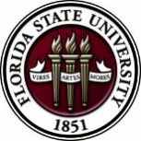
Florida State University
OFFICE OF POSTDOCTORAL AFFAIRS WEEKLY DIGEST

December 19, 2016

NEW SOCIAL MEDIA
A big thank you to Sumudu Tennakoon and Erminia Fardone in creating or updating our social media links! These can be found at the bottom left of the OPDA website in the footer but we will be creating a visible stream on the landing page soon for tweeting. For now - #FSUpostdocs
Please feel free to use these sites to advertise broadly about FSU postdoctoral activities and interests. Please make a profile on LinkedIn so that we can keep in touch with you during and after your training at FSU. This site had not been active for a couple of years and we would like reactivate. Please feel free to forward to alumni that you may be in touch with and for all individuals that have an interest in postdocs at FSU!
Facebook: https://www.facebook.com/FSUPostdocs
Twitter: https://twitter.com/FSUPostdocs
LinkedIn: https://www.linkedin.com/groups/4860161

Spring Symposium – Hold the Date – 12 may 2017
We are excited to host Dr. Lori Conlan, Director of Postdoctoral Services at the National Institutes of Health, as our keynote speaker for this event! Please hold the date on your calendars. If you would like to help with the organization of the afternoon event (great leadership skill building experience), please contact the President (Nikhil Gupta) or Vice-president (Erminia Fardone) of the PDA. Symposium co-chairs are currently being sought.
Upcoming Events

Biological Science/Neuroscience Postdoctoral Mentoring Workshop and Lunch

January 9, 2017, 12:00 p.m. In KIN 2057

Postdoctoral scholars and senior graduate students from all fields are invited to attend. Sandwiches will be served over the lunch hour during the workshops.
For questions, please contact Drs. Erminia Fardone or Kay Jones.

DATE | PRESENTER | TITLE
January 9, 2017 | Dr. Jian Feng | What I know now that I wish I had known when I was a senior postdoctoral scholar
February 13, 2017 | Drs. Emily Moriarty and Alan Lemmon | Balancing work and family
March 13, 2017 |  | Oral Competition Day

Spring PIE Teaching Training Workshop/TA Orientation
The annual Spring PIE Teaching Training Workshop/TA Orientation is held the Friday of the first week of classes each spring. This workshop includes sessions that provide graduate and postdoctoral students with teaching policy training requirements as stated in the University-wide TA Standards along with best practices in grading, communicating with students, and Blackboard and technology usage. This TA training is delivered partly face-to-face and partly online via Blackboard, the centrally supported course management system at FSU. This abridged Spring TA training workshop is primarily offered to meet the needs of graduate and postdoctoral students who will be newly serving as a TA in the Spring or Summer of 2016 and others who were unable to attend the annual Fall PIE conference because of extenuating circumstances that have been documented by the graduate student's academic department (or the department that is appointing the student as a TA).
Note: Postdocs who are needing teaching certifications but have not yet attended the “Program for Instructional Excellence” (PIE) Orientation are required to attend before serving as an independent instructor of record. The next Orientation is listed below!
The face-to-face portion of the spring 2017 PIE Teaching Training Workshop/TA Orientation will be held Friday, January 13th, 2017, 1:00pm-4:30pm in The Great Hall on the 4th floor of the Honors, Scholars and Fellows House. Participants should click here to register to attend this face-to-face session!
Please Note: Participants MUST also complete the ONLINE “University-wide Teaching Policy Training” modules on the PIE Blackboard website prior to this face-to-face Workshop/Orientation if they are required to complete the University-wide TA policy trainings in FERPA, FSU Academic Honor Policy, Sexual Harassment and Discrimination, and Americans with Disabilities Act (ADA). Any questions regarding what requirements a student/TA needs to fulfill should be directed to their academic department.
Academic departments may consult the University-wide TA Standards. **Students should email us at pie-info@fsu.edu to request to be enrolled in these online trainings.
Any questions can be directed to lliseno@admin.fsu.edu, pie-info@fsu.edu, or 850-645-7318.

Funding Announcements

FSU Postdoctoral Travel Awards – Now Accepting Applications by January 1, 2017 (for travel occurring Jan 1 – July 1, 2017)
Eligibility: Must be a postdoctoral scholar for at least 1 year prior to date of anticipated travel; can receive award only once during your training.
Selection Process and Criteria: Applications will be reviewed by an internal selection committee composed of faculty and PDA representatives. Your application will be ranked according to the priorities given above as well as your progress and professional productivity in your field as evaluated from your CV/biosketch and your advisor's letter of recommendation.
Award: Successful applicants will receive up to $1000 to support their travel. Award notification will be made by one month following the application deadline. The recipients will be recognized at the Annual Postdoctoral Scholar Appreciation Symposium in September. This year's symposium will be September 22, 2017. Awardees and advisors are expected to attend the ceremony.
Applications should be submitted through Fluid Review by 11:59 pm on January 1, 2017.
See Details here - http://opda.fsu.edu/awards-and-fellowships/travel-awards

L’Oréal-UNESCO for Women in Science Program:
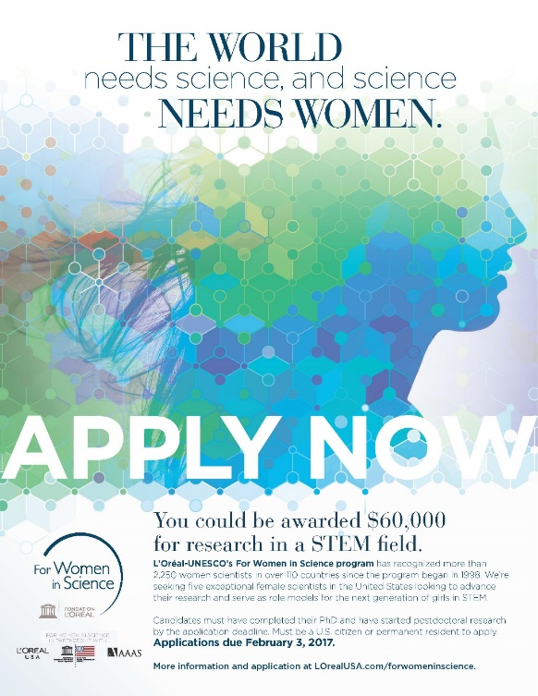
Recognizes and rewards the contributions women make in STEM fields and identifies exceptional women researchers committed to serving as role models for younger generations. More than 2,250 women scientists in over 110 countries have been recognized since the program began in 1998.
In the US, the L’Oréal USA for Women in Science fellowship program awards five post‐doctoral women scientists annually with grants of $60,000 each. Applicants are selected from a variety of fields, including the life and physical/material sciences, technology (including computer science), engineering, and mathematics.

The 2017 L'Oréal USA for Women in Science application period is will open on November 28, 2016 and will close on February 3, 2017. You can learn more about the application process HERE.

Tufts Training in Education and Critical Research Skills Program (TEACRS)

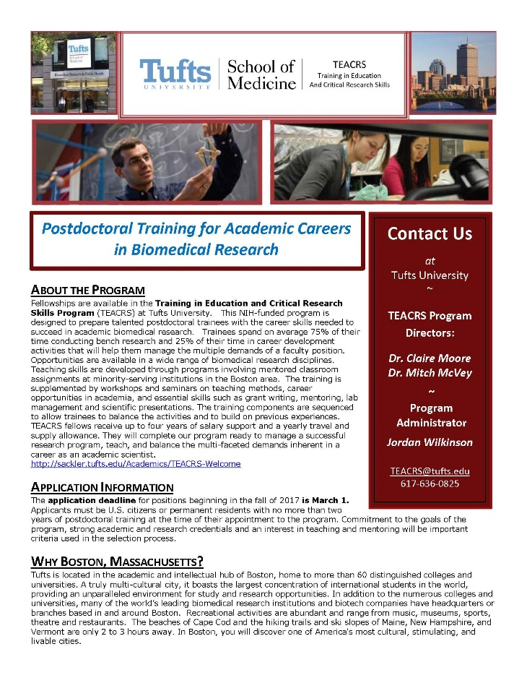
TEACRS is designed to prepare talented young scientists for the multiple demands of an academic career in biomedical research. Trainees spend on average 75% of their time conducting bench research and 25% of their time in career development activities. Teaching skills are developed through programs involving mentored classroom assignments at minority-serving institutions in the Boston area. The training is supplemented by workshops on teaching methods, career opportunities in academia, and essential skills such as grant writing, mentoring, and scientific presentations.

The training components are sequenced to allow trainees to balance the activities and to build on previous experiences. TEACRS fellows receive up to four years of salary support at the NIH postdoctoral stipend levels, and a yearly travel and supply allowance.

The application deadline for positions beginning in the fall of 2017 is March 1, 2017. Later applications will be considered if positions are available. Applicants must be U.S. citizens or permanent residents with no more than two years of postdoctoral training at the time of their appointment to the program. Commitment to the goals of the program, strong academic and research credentials and a demonstrated interest in teaching and mentoring will be important criteria used in the selection process.

For additional information on the TEACRS program and application procedures, please visit our website, or contact Claire Moore, the Program Director, or Jordan Wilkinson, the Program Administrator with questions. We have also attached a printable flier describing the program.
Department of Health and Human Services – HHS; Released November, 2016
National Institutes of Health
NIH Blueprint Diversity Specialized Pre-doctoral to Postdoctoral Advancement in Neuroscience (D-SPAN) Award (F99/K00)
Synopsis 1
Description: The purpose of the NIH Blueprint Diversity Specialized Pre-doctoral to Postdoctoral Advancement in Neuroscience (D-SPAN) Award is to support a defined pathway across career stages for outstanding graduate students who are from diverse backgrounds underrepresented in neuroscience research. This two-phase award will facilitate completion of the doctoral dissertation and transition of talented graduate students to strong neuroscience research postdoctoral positions, and will provide career development opportunities relevant to their long-term career goal of becoming independent neuroscience researchers.

http://www.grants.gov/web/grants/view-opportunity.html?oppId=289824

Howard Hughes Medical Institute: Launches New Program for Early-Career Scientists
Summary: New program aims to recruit and retain early-career scientists who are from gender, racial, ethnic, and other groups underrepresented in the life sciences, including those from disadvantaged backgrounds.
Through an open competition, HHMI plans to select scientists early in their training to become Hanna H. Gray Fellows. Each fellow will receive funding for up to eight years, with mentoring and active involvement within the HHMI community. In this two-phase program, fellows will be supported from early postdoctoral training through several years of a tenure-track faculty position. In the first competition cycle, HHMI will select up to 15 fellows and invest a total of up to $25 million for their support over eight years.
Eligibility:
- The program is open to individuals who are from gender, racial, ethnic, and other groups underrepresented in the life sciences at the career stages targeted by this program, including those from disadvantaged backgrounds.
- The program is open to applicants of any citizenship or nationality who have been accepted to join a laboratory as a postdoctoral researcher at a research institution located in the U.S. at the time of the application due date.
- Applicants must have a PhD and/or MD or equivalent awarded by the anticipated start of the grant term.
- Applicants can have no more than 12 months of postdoctoral research experience at the time of the application due date.
Applicants may obtain more information at www.hhmi.org/HannaGrayFellows2017. The deadline for applications is February 15, 2017, at 3:00 PM (EST). Applications will be assessed by HHMI and distinguished scientists for scientific achievement in prior research experiences, attributes that demonstrate potential for a career as an independent scientist, and quality of training environment to be provided by the selected mentor. The final evaluation will include a scientific presentation to a panel of reviewers. The selection of fellows will be made by the end of September 2017 and grants can start as early as November 15, 2017, but no later than January 15, 2018.
Fellowships
NOAA Climate & Global Change: Postdoctoral Fellowship Program
http://vsp.ucar.edu/cgc/how-postdoctorates-apply
Deadline: January 6, 2017

NOAA Sea Grant John A. Knauss Marine Policy Fellowship
http://seagrant.noaa.gov/FundingFellowships/KnaussFellowship/ProspectiveFellows.aspx
Deadline: February 10, 2017

Hanna H. Gray Fellows Program
http://www.hhmi.org/programs/hanna-h-gray-fellows-program
Deadline: February 15, 2017

Damon Runyon (Cancer Research) Fellowship Award
https://www.damonrunyon.org/for-scientists/application-guidelines/fellowship/forms
Deadline: March 15, 2017

Research Training Groups in the Mathematical Sciences (RTG)
https://www.nsf.gov/funding/pgm_summ.jsp?pims_id=5732&org=DMS
Deadline: June 6, 2017

Use the following databases to identify additional opportunities (click on the links) – Pivot, Foundation Center

Jobs
Below is a sampling of open positions around the world.

Assistant Professor – Department of Family Medicine
https://erecruit.augusta.edu/psp/hrp461/SS/HRSS/c/HRS_HRAM.HRS_CE.GBL
Augusta University, Augusta, GA

Research Engineer – R & D
http://careers.peopleclick.com/careerscp/client_arm/external/jobDetails.do?functionName=getJobDetail&jobPostId=28488&localeCode=en-us&source=Indeed.com&sourceType=PREMIUM_POST_SITE
ARM, Boston, MA

Research Professor – Biosystems & AG Engineering
https://jobs.msu.edu/applicants/jsp/shared/frameset/Frameset.jsp?time=1481728057890
Michigan State University, East Lansing, MI

Research Scientist – Vision Science
https://www3.oculus.com/en-us/careers/a0I1200000JXkGqEAL/
Oculus VR, Redmond, WA

Assistant Professor – Chemical Engineering
https://jobs.lamar.edu/postings/4096
Lamar University, Beaumont, TX

Postdoctoral Appointee – Piezoelectric & Photonic MEMS
https://cg.sandia.gov/psc/applicant/EMPLOYEE/HRMS/c/HRS_HRAM.HRS_APP_SCHJOB.GBL?Page=HRS_APP_JBPST&Action=U&FOCUS=Applicant&SiteId=1&JobOpeningId=655692&PostingSeq=1
Sandia National Laboratories, Albuquerque, NM

Subscribe to receive personalized job announcement emails:
http://floridastate.biocareers.com
http://www.academickeys.com/all/subscribe.php
http://jobs.phds.org/alert.new
http://jobs.fiercebiotech.com

Career Development Webinars and Blogs

Imposter Syndrome Is Definitely a Thing
https://chroniclevitae.com/news/1638-impostor-syndrome-is-definitely-a-thing
Read this article if you feel like you don’t belong doing what you are doing.

Do it yourself? When the researcher becomes the subject.
http://www.sciencemag.org/careers/2016/12/do-it-yourself-when-researcher-becomes-subject
Read how some researchers are using themselves as research subjects..

How to Be Proactive in Your Mentoring Relationships – National Postdoctoral Association http://www.nationalpostdoc.org/?page=Proactive

Versatile PhD
This site helps graduate students and new PhD’s identify, prepare for, and excel in possible non-academic careers.
Click here to learn more. Click here to join
Free NPA Membership
FSU is a sustaining member of the National Postdoctoral Association (NPA). This membership provides free affiliate membership to all FSU postdoctoral scholars. Benefits of joining the NPA include:
    - A subscription to the NPA’s official quarterly newsletter
    - Reduced registration fees to the NPA Annual Meeting
    - Eligibility for the NPA Travel Award Program
    - Professional & Leadership Development
    - Networking opportunities with colleagues nationwide
If you are interested in joining the National Postdoctoral Association, click here.
Please email opda-info@fsu.edu if you encounter any problems.
For previous issues, click here!

