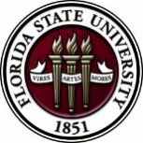
Florida State University
OFFICE OF POSTDOCTORAL AFFAIRS WEEKLY DIGEST

December 4, 2017

Upcoming Events

Biological Science/Neuroscience Postdoctoral Mentoring Workshop & Lunch

KIN Life Science Building, Room 2057, 12:00 – 1:00 PM

Please mark your calendar for the fall 2017 through spring 2018 workshops. This is a special, faculty-led monthly workshop for Postdoctoral Scholars hosted by the Department of Biological Science and the Program in Neuroscience. Although the career focus will be directed to the Life Sciences, all Postdoctoral Scholars and senior Graduate Students are welcome. Sandwiches will be served over the lunch hour during the workshops. Dates and topics are listed below. For questions, please contact Dr. Kay Jones. No registration required.

Date | Presenter | Title
Monday Dec. 11, 2017 | Rebecca Peterson, Asst. Dir. HR, Faculty Relations | Avoiding/Dealing with Potential Conflicts: The HR Perspective
Tuesday Jan. 16, 2018 | Dr. Hank Bass | The Academic Career Trajectory
Monday Feb. 12, 2018 | Dr. Meghan Talkington, Senior Science Writer, Broad Institute, Cambridge MA. | TBA
Monday Mar. 5, 2018 |  | Postdoc Oral Competition – 9 AM – 3 PM
Monday April 9, 2018 | Dr. Joe Travis | Understanding the Structure of a Typical (US) University
TBA | Dr. Anita Nag, Furman University | FSU Postdocs Made Good

sponsorship to the national postdoctoral association!

We are seeking a member of the FSU postdoctoral community to attend the National Postdoctoral Association Conference that will be held in Cleveland, OH on April 6-8, 2018. If you are interested in representing FSU, please see Debra Ann Fadool concerning how to apply. One member of our postdoc community will be sponsored by the OPDA to attend the conference. Preference will be given to postdocs that are involved in organizing events on campus or have contributed to the PDA, and those that have not ever had the opportunity to attend previously.

More about the conference can be found here –
http://www.nationalpostdoc.org/general/custom.asp?page=2018AnnualConference

Deadline to apply = January 15, 2018

Postdoctoral scholars career development travel awards

Have you been invited to deliver a research presentation to an international audience?
Do you have an opportunity to interview at a national job search fair?
Do you want to attend a professional development workshop at a large or specialized conference?
Do you need to network with potential research collaborators?
Would you like to take a specialty class or research program off-campus?
DON'T FORGET TO APPLY TO THE UPCOMING PROFESSIONAL DEVELOPMENT TRAVEL GRANT AWARDS FOR POSTDOCS!!!
Ten awards up to $1,000 will be administered through the Provost’s Office and the OPDA
Next Application Deadline = January 1, 2018
For more information, and to apply, click here.

Abstract categories for 2018 asbmb annual meeting

The ASBMB is accepting abstracts for presentation at the 2018 ASBMB Annual Meeting, held April 21-25, 2018 in San Diego, CA.
For more information, and to submit an abstract by the deadline of Dec. 7, 2017.

Tufts university school of medicine presents teacrs

Fellowships are available in the Training in Education and Critical Research Skills Program (TEACRS) at Tufts University. This NIH-funded program is designed to prepare talented postdoctoral trainees with the career skills needed to succeed in academic biomedical research.
For more information, and to apply click here. Download the flyer here.
Applicants must be U.S. citizens or permanent residents with no more than two years of postdoctoral training at the time of their appointment to the program.
The application deadline for positions beginning in the fall of 2018 is March 1, 2018.

Funding Announcements
L’Oréal-UNESCO for Women in Science Program:
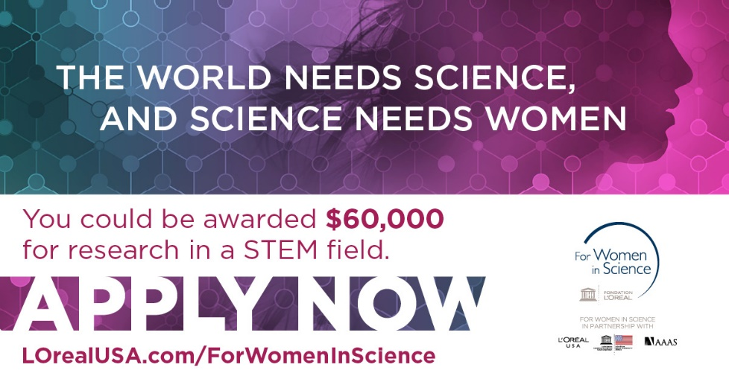
Fellowship program honors female scientists at a critical stage in their careers. Since 2003, they have awarded 70 postdoctoral women scientists over $3.5 million in grants. In 2018, they are seeking five exceptional female scientists looking to advance their research and serve as role models for the next generation of females in STEM.
The 2018 L'Oréal USA for Women in Science application period is will open on December 4, 2017 and applications are due by February 2, 2018.
For more information and to apply, please click here.
Cancer control research training program
The University of Rochester Medical Center Cancer Control & Psychoneuroimmunology Laboratory is actively seeking outstanding candidates for their upcoming group of Fellows for 2018. The applicants should be interested in longitudinal studies and clinical trials on translational (e.g. biomarker) symptom science research and/or cancer-related cognitive impairment research to work closely with Dr. Michelle Janelsins (Associate Professor) and her research team. Candidates they are interested in come from a variety of backgrounds including, but not limited to, neuroscience, cognitive science, clinical psychology, epidemiology, clinical trials, applied sciences, and many more.
They will begin interviewing candidates in January 2018. For more information, and to apply, please click here.

Materials can be sent directly to Dr. Michelle Janelsins and Dr. Gary Morrow (Program Director)

Fellowships
Ford Foundation Fellowship Programs
Postdoctoral Application Deadline: December 7, 2017 (5:00 PM EST)

Howard Hughes Medical Institute Medical Research Fellows Program
Deadline: January 11, 2018
Postdoctoral Enrichment Program Grant
Application Deadline: January 16, 2018 4:00 pm EST

Burroughs Wellcome Fund Postdoctoral Enrichment Program
Deadline: January 16, 2018

American Epilepsy Society Postdoctoral Research Fellowship
Letters of Intent due: Oct. 5, 2017, Full proposals due: Jan. 31, 2018

Index of Postdoc Fellowships in the Life Sciences (Broad Institute)

EPA Research Grants

Use the following databases to identify additional opportunities (click on the links) – Pivot, Foundation Center

Jobs
Below is a sampling of open positions in the United States -

Assistant Professor – Microbiology/Genetics – Applied Biomedical Sciences
University of the Incarnate Word, San Antonio, TX

Research Scientist – Mechanical & Aerospace Engineering
University of Florida, Gainesville, FL

Assistant Professor – Department of Microbiology
University of Hawaii, Honolulu, HI

Research Scientist – Energy & Power
Lynntech Inc., College Station, TX

Assistant Professor – Computer Science & Engineering
University of Connecticut, Storrs, CT

Assistant Research Scientist – Space Physics
University of Michigan, Ann Arbor, MI

Assistant Professor Positions – Exercise Physiology (Job ID: 42380) & Nutrition (Job ID:42371)
FSU College of Human Sciences, Department of Nutrition, Food & Exercise Sciences
Assistant Professor of Research – Center for Craniofacial Molecular Biology
University of Southern California (USC), Biomedical Sciences

Assistant Professor – Clinical Occupational Therapy
University of Southern California, Occupational Therapy

Assistant Professor – Research Emergency Medicine
University of Southern California, Department of Emergency Medicine

Clinical Assistant Professor – Pediatrics
University of Southern California, Department of Pediatrics

University of Washington Faculty Positions
The College of Engineering & School of Medicine is accepting applications for tenure-track Assistant Professor position in the Department of Bioengineering. Download flyer for more information. To apply, click here.

Postdoctoral Position in Public Participation in Digitization of Biodiversity Collections
A postdoctoral position is available with iDigBio in the research group of Prof. Austin Mast (Department of Biological Science, Florida State University; http://www.bio.fsu.edu/faculty-mast.php) to study engagement of the public in the digitization of biodiversity research
collections, especially as it relates to the community’s Worldwide Engagement for Digitizing Bio collections (WeDigBio) Event. iDigBio (www.idigbio.org) is the US NSF's National Resource for Advancing Digitization of Biodiversity Collections, and it is located at the University of Florida and Florida State University. The WeDigBio Event (www.wedigbio.org) is an annual, 4-day event that mixes onsite engagement at museums, universities, etc. with engagement of distributed participants to produce an exciting, educational global data campaign for science. New developments that could be a part of this postdoc’s activities include the build-out of the nascent WeDigBio virtual science festival, creation of virtual reality bio collections tours, and completion of a strategic plan for the WeDigBio Event. The WeDigBio Event has a history of innovation, including in the area of augmented reality.

To apply, send a cover letter and CV with contact information for three references in a single pdf file to Austin Mast (amast@bio.fsu.edu). In the cover letter, please cite past activities that demonstrate each of (1) through (4) above as well as provide the
date on which you could start the position and a paragraph or two on your long-term career goals and how you see this position fitting into them. Applications will be considered beginning on Nov 15 until the position is filled.
Below is a sampling of open positions around the world -

Canada: Assistant Clinical Professor – in Pharmacy & Pharm Science
University of Alberta, Faculty of Pharmacy & Pharmaceutical Sciences

Tenure Track Assistant Professor – Biomedical or Electrical Engineering
University of Guelph, School of Engineering/Biomedical Engineering

Assistant Professor – REHAB Occupational Therapy
University of Alberta, Department of Occupational Therapy

Assistant Professor – Microbial Science & Micro/Nanomaterials
University of Calgary Canada First Research Excellence Fund

Assistant Professor – Department of Medicine
University of Alberta, Faculty of Medicine & Dentistry

Assistant Professor – Division of Developmental Pediatrics
University of Alberta, Faculty of Medicine & Dentistry

Staff Scientist in Hematology Research
Keenan Research Centre for Biomedical Research of St. Michael’s Hospital

Japan: Assistant Professor in the Graduate School of Biomedical & Health Sciences
Hiroshima University, Graduate School of Biomedical & Health Sciences

Assistant Professor in Medical Education, Pharmacology, Neuroscience
Hiroshima University, Graduate School of Biomedical & Health Sciences

Norway: Head Engineer at Electron Microscopy Core Facility
University of Oslo, Department of Biosciences (IBV)

Singapore: Assistant Professor for Bio-Behaviorist
Duke NUS Medical School, Academic Medicine Research Institute

Assistant Professor – Center for Aging Research & Education
Duke NUS Medical School, Center for Aging Research & Education

South Africa: Associate Researcher in Clinical Micro Infectious Diseases (CMID)
Wits University, School of Pathology, Johannesburg, ZA

Switzerland: PhD in Biomedical Engineering
University of Basel, Adaptable MRI Technology

Click here for featured Biology careers

Subscribe to receive personalized job announcement emails:
Florida State University Bio Careers
Academic Keys
PhD Jobs
Fierce Biotech Jobs
ASBMB - American Society for Biochemistry and Molecular Biology
http://www.asbmb.org/careers/ (career information)

Career Development Webinars and Blogs
The Job Market: The Campus Interview
In this article, the author details that the person you present during your two-day campus visit is the person the search committee will assume you to be.

Four lessons for being a great mentor to undergrads
Read an article, the author highlights how to be a great mentor to undergraduate students.

How to Be Proactive in Your Mentoring Relationships – National Postdoctoral Association http://www.nationalpostdoc.org/?page=Proactive

AAAS Live Training Event – Demystifying the review process in publishing
Wednesday, Dec. 6, 2017, 1:00 – 2:00 pm EST

Versatile PhD
This site helps graduate students and new PhD’s identify, prepare for, and excel in possible non-academic careers.
Click here to learn more. Click here to join
Free NPA Membership
FSU is a sustaining member of the National Postdoctoral Association (NPA). This membership provides free affiliate membership to all FSU postdoctoral scholars. Benefits of joining the NPA include:
    - A subscription to the NPA’s official quarterly newsletter
    - Reduced registration fees to the NPA Annual Meeting
    - Eligibility for the NPA Travel Award Program
    - Professional & Leadership Development
    - Networking opportunities with colleagues nationwide
If you are interested in joining the National Postdoctoral Association, click here.
Please email opda-info@fsu.edu if you encounter any problems.

For previous issues, click here!

