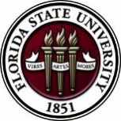
Florida State University
OFFICE OF POSTDOCTORAL AFFAIRS WEEKLY DIGEST

February 12, 2018

Upcoming Events
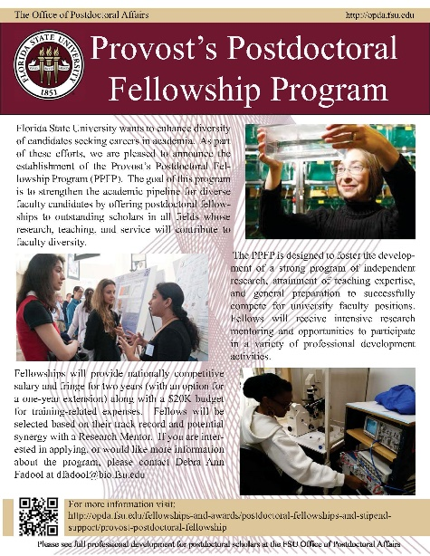
PPFP Program – Applications now Being Accepted!
Florida State University is launching a new training program called the Provost Postdoctoral Fellowship Program (PPFP) that will support the training of postdoctoral scholars for a two year fellowship with the goal to increase diversity of faculty entering academia. 10 PPFP fellows will be supported (salary, fringe, plus up to a 20K training-related expense internal award) through generous funding from the Provost/VP Faculty Development. Applicants must identify a faculty mentor to provide a letter of nomination for this mentored-guided training. Please see the OPDA for more information concerning eligibility and required application materials. Questions? Please direct to Debra Fadool, Director of the Office of Postdoctoral Affairs.
Postdoctoral scholars can start pairing with faculty mentors to submit their applications – Portal is NOW open!
NEW POSTDOCTORAL ASSOCIATION MEMBERS BEING SOUGHT
The FSU PDA is looking for new representatives to help lead postdoctoral events and policies across campus and especially in several departments including Chemistry, Magnet Lab, Humanities, Engineering, College of Medicine, among others! If you want to network and gain leadership experience as a postdoctoral scholar, please join us for our next PDA meeting at 5 pm, Monday, March 5th in Room 3009, KIN Life Science Building

Biological Science/Neuroscience Postdoctoral Mentoring Workshop & Lunch
KIN Life Science Building, Room 2057, 12:00 – 1:00 PM

Please mark your calendar for the spring 2018 postdoc workshops. This is a special, faculty-led monthly workshop for Postdoctoral Scholars hosted by the Department of Biological Science and the Program in Neuroscience. Although the career focus will be directed to the Life Sciences, all Postdoctoral Scholars and senior Graduate Students are welcome. Sandwiches will be served over the lunch hour during the workshops. Dates and topics are listed below. For questions, please contact Dr. Kay Jones. No registration required.

Date | Presenter | Title
Monday Mar. 5, 2018 |  | Postdoc Oral Competition – 10 AM – 3 PM
Monday April 9, 2018 | Dr. Joe Travis | Understanding the Structure of a Typical (US) University
TBA | Dr. Anita Nag, Furman University | FSU Postdocs Made Good

Oral Postdoctoral Competition – March 5th 10 am to 3 pm
Are you looking to obtain speaking experience with faculty judged feedback on the delivery and organization of your scientific presentation? Sign up for the oral postdoctoral competition in Biological Science and Neuroscience. All Life Science areas are welcome. Presentations will be 15 minutes each with 3 min. for questions. This is a great time of year to give a presentation in preparation for spring and summer conferences. There will be a donation of $1000 in VWR-brand research supplies to the postdoc with the highest score!
Talk sessions will be accommodated in the morning 2 hours and the afternoon 2 hours, with a group lunch provided in between. We have had many new postdoctoral scholars arrive this year and others have departed to permanent jobs. That means that even if you have been here less than 1 year, you should still volunteer to give a presentation! Talking about a relatively new project is exciting and early in your postdoc is a great time to get feedback from those outside your group. To register and schedule your time block and submit the title of your planned presentation please contact Dr. Kay Jones, Associate Professor Biological Science at kmjones@bio.fsu.edu. Questions about the event or can also be directed to Dr. Jones. If you are a faculty member that would like to judge the event, please also let Dr. Jones know – much appreciated to help our scholars with this skill!
explore cultures from around the world at the 2018 International Bazaar
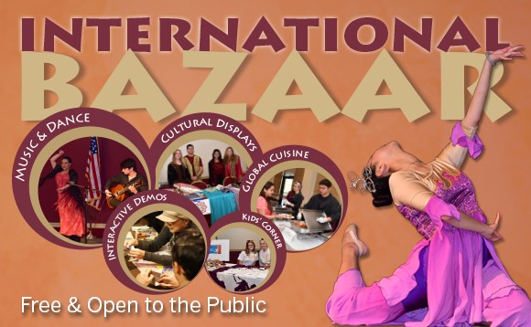
The 2018 International Bazaar is FREE & Open to the Public
When: Saturday, February 17, 2018 from 2-5 pm.
Where: FSU Union Ballrooms (75 N. Woodward Ave., Tallahassee, FL 32313)
What: music & dance, cultural displays, interactive demos, global cuisine, kid’s corner
For more information, click here
Tufts university school of medicine presents teacrs
Fellowships are available in the Training in Education and Critical Research Skills Program (TEACRS) at Tufts University. This NIH-funded program is designed to prepare talented postdoctoral trainees with the career skills needed to succeed in academic biomedical research.
For more information, and to apply click here. Download the flyer here.
Applicants must be U.S. citizens or permanent residents with no more than two years of postdoctoral training at the time of their appointment to the program.
The application deadline for positions beginning in the fall of 2018 is March 1, 2018.
New National Database for Postdoctoral funding
A new postdoctoral-centered, searchable database of 275 funding opportunities for postdoctoral scholars has been released by John Hopkins University. Please check it out for good ideas for your next extramural grant/award application! Remember that if you submit an extramural application to a federally supported or major other mechanism, then you are eligible to receive a $1,000 intramural award from the OPDA to use for your general research-related expenses at FSU.
John Hopkins University Funding Resources
Cancer control research training program
The University of Rochester Medical Center Cancer Control & Psychoneuroimmunology Laboratory is actively seeking outstanding candidates for their upcoming group of Fellows for 2018. The applicants should be interested in longitudinal studies and clinical trials on translational (e.g. biomarker) symptom science research and/or cancer-related cognitive impairment research to work closely with Dr. Michelle Janelsins (Associate Professor) and her research team. Candidates they are interested in come from a variety of backgrounds including, but not limited to, neuroscience, cognitive science, clinical psychology, epidemiology, clinical trials, applied sciences, and many more.
They will begin interviewing candidates in January 2018. For more information, and to apply, please click here.
Materials can be sent directly to Dr. Michelle Janelsins or Dr. Gary Morrow (Program Director)
fens – ibro forum of neuroscience
FENS, the European voice for Neuroscience is hosting a forum of Neuroscience July 7-11, 2018 in Berlin, Germany. FENS is also providing travel grants to young investigators to attend the forum. For more information about the forum, click here.
Young investigators in Neuroscience may also apply for a training program where German Neuroscience PI’s allow young investigators to spend 2-3 weeks in German lab. For more information on the training program, click here. The deadline to apply is February 13, 2018.
early-career investigators: Submit your Paper for NIH Behavioral Science Award
If you’ve published recently on the topic of enhancing health, lengthening life, or reducing illness and disability, and if you’ve received your PhD within the last 10 years, you may be interested in applying for a paper competition hosted by the NIH Office of Behavioral and Social Sciences Research (OBSSR).
For more information, and to apply by the deadline: February 16, 2018, 9:00am ET, click here.

Fellowships
AACR-Kure it Research Grant for Immunotherapy in Kidney Cancer
Application deadline: February 15, 2018

American Cancer Society Postdoctoral Fellowships
Application deadline: April 2, 2018
The Company of Biologists – Traveling Fellowships
Deadlines vary throughout the year. Please click above for dates.

American Diabetes Association Mentor Based Postdoctoral Fellowship
Application deadline: April 16, 2018 for January 1, 2019 funding.

Helen Hay Whitney Fellowship for Biomedical Research
Application deadline: No later than 5pm EST, July 2, 2018

Index of Postdoc Fellowships in the Life Sciences (Broad Institute)

EPA Research Grants

Use the following databases to identify additional opportunities (click on the links) – Pivot, Foundation Center

Jobs
Below is a sampling of open positions in the United States –

Florida College System, seeks to fill a position for Executive Director, Florida Student Success Center.

The Florida Student Success Center (FSSC) serves as an intermediary between colleges, and provides greater opportunities for colleges to collaborate and learn from one another. The Executive Director works under the supervision of the Chancellor of the Florida College System.
For more information on the role of the position, qualifications and to apply please click here.
Research Assistant Professor – Department of Mechanical Engineering
University of Houston, Houston, TX

Remote Sensing Scientist – Job ID: 16601
John Hopkins Applied Physics Lab, Laurel, MD

Tenure Track Assistant Professor – College of Engineering
Oregon Institute of Technology, Klamath Falls, Oregon

Assistant Research Scientist – Department of Biomedical Engineering
University of Michigan, Ann Arbor, MI

Teaching Assistant Professor – Veterinary & Biomedical Sciences
Penn State University, University Park, PA

Electrical Engineer – Power Supply Design (Job Code: SIS20180602-23182)
Harris Corporation, Inc., Palm Bay, FL

Assistant Professor – Department of Chemical & Biological Engineering
Colorado State University, Fort Collins, CO

Assistant Professor Positions – Exercise Physiology (Job ID: 42380) & Nutrition (Job ID:42371)
FSU College of Human Sciences, Department of Nutrition, Food & Exercise Sciences
Assistant Professor of Research – Center for Craniofacial Molecular Biology
University of Southern California (USC), Biomedical Sciences

Assistant Professor – Clinical Occupational Therapy
University of Southern California, Occupational Therapy

Assistant Professor – Research Emergency Medicine
University of Southern California, Department of Emergency Medicine
Clinical Assistant Professor – Pediatrics
University of Southern California, Department of Pediatrics
University of Washington Faculty Positions
The College of Engineering & School of Medicine is accepting applications for tenure-track Assistant Professor position in the Department of Bioengineering. Download flyer for more information. To apply, click here.

Postdoctoral Position in Public Participation in Digitization of Biodiversity Collections
A postdoctoral position is available with iDigBio in the research group of Prof. Austin Mast (Department of Biological Science, Florida State University; http://www.bio.fsu.edu/faculty-mast.php) to study engagement of the public in the digitization of biodiversity research
collections, especially as it relates to the community’s Worldwide Engagement for Digitizing Bio collections (WeDigBio) Event. iDigBio (www.idigbio.org) is the US NSF's National Resource for Advancing Digitization of Biodiversity Collections, and it is located at the University of Florida and Florida State University. The WeDigBio Event (www.wedigbio.org) is an annual, 4-day event that mixes onsite engagement at museums, universities, etc. with engagement of distributed participants to produce an exciting, educational global data campaign for science. New developments that could be a part of this postdoc’s activities include the build-out of the nascent WeDigBio virtual science festival, creation of virtual reality bio collections tours, and completion of a strategic plan for the WeDigBio Event. The WeDigBio Event has a history of innovation, including in the area of augmented reality.
To apply, send a cover letter and CV with contact information for three references in a single pdf file to Austin Mast (amast@bio.fsu.edu). In the cover letter, please cite past activities that demonstrate each of (1) through (4) above as well as provide the
date on which you could start the position and a paragraph or two on your long-term career goals and how you see this position fitting into them. Applications will be considered beginning on Nov 15, 2017 until the position is filled.
Below is a sampling of open positions around the world -
Canada: Assistant Clinical Professor – in Pharmacy & Pharmaceutical Science
University of Alberta, Faculty of Pharmacy & Pharmaceutical Sciences

Tenure Track Assistant Professor – Biomedical or Electrical Engineering
University of Guelph, School of Engineering/Biomedical Engineering
Assistant Professor – REHAB Occupational Therapy
University of Alberta, Department of Occupational Therapy

Assistant Professor – Microbial Science & Micro/Nanomaterials
University of Calgary Canada First Research Excellence Fund
Assistant Professor – Department of Medicine
University of Alberta, Faculty of Medicine & Dentistry

Assistant Professor – Division of Developmental Pediatrics
University of Alberta, Faculty of Medicine & Dentistry

Staff Scientist in Hematology Research
Keenan Research Centre for Biomedical Research of St. Michael’s Hospital
Japan: Assistant Professor in the Graduate School of Biomedical & Health Sciences
Hiroshima University, Graduate School of Biomedical & Health Sciences

Assistant Professor in Medical Education, Pharmacology, Neuroscience
Hiroshima University, Graduate School of Biomedical & Health Sciences

Norway: Head Engineer at Electron Microscopy Core Facility
University of Oslo, Department of Biosciences (IBV)
Singapore: Assistant Professor for Bio-Behaviorist
Duke NUS Medical School, Academic Medicine Research Institute

Assistant Professor – Center for Aging Research & Education
Duke NUS Medical School, Center for Aging Research & Education
South Africa: Associate Researcher in Clinical Micro Infectious Diseases (CMID)
Wits University, School of Pathology, Johannesburg, ZA
Switzerland: PhD in Biomedical Engineering
University of Basel, Adaptable MRI Technology

Click here for featured Biology careers

Subscribe to receive personalized job announcement emails:
Bio Careers
Academic Keys
PhD Jobs
Fierce Biotech Jobs

ASBMB - American Society for Biochemistry and Molecular Biology
http://www.asbmb.org/careers/ (career information)
Career Development Webinars and Blogs
The Job Market: Waiting for the Day
Read an article, where the explains that you can’t speed up the academic hiring process, but you can take steps to maintain your sanity as it plays out.

How I learned to pursue my career at my own pace
In this article, the author explains how she paced her career and compared it to running.

Personalizing cancer immunotherapy: From biomarker discovery to clinical diagnostics
Wednesday, February 21, 2018, 12 pm – 1 pm ET

Bio Career Webinar: Acing the Interview – February 28, 1pm ET
How to Be Proactive in Your Mentoring Relationships – National Postdoctoral Association http://www.nationalpostdoc.org/?page=Proactive

Versatile PhD
This site helps graduate students and new PhD’s identify, prepare for, and excel in possible non-academic careers.
Click here to learn more. Click here to join
Free NPA Membership
FSU is a sustaining member of the National Postdoctoral Association (NPA). This membership provides free affiliate membership to all FSU postdoctoral scholars. Benefits of joining the NPA include:
    - A subscription to the NPA’s official quarterly newsletter
    - Reduced registration fees to the NPA Annual Meeting
    - Eligibility for the NPA Travel Award Program
    - Professional & Leadership Development
    - Networking opportunities with colleagues nationwide
If you are interested in joining the National Postdoctoral Association, click here.
Please email opda-info@fsu.edu if you encounter any problems.

For previous issues, click here!

