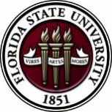
Florida State University
OFFICE OF POSTDOCTORAL AFFAIRS WEEKLY DIGEST

February 27, 2017

Upcoming Events

Biological Science/Neuroscience Postdoctoral Oral Competition Day
KIN Life Science Building, Room 2057, March 6, 2017, 10 to 2 pm
Postdoctoral scholars are invited to present 12 minute research talks to a panel of faculty judges specializing in Biological Science and Neuroscience. This is a great way to obtain feedback on your delivery and ability to communicate your science at a conference, data club, meeting brief, or job interview. Judges will complete a template to provide to all participants on the quality and methods of their oral ability. The winner of the oral competition will receive a $500 shopping spree in the VWR stock room on the first floor of the KIN building. Other disciplines are also invited to participate. If you are interested, there are a few more spots available for participants. Please contact Dr. Kay Jones, Biological Science.

"Welcome" Mini-Orientation Sessions for New Postdoctoral Scholars on Campus
Honors, Scholars & Fellows House, Room 3009, April 24, 2017 12:00 PM
If you are a new postdoctoral scholar to the FSU campus, this “Welcome” is a nice brown bag lunch activity that will fit into your busy research schedule. The design will be limited to strictly a one-hour session, where you will receive the essentials of getting your research started at FSU and have access to Human Resources and Office of Postdoctoral Affairs Staff. At this time, you will also be introduced to the Postdoctoral Association (PDA) - your peer network of postdocs on campus. Attending a “welcome” in your few months of employment at FSU will serve to fulfill your mandatory orientation. Registration for April will open in late March; continue to check website http://opda.fsu.edu/upcoming-events-workshops/upcoming-events for link.

POSTDOCTORAL SPRING EVENT – Hold the Date – 19 may 2017
Matriculating to your Career after your Postdoctoral Training
Please save the date for this special afternoon workshop for postdoctoral scholars, senior graduate students, and mentors. Our keynote address will be given by Dr. Lori Conlan, Director of Postdoctoral Affairs at the National Institutes of Health (NIH). Dr. Conlan will help map the course to different pathways to be pursued in academia, industry, and federal government and the transferable skills that have been built during your postdoctoral training to transition you to these career tracks. She will present strategies for the application packet, interviewing, and securing the best position for your ambitions. We are thrilled she will share her experiences from her insight working with the NIH and her knowledge of postdoctoral hiring trends across the country. A potluck dinner for scholars, their lab mates, mentors, and family members will follow the afternoon event, so we hope you will come out to network and engage with the FSU postdoctoral community. Postdoctoral scholars interested in helping to organize this event please contact PDA President, Nikhil Gupta or Vice-president, Erminia Fardone.
Professional Development Workshops

PIE Coffee Hour & Teaching Workshop: Go Big or Go Home: Activities for Large Classrooms (PIE/PFF/PFP)

February 27, 2017, 3:30 PM – 5:00 PM
Honors, Scholars & Fellows House, 4th Floor, Great Hall

Presenters: PIE Associates, Mary Marcous, Philosophy, and Ashley Artese, Nutrition, Food & Exercise Sciences
Do you ever wonder how to get those 70 students in your lecture to wake up and participate? Teaching a large number of students can be difficult because of space limits, classroom sizes, or even the layout of the room. This workshop will present a number of strategies and activities to facilitate engagement in classes with a large number of students, regardless of subject area.

Free PIE & Coffee Included!

Click here to register: https://fsu.qualtrics.com/SE/?SID=SV_71G3jIg4IyoGtJX

Preparing Cover Letters & Application Packets for Academic Positions [PFF/PIE]

March 3, 2017, 10:00 AM – 11:30 AM
Honors, Scholars & Fellows House, Room 3009

Presenter: Dr. Brad Gomez, Associate Professor and Placement Director, Political Science
Do you know how to craft a cover letter and application packet for an academic position? What can you do to convince a search committee to interview you after reviewing your application materials? Participate in this workshop for a discussion of effective cover letters and application packets. Refreshments will be provided by the Congress of Graduate Students.

To register: https://fsu.qualtrics.com/SE/?SID=SV_e5SkGlglfC4frbn

Interviewing for Positions Outside of Academia: How to Prepare!

March 9, 2017, 3:30 PM – 5:00 PM
Honors, Scholars & Fellows House, Room 3009

Presenter: Amanda Sargent, Assistant Director, FSU Career Center
Interviewing is the most widely accepted method of selecting employees. The goal of an interview is to find out if you fit with the organization, if you have the skills you say you have, and if you can do the job. Based on your resume, they already have an idea of your skill set. So the primary reason for the interview is to assess your personality and to fact check your skills. This workshop will clarify your role as the interviewee and how to prepare. Refreshments will be provided by the Congress of Graduate Students.

To register: https://fsu.qualtrics.com/SE/?SID=SV_9Kvju7d2KCusHxb

Formative Assessment and Review Strategies (PIE/PFF/PFP)

March 23, 2017, 3:30 PM – 5:00 PM
Honors, Scholars & Fellows House, 4th Floor, Great Hall

Presenters: PIE Associates, Kate Hill, Biology, and Ana Ndumu, Information Science
Formative assessment strategies are effective ways of gauging ongoing student learning to provide feedback for both the student and teacher. In this session, participants will discover ways of monitoring student learning and improving content mastery through timely feedback and purposeful review activities. The presenters will provide tips for large and small classes in a variety of content areas.

Free PIE & Coffee Included!

To register: https://fsu.qualtrics.com/SE/?SID=SV_5tAXhpTLeE6QZZb

Negotiating Job Offers

March 24, 2017, 3:30 PM – 5:00 PM
Honors, Scholars & Fellows House, Room 3009

Presenter: Ms. Amanda Sargent, Assistant Director, FSU Career Center
Did you know that you can prepare to negotiate job offers? This workshop will include discussion of the uniqueness of each negotiation, factors that may be negotiated, what is involved in making the best decision, how to negotiate from a point of power, and the final steps.

To register: https://fsu.qualtrics.com/SE/?SID=SV_d6lw0AnGAjcwQpT

Faculty in a Research Institution: Expectations, Opportunities & Challenges

March 28, 2017, 8:30 AM – 12:00 PM
Honors, Scholars & Fellows House, Great Hall

Presenters: FSU administrators and faculty
This workshop will help graduate students and postdoctoral scholars prepare for faculty responsibilities in a research work environment. Senior administrators will provide their perspectives on faculty life and/or current responsibilities at FSU. This workshop can be used for the “Career Development” requirement for the Preparing Future Faculty (PFF). Refreshments will be provided by the Congress of Graduate Students.

To register: https://fsu.qualtrics.com/SE/?SID=SV_6lOZ1IxTwzvQpHT

Funding Announcements

Tufts Training in Education and Critical Research Skills Program (TEACRS)
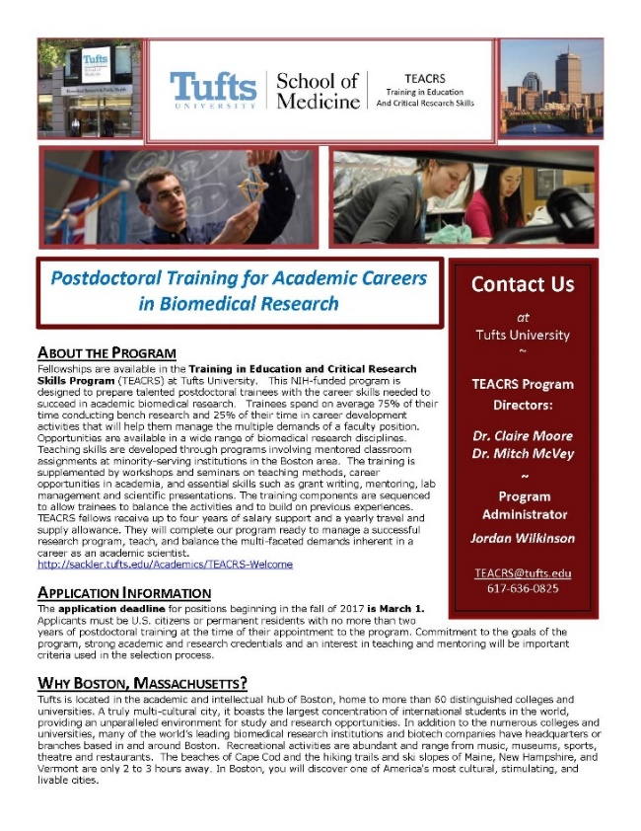
TEACRS is designed to prepare talented young scientists for the multiple demands of an academic career in biomedical research. Trainees spend on average 75% of their time conducting bench research and 25% of their time in career development activities. Teaching skills are developed through programs involving mentored classroom assignments at minority-serving institutions in the Boston area. The training is supplemented by workshops on teaching methods, career opportunities in academia, and essential skills such as grant writing, mentoring, and scientific presentations. The training components are sequenced to allow trainees to balance the activities and to build on previous experiences. TEACRS fellows receive up to four years of salary support at the NIH postdoctoral stipend levels, and a yearly travel and supply allowance.

The application deadline for positions beginning in the fall of 2017 is March 1, 2017. Later applications will be considered if positions are available. Applicants must be U.S. citizens or permanent residents with no more than two years of postdoctoral training at the time of their appointment to the program. Commitment to the goals of the program, strong academic and research credentials and a demonstrated interest in teaching and mentoring will be important criteria used in the selection process.

For additional information on the TEACRS program and application procedures, please visit our website, or contact Claire Moore, the Program Director, or Jordan Wilkinson, the Program Administrator with questions. We have also attached a printable flier describing the program.
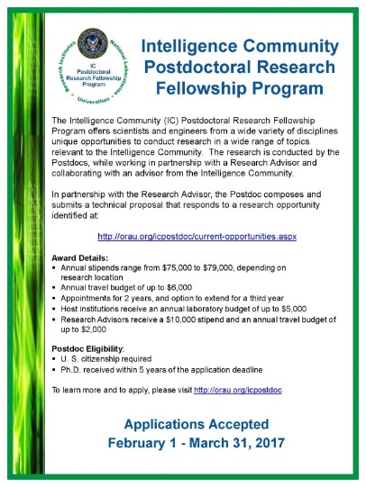
Fellowships

UMBC Postdoc / Pre-Professoriate Fellowship
UMBC Biology, Natural Sciences Pre-Professoriate Fellowship, 2017-2019
https://apply.interfolio.com/39954

The Department of Biological Sciences at the University of Maryland Baltimore County (UMBC) invites applications for the Natural Sciences Pre-Professoriate Fellowship. Candidates with research and teaching interests in all areas of Biological Sciences will be considered. The purpose of the Program is to support promising scholars who are committed to diversity in academia and prepare those scholars for a possible tenure track appointment at UMBC upon completion of the two-year appointment period. We are particularly interested in receiving applications from individuals who are members of groups that historically have been underrepresented in the professoriate.

The fellow will be appointed as Research Assistant Professor for a two-year term beginning August 17, 2017. The fellow will receive a starting stipend of $50,000, health benefits, $5,000 for conference travel and preparation of scholarly work, up to $5,000 in instrument services, up to $10,000 for supplies/consumables, lab space, office space with computer, library access, and other privileges at the university. During the two-year term of appointment, most of the fellow’s time will be devoted to pursuing research. In addition, the fellow will teach one course (one semester only) per year. Highly experienced research and teaching mentors will meet with the fellow regularly to provide guidance on developing a pedagogically sound teaching philosophy and plan, and improving the skills needed to pursue an academic research career, including proposal and manuscript writing, and technical presentation skills. The fellow will also benefit from professional development opportunities across the campus.

Candidates will be selected on the basis of scholarly promise and the potential to add to the diversity of the UMBC community. Applicants must have completed their doctoral degree when the term of appointment commences (August 17, 2017).
Application instructions: to apply, please visit https://apply.interfolio.com/39954
Deadline: Full consideration will be given to those applicants who submit all materials to https://apply.interfolio.com/39954 by March 15, 2017. A complete submission will consist of:

- Cover Letter
- Curriculum Vitae
- Three Letters of Reference
- Statement of Proposed Research Plan (2-3 pages)
- Personal Statement that details your demonstrated commitment to diversity efforts and the mission of UMBC, and why you should be selected for this position (1-3 pages)
- Teaching Statement (1-2 pages)

Questions regarding the program may be addressed to: Dr. Phyllis Robinson, probinso@umbc.edu, however all application materials MUST be submitted through Interfolio. The University of Maryland Baltimore County is an Equal Opportunity Employer/Affirmative Action. UMBC is the recipient of an NSF ADVANCE Institutional Transformation Award to increase the participation of women in academic careers.
https://apply.interfolio.com/39954

Damon Runyon (Cancer Research) Fellowship Award
https://www.damonrunyon.org/for-scientists/application-guidelines/fellowship/forms
Deadline: March 15, 2017

Summer Scholarships in Epidemiology (Cystic Fibrosis Foundation)
https://www.cff.org/Our-Research/For-Researchers/Training-Awards/Summer-Scholarships-in-Epidemiology/
Deadline: April 1, 2017

Research Training Groups in the Mathematical Sciences (RTG)
https://www.nsf.gov/funding/pgm_summ.jsp?pims_id=5732&org=DMS
Deadline: June 6, 2017

Postdoctoral Program in Environmental Chemistry
http://dreyfus.org/awards/postdoctoral_program.shtml
Deadline: August 1, 2017

Mathematical Sciences Postdoctoral Research Fellowships (MSPRF)
https://www.nsf.gov/funding/pgm_summ.jsp?pims_id=5301&org=NSF&sel_org=NSF&from=fund
Deadline: October 18, 2017

Use the following databases to identify additional opportunities (click on the links) – Pivot, Foundation Center

Jobs
Below is a sampling of open positions around the world.

Assistant Professor Biology – Tenure Track
http://jobs.sciencecareers.org/job/437114/assistant-professor-biology-tenure-track/?TrackID=148656#sc=emailfriend&me=email&cm=0
Manhattan College, Bronx, NY

Research Engineer/Scientist
https://careers-engility.icims.com/jobs/25717/research-engineer-scientist/job
Engility Corportation, Fort Bragg, NC

Assistant Professor – College of Health & Human Service
https://jobs.uncc.edu/postings/14681
University of North Carolina Charlotte, Charlotte, NC

Technology Project Engineer
https://honeywell.taleo.net/careersection/9/jobdetail.ftl?lang=en&job=2331082&src=JB-12349
Honeywell, Phoenix, AZ

Assistant Professor – Department of Health Policy & Management
https://www.pittsource.com/postings/132576
University of Pittsburgh, Pittsburgh, PA

Assistant Member Faculty – Biostat/Bioinform Fac
https://www.healthcaresource.com/moffitt/index.cfm?fuseaction=search.jobDetails&template=dsp_job_details.cfm&cJobId=108398&source=Indeed.com
Moffitt Cancer Center, Tampa, FL

Assistant Professor – College of Computer & Information Science
https://neu.peopleadmin.com/postings/46736
Northeastern University, Boston, MA

Subscribe to receive personalized job announcement emails:
http://floridastate.biocareers.com
http://www.academickeys.com/all/subscribe.php
http://jobs.phds.org/alert.new
http://jobs.fiercebiotech.com

ASBMB - American Society for Biochemistry and Molecular Biology
http://www.asbmb.org/careers/
Career Development Webinars and Blogs
Choosing Your Own Adventure
https://chroniclevitae.com/news/1711-choosing-your-own-adventure
Read how you can create career opportunities by broadening your skills.

Women miss out on authorship opportunities early on
http://www.sciencemag.org/careers/2017/02/women-miss-out-authorship-opportunities-early
Read an article on how women are missing out on authorship opportunities.

From Homer to High Tech
https://chroniclevitae.com/news/1708-from-homer-to-high-tech
Read about other career opportunities if you have not landed an academic appointment.

How to Be Proactive in Your Mentoring Relationships – National Postdoctoral Association http://www.nationalpostdoc.org/?page=Proactive

Versatile PhD
This site helps graduate students and new PhD’s identify, prepare for, and excel in possible non-academic careers.
Click here to learn more. Click here to join
Free NPA Membership
FSU is a sustaining member of the National Postdoctoral Association (NPA). This membership provides free affiliate membership to all FSU postdoctoral scholars. Benefits of joining the NPA include:
    - A subscription to the NPA’s official quarterly newsletter
    - Reduced registration fees to the NPA Annual Meeting
    - Eligibility for the NPA Travel Award Program
    - Professional & Leadership Development
    - Networking opportunities with colleagues nationwide
If you are interested in joining the National Postdoctoral Association, click here.
Please email opda-info@fsu.edu if you encounter any problems.
For previous issues, click here!

