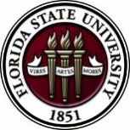
Florida State University
OFFICE OF POSTDOCTORAL AFFAIRS WEEKLY DIGEST

January 16, 2017

Spring Symposium – Hold the Date – 12 may 2017
We are excited to host Dr. Lori Conlan, Director of Postdoctoral Services at the National Institutes of Health, as our keynote speaker for this event! Please hold the date on your calendars. If you would like to help with the organization of the afternoon event (great leadership skill building experience), please contact the President (Nikhil Gupta) or Vice-president (Erminia Fardone) of the PDA. Symposium co-chairs are currently being sought.
Upcoming Events

Postdoctoral Association Meeting (PDA)
January 18, 2017, 11:00 am Room KIN 3008

If you are interested in learning more about the postdoctoral association, come out to the meeting and meet other postdoctoral members and get your questions answered. This is an association ran by postdocs for postdocs. For more information please contact the President Nikhil Gupta, or Vice-president Erminia Fardone.

"Welcome" Mini-Orientation Sessions for New Postdoctoral Scholars on Campus
Honors, Scholars & Fellows House, Room 3009, January 30, 2017 at noon

If you are a new postdoctoral scholar to the FSU campus, this “Welcome” is a nice brown bag lunch activity that will fit into your busy research schedule. The design will be limited to strictly an one hour session, where you will receive the essentials of getting your research started at FSU and have access to Human Resources and Office of Postdoctoral Affairs Staff. At this time, you will also be introduced to the Postdoctoral Association (PDA) - your peer network of postdocs on campus. Attending a “welcome” in your few months of employment at FSU will serve to fulfill your mandatory orientation. Visuals from past Welcomes can be found in the presentation archive section of the OPDA website.

PLEASE REGISTER BY FRIDAY, JAN 27th, by following the link: Take the survey

12:00 pm Welcome, Debra Ann Fadool, Director of the Office of Postdoctoral Affairs (OPDA)
12:05-12:15 Kristen Hagan, Associate Director for the Center for Global Engagement (VISA, International Scholars)
12:15-12:25 Lisa Liseno, Assistant Dean, Director of Instructional Excellence (Teaching Postdoctoral Scholars)
12:25-12:40 Debra Fadool, Opportunities, Resources, Annual Events, and Policies (Mini- Orientation)
12:40-12:50 Kathy Worthman, Human Resources (Health Insurance, Retirement, and Campus Benefits)
12:50-1 pm Erminia Fardone, Vice President of the Postdoctoral Association (PDA Activities)

Biological Science/Neuroscience Postdoctoral Mentoring Workshop and Lunch

February 13, 2017, 12:00 p.m. In KIN 2057

Postdoctoral scholars and senior graduate students from all fields are invited to attend. Sandwiches will be served over the lunch hour during the workshops.
For questions, please contact Drs. Erminia Fardone or Kay Jones.

DATE | PRESENTER | TITLE
February 13, 2017 | Drs. Emily Moriarty and Alan Lemmon | Balancing work and family
March 6, 2017 |  | Oral Competition Day

Save the date for the Oral Competition Day. Postdoctoral Scholars orally deliver their research in a 12 minute presentation format to a panel of judges. Great way to receive feedback on your oral communication skills that are essential for interviewing!

Professional Development Workshops

What do I need to do to apply for, and receive, Human Subjects approval (also known as IRB approval)? [PFF, PFP/PIE]

January 20, 2017, 10:30 AM – 11:30 AM
Honors, Scholars & Fellows house, room 3009
Presenter: Julie Haltiwanger, FSU Human Subjects Committee
Will you be using humans for your research study? Do you plan to publish the results of your research? Will you submit a conference presentation proposal? If so, this is the workshop for you-you must receive IRB approval prior to conducting human subjects’ research!

To register: https://fsu.qualtrics.com/SE/?SID=SV_cMyQ8IyBaH16FSZ

Insider English: Reduced Speech

January 23, 2017, 3:30 PM – 4:30 PM
311 Hecht House
Presenter: Dr. Jennifer Grill, International TA Program

As a non-native speaker of English, you may notice that your English sounds different from native speakers, but you’re not sure why. In this workshop, we’ll explore two aspects of pronunciation: reduced speech and linking. We’ll learn what these are and how they function, and we’ll practice these aspects through several short listening and speaking activities.

To register: https://fsu.qualtrics.com/SE/?SID=SV_86MZGbvRA5v35Mp

Do you know how to protect your designs, inventions, writing, and even your unique packaging?

January 27, 2017, 10:00 AM – 11:30 AM
Honors, Scholars & Fellows House, room 3009
Presenters: Abby Queale, Office of Commercialization; Devin Soper, University Libraries

Attend this workshop to learn how patents, trademarks, and copyrights are essential when you hope to sell your work. There is also another form of protection—“trade dresses”—as decided in a 1992 Supreme Court decision that found the a chain of Mexican restaurants’ interior design was unique and protected. Refreshments will be served by the Congress of Graduate Students.
To register: https://fsu.qualtrics.com/SE/?SID=SV_cILgjglTo9ZQJtH

Funding Announcements

L’Oréal-UNESCO for Women in Science Program:
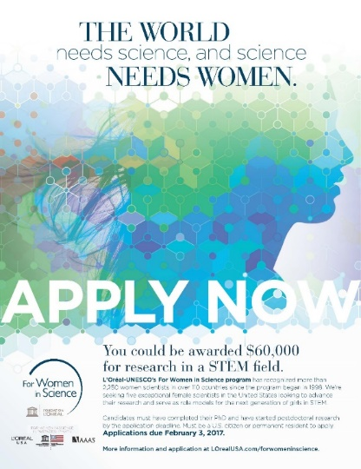
Recognizes and rewards the contributions women make in STEM fields and identifies exceptional women researchers committed to serving as role models for younger generations. More than 2,250 women scientists in over 110 countries have been recognized since the program began in 1998.

In the US, the L’Oréal USA for Women in Science fellowship program awards five post‐doctoral women scientists annually with grants of $60,000 each. Applicants are selected from a variety of fields, including the life and physical/material sciences, technology (including computer science). Engineering, and mathematics.

The 2017 L'Oréal USA for Women in Science application period is will open on November 28, 2016 and will close on February 3, 2017. You can learn more about the application process HERE.

Tufts Training in Education and Critical Research Skills Program (TEACRS)

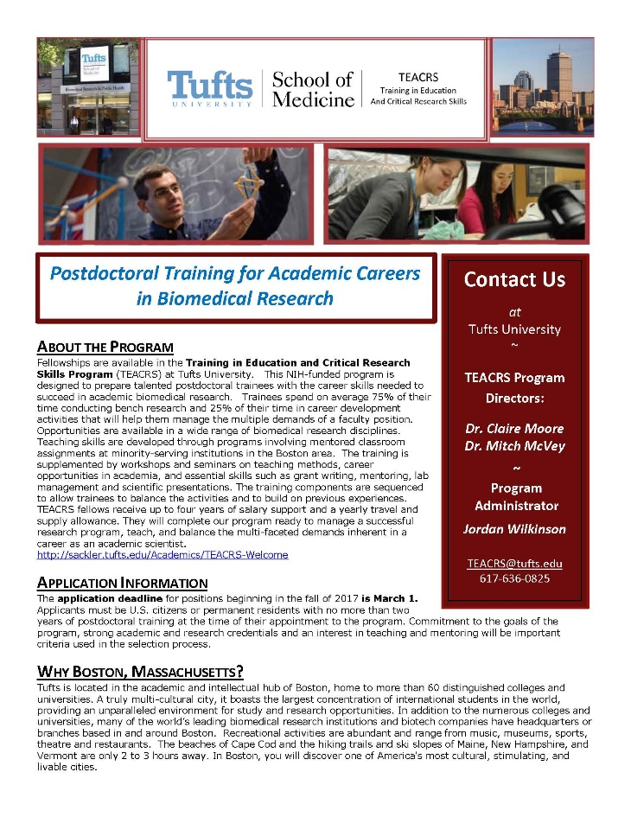
TEACRS is designed to prepare talented young scientists for the multiple demands of an academic career in biomedical research. Trainees spend on average 75% of their time conducting bench research and 25% of their time in career development activities. Teaching skills are developed through programs involving mentored classroom assignments at minority-serving institutions in the Boston area. The training is supplemented by workshops on teaching methods, career opportunities in academia, and essential skills such as grant writing, mentoring, and scientific presentations.

The training components are sequenced to allow trainees to balance the activities and to build on previous experiences. TEACRS fellows receive up to four years of salary support at the NIH postdoctoral stipend levels, and a yearly travel and supply allowance.

The application deadline for positions beginning in the fall of 2017 is March 1, 2017. Later applications will be considered if positions are available. Applicants must be U.S. citizens or permanent residents with no more than two years of postdoctoral training at the time of their appointment to the program. Commitment to the goals of the program, strong academic and research credentials and a demonstrated interest in teaching and mentoring will be important criteria used in the selection process.

For additional information on the TEACRS program and application procedures, please visit our website, or contact Claire Moore, the Program Director, or Jordan Wilkinson, the Program Administrator with questions. We have also attached a printable flier describing the program.

Department of Health and Human Services – HHS; Released November, 2016
National Institutes of Health
NIH Blueprint Diversity Specialized Pre-doctoral to Postdoctoral Advancement in Neuroscience (D-SPAN) Award (F99/K00)
Synopsis 1
Description: The purpose of the NIH Blueprint Diversity Specialized Pre-doctoral to Postdoctoral Advancement in Neuroscience (D-SPAN) Award is to support a defined pathway across career stages for outstanding graduate students who are from diverse backgrounds underrepresented in neuroscience research. This two-phase award will facilitate completion of the doctoral dissertation and transition of talented graduate students to strong neuroscience research postdoctoral positions, and will provide career development opportunities relevant to their long-term career goal of becoming independent neuroscience researchers.

http://www.grants.gov/web/grants/view-opportunity.html?oppId=289824

Howard Hughes Medical Institute: Launches New Program for Early-Career Scientists
Summary: New program aims to recruit and retain early-career scientists who are from gender, racial, ethnic, and other groups underrepresented in the life sciences, including those from disadvantaged backgrounds.
Through an open competition, HHMI plans to select scientists early in their training to become Hanna H. Gray Fellows. Each fellow will receive funding for up to eight years, with mentoring and active involvement within the HHMI community. In this two-phase program, fellows will be supported from early postdoctoral training through several years of a tenure-track faculty position. In the first competition cycle, HHMI will select up to 15 fellows and invest a total of up to $25 million for their support over eight years.
Eligibility:
- The program is open to individuals who are from gender, racial, ethnic, and other groups underrepresented in the life sciences at the career stages targeted by this program, including those from disadvantaged backgrounds.
- The program is open to applicants of any citizenship or nationality who have been accepted to join a laboratory as a postdoctoral researcher at a research institution located in the U.S. at the time of the application due date.
- Applicants must have a PhD and/or MD or equivalent awarded by the anticipated start of the grant term.
- Applicants can have no more than 12 months of postdoctoral research experience at the time of the application due date.
Applicants may obtain more information at www.hhmi.org/HannaGrayFellows2017. The deadline for applications is February 15, 2017, at 3:00 PM (EST). Applications will be assessed by HHMI and distinguished scientists for scientific achievement in prior research experiences, attributes that demonstrate potential for a career as an independent scientist, and quality of training environment to be provided by the selected mentor. The final evaluation will include a scientific presentation to a panel of reviewers. The selection of fellows will be made by the end of September 2017 and grants can start as early as November 15, 2017, but no later than January 15, 2018.

Fellowships

Collaborative Research Travel Grants
http://www.bwfund.org/grant-programs/biomedical-sciences/collaborative-research-travel-grants
Deadline: February 1, 2017

NOAA Sea Grant John A. Knauss Marine Policy Fellowship
http://seagrant.noaa.gov/FundingFellowships/KnaussFellowship/ProspectiveFellows.aspx
Deadline: February 10, 2017

American Heart Association Postdoctoral Fellowship
http://professional.heart.org/professional/ResearchPrograms/ApplicationInformation/UCM_443314_Postdoctoral-Fellowship.jsp
Deadline: February 10, 2017

Damon Runyon (Cancer Research) Fellowship Award
https://www.damonrunyon.org/for-scientists/application-guidelines/fellowship/forms
Deadline: March 15, 2017

Summer Scholarships in Epidemiology
https://www.cff.org/Our-Research/For-Researchers/Training-Awards/Summer-Scholarships-in-Epidemiology/
Deadline: April 1, 2017

Research Training Groups in the Mathematical Sciences (RTG)
https://www.nsf.gov/funding/pgm_summ.jsp?pims_id=5732&org=DMS
Deadline: June 6, 2017

Postdoctoral Program in Environmental Chemistry
http://dreyfus.org/awards/postdoctoral_program.shtml
Deadline: August 1, 2017

Use the following databases to identify additional opportunities (click on the links) – Pivot, Foundation Center

Jobs
Below is a sampling of open positions around the world.

Assistant Professor - Mathematics
http://workatuh.hawaii.edu/Jobs/NAdvert/24327/4176683/1/postdate/desc
University of Hawaii, Honolulu, HI

Computer Science & Computational Science & Engineering
https://academicpositions.harvard.edu/postings/7334
Harvard University, Cambridge MA
Assistant Professor – Virology, Microbiology
http://workatuh.hawaii.edu/Jobs/NAdvert/24333/4176683/1/postdate/desc
University of Hawaii, Honolulu, HI

Full Time Tenure-Track Position – Mining Engineering
https://psu.jobs/job/67236
Penn State University, University Park, PA

Assistant Professor – Computer Science
https://facultyjobs.ua.edu/postings/39614
University of Alabama, Tuscaloosa, AL

Mechanical Engineer - Neuromodulation
https://careers.google.com/jobs#!t=jo&jid=/verily-life-sciences/mechanical-engineer-neuromodulation-south-san-francisco-ca-usa-1247060102&
Google, San Francisco, CA

Assistant Professor – Basic Medical Sciences
https://uacareers.com/postings/14671
University of Arizona, Phoenix, AZ

Subscribe to receive personalized job announcement emails:
http://floridastate.biocareers.com
http://www.academickeys.com/all/subscribe.php
http://jobs.phds.org/alert.new
http://jobs.fiercebiotech.com

Career Development Webinars and Blogs

Claiming Your Right to say No
https://chroniclevitae.com/news/1657-claiming-your-right-to-say-no
Read advice on writing recommendation letters.

How to Shorten a CV
https://chroniclevitae.com/news/1662-how-to-shorten-a-cv
Read about what to include on your CV if the job application only allows for 2-3 pages.

How to Be Proactive in Your Mentoring Relationships – National Postdoctoral Association http://www.nationalpostdoc.org/?page=Proactive

Versatile PhD
This site helps graduate students and new PhD’s identify, prepare for, and excel in possible non-academic careers.
Click here to learn more. Click here to join
Free NPA Membership
FSU is a sustaining member of the National Postdoctoral Association (NPA). This membership provides free affiliate membership to all FSU postdoctoral scholars. Benefits of joining the NPA include:
    - A subscription to the NPA’s official quarterly newsletter
    - Reduced registration fees to the NPA Annual Meeting
    - Eligibility for the NPA Travel Award Program
    - Professional & Leadership Development
    - Networking opportunities with colleagues nationwide
If you are interested in joining the National Postdoctoral Association, click here.
Please email opda-info@fsu.edu if you encounter any problems.
For previous issues, click here!

