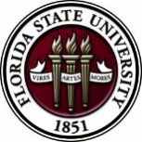
Florida State University
OFFICE OF POSTDOCTORAL AFFAIRS WEEKLY DIGEST

January 30, 2017

Upcoming Events

"Welcome" Mini-Orientation Sessions for New Postdoctoral Scholars on Campus
Honors, Scholars & Fellows House, Room 3009, January 30, 2017 at noon
If you are a new postdoctoral scholar to the FSU campus, this “Welcome” is a nice brown bag lunch activity that will fit into your busy research schedule. The design will be limited to strictly a one hour session, where you will receive the essentials of getting your research started at FSU and have access to Human Resources and Office of Postdoctoral Affairs Staff. At this time, you will also be introduced to the Postdoctoral Association (PDA) - your peer network of postdocs on campus. Attending a “welcome” in your few months of employment at FSU will serve to fulfill your mandatory orientation.
PLEASE REGISTER BY FRIDAY, JAN 27th, by following the link: Take the survey

POSTDOCTORAL SPRING EVENT – Hold the Date – 12 may 2017
We are excited to host Dr. Lori Conlan, Director of Postdoctoral Services at the National Institutes of Health, as our keynote speaker for this event! Please hold the date on your calendars. We would like to get your input on programming for the Spring Event!!
Please take this 2 minute survey so we know what programming to generate for the event!
Thank you so much – your PDA
https://fsu.qualtrics.com/SE/?SID=SV_aWxzIFu8M0QqtzD

Postdoctoral scholars and senior graduate students from all fields are invited to attend. Sandwiches will be served over the lunch hour during the workshops.
For questions, please contact Drs. Erminia Fardone or Kay Jones.

Biological Science/Neuroscience Postdoctoral Mentoring Workshop and Lunch

DATE | PRESENTER | TITLE
February 13, 2017 | Drs. Emily Moriarty and Alan Lemmon | Balancing work and family
March 6, 2017 |  | Oral Competition Day

Save the date for the Oral Competition Day. Postdoctoral Scholars orally deliver their research in a 12 minute presentation format to a panel of judges. Great way to receive feedback on your oral communication skills that are essential for interviewing!

Professional Development Workshops

I received an invitation to present a poster at my first academic conference, so how do I begin?

Feb 3, 2017, 3:30 PM – 4:30 PM
Honors, Scholars & Fellows House, Room 3009

Presenter: Dr. Amy Huber, Assistant Professor, Interior Design
Imagine a crowded, noisy room, possibly with poor lighting and many other poster presentations. Given the previous setting, how will you communicate your research/creativity most effectively? Beginning with the rough draft stage, the use of color, font, and more will be covered in this workshop. There will be plenty of time for discussion, and of course, refreshments provided by the Congress of Graduate Students!

To register: https://fsu.qualtrics.com/SE/?SID=SV_bO7I808srpuGkcd

Connecting Skills with Options: Putting your degree to Work

February 10, 2017, 3:30 PM – 5:00 PM
Honors, Scholars & Fellows House, Room 3009

Presenter: Amanda Sargent, Assistant Director, FSU Career Center
You know that your education has given you important and valuable skills, but how does this translate into the world of work? In this presentation, learn how to acquire quality occupational information, identify transferable skills, and articulate your value to future employers.

To register: https://fsu.qualtrics.com/SE/?SID=SV_0dFAFL1pdS3Yb41

Interviewing for the Academic Position [PFF/PFP/PIE]

February 17, 2017, 12:30 PM – 2:00 PM
Honors, Scholars & Fellows House, Room 3009

Presenter: Dr. Jonathan Grant, History Department
Do you plan to attend a conference where you may have several interviews? How do you plan for a telephone interview? What should you expect during an interview at a neutral place, such as an airport? How do you prepare for the interview process on a college/university campus?
These and other questions will be answered in this informative workshop led by an experienced faculty member.

To register: https://fsu.qualtrics.com/SE/?SID=SV_cBySO9Whu9wTkNv

Funding Announcements

L’Oréal-UNESCO for Women in Science Program:
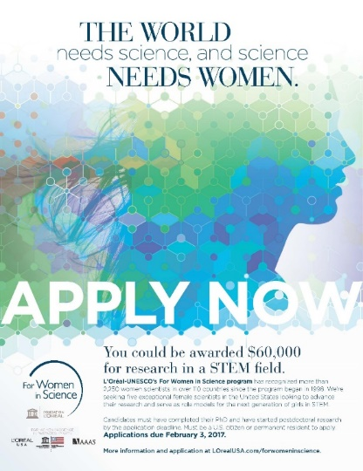
Recognizes and rewards the contributions women make in STEM fields and identifies exceptional women researchers committed to serving as role models for younger generations. More than 2,250 women scientists in over 110 countries have been recognized since the program began in 1998.

In the US, the L’Oréal USA for Women in Science fellowship program awards five post‐doctoral women scientists annually with grants of $60,000 each. Applicants are selected from a variety of fields, including the life and physical/material sciences, technology (including computer science). Engineering, and mathematics.

The 2017 L'Oréal USA for Women in Science application period is will open on November 28, 2016 and will close on February 3, 2017. You can learn more about the application process HERE.

Tufts Training in Education and Critical Research Skills Program (TEACRS)

TEACRS is designed to prepare talented young scientists for the multiple demands of an academic career in biomedical research. Trainees spend on average 75% of their time conducting bench research and 25% of their time in career development activities. Teaching skills are developed through programs involving mentored classroom assignments at minority-serving institutions in the Boston area. The training is supplemented by workshops on teaching methods, career opportunities in academia, and essential skills such as grant writing, mentoring, and scientific presentations.

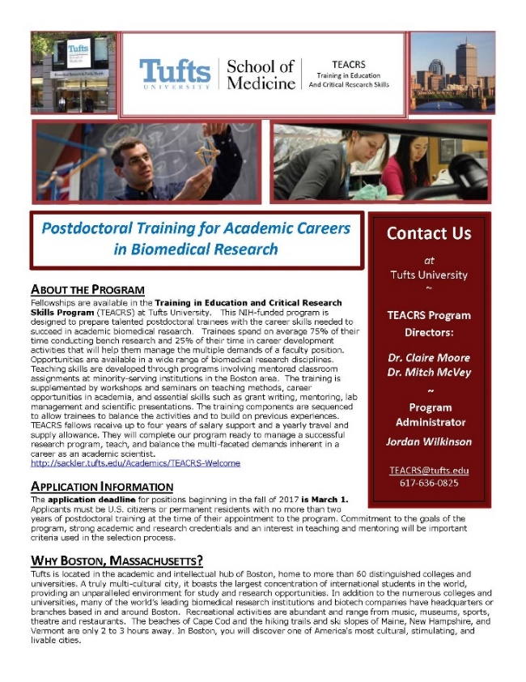
The training components are sequenced to allow trainees to balance the activities and to build on previous experiences. TEACRS fellows receive up to four years of salary support at the NIH postdoctoral stipend levels, and a yearly travel and supply allowance.

The application deadline for positions beginning in the fall of 2017 is March 1, 2017. Later applications will be considered if positions are available. Applicants must be U.S. citizens or permanent residents with no more than two years of postdoctoral training at the time of their appointment to the program. Commitment to the goals of the program, strong academic and research credentials and a demonstrated interest in teaching and mentoring will be important criteria used in the selection process.

For additional information on the TEACRS program and application procedures, please visit our website, or contact Claire Moore, the Program Director, or Jordan Wilkinson, the Program Administrator with questions. We have also attached a printable flier describing the program.

Fellowships
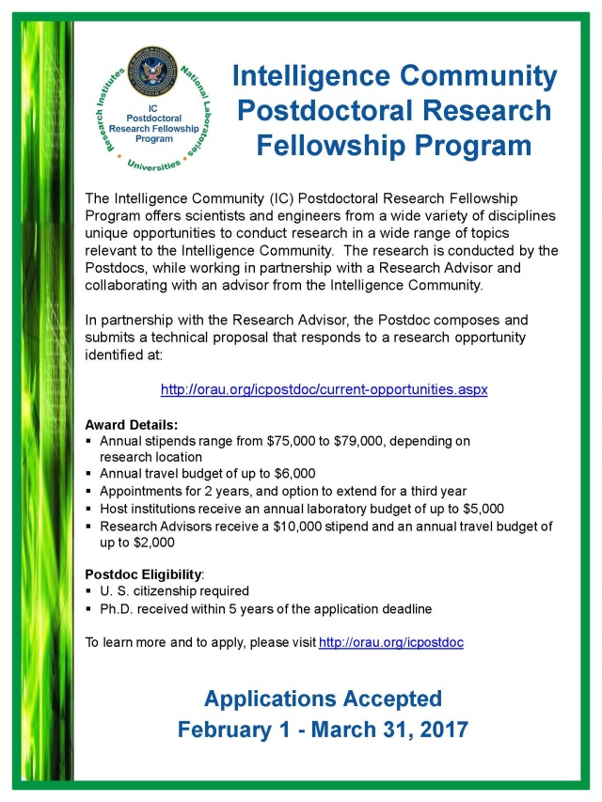

Collaborative Research Travel Grants
http://www.bwfund.org/grant-programs/biomedical-sciences/collaborative-research-travel-grants
Deadline: February 1, 2017

NOAA Sea Grant John A. Knauss Marine Policy Fellowship
http://seagrant.noaa.gov/FundingFellowships/KnaussFellowship/ProspectiveFellows.aspx
Deadline: February 10, 2017

American Heart Association Postdoctoral Fellowship
http://professional.heart.org/professional/ResearchPrograms/ApplicationInformation/UCM_443314_Postdoctoral-Fellowship.jsp
Deadline: February 10, 2017

Damon Runyon (Cancer Research) Fellowship Award
https://www.damonrunyon.org/for-scientists/application-guidelines/fellowship/forms
Deadline: March 15, 2017

Summer Scholarships in Epidemiology
https://www.cff.org/Our-Research/For-Researchers/Training-Awards/Summer-Scholarships-in-Epidemiology/
Deadline: April 1, 2017

Research Training Groups in the Mathematical Sciences (RTG)
https://www.nsf.gov/funding/pgm_summ.jsp?pims_id=5732&org=DMS
Deadline: June 6, 2017

Postdoctoral Program in Environmental Chemistry
http://dreyfus.org/awards/postdoctoral_program.shtml
Deadline: August 1, 2017

Use the following databases to identify additional opportunities (click on the links) – Pivot, Foundation Center

Jobs
Below is a sampling of open positions around the world.

Assistant Professor – Dynamic Compression of Heterogeneous Materials
https://www.wsujobs.com/postings/30143
Washington State University, Pullman, WA

Health Scientist
https://jobs.cdc.gov/job/morgantown/health-scientist/250/3873999
Centers for Disease Control & Prevention, Morgantown, WV

Assistant Professor – Resolution of Pain & Inflammation
https://research.bwhanesthesia.org/research-groups/cetri/serhan-lab/position
Harvard Medical School, Boston, MA

Scientist – Human Genetics
https://www.gene.com/careers/detail/3395936007/Bioinformatics-Scientist-Associate-Scientist-Human-Genetics?src=JB-12568
Genentech, San Francisco, CA

Assistant Professor – College of Health Professions
http://careers.pageuppeople.com/756/cw/en-us/job/498181/assistant-professor
Medical University of South Carolina, Charleston, SC

Scientist I/II - Biotechnology
https://job-search.astrazeneca.com/job/frederick/scientist-i-ii-downstream-frederick-md/7684/3869360
AstraZeneca, Frederick, MD

Assistant Professor – Public Health
https://www.gwu.jobs/postings/40616
George Washington University, Washington, DC

Subscribe to receive personalized job announcement emails:
http://floridastate.biocareers.com
http://www.academickeys.com/all/subscribe.php
http://jobs.phds.org/alert.new
http://jobs.fiercebiotech.com

Career Development Webinars and Blogs

Writing a Book Proposal
https://chroniclevitae.com/news/1677-writing-a-book-proposal
Read advice on how to get your book published.

How to handle grad school doubts
http://www.sciencemag.org/careers/2017/01/how-handle-grad-school-doubts
Read advice if you are having doubts about whether to finish grad school.

I’m not a doctor, but I play one on my CV
http://www.sciencemag.org/careers/2017/01/i-m-not-doctor-i-play-one-my-cv
Read PhD’s thoughts regarding using the title “Doctor”.

How to Be Proactive in Your Mentoring Relationships – National Postdoctoral Association http://www.nationalpostdoc.org/?page=Proactive

Versatile PhD
This site helps graduate students and new PhD’s identify, prepare for, and excel in possible non-academic careers.
Click here to learn more. Click here to join
Free NPA Membership
FSU is a sustaining member of the National Postdoctoral Association (NPA). This membership provides free affiliate membership to all FSU postdoctoral scholars. Benefits of joining the NPA include:
    - A subscription to the NPA’s official quarterly newsletter
    - Reduced registration fees to the NPA Annual Meeting
    - Eligibility for the NPA Travel Award Program
    - Professional & Leadership Development
    - Networking opportunities with colleagues nationwide
If you are interested in joining the National Postdoctoral Association, click here.
Please email opda-info@fsu.edu if you encounter any problems.
For previous issues, click here!

