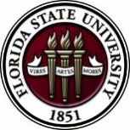
Florida State University
OFFICE OF POSTDOCTORAL AFFAIRS WEEKLY DIGEST

June 20, 2018

Upcoming Events
Postdoctoral and Advisor Appreciation Lunch
The PDA and OPDA are hosting an appreciation lunch for postdoctoral scholars and their advisors this summer on June 29th, noon to 1:15 pm in the Honors Scholars Fellows (HSF) building. Come have a relaxed lunch and hear three short research presentations during the lunch – “5 Minute Research or 5MR” – by fellow postdocs, and hear about exciting research around campus from your peers. Who knows where that next collaborative collision might lead you! Please register by June 27th so we can plan catering – we will be having Indian food! Click here to register. For further questions about the event, please see PDA members Naween or Swapnel.

Postdoctoral travel awards

Travel Award Registration for July – December 2018 is NOW Open! To read about what the Travel Awards cover including costs, eligibility, and application procedures, please visit: https://opda.fsu.edu/awards-and-fellowships/travel-awards. Travel award applications are due on July 1 by midnight for travel occurring through December 31st, 2018.
New Postdoctoral Orientation
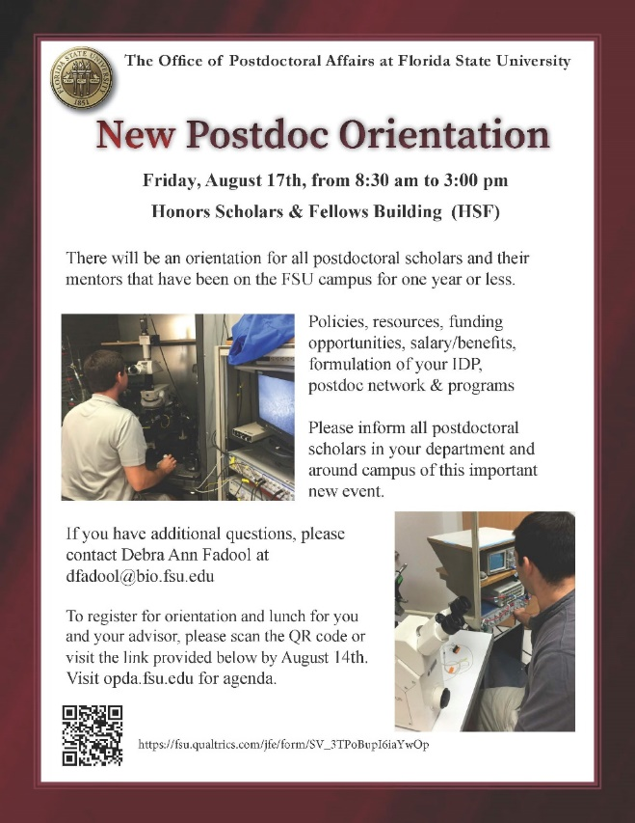
New Postdoctoral Orientation will be held on August 17, 2018 in the Nancy Marcus Great Hall of the Honors Scholar and Fellows Building (HSF), from 8:30 am to 3 pm. All new postdoctoral scholars on campus less than 6 months are required to attend.
Postdoctoral advisors/mentors are highly encouraged to accompany your postdoctoral scholar to assist in the development of the Individual Development Plan (IDP) that is required for individual investigator NIH research performance progress reports (RPPR).
Registration link is NOW open “Click Here”
For more information about the orientation, please see our archive and New Postdoctoral Orientation division of the website. Download Orientation flyer here.
‘Postdoc Made Good’ Special Mentoring Workshop & Lunch
KIN Life Science Building, Room 2057, 12:00 – 1:00 PM
Please welcome Dr. Anita Nag who will be this year’s ‘Postdocs Made Good’ invited guest from Furman University on July 23, 2018. Every wonder what it would be like to take on a one-year temporary position in academia? Come on out to ask her about transitioning as an FSU Postdoctoral Scholar to a university position as a Visiting Assistant Professor in Chemistry. Lunch will be provided. Senior graduate scholars and postdoctoral scholars are welcome! For questions, please contact Dr. Kay Jones. No registration required.

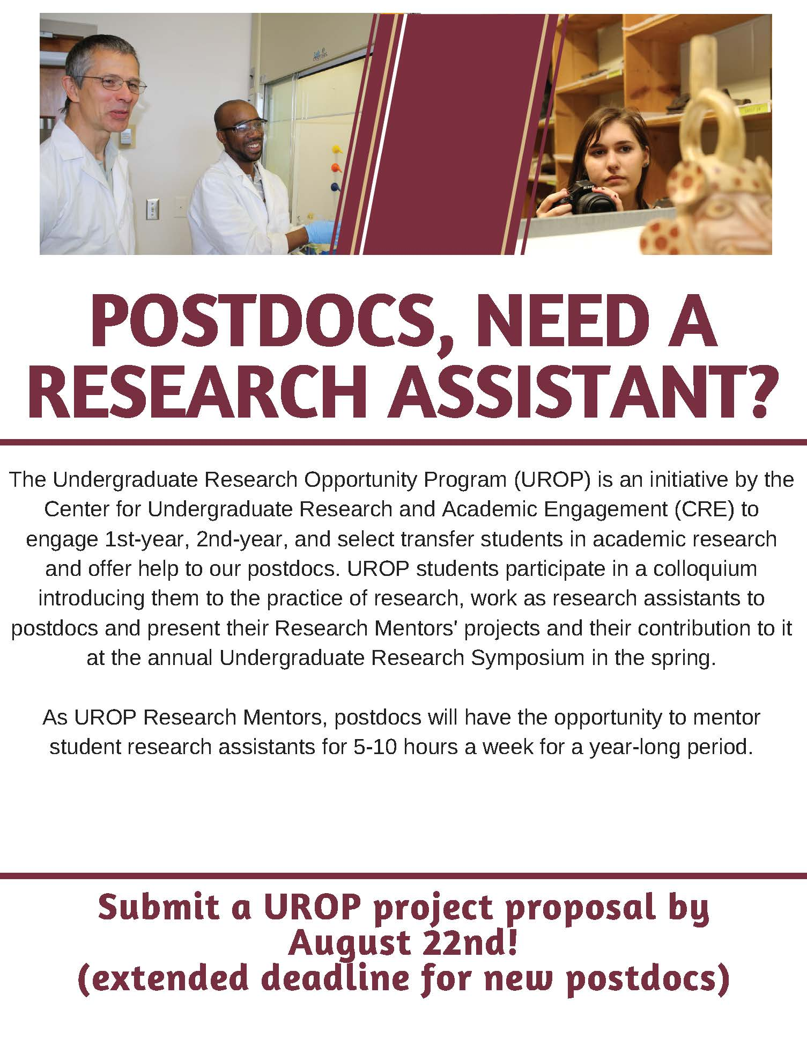
Undergraduate Research Opportunity Program (UROP)

Could you use a research assistant for the 2018-2019 academic year (at no cost to you and up to $250 to help cover the cost of research materials)?
Why not consider becoming a UROP Mentor? Come learn about the Undergraduate Research Opportunity Program (UROP) at one of the info sessions listed on the flyer.

UROP helps FSU first & second year, and transfer students in all majors, get started in research.

If you are interested in this exciting opportunity, you can find more information by visiting: https://fla.st/2rwKjGh.

New National Database for Postdoctoral funding
A new postdoctoral-centered, searchable database of 275 funding opportunities for postdoctoral scholars has been released by John Hopkins University. Please check it out for good ideas for your next extramural grant/award application! Remember that if you submit an extramural application to a federally supported or major other mechanism, then you are eligible to receive a $1,000 intramural award from the OPDA to use for your general research-related expenses at FSU.
John Hopkins University Funding Resources
Cancer control research training program
The University of Rochester Medical Center Cancer Control & Psychoneuroimmunology Laboratory is actively seeking outstanding candidates for their upcoming group of Fellows for 2018. The applicants should be interested in longitudinal studies and clinical trials on translational (e.g. biomarker) symptom science research and/or cancer-related cognitive impairment research to work closely with Dr. Michelle Janelsins (Associate Professor) and her research team. Candidates they are interested in come from a variety of backgrounds including, but not limited to, neuroscience, cognitive science, clinical psychology, epidemiology, clinical trials, applied sciences, and many more.
For more information, and to apply, please click here.
Materials can be sent directly to Dr. Michelle Janelsins or Dr. Gary Morrow (Program Director)
Fellowships
Moffitt Cancer Center – Innovation Fellowship
This two-year fellowship program within the Office of Innovation & Industry Alliances is
designed to train STEM PhD graduates having little knowledge of academic technology transfer with what they need to know to be hired into any technology transfer office (TTO) or related position in the U.S.
Click Here to go to website for more information.
Currently accepting applications until July 1, 2018
For more information email Carol.Waits@Moffitt.org
TRIUMPH Postdoctoral Fellowship
Application deadline: June 30, 2018

Helen Hay Whitney Fellowship for Biomedical Research
Application deadline: No later than 5pm EST, July 2, 2018

The Company of Biologists – Traveling Fellowships
Next deadline: August 31, 2018
Postdoc Research Funding Opportunities in Germany
Application deadlines vary
Index of Postdoc Fellowships in the Life Sciences (Broad Institute)
EPA Research Grants

Use the following databases to identify additional opportunities (click on the links) – Pivot, Foundation Center
Jobs
Below is a sampling of open positions in the United States –

Florida College System, seeks to fill a position for Executive Director, Florida Student Success Center.

The Florida Student Success Center (FSSC) serves as an intermediary between colleges, and provides greater opportunities for colleges to collaborate and learn from one another. The Executive Director works under the supervision of the Chancellor of the Florida College System.
For more information on the role of the position, qualifications and to apply please click here.
Assistant Professor – Clinical Scientist
Louisiana State University, Baton Rouge, LA

Research Scientist – Immunochemistry Development & Validation Team - 142521
Pharmaceutical Product Development, LLC, Richmond, VA
Assistant Teaching Professor – Marine Biology (Job # JPF01747)
Scripps Institution of Oceanography, UC San Diego, San Diego, CA
Scientist - Chemistry
Cayman Chemical, Ann Arbor, MI

Assistant Professor – Human Sciences – Ag. Nutrition & Human Ecology
Prairie View A&M University, Prairie View, TX

Director’s Fellowship Postdoctoral Researcher: Scientist
National Renewable Energy Laboratory, Golden, CO

Project Manager, Student Communities/Learning and Career Development
American Chemical Society, Washington, DC

Science Editor for Educational Media – Tracking Code: 774-908
Howard Hughes Medical Institute, Chevy Chase, MD
Postdoctoral Fellowship in Cognitive Aging
School of Psychology, Georgia Institute of Technology, Atlanta, GA

Assistant Professor Positions – Exercise Physiology (Job ID: 42380) & Nutrition (Job ID:42371)
FSU College of Human Sciences, Department of Nutrition, Food & Exercise Sciences
Assistant Professor of Research – Center for Craniofacial Molecular Biology
University of Southern California (USC), Biomedical Sciences

Assistant Professor – Clinical Occupational Therapy
University of Southern California, Occupational Therapy
Assistant Professor – Research Emergency Medicine
University of Southern California, Department of Emergency Medicine
Clinical Assistant Professor – Pediatrics
University of Southern California, Department of Pediatrics
Below is a sampling of open positions around the world -
Canada: Assistant Clinical Professor – in Pharmacy & Pharmaceutical Science
University of Alberta, Faculty of Pharmacy & Pharmaceutical Sciences

Tenure Track Assistant Professor – Biomedical or Electrical Engineering
University of Guelph, School of Engineering/Biomedical Engineering
Assistant Professor – REHAB Occupational Therapy
University of Alberta, Department of Occupational Therapy
Assistant Professor – Microbial Science & Micro/Nanomaterials
University of Calgary Canada First Research Excellence Fund
Assistant Professor – Department of Medicine
University of Alberta, Faculty of Medicine & Dentistry
Assistant Professor – Division of Developmental Pediatrics
University of Alberta, Faculty of Medicine & Dentistry

Staff Scientist in Hematology Research
Keenan Research Centre for Biomedical Research of St. Michael’s Hospital
Japan: Assistant Professor in the Graduate School of Biomedical & Health Sciences
Hiroshima University, Graduate School of Biomedical & Health Sciences

Assistant Professor in Medical Education, Pharmacology, Neuroscience
Hiroshima University, Graduate School of Biomedical & Health Sciences

Norway: Head Engineer at Electron Microscopy Core Facility
University of Oslo, Department of Biosciences (IBV)
Singapore: Assistant Professor for Bio-Behaviorist
Duke NUS Medical School, Academic Medicine Research Institute

Assistant Professor – Center for Aging Research & Education
Duke NUS Medical School, Center for Aging Research & Education
South Africa: Associate Researcher in Clinical Micro Infectious Diseases (CMID)
Wits University, School of Pathology, Johannesburg, ZA
Switzerland: PhD in Biomedical Engineering
University of Basel, Adaptable MRI Technology
Click here for featured Biology careers
Subscribe to receive personalized job announcement emails:
Bio Careers
Academic Keys
PhD Jobs
Fierce Biotech Jobs

ASBMB - American Society for Biochemistry and Molecular Biology
http://www.asbmb.org/careers/ (career information)
Career Development Webinars and Blogs
Should You reach Out to Potential Colleagues Before the Campus Interview?
Read an article, where the author states calling or emailing ahead of time might seem like a good way to get information about the place, but it’s more than a little risky.
Interview prep is key to hitting your job search target
In this article the author continues to provide tips to make it to the interview stage.

Summer Advocacy Activities for Scientists – FASEB Webinar
Wednesday, June 27, 2018 2:00 pm – 3:00 pm EDT

Career Path: “Leveraging Your PhD for Career Success” – Bio Careers Webinar
Wednesday, July 18, 2018 1:00 pm – 2:00 pm EDT

Career Path: “What industry can offer: Tips for putting your foot inside the door” – Webinar
Wednesday, August 29, 2018 1:00 pm – 2:00 pm EDT Bio Careers

How to Be Proactive in Your Mentoring Relationships – National Postdoctoral Association http://www.nationalpostdoc.org/?page=Proactive
ASBMB - Postdoctoral Education & Resources

Versatile PhD
This site helps graduate students and new PhD’s identify, prepare for, and excel in possible non-academic careers.
Click here to learn more. Click here to join
Free NPA Membership
FSU is a sustaining member of the National Postdoctoral Association (NPA). This membership provides free affiliate membership to all FSU postdoctoral scholars. Benefits of joining the NPA include:
    - A subscription to the NPA’s official quarterly newsletter
    - Reduced registration fees to the NPA Annual Meeting
    - Eligibility for the NPA Travel Award Program
    - Professional & Leadership Development
    - Networking opportunities with colleagues nationwide
If you are interested in joining the National Postdoctoral Association, click here.
Please email opda-info@fsu.edu if you encounter any problems.
For previous issues, click here!

