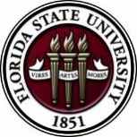
Florida State University
OFFICE OF POSTDOCTORAL AFFAIRS WEEKLY DIGEST

March 5, 2018

Upcoming Events
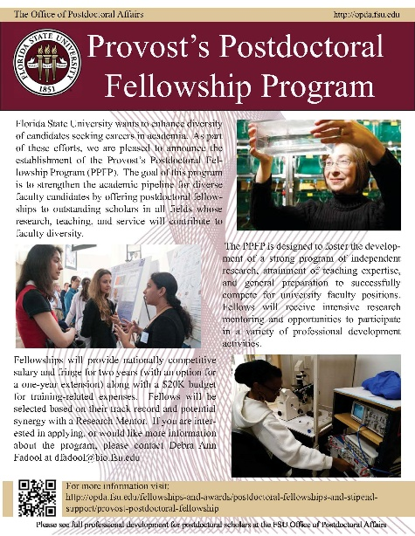
PPFP Program – Applications now Being Accepted!
Florida State University is launching a new training program called the Provost Postdoctoral Fellowship Program (PPFP) that will support the training of postdoctoral scholars for a two year fellowship with the goal to increase diversity of faculty entering academia. 10 PPFP fellows will be supported (salary, fringe, plus up to a 20K training-related expense internal award) through generous funding from the Provost/VP Faculty Development. Applicants must identify a faculty mentor to provide a letter of nomination for this mentored-guided training. Please see the OPDA for more information concerning eligibility and required application materials. Questions? Please direct to Debra Fadool, Director of the Office of Postdoctoral Affairs.
Postdoctoral scholars can start pairing with faculty mentors to submit their applications – Portal is NOW open!

NEW POSTDOCTORAL ASSOCIATION MEMBERS BEING SOUGHT
The FSU PDA is looking for new representatives to help lead postdoctoral events and policies across campus and especially in several departments including Chemistry, Magnet Lab, Humanities, Engineering, College of Medicine, among others! If you want to network and gain leadership experience as a postdoctoral scholar, please join us for our next PDA meeting at 5:30 pm, Monday, March 5th in Room 3075, KIN Life Science Building. PIZZA will be provided to inspire those Spring Event planning thoughts and ideas!!!! Hope to see you there. Questions, contact, Debi Fadool, Director of OPDA at dfadool@bio.fsu.edu
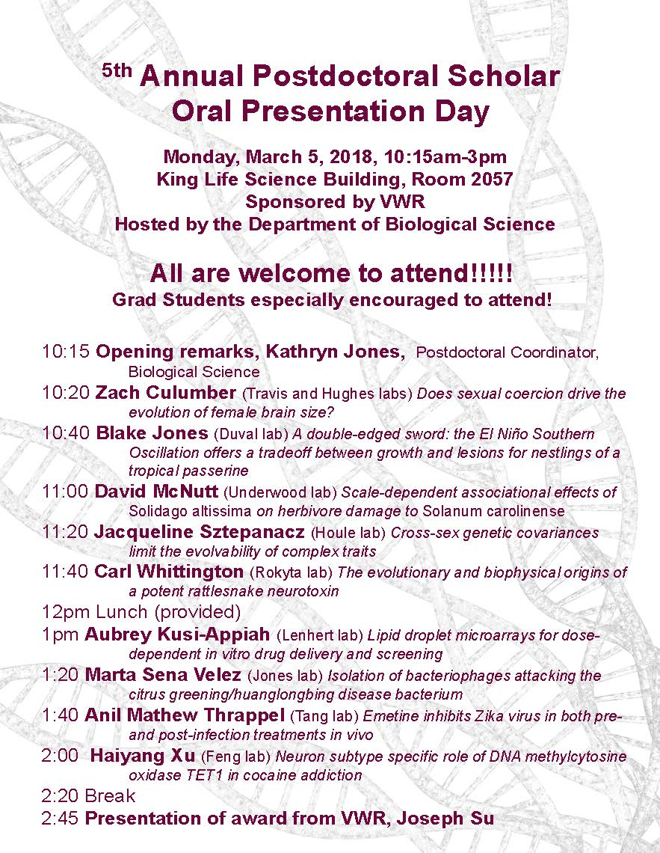
Oral Postdoctoral Competition – March 5th 10:15 am to 3 pm
EVENT IS TODAY!
ome on out to hear your fellow postdoctoral scholar participate in the Oral Presentation Day and hear the interesting research ongoing across the campus! There will be a $1000 prize as a donation from VWR brand supplies for lab-related expenses to the postdoc with the highest score! Lunch will be provided for participants and judges.
Questions?? See Dr. Kay Jones, Associate Professor Biological Science at kmjones@bio.fsu.edu.

Biological Science/Neuroscience Postdoctoral Mentoring Workshop & Lunch
KIN Life Science Building, Room 2057, 12:00 – 1:00 PM

Please mark your calendar for the Spring 2018 postdoc workshops. This is a special, faculty-led monthly workshop for Postdoctoral Scholars hosted by the Department of Biological Science and the Program in Neuroscience. Although the career focus will be directed to the Life Sciences, all Postdoctoral Scholars and senior Graduate Students are welcome. Sandwiches will be served over the lunch hour during the workshops. Dates and topics are listed below. For questions, please contact Dr. Kay Jones. No registration required.

Date | Presenter | Title
Monday Mar. 5, 2018 | SEE ABOVE! | Postdoc Oral Competition – 10 AM – 3 PM
Monday April 9, 2018 | Dr. Joe Travis | Understanding the Structure of a Typical (US) University
TBA | Dr. Anita Nag, Furman University | FSU Postdocs Made Good

ASCB-KGI Biotech Course
The American Society for Cell Biology (ASCB), in partnership with the Keck Graduate Institute, is offering a one-week intensive course from July 9-14, 2018, at the Keck Graduate Institute in Claremont, CA. This course will accommodate 50 graduate students and postdocs (international and domestic). The course registration fee is $525, with an additional, optional accommodations package of $350. Application window is now open and will close April 13.
For more information and to apply, click here.
POSTDOCTORAL SPRING EVENT – MAY 11TH
Please hold the date!
Announcing plans for the Postdoctoral Spring Event on May 11th at the Honors Scholars and Fellows House building (Nancy Marcus Great Hall)
The postdoctoral association and the OPDA are planning our 5th annual Spring Event and enthusiastically want to tell you about upcoming confirmed speakers! Jessica Lee (founder of The Pregnant Scholar – an organization supported and sponsored by the National Science Foundation) and Jabbar Bennet (Associate Provost and Chief Diversity Officer at Northwestern University) will be coordinating a program concerning women in research and how diversity drives research to a new level. These gifted and knowledgeable speakers will work life balance, how to handle differential treatment, how cultural differences enhance research, and national surveys performed with NSF support on the advances of culturally diverse groups and women with respect to achieving postdoctoral positions and faculty tenure. How do you obtain a permanent job commensurate with your training and identify a good work environment? Postdoctoral advisor’s and senior graduate students are encouraged to attend along with our postdoctoral scholars to enhance awareness of modern postdoctoral training. Hope you can join us!
If you are interested in helping develop the afternoon, please contact Sarah Baisley and Marta Sena, president and vice-president of the PDA. For questions about the event, please contact Debi Fadool, Director of the OPDA.
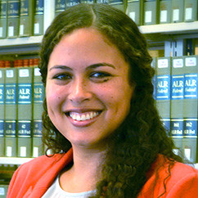
Jessica Lee, Founder of The Pregnant Scholar.org – an organization supported and sponsored by the National Science Foundation.
Worklife Law, University of California, Hastings College of Law
http://www.thepregnantscholar.org/

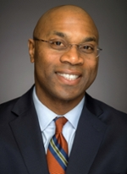
Jabbar Bennet, Associate Provost & Chief Diversity Officer at Northwestern University.
Associate Professor of Medicine, Northwestern University’s Feinberg School of Medicine.
http://www.northwestern.edu/provost/about/bios/jabbar-bennett.html
New National Database for Postdoctoral funding
A new postdoctoral-centered, searchable database of 275 funding opportunities for postdoctoral scholars has been released by John Hopkins University. Please check it out for good ideas for your next extramural grant/award application! Remember that if you submit an extramural application to a federally supported or major other mechanism, then you are eligible to receive a $1,000 intramural award from the OPDA to use for your general research-related expenses at FSU.
John Hopkins University Funding Resources
Cancer control research training program
The University of Rochester Medical Center Cancer Control & Psychoneuroimmunology Laboratory is actively seeking outstanding candidates for their upcoming group of Fellows for 2018. The applicants should be interested in longitudinal studies and clinical trials on translational (e.g. biomarker) symptom science research and/or cancer-related cognitive impairment research to work closely with Dr. Michelle Janelsins (Associate Professor) and her research team. Candidates they are interested in come from a variety of backgrounds including, but not limited to, neuroscience, cognitive science, clinical psychology, epidemiology, clinical trials, applied sciences, and many more.
They will begin interviewing candidates in January 2018. For more information, and to apply, please click here.
Materials can be sent directly to Dr. Michelle Janelsins or Dr. Gary Morrow (Program Director)
National Postdoctoral Association Conference
Join the NPA for their 2018 Annual Conference held April 6-8, 2018 in Cleveland, OH
The NPA states this is largest national conference and networking event dedicated to the postdoctoral community. Postdoctoral scholars, administrators, faculty, and representatives from disciplinary societies, industry, and corporations – are provided with the opportunity to gather and enhance their professional development and leadership skills.
For more information, and to register for the conference, click here!
Fellowships
American Cancer Society Postdoctoral Fellowships
Application deadline: April 2, 2018
The Company of Biologists – Traveling Fellowships
Deadlines vary throughout the year. Please click above for dates.

American Diabetes Association Mentor Based Postdoctoral Fellowship
Application deadline: April 16, 2018 for January 1, 2019 funding.

Helen Hay Whitney Fellowship for Biomedical Research
Application deadline: No later than 5pm EST, July 2, 2018

Index of Postdoc Fellowships in the Life Sciences (Broad Institute)

EPA Research Grants

Use the following databases to identify additional opportunities (click on the links) – Pivot, Foundation Center

Jobs
Below is a sampling of open positions in the United States –

Florida College System, seeks to fill a position for Executive Director, Florida Student Success Center.

The Florida Student Success Center (FSSC) serves as an intermediary between colleges, and provides greater opportunities for colleges to collaborate and learn from one another. The Executive Director works under the supervision of the Chancellor of the Florida College System.
For more information on the role of the position, qualifications and to apply please click here.
Assistant Professor – Tree Improvement Cooperative
North Carolina State University, Raleigh, NC

Institute Research Scientist – Translational Biology
MD Anderson Cancer Center, Houston, TX

Assistant Professor – International & Global Studies (Job ID: F19-008)
Mercer University, Macon, GA

Engineer – Junior Dev Ops
Trusted Knowledge Options Inc., Springfield, VA

Research Assistant Professor – The Bio Manufacturing Research Institute & Technology
North Carolina Central University, Durham, NC

Research Scientist – Statistics or Biostatistics (Job ID: 39107)
Eli Lilly, Indianapolis, IN

Assistant Professor Positions – Exercise Physiology (Job ID: 42380) & Nutrition (Job ID:42371)
FSU College of Human Sciences, Department of Nutrition, Food & Exercise Sciences
Assistant Professor of Research – Center for Craniofacial Molecular Biology
University of Southern California (USC), Biomedical Sciences

Assistant Professor – Clinical Occupational Therapy
University of Southern California, Occupational Therapy
Assistant Professor – Research Emergency Medicine
University of Southern California, Department of Emergency Medicine
Clinical Assistant Professor – Pediatrics
University of Southern California, Department of Pediatrics

University of Washington Faculty Positions
The College of Engineering & School of Medicine is accepting applications for tenure-track Assistant Professor position in the Department of Bioengineering. Download flyer for more information. To apply, click here.

Postdoctoral Position in Public Participation in Digitization of Biodiversity Collections
A postdoctoral position is available with iDigBio in the research group of Prof. Austin Mast (Department of Biological Science, Florida State University; http://www.bio.fsu.edu/faculty-mast.php) to study engagement of the public in the digitization of biodiversity research
collections, especially as it relates to the community’s Worldwide Engagement for Digitizing Bio collections (WeDigBio) Event. iDigBio (www.idigbio.org) is the US NSF's National Resource for Advancing Digitization of Biodiversity Collections, and it is located at the University of Florida and Florida State University. The WeDigBio Event (www.wedigbio.org) is an annual, 4-day event that mixes onsite engagement at museums, universities, etc. with engagement of distributed participants to produce an exciting, educational global data campaign for science. New developments that could be a part of this postdoc’s activities include the build-out of the nascent WeDigBio virtual science festival, creation of virtual reality bio collections tours, and completion of a strategic plan for the WeDigBio Event. The WeDigBio Event has a history of innovation, including in the area of augmented reality.
To apply, send a cover letter and CV with contact information for three references in a single pdf file to Austin Mast (amast@bio.fsu.edu). In the cover letter, please cite past activities that demonstrate each of (1) through (4) above as well as provide the
date on which you could start the position and a paragraph or two on your long-term career goals and how you see this position fitting into them. Applications will be considered beginning on Nov 15, 2017 until the position is filled.
Below is a sampling of open positions around the world -
Canada: Assistant Clinical Professor – in Pharmacy & Pharmaceutical Science
University of Alberta, Faculty of Pharmacy & Pharmaceutical Sciences

Tenure Track Assistant Professor – Biomedical or Electrical Engineering
University of Guelph, School of Engineering/Biomedical Engineering
Assistant Professor – REHAB Occupational Therapy
University of Alberta, Department of Occupational Therapy

Assistant Professor – Microbial Science & Micro/Nanomaterials
University of Calgary Canada First Research Excellence Fund
Assistant Professor – Department of Medicine
University of Alberta, Faculty of Medicine & Dentistry
Assistant Professor – Division of Developmental Pediatrics
University of Alberta, Faculty of Medicine & Dentistry

Staff Scientist in Hematology Research
Keenan Research Centre for Biomedical Research of St. Michael’s Hospital
Japan: Assistant Professor in the Graduate School of Biomedical & Health Sciences
Hiroshima University, Graduate School of Biomedical & Health Sciences

Assistant Professor in Medical Education, Pharmacology, Neuroscience
Hiroshima University, Graduate School of Biomedical & Health Sciences

Norway: Head Engineer at Electron Microscopy Core Facility
University of Oslo, Department of Biosciences (IBV)
Singapore: Assistant Professor for Bio-Behaviorist
Duke NUS Medical School, Academic Medicine Research Institute

Assistant Professor – Center for Aging Research & Education
Duke NUS Medical School, Center for Aging Research & Education
South Africa: Associate Researcher in Clinical Micro Infectious Diseases (CMID)
Wits University, School of Pathology, Johannesburg, ZA
Switzerland: PhD in Biomedical Engineering
University of Basel, Adaptable MRI Technology

Click here for featured Biology careers

Subscribe to receive personalized job announcement emails:
Bio Careers
Academic Keys
PhD Jobs
Fierce Biotech Jobs

ASBMB - American Society for Biochemistry and Molecular Biology
http://www.asbmb.org/careers/ (career information)

Career Development Webinars and Blogs
The Grief of the Ex-Academic
In this article, the author tells the story about an ex-academic and what the decision to leave the professoriate behind says about graduate education.

Because a scientist says so
In this article, the author challenges scientists to not abuse their power, and sometimes admit that they do not know everything!

Reproducibility in crisis: Sample quality and the importance of early and ongoing analysis
Science Webinar, Wednesday, March 14, 2018 12pm – 1pm, ET

Making the most of your Ph.D. or postdoc webinar
Wed, March 28, 2018 1:00 PM – 2:00 PM EDT
How to Be Proactive in Your Mentoring Relationships – National Postdoctoral Association http://www.nationalpostdoc.org/?page=Proactive

Versatile PhD
This site helps graduate students and new PhD’s identify, prepare for, and excel in possible non-academic careers.
Click here to learn more. Click here to join
Free NPA Membership
FSU is a sustaining member of the National Postdoctoral Association (NPA). This membership provides free affiliate membership to all FSU postdoctoral scholars. Benefits of joining the NPA include:
    - A subscription to the NPA’s official quarterly newsletter
    - Reduced registration fees to the NPA Annual Meeting
    - Eligibility for the NPA Travel Award Program
    - Professional & Leadership Development
    - Networking opportunities with colleagues nationwide
If you are interested in joining the National Postdoctoral Association, click here.
Please email opda-info@fsu.edu if you encounter any problems.

For previous issues, click here!

