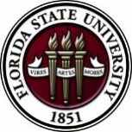
Florida State University
OFFICE OF POSTDOCTORAL AFFAIRS WEEKLY DIGEST

March 6, 2017

Upcoming Events

Biological Science/Neuroscience Postdoctoral Oral Competition Day
KIN Life Science Building, Room 2057, March 6, 2017, 10:15 am to 2 pm
Postdoctoral scholars will be delivering 12-minute research talks to a panel of faculty judges specializing in Biological Science and Neuroscience. If you are a junior postdoctoral scholar or senior graduate student, come on out and hear the interesting research projects of our active postdoctoral scholars! The intention of the event is to provide constructive feedback on your delivery and ability to communicate your science at a conference, data club, meeting brief, or job interview. Judges will complete a template to provide to all participants on the quality and methods of their oral ability. The winner of the oral competition will receive a $500 shopping spree in the VWR stock room on the first floor of the KIN building. Questions? Please contact Dr. Kay Jones, Biological Science.

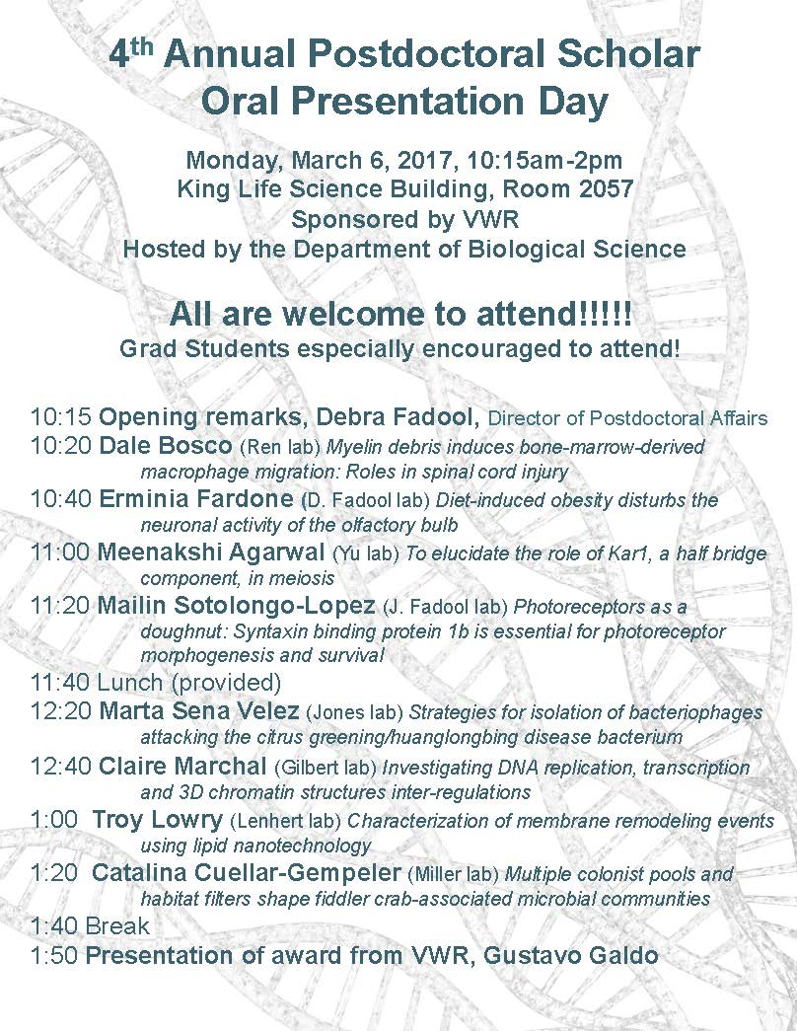

"Welcome" Mini-Orientation Sessions for New Postdoctoral Scholars on Campus
Honors, Scholars & Fellows House, Room 3009, April 24, 2017 12:00 PM
If you are a new postdoctoral scholar to the FSU campus, this “Welcome” is a nice brown bag lunch activity that will fit into your busy research schedule. The design will be limited to strictly a one-hour session, where you will receive the essentials of getting your research started at FSU and have access to Human Resources and Office of Postdoctoral Affairs Staff. At this time, you will also be introduced to the Postdoctoral Association (PDA) - your peer network of postdocs on campus. Attending a “welcome” in your few months of employment at FSU will serve to fulfill your mandatory orientation. Registration for April will open in late March; continue to check website http://opda.fsu.edu/upcoming-events-workshops/upcoming-events for link.

POSTDOCTORAL SPRING EVENT – Hold the Date – 19 may 2017
Matriculating to your Career after your Postdoctoral Training
Please save the date for this special afternoon workshop for postdoctoral scholars, senior graduate students, and mentors. Our keynote address will be given by Dr. Lori Conlan, Director of Postdoctoral Affairs at the National Institutes of Health (NIH). Dr. Conlan will help map the course to different pathways to be pursued in academia, industry, and federal government and the transferable skills that have been built during your postdoctoral training to transition you to these career tracks. She will present strategies for the application packet, interviewing, and securing the best position for your ambitions. We are thrilled she will share her experiences from her insight working with the NIH and her knowledge of postdoctoral hiring trends across the country. A potluck dinner for scholars, their lab mates, mentors, and family members will follow the afternoon event, so we hope you will come out to network and engage with the FSU postdoctoral community. Postdoctoral scholars interested in helping to organize this event please contact PDA President, Nikhil Gupta or Vice-president, Erminia Fardone.
Professional Development Workshops

Interviewing for Positions Outside of Academia: How to Prepare!
March 9, 2017, 3:30 PM – 5:00 PM
Honors, Scholars & Fellows House, Room 3009

Presenter: Amanda Sargent, Assistant Director, FSU Career Center
Interviewing is the most widely accepted method of selecting employees. The goal of an interview is to find out if you fit with the organization, if you have the skills you say you have, and if you can do the job. Based on your resume, they already have an idea of your skill set. So the primary reason for the interview is to assess your personality and to fact check your skills. This workshop will clarify your role as the interviewee and how to prepare. Refreshments will be provided by the Congress of Graduate Students.

To register: https://fsu.qualtrics.com/SE/?SID=SV_9Kvju7d2KCusHxb
Formative Assessment and Review Strategies (PIE/PFF/PFP)
March 23, 2017, 3:30 PM – 5:00 PM
Honors, Scholars & Fellows House, 4th Floor, Great Hall

Presenters: PIE Associates, Kate Hill, Biology, and Ana Ndumu, Information Science
Formative assessment strategies are effective ways of gauging ongoing student learning to provide feedback for both the student and teacher. In this session, participants will discover ways of monitoring student learning and improving content mastery through timely feedback and purposeful review activities. The presenters will provide tips for large and small classes in a variety of content areas.

Free PIE & Coffee Included!

To register: https://fsu.qualtrics.com/SE/?SID=SV_5tAXhpTLeE6QZZb

Negotiating Job Offers
March 24, 2017, 3:30 PM – 5:00 PM
Honors, Scholars & Fellows House, Room 3009

Presenter: Ms. Amanda Sargent, Assistant Director, FSU Career Center
Did you know that you can prepare to negotiate job offers? This workshop will include discussion of the uniqueness of each negotiation, factors that may be negotiated, what is involved in making the best decision, how to negotiate from a point of power, and the final steps.

To register: https://fsu.qualtrics.com/SE/?SID=SV_d6lw0AnGAjcwQpT

Faculty in a Research Institution: Expectations, Opportunities & Challenges
March 28, 2017, 8:30 AM – 12:00 PM
Honors, Scholars & Fellows House, 4th Floor, Great Hall

Presenters: FSU administrators and faculty
The workshop will help graduate students and postdoctoral scholars prepare for faculty responsibilities in a research work environment. Senior administrators will provide their perspectives on faculty life and/or current responsibilities at FSU. This workshop can be used for the “Career Development” requirement for the Preparing Future Faculty (PFF). Refreshments will be provided by the Congress of Graduate Students.

To register: https://fsu.qualtrics.com/SE/?SID=SV_6lOZ1IxTwzvQpHT

Engaging Students with Social Media, Apps & More! (PIE/PFF/PFP)
April 3, 2017, 3:30 PM – 5:00 PM
Honors, Scholars & Fellows House, 4th Floor, Great Hall
Presenter: Kendra Scholz, School of Communication
Learn about and practice using social media, apps, and more to help you engage your students both in and out of the classroom. You need not be a tech expert – all levels of experience are welcome! Come join us, and bring your laptop if you can (we will also have some laptops available for you to use)!

Free PIE & Coffee Included!

To register: https://fsu.qualtrics.com/SE/?SID=SV_6rqRsKdNQSP7AGh

Ace my networking & interviewing skills during a meal? How can I possibly talk & eat?
April 4, 2017, 11:00 AM – 12:30 PM
Honors, Scholars & Fellows House, Room 3009

Presenters: Ms. Amanda Sargent, Assistant Director, FSU Career Center; Dr. Judith Devine, Senior Associate Dean, FSU Graduate School

To register: https://fsu.qualtrics.com/SE/?SID=SV_1AGu4tLUGyWNFLn

Fellowships

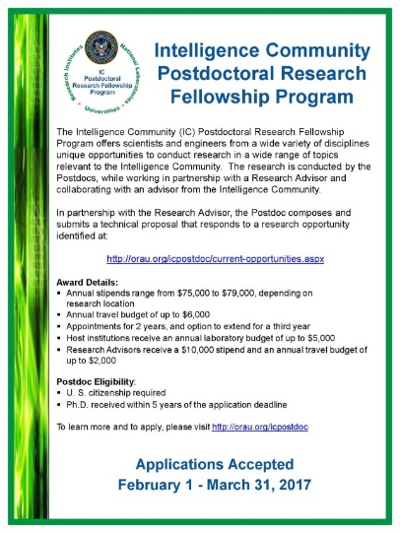

UMBC Postdoc / Pre-Professoriate Fellowship
UMBC Biology, Natural Sciences Pre-Professoriate Fellowship, 2017-2019
https://apply.interfolio.com/39954

The Department of Biological Sciences at the University of Maryland Baltimore County (UMBC) invites applications for the Natural Sciences Pre-Professoriate Fellowship. Candidates with research and teaching interests in all areas of Biological Sciences will be considered. The purpose of the Program is to support promising scholars who are committed to diversity in academia and prepare those scholars for a possible tenure track appointment at UMBC upon completion of the two-year appointment period. We are particularly interested in receiving applications from individuals who are members of groups that historically have been underrepresented in the professoriate.

The fellow will be appointed as Research Assistant Professor for a two-year term beginning August 17, 2017. The fellow will receive a starting stipend of $50,000, health benefits, $5,000 for conference travel and preparation of scholarly work, up to $5,000 in instrument services, up to $10,000 for supplies/consumables, lab space, office space with computer, library access, and other privileges at the university. During the two-year term of appointment, most of the fellow’s time will be devoted to pursuing research. In addition, the fellow will teach one course (one semester only) per year. Highly experienced research and teaching mentors will meet with the fellow regularly to provide guidance on developing a pedagogically sound teaching philosophy and plan, and improving the skills needed to pursue an academic research career, including proposal and manuscript writing, and technical presentation skills. The fellow will also benefit from professional development opportunities across the campus.

Candidates will be selected on the basis of scholarly promise and the potential to add to the diversity of the UMBC community. Applicants must have completed their doctoral degree when the term of appointment commences (August 17, 2017).
Application instructions: to apply, please visit https://apply.interfolio.com/39954
Deadline: Full consideration will be given to those applicants who submit all materials to https://apply.interfolio.com/39954 by March 15, 2017. A complete submission will consist of:

- Cover Letter
- Curriculum Vitae
- Three Letters of Reference
- Statement of Proposed Research Plan (2-3 pages)
- Personal Statement that details your demonstrated commitment to diversity efforts and the mission of UMBC, and why you should be selected for this position (1-3 pages)
- Teaching Statement (1-2 pages)

Questions regarding the program may be addressed to: Dr. Phyllis Robinson, probinso@umbc.edu, however all application materials MUST be submitted through Interfolio. The University of Maryland Baltimore County is an Equal Opportunity Employer/Affirmative Action. UMBC is the recipient of an NSF ADVANCE Institutional Transformation Award to increase the participation of women in academic careers.
https://apply.interfolio.com/39954

Damon Runyon (Cancer Research) Fellowship Award
https://www.damonrunyon.org/for-scientists/application-guidelines/fellowship/forms
Deadline: March 15, 2017 by 4:00 PM (EST)

Summer Scholarships in Epidemiology (Cystic Fibrosis Foundation)
https://www.cff.org/Our-Research/For-Researchers/Training-Awards/Summer-Scholarships-in-Epidemiology/
Deadline: April 1, 2017 by 5:00 PM (EST)

American Diabetes Association
http://professional.diabetes.org/meetings/core-program
Deadline April 17, 2017 by 8:00 PM (EST)

Research Training Groups in the Mathematical Sciences (RTG)
https://www.nsf.gov/funding/pgm_summ.jsp?pims_id=5732&org=DMS
Deadline: June 6, 2017 by 5:00 PM (EST)

Postdoctoral Program in Environmental Chemistry
http://dreyfus.org/awards/postdoctoral_program.shtml
Deadline: August 1, 2017

Mathematical Sciences Postdoctoral Research Fellowships (MSPRF)
https://www.nsf.gov/funding/pgm_summ.jsp?pims_id=5301&org=NSF&sel_org=NSF&from=fund
Deadline: October 18, 2017 by 5:00 PM (EST)

Use the following databases to identify additional opportunities (click on the links) – Pivot, Foundation Center

Jobs
Below is a sampling of open positions around the world.

Assistant Professor – Byers School of Nursing
https://jobs.walsh.edu/postings/693
Walsh University, North Canton, OH

Scientist – regenerative Medicine Neuro
https://www.houstonmethodistcareers.org/job/26683/scientist/
Houston Methodist Hospital, Houston, TX

Assistant/Professor – Department of Mechanical & Aerospace Engineering
https://jobs.virginia.edu/applicants/jsp/shared/position/PrinterFriendlyJobDetails.jsp?time=1488380576199
University of Virginia, Charlottesville, VA

Junior Data Scientist – Software-Development Operations
https://jobs.sap.com/job/San-Francisco-Senior-Data-Scientist-for-the-SAP_iO-Start-Up-Incubator-Team-Job-CA-94101/329876201/
SAP, San Francisco, CA

Assistant Professor – Department of Nutritional Sciences
http://careers.umich.edu/job_detail/135930/asst_professor_-_professor
University of Michigan, Ann Arbor, MI

Material Scientist/Engineer - Nanofabrication
https://www.facebook.com/careers/jobs/a0I1200000JY3dXEAT/
Facebook, Redmond, WA

Postdoctoral Research Associate – Cardiovascular
http://jobs.lifespan.org/us/en-US/Job-Details/Post-Doctoral-Research-Associate-Job/Rhode-Island-Hospital/XjdP-jf779-ct106221-jid52642139
Rhode Island Hospital, Providence, RI

Subscribe to receive personalized job announcement emails:
http://floridastate.biocareers.com
http://www.academickeys.com/all/subscribe.php
http://jobs.phds.org/alert.new
http://jobs.fiercebiotech.com
https://www.usajobs.gov/

ASBMB - American Society for Biochemistry and Molecular Biology
http://www.asbmb.org/careers/

Career Development Webinars and Blogs

Career Lingo: “Demonstrated Commitment to…”
https://chroniclevitae.com/news/1716-career-lingo-demonstrated-commitment-to
Learn what demonstrate commitment to, means to search committees & administrators.

What early-career researchers can do to advocate for science.
http://www.sciencemag.org/careers/2017/02/what-early-career-researchers-can-do-advocate-science
Learn how to get involved and be a voice for science.

Why Students Hate Peer Review
https://chroniclevitae.com/news/1718-why-students-hate-peer-review
Read advice on how to get students involved in reviewing other students work

How to Be Proactive in Your Mentoring Relationships – National Postdoctoral Association http://www.nationalpostdoc.org/?page=Proactive
Leveraging your PhD for Career Success (webinar)
Wed. March 15, 2017, 1:00 PM – 2:00 PM (EST)
Presenter: James Gould

To register: https://attendee.gotowebinar.com/register/3821074866723425026

Negotiating Your Way to a Job in Academia (webinar)
Wed. April 5, 2017, 1:00 PM – 2:00 PM (EST)
Presenter: James Gould

To register: https://attendee.gotowebinar.com/register/478591404121468418

Versatile PhD
This site helps graduate students and new PhD’s identify, prepare for, and excel in possible non-academic careers.
Click here to learn more. Click here to join
Free NPA Membership
FSU is a sustaining member of the National Postdoctoral Association (NPA). This membership provides free affiliate membership to all FSU postdoctoral scholars. Benefits of joining the NPA include:
    - A subscription to the NPA’s official quarterly newsletter
    - Reduced registration fees to the NPA Annual Meeting
    - Eligibility for the NPA Travel Award Program
    - Professional & Leadership Development
    - Networking opportunities with colleagues nationwide
If you are interested in joining the National Postdoctoral Association, click here.
Please email opda-info@fsu.edu if you encounter any problems.
For previous issues, click here

