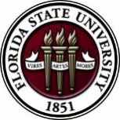
Florida State University
OFFICE OF POSTDOCTORAL AFFAIRS WEEKLY DIGEST

October 24, 2018

17th Annual Postdoctoral Association Conference
FSU wants to send at least one individual to the National Postdoctoral Association (NPA) Conference in April and will sponsor the travel. If you are interested in representing FSU in this capacity, please contact Debra Ann Fadool. The conference will be held in Orlando, Florida, April 12 – 14, 2019. Because of the close proximity, and the fact that Florida Institutions are coordinating to serve as the host university, we hope that several FSU postdoctoral scholars will attend and represent Florida State University. There will be a special career fair on Sunday April 14th with a wide range of employers – the event is free to all NPA members (which you all are with FSU’s institutional membership!) -
For more information about the NPA Conference, please click here.
Beyond the OPDA sponsoring at least one individual to the NPA, there are several ways in which you can apply for a Travel Award for the Conference.
Childcare Travel Award from the NPA (Nov 7th deadline) = https://www.nationalpostdoc.org/page/2019CCAwards
NPA General Travel Award (Nov 7th deadline) = https://www.nationalpostdoc.org/page/2019TravelAwards
FSU Professional Development Travel Award (Jan 1st deadline) = https://opda.fsu.edu/awards-and-fellowships/travel-awards

Mandatory sexual misconduct training for all employees
Important message from Florida State University President John Thrasher:
Every member of the campus community has a role in putting the written word into action. To that end, in Fall 2018, Florida State is launching a mandatory online sexual misconduct training for all employees (faculty, staff, and OPS). This training expands our existing training program and provides information about confidential resources, employee reporting responsibilities, and strategies to support impacted individuals.
Within the next week, you will receive an e-mail notification with the subject heading “FSU Sexual Misconduct Training - Required.” This e-mail will have a link that will take you directly to the training. You will have four (4) weeks to complete the self-paced training, which is estimated to take 30-45 minutes in total. Please take a moment to review the policy, the Title IX Statement (including frequently asked questions), and the University’s reporting portal:
- Sexual Discrimination and Sexual Misconduct Policy

- Title IX Statement

- REPORT.FSU.EDU

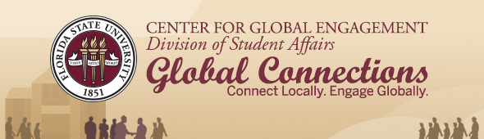
Join the CGE and the Mexican-American Student Association (MASA) on Wednesday, October 24, from 7-8:30 p.m. in The Globe Auditorium for an Intercultural Program Series event featuring Día de los Muertos, the Day of the Dead. Experience this Mexican holiday tradition of honoring the dead through interactive activities and more.
President of MASA Ruby Ramos-Basaldua, junior studying international affairs, welcomes everyone to attend the event.
“The Mexican-American Student Association has provided a home away from home for FSU Mexican-American Students as well as students interested in the culture," said Ramos-Basaldua. "We are excited to be able to share our culture on campus with the FSU community.”

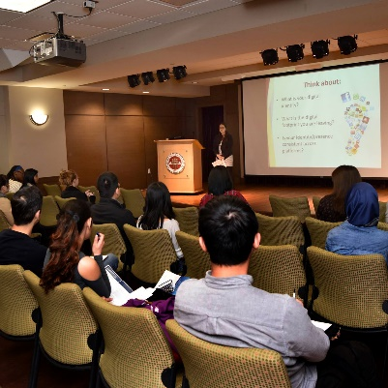
Jumpstart Your Career with Handshake (International Student Workshop)
Wednesday, October 24
2:00-4:00 p.m. | Globe Room 2400
Learn how to navigate the Career Center's complimentary job database and stand out as an applicant. Registration is required.
Register

Global Café China*
Friday, October 26
11:30 a.m. until food runs out | Globe Dining Room
Enjoy a culturally enriching lunch hour eating authentic food, listening to music, and meeting members from the Chinese Students and Scholars Associations.
Read More

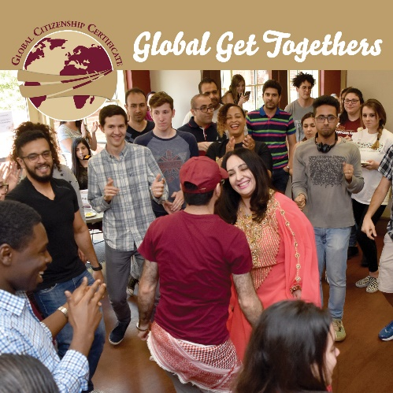
GCC Global Get Together
Sunday, October 28
4-6 p.m. | Globe Auditorium
Join us for food, fun, and community! Open to all Global Citizenship Certificate students, as well as students interested in learning more about the certificate.
Read More

Biological Science/Neuroscience Postdoctoral Mentoring Workshop & Lunch
Kin Life Science Building, room 2057, 12:00 – 1:00 PM
Please mark your calendars for the Fall 2018/Spring 2019 postdoc workshops. This is a special, faculty-led monthly workshop for Postdoctoral Scholars hosted by the Department of Biological Science and the Program in Neuroscience. Although the career focus will be directed to the Life Sciences, all Postdoctoral Scholars and senior Graduate Students are welcome. Sandwiches will be served over the lunch hour during the workshops. Dates, presenters and topics are listed below. For questions, please contact Dr. Kay Jones. No registration required.
Date | Presenter | Title
Mon. Sept. 10 | Dr. Peter Fajer, Cell & Molecular Biology Professor & Director of the Institute of Molecular Biophysics | How to make yourself palatable to academic search committees. A view from the other side of the table.
Mon. Oct. 8 | Dr. Scott Steppan, Professor of Ecology & Evolution in Biological Science | Interviewing for an academic position.
Tues. Nov. 13 | Dr. Qian Yin, Assistant Professor in Cell & Molecular Biology in Biological Science | Plan ahead: from K to interview
Mon. Dec. 10 | Dr. Scott Burgess, Assistant Professor in Ecology & Evolution in Biological Science | Thinking like the job you want
Mon. Jan. 14 | Dr. Yuan Wang, Assistant Professor Biomedical Sciences, College of Medicine & Neuroscience Program | Job search in Neuroscience: where to start and how to decide?
Mon. Feb. 11 | TBA | TBA
Mon. March 11 |  | Oral Presentation Day
Mon. April 8 | TBA

Graduate certificate in biomedical scientists as educators
Want to develop proficiency and acquire valuable strategies and skills to make you a better instructor? The University of Florida is hosting “The Graduate Certificate in Biomedical Scientist as Educators” program will help you develop the essential skills required to become an instructional leader in any teaching environment from writing a curriculum to developing a syllabus and your teaching philosophy. Whether you are a graduate student or postdoc seeking the teaching training to position yourself for your first academic job or a working professional looking to improve your teaching abilities, this certificate will prepare you to be a better and more effective educator. For more information regarding the program, please click here.
Cancer control research training program
The University of Rochester Medical Center Cancer Control & Psychoneuroimmunology Laboratory is actively seeking outstanding candidates for their upcoming group of Fellows for 2018. The applicants should be interested in longitudinal studies and clinical trials on translational (e.g. biomarker) symptom science research and/or cancer-related cognitive impairment research to work closely with Dr. Michelle Janelsins (Associate Professor) and her research team. Candidates they are interested in come from a variety of backgrounds including, but not limited to, neuroscience, cognitive science, clinical psychology, epidemiology, clinical trials, applied sciences, and many more.
For more information, and to apply, please click here.
Materials can be sent directly to Dr. Michelle Janelsins or Dr. Gary Morrow (Program Director)
Fellowships
AACR Gertrude B. Elion Cancer Research Award
Application Deadline: October 31, 2018, 1:00 PM, EST
The Company of Biologists – Traveling Fellowships
Next deadline: November 30, 2018
Postdoc Research Funding Opportunities in Germany
Application deadlines vary
Index of Postdoc Fellowships in the Life Sciences (Broad Institute)
EPA Research Grants

Jobs
Below is a sampling of open positions in the United States –
Postdoctoral Positions Available -
Looking for motivated Postdocs to research mechanisms involved in regulated remodeling of muscle T-tubule membranes in fly models of human myopathy with funding for immediate start date!
For more information, please click here to view flyer. Please contact Dr. Amy Kiger, Section of Cell & Development Biology, University of California, San Diego at: akiger@ucsd.edu.
Florida College System, seeks to fill a position for Executive Director, Florida Student Success Center.
The Florida Student Success Center (FSSC) serves as an intermediary between colleges, and provides greater opportunities for colleges to collaborate and learn from one another. The Executive Director works under the supervision of the Chancellor of the Florida College System.
For more information on the role of the position, qualifications and to apply please click here.
Assistant Professor – Organic Chemistry
Clemson University, Hunter, OH

Engineer - Research & Development Rocket Propulsion Chemist/Chemical
ERC, Inc., Edwards, CA

Assistant Professor – Linguistics - 311800
University of North Carolina at Chapel Hill, Chapel Hill, NC

Associate Scientist – Small Molecule Product Development
Wolfe Laboratories, Woburn, MA

Assistant Professor – Biological Science - Botany
Marshall University, Marshall, TX

Saw/Baw Technology Development Engineer – Job ID: 47999
Skyworks, Irvine, CA

Assistant Professor - Neurobiology
University of Wisconsin-Madison, Madison, WI
Assistant Professor Positions – Exercise Physiology (Job ID: 42380) & Nutrition (Job ID:42371)
FSU College of Human Sciences, Department of Nutrition, Food & Exercise Sciences
Assistant Professor of Research – Center for Craniofacial Molecular Biology
University of Southern California (USC), Biomedical Sciences

Assistant Professor – Clinical Occupational Therapy
University of Southern California, Occupational Therapy
Assistant Professor – Research Emergency Medicine
University of Southern California, Department of Emergency Medicine
Clinical Assistant Professor – Pediatrics
University of Southern California, Department of Pediatrics
Below is a sampling of open positions around the world -
Canada: Assistant Clinical Professor – in Pharmacy & Pharmaceutical Science
University of Alberta, Faculty of Pharmacy & Pharmaceutical Sciences

Tenure Track Assistant Professor – Biomedical or Electrical Engineering
University of Guelph, School of Engineering/Biomedical Engineering
Assistant Professor – REHAB Occupational Therapy
University of Alberta, Department of Occupational Therapy
Assistant Professor – Microbial Science & Micro/Nanomaterials
University of Calgary Canada First Research Excellence Fund
Assistant Professor – Department of Medicine
University of Alberta, Faculty of Medicine & Dentistry
Assistant Professor – Division of Developmental Pediatrics
University of Alberta, Faculty of Medicine & Dentistry

Staff Scientist in Hematology Research
Keenan Research Centre for Biomedical Research of St. Michael’s Hospital
Japan: Assistant Professor in the Graduate School of Biomedical & Health Sciences
Hiroshima University, Graduate School of Biomedical & Health Sciences

Assistant Professor in Medical Education, Pharmacology, Neuroscience
Hiroshima University, Graduate School of Biomedical & Health Sciences
Norway: Head Engineer at Electron Microscopy Core Facility
University of Oslo, Department of Biosciences (IBV)
Singapore: Assistant Professor for Bio-Behaviorist
Duke NUS Medical School, Academic Medicine Research Institute

Assistant Professor – Center for Aging Research & Education
Duke NUS Medical School, Center for Aging Research & Education
South Africa: Associate Researcher in Clinical Micro Infectious Diseases (CMID)
Wits University, School of Pathology, Johannesburg, ZA
Switzerland: PhD in Biomedical Engineering
University of Basel, Adaptable MRI Technology
Click here for featured Biology careers
Subscribe to receive personalized job announcement emails:
Bio Careers
Academic Keys
PhD Jobs
Fierce Biotech Jobs
ASBMB - American Society for Biochemistry and Molecular Biology
http://www.asbmb.org/careers/ (career information)
Career Development Webinars and Blogs
When You Communicate With Students, Tone Matters
Read an article where the author asks, do you really think talking down to undergraduates makes them want to work hard in your class?
The best way to learn about issues on the career road ahead
Read the author’s list of essential skills that today’s employers are looking for, in today, and tomorrow’s employees.

Webinar | Supersizing super resolution microscopy: Open-source approaches to accelerate your microscopy research Wednesday, October 24, 2018, 12 noon Eastern
Webinar | Time-resolved RNA profiling for cancer research and beyond
Wednesday, October 31, 2018, 3:00 p.m. ET
How to Be Proactive in Your Mentoring Relationships – National Postdoctoral Association http://www.nationalpostdoc.org/?page=Proactive
ASBMB - Postdoctoral Education & Resources
Versatile PhD
This site helps graduate students and new PhD’s identify, prepare for, and excel in possible non-academic careers.
Click here to learn more. Click here to join
Free NPA Membership
FSU is a sustaining member of the National Postdoctoral Association (NPA). This membership provides free affiliate membership to all FSU postdoctoral scholars. Benefits of joining the NPA include:
    - A subscription to the NPA’s official quarterly newsletter
    - Reduced registration fees to the NPA Annual Meeting
    - Eligibility for the NPA Travel Award Program
    - Professional & Leadership Development
    - Networking opportunities with colleagues nationwide
If you are interested in joining the National Postdoctoral Association, click here.
Please email opda-info@fsu.edu if you encounter any problems.
For previous issues, click here!

