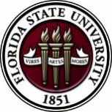
Florida State University
OFFICE OF POSTDOCTORAL AFFAIRS WEEKLY DIGEST

September 19, 2018

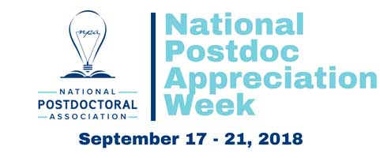

See the events that are going on locally at Florida State University! – Click on the “PIN” for Tallahassee!! https://www.nationalpostdoc.org/page/NPAW Two Highlighted events are listed below. To learn more about the National Postdoctoral Association and how they advocate for Postdoctoral Scholars, please click here. To find out about the next annual postdoctoral conference in beautiful Orlando, FL, please click here. If you would like to join our local postdoctoral association (PDA) here at FSU, please click here.
Fall Symposium and 5 Minute research competition! – September 21, 2018
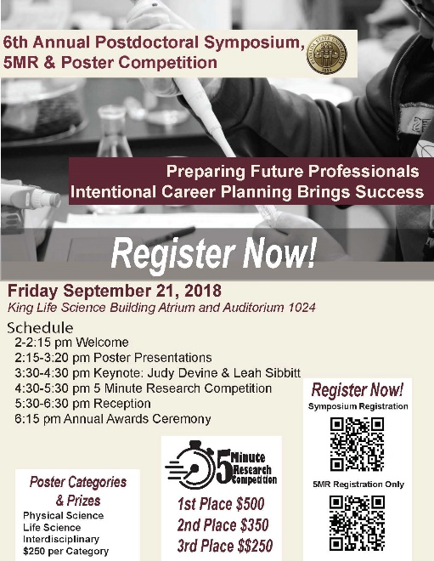
Are you a postdoc, postdoc advisor, administrator wanting more postdocs on campus, mentored by a postdoc, married to a postdoc??!!
Come on out to help us celebrate the National Postdoc Awareness Week at our 6th Annual Fall Symposium. Time to explore creative research across campus, hear about navigating the career you want, watch 5 minute research presentations, and socialize with other scholars at our reception & annual awards ceremony.
To register for the Fall Symposium click here
This year’s Fall Symposium will highlight a dual keynote address by our own Judy Devine and Leah Sibbitt. Dr. Devine will roll out the new Preparing Future Professional Program (PFP) along with the accompanying Preparing Future Faculty (PFF) that was launched last Spring as a program to guide Postdoctoral Scholars during their job search preparations. Ms. Leah Sibbitt, Director of the Career Center, will provide helpful tips in the job search process to include resources available to postdoctoral scholars and their spouses during the process of the job hunt.
5 Minute Research Competition
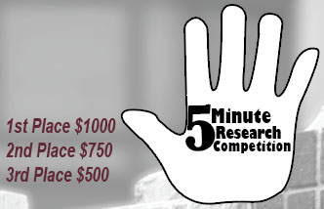
In celebration of the National Postdoctoral Awareness Week that is held in the third week of September, the Florida State University Office of Postdoctoral Affairs (OPDA) and Postdoctoral Association (PDA) are jointly hosting the sixth annual Fall Postdoctoral Poster Competition and Symposium. Poster awards will be $250 for first place in three divisions – Life Sciences, Physical Sciences, and Interdisciplinary/Humanities. New this year is a 5 Minute Research Competition – Hands Down the Best Event!!! The only two regulations are that you (1) have to explain the impact of your research in 5 minutes and (2) have to do so alone (no teams). You are allowed to use ANY medium you want (slides, video, sing, dance, recite literature, props – anything) but must appeal to an Educated Lay Audience, Reach Across your Discipline, and Challenge your Audience to Want to Know More! Prizes will be awarded, 1st - $1000, 2nd - $750, and People’s Choice - $500 (hint hint… Get your friends to attend!!!! ) and you must agree to be filmed. Competitors should email their final presentation to Ms. Williams at knwilliams@fsu.edu through the FSU dropbox by today, September 19th. Please see Debi Fadool for questions, dfadool@bio.fsu.edu
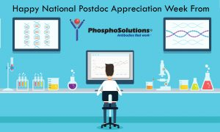

National Postdoc Appreciation Week!
Get 30% off your order
In honor of the Ninth Annual National Postdoc Appreciation Week (NPAW), PhosphoSolutions would like to recognize the achievements and contributions that all postdoctoral scholars make to scientific research and discovery!!!
Enter code NPAW at checkout to receive 30% off your entire order! Please more information, please click here.

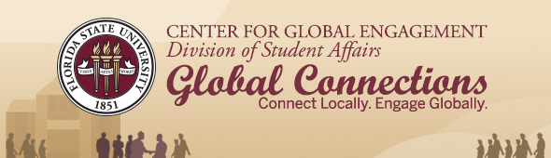
Exciting information for International students and postdoctoral scholars. Including Global Café with Global Cuisine hosted by International Associations with dates, Fellowships awarded, and events. For more information, please click here.

Biological Science/Neuroscience Postdoctoral Mentoring Workshop & Lunch
Kin Life Science Building, room 2057, 12:00 – 1:00 PM
Please mark your calendars for the Fall 2018/Spring 2019 postdoc workshops. This is a special, faculty-led monthly workshop for Postdoctoral Scholars hosted by the Department of Biological Science and the Program in Neuroscience. Although the career focus will be directed to the Life Sciences, all Postdoctoral Scholars and senior Graduate Students are welcome. Sandwiches will be served over the lunch hour during the workshops. Dates, presenters and topics are listed below. For questions, please contact Dr. Kay Jones. No registration required.
Date | Presenter | Title
Mon. Sept. 10 | Dr. Peter Fajer, Cell & Molecular Biology Professor & Director of the Institute of Molecular Biophysics | How to make yourself palatable to academic search committees. A view from the other side of the table.
Mon. Oct. 8 | Dr. Scott Steppan, Professor of Ecology & Evolution in Biological Science | Interviewing for an academic position.
Tues. Nov. 13 | Dr. Qian Yin, Assistant Professor in Cell & Molecular Biology in Biological Science | TBA
Mon. Dec. 10 | Dr. Scott Burgess, Assistant Professor in Ecology & Evolution in Biological Science | Thinking like the job you want
Mon. Jan. 14 | Dr. Yuan Wang, Assistant Professor Biomedical Sciences, College of Medicine & Neuroscience Program | TBA
Mon. Feb. 11 | TBA | TBA
Mon. March 11 |  | Oral Presentation Day
Mon. April 8 | TBA

Cancer control research training program
The University of Rochester Medical Center Cancer Control & Psychoneuroimmunology Laboratory is actively seeking outstanding candidates for their upcoming group of Fellows for 2018. The applicants should be interested in longitudinal studies and clinical trials on translational (e.g. biomarker) symptom science research and/or cancer-related cognitive impairment research to work closely with Dr. Michelle Janelsins (Associate Professor) and her research team. Candidates they are interested in come from a variety of backgrounds including, but not limited to, neuroscience, cognitive science, clinical psychology, epidemiology, clinical trials, applied sciences, and many more.
For more information, and to apply, please click here.
Materials can be sent directly to Dr. Michelle Janelsins or Dr. Gary Morrow (Program Director)

Fellowships
National Humanities Center Fellowships
Deadline: 11:59 pm ET, October, 17, 2018

AACR Gertrude B. Elion Cancer Research Award
Application Deadline: October 31, 2018, 1:00 PM, EST
The Company of Biologists – Traveling Fellowships
Next deadline: November 30, 2018
Postdoc Research Funding Opportunities in Germany
Application deadlines vary
Index of Postdoc Fellowships in the Life Sciences (Broad Institute)
EPA Research Grants

Jobs
Below is a sampling of open positions in the United States –

Postdoctoral Positions Available -
Looking for motivated Postdocs to research mechanisms involved in regulated remodeling of muscle T-tubule membranes in fly models of human myopathy with funding for immediate start date!
For more information, please click here to view flyer. Please contact Dr. Amy Kiger, Section of Cell & Development Biology, University of California, San Diego at: akiger@ucsd.edu.

Florida College System, seeks to fill a position for Executive Director, Florida Student Success Center.
The Florida Student Success Center (FSSC) serves as an intermediary between colleges, and provides greater opportunities for colleges to collaborate and learn from one another. The Executive Director works under the supervision of the Chancellor of the Florida College System.
For more information on the role of the position, qualifications and to apply please click here.
Assistant Professor – Department of Chemistry
Clemson University, Hunter, OH

Research Investigator, Chemical Engineering (PhD)
DuPont, Richmond, VA

Research Assistant Professor – Department of Surgery
University of Pittsburgh, Pittsburgh, PA

Materials Research Chemist/Engineer (Req. ID:29085)
Cooper Tire & Rubber Company, Findlay, OH

Assistant Professor – Department of Anthropology
University of Memphis, Memphis, TN

Scientist I/II – Chemical & Materials Engineering
Vertex Pharmaceuticals, Boston, MA
Tenure-Track Assistant Professor – CALS Ecology & Evolutionary Biology
Cornell University, Ithaca, NY
Assistant Professor Positions – Exercise Physiology (Job ID: 42380) & Nutrition (Job ID:42371)
FSU College of Human Sciences, Department of Nutrition, Food & Exercise Sciences
Assistant Professor of Research – Center for Craniofacial Molecular Biology
University of Southern California (USC), Biomedical Sciences

Assistant Professor – Clinical Occupational Therapy
University of Southern California, Occupational Therapy
Assistant Professor – Research Emergency Medicine
University of Southern California, Department of Emergency Medicine
Clinical Assistant Professor – Pediatrics
University of Southern California, Department of Pediatrics
Below is a sampling of open positions around the world -
Canada: Assistant Clinical Professor – in Pharmacy & Pharmaceutical Science
University of Alberta, Faculty of Pharmacy & Pharmaceutical Sciences

Tenure Track Assistant Professor – Biomedical or Electrical Engineering
University of Guelph, School of Engineering/Biomedical Engineering
Assistant Professor – REHAB Occupational Therapy
University of Alberta, Department of Occupational Therapy
Assistant Professor – Microbial Science & Micro/Nanomaterials
University of Calgary Canada First Research Excellence Fund
Assistant Professor – Department of Medicine
University of Alberta, Faculty of Medicine & Dentistry
Assistant Professor – Division of Developmental Pediatrics
University of Alberta, Faculty of Medicine & Dentistry

Staff Scientist in Hematology Research
Keenan Research Centre for Biomedical Research of St. Michael’s Hospital
Japan: Assistant Professor in the Graduate School of Biomedical & Health Sciences
Hiroshima University, Graduate School of Biomedical & Health Sciences

Assistant Professor in Medical Education, Pharmacology, Neuroscience
Hiroshima University, Graduate School of Biomedical & Health Sciences
Norway: Head Engineer at Electron Microscopy Core Facility
University of Oslo, Department of Biosciences (IBV)
Singapore: Assistant Professor for Bio-Behaviorist
Duke NUS Medical School, Academic Medicine Research Institute

Assistant Professor – Center for Aging Research & Education
Duke NUS Medical School, Center for Aging Research & Education
South Africa: Associate Researcher in Clinical Micro Infectious Diseases (CMID)
Wits University, School of Pathology, Johannesburg, ZA
Switzerland: PhD in Biomedical Engineering
University of Basel, Adaptable MRI Technology
Click here for featured Biology careers
Subscribe to receive personalized job announcement emails:
Bio Careers
Academic Keys
PhD Jobs
Fierce Biotech Jobs
ASBMB - American Society for Biochemistry and Molecular Biology
http://www.asbmb.org/careers/ (career information)
Career Development Webinars and Blogs
Will Students Actually Believe They Can Do This Assignment?
In this article, the more that students believe they can succeed in your course, the more motivated they will be to try.
Why this postdoc is working to make venomous snake research safer and more inclusive
Read an article where a postdoc scholar is working to make her research much safer, and is receiving an outstanding postdoc fellowship at her university as result.

Deciphering aging: Linking senescence with DNA damage and the cell cycle
Webinar, Wednesday, September 19, 2018, 12:00 pm ET

Driving precision medicine through biostatistics: Translating multiomics biomarker data into breakthrough knowledge Webinar, Wednesday, October 3, 2018 12:00 pm ET

Upgrading your recombinant protein expression: Expert advice on optimizing mammalian cell-based production Webinar, Wednesday, October 10, 2018, 12:00 pm ET

How to Be Proactive in Your Mentoring Relationships – National Postdoctoral Association http://www.nationalpostdoc.org/?page=Proactive
ASBMB - Postdoctoral Education & Resources
Versatile PhD
This site helps graduate students and new PhD’s identify, prepare for, and excel in possible non-academic careers.
Click here to learn more. Click here to join
Free NPA Membership
FSU is a sustaining member of the National Postdoctoral Association (NPA). This membership provides free affiliate membership to all FSU postdoctoral scholars. Benefits of joining the NPA include:
    - A subscription to the NPA’s official quarterly newsletter
    - Reduced registration fees to the NPA Annual Meeting
    - Eligibility for the NPA Travel Award Program
    - Professional & Leadership Development
    - Networking opportunities with colleagues nationwide
If you are interested in joining the National Postdoctoral Association, click here.
Please email opda-info@fsu.edu if you encounter any problems.
For previous issues, click here!

