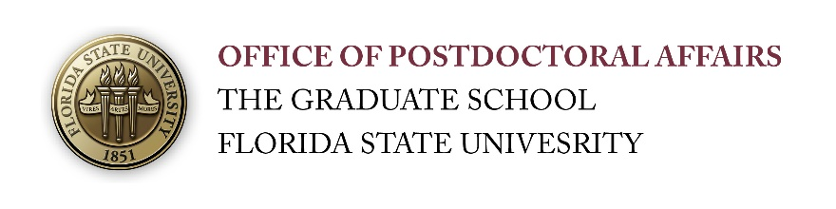.
September 18, 2017

Special Edition for the
National Postdoc Awareness Week #NPAW

Postdocs, Senior Graduate Students, Mentors - Come on out to the…..

Postdoctoral Fall Symposium, Poster Competition, and Awards Ceremony

At the FSU College of Medicine Atrium & COM 1306, THIS FRIDAY, September 22, 2017, 12:00 PM to 6:00 PM; Happy Hour/Reception starting at 4 pm and awards at 5:30 pm.

Flyer and Agenda for the Event DEADLINES EXTENDED DUE TO HURRICANE IRMA

Abstracts will be accepted through Wednesday September 20th, 2017.
All attendees should register whether or not presenting. REGISTER HERE through Thursday September 21st, 2017

The 5th Annual Postdoctoral Symposium and Poster Competition will start at the FSU College of Medicine Atrium. This event is in celebration of the National Postdoctoral Awareness Week and is a wonderful opportunity for you to meet your fellow postdoctoral colleagues!

Please join us for a wonderful afternoon of research interactions, a keynote address by Dr. Timothy McClintock of the University of Kentucky (“Creating Opportunities for Others is the Essence of Leadership and Management”), and an interactive LinkedIn workshop by our own Thierry Dubroca on the theme “Management, Leadership, and Networking – Connecting People!” There will be faculty judges for postdoctoral submitted poster presentations in 4 different divisions ($150 award checks to the top presenters) including a People’s Choice Award.

Postdoctoral scholars, senior graduate students, advisors, and laboratory colleagues are all invited to participate! Lunch will be served prior to the first poster session and there will be a reception/bar starting at 4 pm during the second poster session. Annual awards and poster competition awards will be presented at approximately 5:30 pm. Professional Development Travel Award Grantees over the 2016-2017 selections will receive recognition at this ceremony. All categories of attendees (presenters, non-presenters, judges, and speakers) should register to help us prepare food quantities.

Click here for How to Write a Strong Scientific Abstract (Submission instructions within the registration survey)

